**220962404 , Week 8 HW , Form Processing using Django – Part II**

**Roll no : 65, AIML A2**

**1.Create a website with two pages.**

**First page contains:**

**RadioButton with HP, Nokia, Samsung, Motorola, Apple as options.**

**CheckBox with Mobile and Laptop as items.**

**TextBox to enter quantity.**

**There is a button with text as "Produce Bill".**

**On Clicking Produce Bill button, item should be displayed with total amount on**

**another**

**page.**

**Page1.html**

<!DOCTYPE html>

<html lang="en">

<head>

<meta charset="UTF-8" />

<meta name="viewport" content="width=device-width, initial-scale=1.0" />

<title>Bill Generation</title>

<style>

/* Global Styles */

body {

font-family: "Arial", sans-serif;

background-color: #f0f4f8;

margin: 0;

padding: 0;

}

h2 {

font-size: 2rem;

color: #333;

text-align: center;

margin-bottom: 20px;

}

/* Form Styling */

form {

max-width: 500px;

margin: 0 auto;

background-color: #fff;

padding: 30px;

border-radius: 10px;

box-shadow: 0 4px 10px rgba(0, 0, 0, 0.1);

}

form input[type="radio"],

form input[type="checkbox"] {

margin-right: 10px;

}

form input[type="text"] {

width: 100%;

padding: 12px;

margin: 10px 0;

border: 2px solid #ddd;

border-radius: 5px;

font-size: 1rem;

box-sizing: border-box;

}

form button {

width: 100%;

padding: 15px;

background-color: #007bff;

color: white;

border: none;

border-radius: 5px;

font-size: 1.1rem;

cursor: pointer;

transition: background-color 0.3s;

}

form button:hover {

background-color: #0056b3;

}

a {

display: block;

text-align: center;

margin-top: 20px;

color: #007bff;

text-decoration: none;

font-size: 1.1rem;

}

a:hover {

text-decoration: underline;

}

</style>

</head>

<body>

<h2>Choose Product and Quantity</h2>

<form method="POST">

{% csrf_token %}

<label><input type="radio" name="brand" value="HP" /> HP</label><br />

<label><input type="radio" name="brand" value="Nokia" /> Nokia</label

><br />

<label><input type="radio" name="brand" value="Samsung" /> Samsung</label

><br />

<label

><input type="radio" name="brand" value="Motorola" /> Motorola</label

><br />

<label><input type="radio" name="brand" value="Apple" /> Apple</label

><br /><br />

<label

><input type="checkbox" name="category" value="Mobile" /> Mobile</label

><br />

<label

><input type="checkbox" name="category" value="Laptop" /> Laptop</label

><br /><br />

<label for="quantity">Enter Quantity:</label>

<input type="text" name="quantity" id="quantity" required /><br /><br />

<button type="submit">Produce Bill</button>

</form>

<a href="{% url 'page2' %}">Go to Bill Page</a>

</body>

</html>

**page2.html**

<!DOCTYPE html>

<html lang="en">

<head>

<meta charset="UTF-8" />

<meta name="viewport" content="width=device-width, initial-scale=1.0" />

<title>Bill Details</title>

<style>

/* Global Styles */

body {

font-family: "Arial", sans-serif;

background-color: #f0f4f8;

margin: 0;

padding: 0;

}

h2 {

font-size: 2rem;

color: #333;

text-align: center;

margin-bottom: 20px;

}

.bill-container {

max-width: 500px;

margin: 0 auto;

padding: 40px;

background-color: #fff;

border-radius: 10px;

box-shadow: 0 4px 10px rgba(0, 0, 0, 0.1);

text-align: center;

}

.bill-container p {

font-size: 1.5rem;

margin: 15px 0;

}

.bill-container a {

margin-top: 20px;

font-size: 1.2rem;

color: #007bff;

text-decoration: none;

}

.bill-container a:hover {

text-decoration: underline;

}

</style>

</head>

<body>

<div class="bill-container">

<h2>Bill Summary</h2>

<p><strong>Brand:</strong> {{ brand }}</p>

<p><strong>Category:</strong> {{ category }}</p>

<p><strong>Quantity:</strong> {{ quantity }}</p>

<p><strong>Total Amount:</strong> ${{ total_amount }}</p>

<a href="{% url 'page1' %}">Go Back</a>

</div>

</body>

</html>

**views.py**

from django.shortcuts import render, redirect

from django.http import HttpResponse

def page1(request):

if request.method == 'POST':

brand = request.POST.get('brand')

category = request.POST.getlist('category')

quantity = int(request.POST.get('quantity'))

prices = {

'HP': 500,

'Nokia': 300,

'Samsung': 700,

'Motorola': 600,

'Apple': 1000,

}

price_per_item = prices.get(brand, 0)

total_amount = price_per_item * quantity

total_amount = total_amount + 200 * quantity if 'Laptop' in category else total_amount

request.session['brand'] = brand

request.session['category'] = ', '.join(category)

request.session['quantity'] = quantity

request.session['total_amount'] = total_amount

return redirect('page2')

return render(request, 'page1.html')

def page2(request):

brand = request.session.get('brand', '')

category = request.session.get('category', '')

quantity = request.session.get('quantity', 0)

total_amount = request.session.get('total_amount', 0)

return render(request, 'page2.html', {

'brand': brand,

'category': category,

'quantity': quantity,

'total_amount': total_amount,

})

**urls.py**

from django.urls import path

from . import views

urlpatterns = [

path('', views.page1, name='page1'),

path('bill/', views.page2, name='page2'),

]

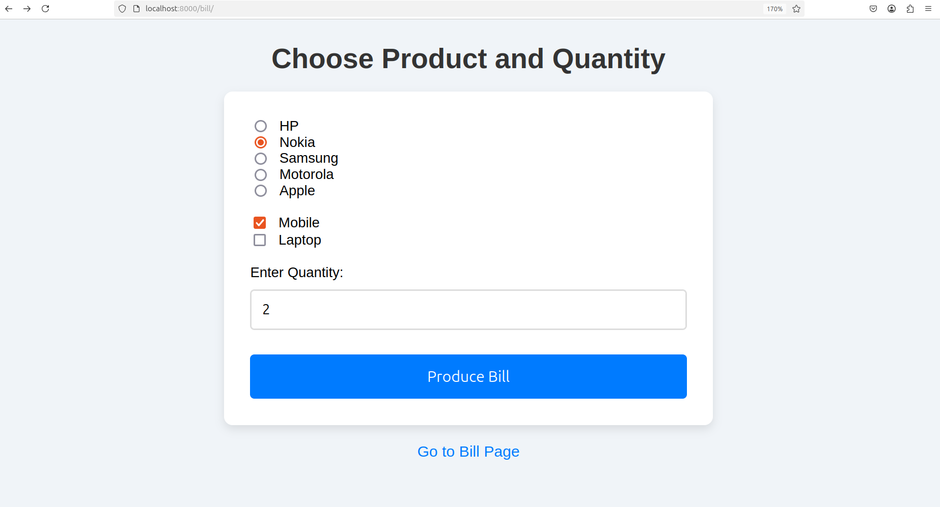

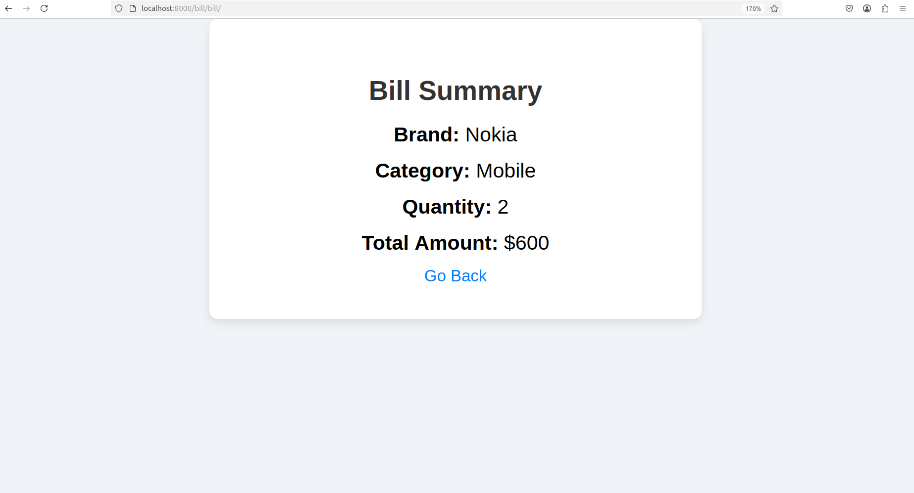

**2.)Write a program to display the following feedback form. The different options for**

**the list box must be ASP-XML, DotNET, JavaPro and Unix,C,C++. When the Submit**

**Form button is clicked after entering the data, a message as seen in the last line of**

**the above figure must be displayed.**

**feedback_form.html**

<!DOCTYPE html>

<html lang="en">

<head>

<meta charset="UTF-8" />

<meta name="viewport" content="width=device-width, initial-scale=1.0" />

<title>Feedback Form</title>

<style>

body {

font-family: Arial, sans-serif;

background-color: #f4f4f9;

margin: 0;

padding: 0;

}

.container {

max-width: 600px;

margin: 50px auto;

padding: 20px;

background-color: white;

border-radius: 8px;

box-shadow: 0 2px 10px rgba(0, 0, 0, 0.1);

}

h2 {

text-align: center;

color: #333;

}

.form-group {

margin-bottom: 15px;

}

label {

font-weight: bold;

display: block;

margin-bottom: 5px;

}

input[type="text"],

textarea,

select {

width: 100%;

padding: 8px;

margin-top: 5px;

border: 1px solid #ccc;

border-radius: 4px;

font-size: 14px;

}

input[type="radio"],

input[type="checkbox"] {

margin-right: 10px;

}

.button {

width: 100%;

padding: 10px;

background-color: #4caf50;

color: white;

font-size: 16px;

border: none;

border-radius: 4px;

cursor: pointer;

margin-top: 20px;

}

.button:hover {

background-color: #45a049;

}

.response-message {

margin-top: 20px;

text-align: center;

font-size: 16px;

color: #333;

}

</style>

</head>

<body>

<div class="container">

<h2>Feedback Form</h2>

<form method="POST">

{% csrf_token %}

<div class="form-group">

<label for="name">Name:</label>

<input type="text" id="name" name="name" required />

</div>

<div class="form-group">

<label>Gender:</label>

<input type="radio" id="male" name="gender" value="Male" required />

<label for="male">Male</label>

<input type="radio" id="female" name="gender" value="Female" />

<label for="female">Female</label>

</div>

<div class="form-group">

<label for="course">Course:</label>

<select id="course" name="course">

<option value="ASP-XML">ASP-XML</option>

<option value="DotNET">DotNET</option>

<option value="JavaPro">JavaPro</option>

<option value="Unix,C,C++">Unix, C, C++</option>

</select>

</div>

<div class="form-group">

<label for="coverage">Technical Coverage:</label>

<select id="coverage" name="coverage">

<option value="Excellent">Excellent</option>

<option value="Good">Good</option>

<option value="Average">Average</option>

<option value="Poor">Poor</option>

</select>

</div>

<div class="form-group">

<label for="suggestions">Suggestions:</label>

<textarea id="suggestions" name="suggestions" rows="4"></textarea>

</div>

<button type="submit" class="button">Submit Form</button>

</form>

{% if name %}

<div class="response-message">

<p>Thanks Mr/Miss {{ name }} for your feedback!</p>

</div>

{% endif %}

</div>

</body>

</html>

**views.py**

from django.shortcuts import render

from django.http import HttpResponse

def feedback_form(request):

name = ''

if request.method == 'POST':

name = request.POST.get('name')

gender = request.POST.get('gender')

course = request.POST.get('course')

coverage = request.POST.get('coverage')

suggestions = request.POST.get('suggestions')

request.session['name'] = name

request.session['gender'] = gender

request.session['course'] = course

request.session['coverage'] = coverage

request.session['suggestions'] = suggestions

return render(request, 'feedback_form.html', {'name': name})

return render(request, 'feedback_form.html', {'name': name})

**urls.py**

from django.urls import path

from . import views

urlpatterns = [

path('', views.feedback_form, name='feedback_form'),

]

