Paradigm Experts — Website Tickets: Tysons Expansion + Areas-We-Serve Fix
Prepared by PracticeRank for the Paradigm Experts web developer. Three tickets: (1) fix the Areas-We-Serve headline contrast bug, (2) add the new Vienna/Tysons location as “Coming Soon,” and (3) a homepage “Opening Soon” banner + a dedicated Tysons landing page.

Business details (use exactly)
- Existing (primary): 6310-A Springfield Plaza, Springfield, VA 22150
- NEW (Coming Soon): 8381 Old Courthouse Road, Suite 211, Vienna, VA 22181 (Tysons area)
- Contact: Danny Gouterman · Danny@ParadigmExperts.com · (703) 650-5034 (main) / 703-585-1964 (Danny)
- Buys: gold, precious metals, diamonds, jewelry, timepieces (watches), and coins.
Source — new business card (new Vienna/Tysons address):
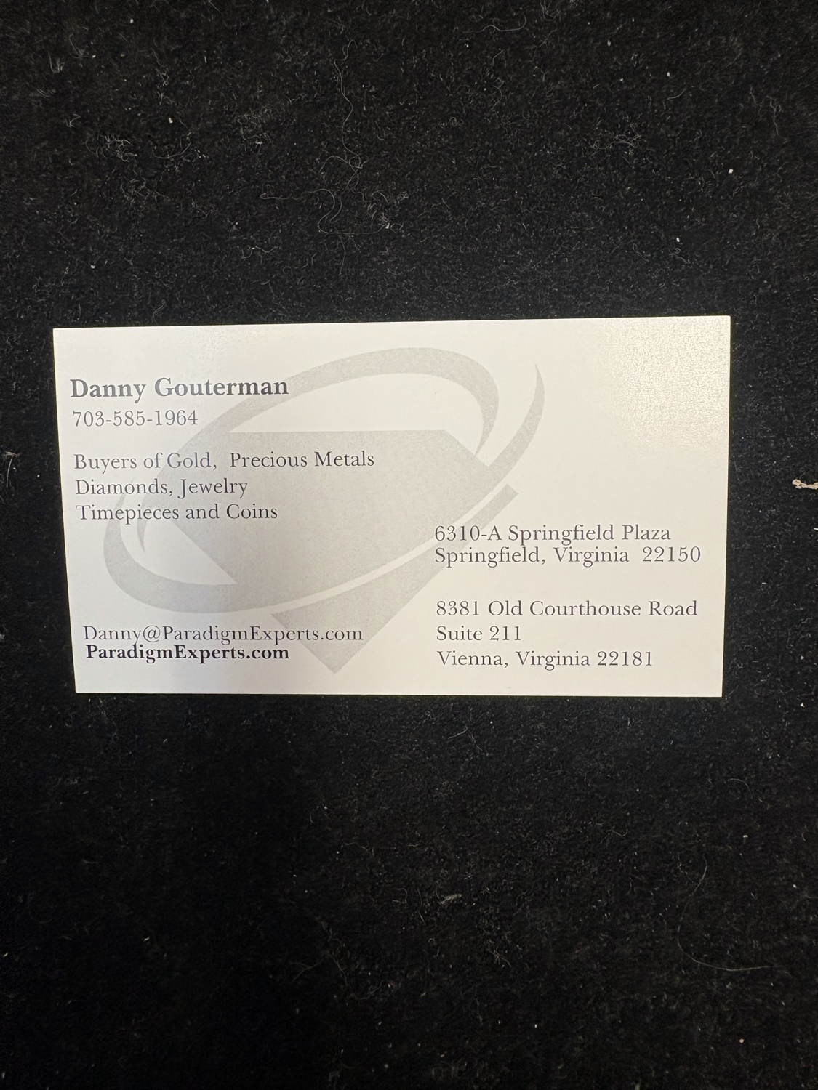

PE-1 — Fix “Areas We Serve” headline — unreadable over hero image
Priority: High – client-reported · Site: paradigmexperts.com (Webflow) · Owner: Dev
Problem / Goal — On the “Areas We Serve” city landing pages, the headline/H1 color blends into the background hero image (low contrast), so it’s hard to read. These pages share one template/CMS collection, so fix it once at the template level.

Tasks
- Add a dark overlay/scrim between the hero image and the text (e.g. a linear-gradient or rgba(0,0,0,0.45–0.6) layer) so text is legible over any photo.
- Set the headline to a high-contrast color (white) with a subtle text-shadow for safety.
- Verify WCAG AA contrast (≥ 4.5:1) against the LIGHTEST hero image in the set, not just a dark one.
- Apply on the shared hero component/symbol so every area page inherits the fix (don’t patch pages one by one).
Acceptance criteria — Headline is clearly legible and passes AA contrast on every Areas-We-Serve page, desktop and mobile, including the lightest hero image.

PE-2 — Add new Vienna/Tysons location (Coming Soon)
Priority: High · Site: paradigmexperts.com (Webflow) · Owner: Dev
Problem / Goal — Paradigm is opening a second location and wants it announced now (good for growth + credibility). Add it site-wide as “Coming Soon” without implying it’s open for walk-ins yet.

Tasks
- Add the Vienna location to the Locations section/CMS: 8381 Old Courthouse Road, Suite 211, Vienna, VA 22181, with a visible “Coming Soon” badge/label.
- Add second-office details to the footer and Contact page, clearly marked Coming Soon (no live hours; use the main phone for now).
- Add a second PostalAddress to the Organization/LocalBusiness JSON-LD (or a second location entity) so search engines learn about the new address; keep Springfield as the primary location.
- Do NOT set up or link a Google Business Profile as “open” yet — coming-soon only until Danny confirms the open date.
Acceptance criteria — The Vienna location appears with a “Coming Soon” treatment in Locations, footer, and Contact; JSON-LD validates in Google’s Rich Results test; the Springfield location is unchanged.

PE-3 — Homepage “Opening Soon” banner + dedicated Tysons landing page
Priority: High · Site: paradigmexperts.com (Webflow) · Owner: Dev
Problem / Goal — Announce the Tysons expansion on the homepage with a CTA that drives visitors to a dedicated Tysons landing page (captures the expansion news + local Tysons/Vienna search intent).

Tasks
- Build a dedicated Tysons landing page (suggested URL /tysons or /locations/tysons): hero with “Opening Soon in Tysons / Vienna”, the new address, what Paradigm buys, and copy targeting Tysons, Vienna, McLean, and Falls Church sellers.
- Add a “Notify me / Get a free evaluation” lead form + phone CTA on the Tysons page.
- Set the Tysons page’s SEO: title/meta + LocalBusiness schema for the Vienna address; make it indexable.
- Add a dismissible announcement banner on the HOMEPAGE (top strip or hero ribbon): “Opening Soon in Tysons” + a CTA button linking to the Tysons page.
- Ensure the banner is mobile-friendly, doesn’t cover key content, and the Tysons page inherits the PE-1 hero contrast fix.
Acceptance criteria — Homepage shows the Opening-Soon banner on desktop + mobile linking to a live, indexable Tysons landing page with correct NAP, schema, working form, and legible hero.

