Drug Traceability in HealthCare Supply Chain using Blockchain Technology

For any country development correct pharmacy Drugs play an important role and its quality and tracing (finding current stage of product such as Under Production, transport or processing etc.) details must be appropriate. To get trusted traceability author of this paper employing Blockchain technology in Drug supply chain management. As all existing supply chain managements are based on centralized server and if this server down then traceability becomes impossible and there is a chance that if centralized server hack then there is no possible mean to recover or extract hacking details.

Due to above centralized server disadvantages many organizations are moving or migrating their application to Blockchain. Blockchain is a distributed technology (data store at multiple connected nodes) and has inbuilt support for data encryption and verification. As Blockchain store data at multiple nodes and if one node down then traceability information can be obtained from other working nodes. Another advantage of Blockchain is data verification where Blockchain store each data as Block/Transaction and associate each block with unique hashcode and before storing new block then Blockchain verify hashcode of each block and if any block data alter then it result into mismatched hashcode and verification will get failed and detected.

This project can be used by multiple users such as Admin (manufacturer), supplier, pharmacy, normal users can signup and login and then get tracing details of desired drug.

To implement this Drug products tracing project we have used Blockchain Ethereum with Truffle environment and to store or retrieve data in Blockchain we need to design SOLIDITY (Smart Contract) code which will contains function to store and retrieve data. To implement this project we have designed below Solidity code

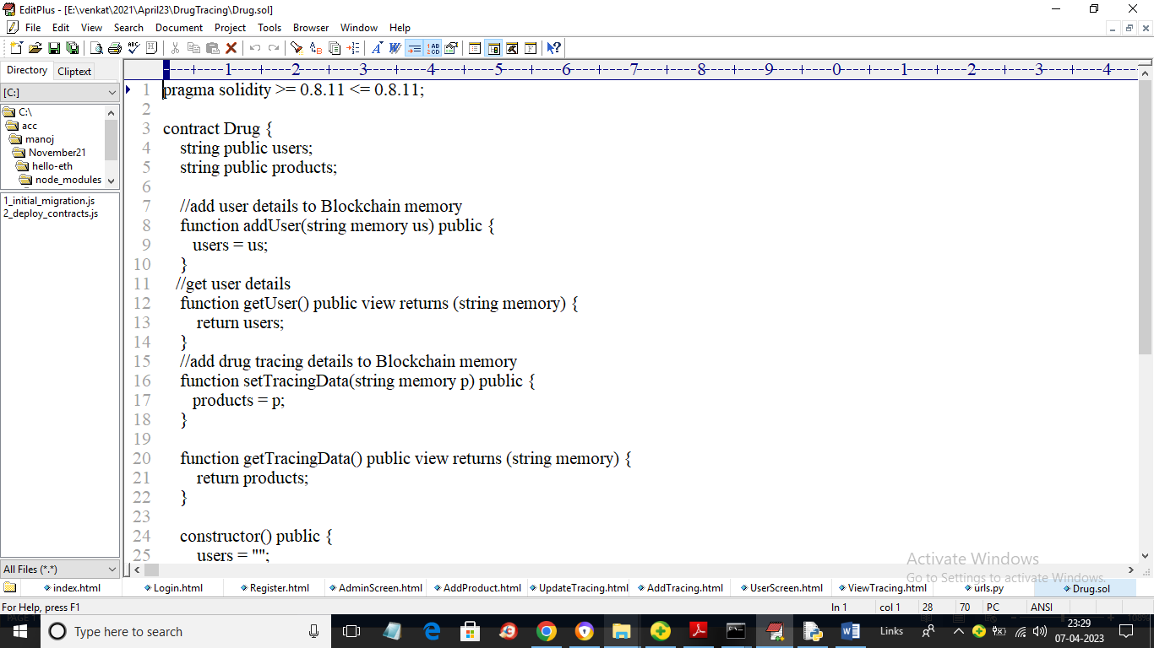

In above Solidity code also known as smart contract we have designed functions to store and retrieve USERS and Drug Tracing details. Now we need to deploy above contract in Ethereum by using below instructions

1. Go inside ‘hello-eth/node_modules/.bin’ folder and then double click on ‘runBlockchain.bat’ file to get below screen
2. 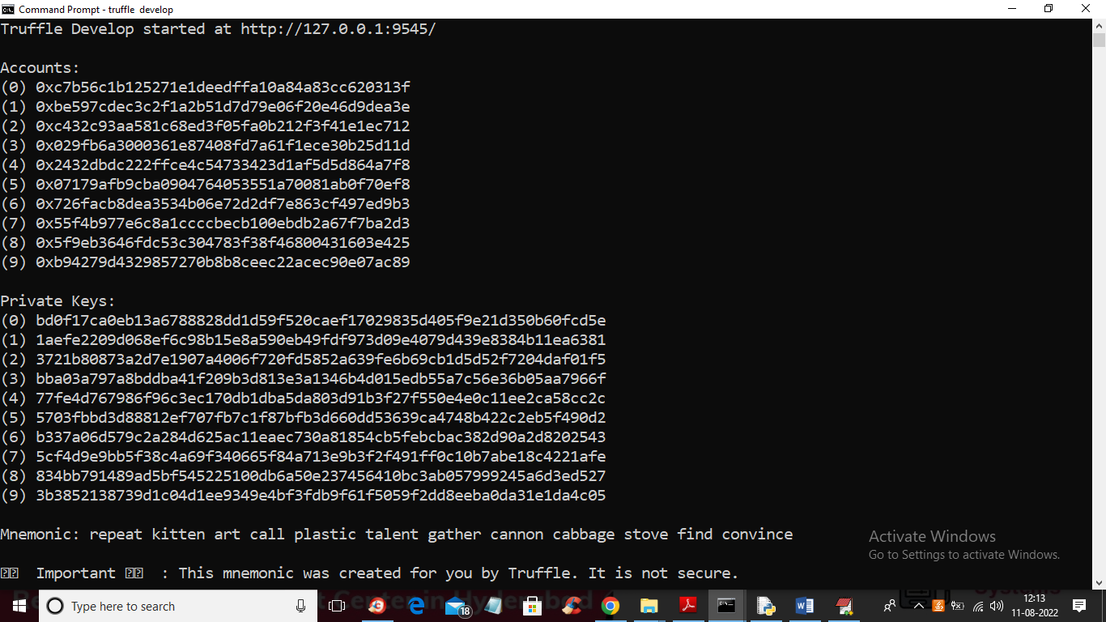
3. In above screen we can see Blockchain created some default accounts and private keys and in above screen just type command as ‘truffle migrate’ and press enter key to deploy contract and get below output
4. 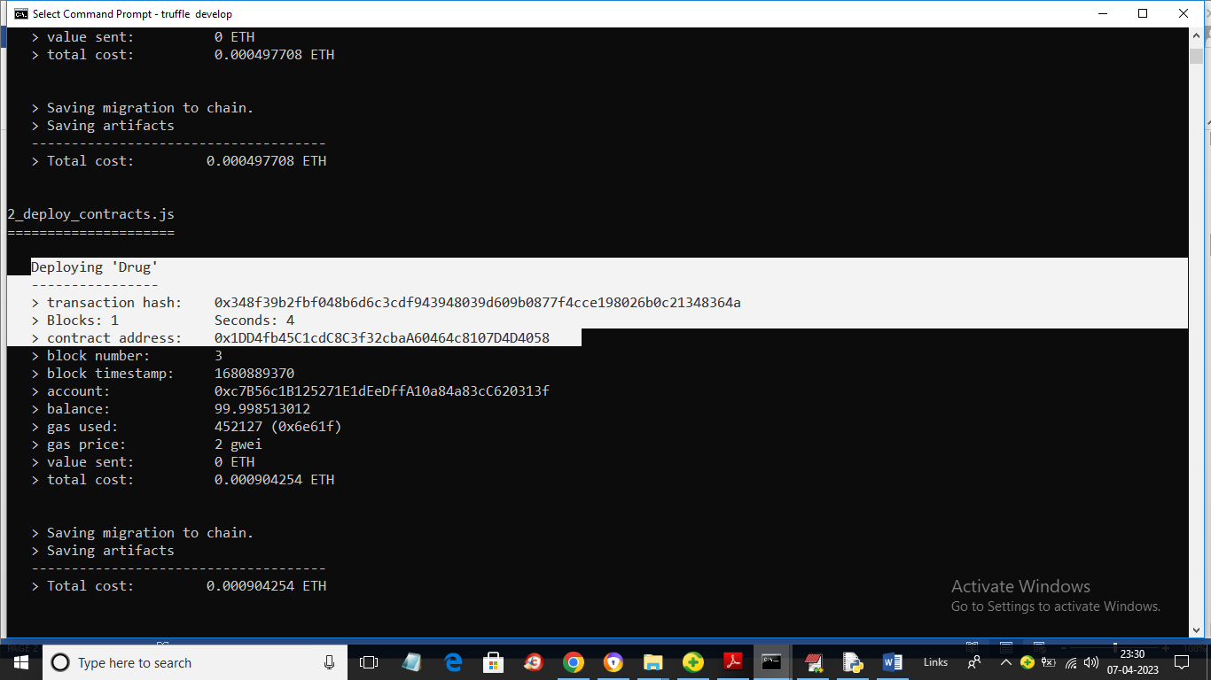
5. In above screen in white colour text we can see ‘Drug’ contract deployed and we got contract address also and this address we need to specify in python program to store and retrieve TRACING details. In below screen I am showing python code to access Blockchain contract by using above contract address
6. 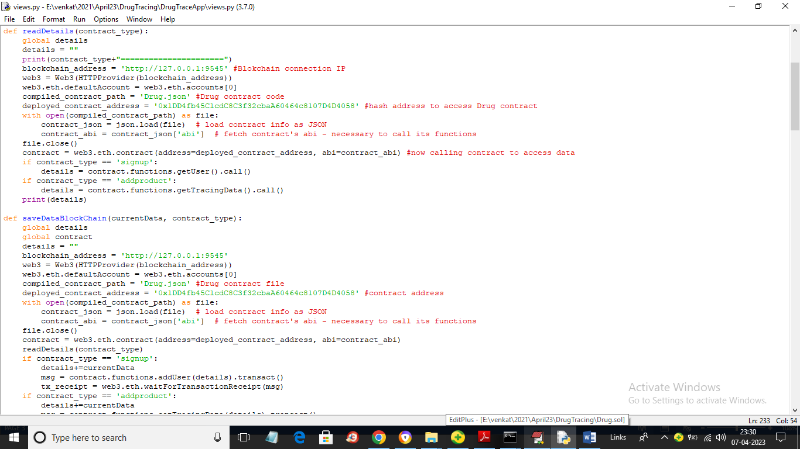
7. In above screen read red colour comments to know about calling Blockchain contract to store and retrieve data using python program.

Modules Information

To implement this project we have designed 2 modules called Admin and User. Admin can login to application using username and password as ‘admin’. After login admin can add Drug details and then update tracing information.

User can signup and login and then can view current tracing information of Drugs. Users can be pharmacy, distributors, users or any other normal user.

Now contract and modules are ready and now we can run project

SCREEN SHOTS

To run project double click on ‘run.bat’ file to get below screen

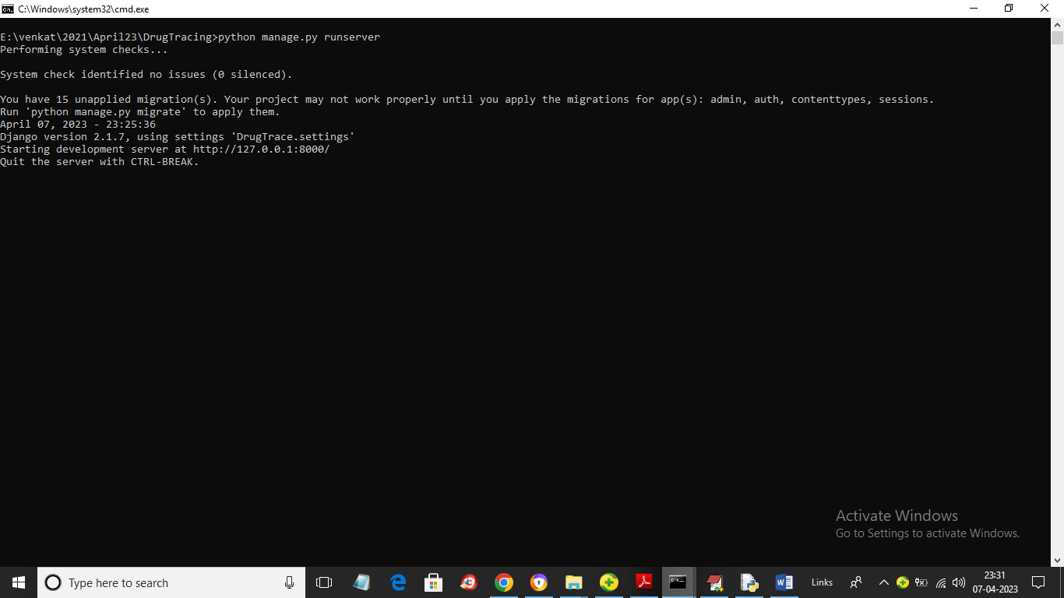

In above screen python server started and now open browser and enter URL as ‘http://127.0.0.1:8000/index.html’ and press enter key to get below home page

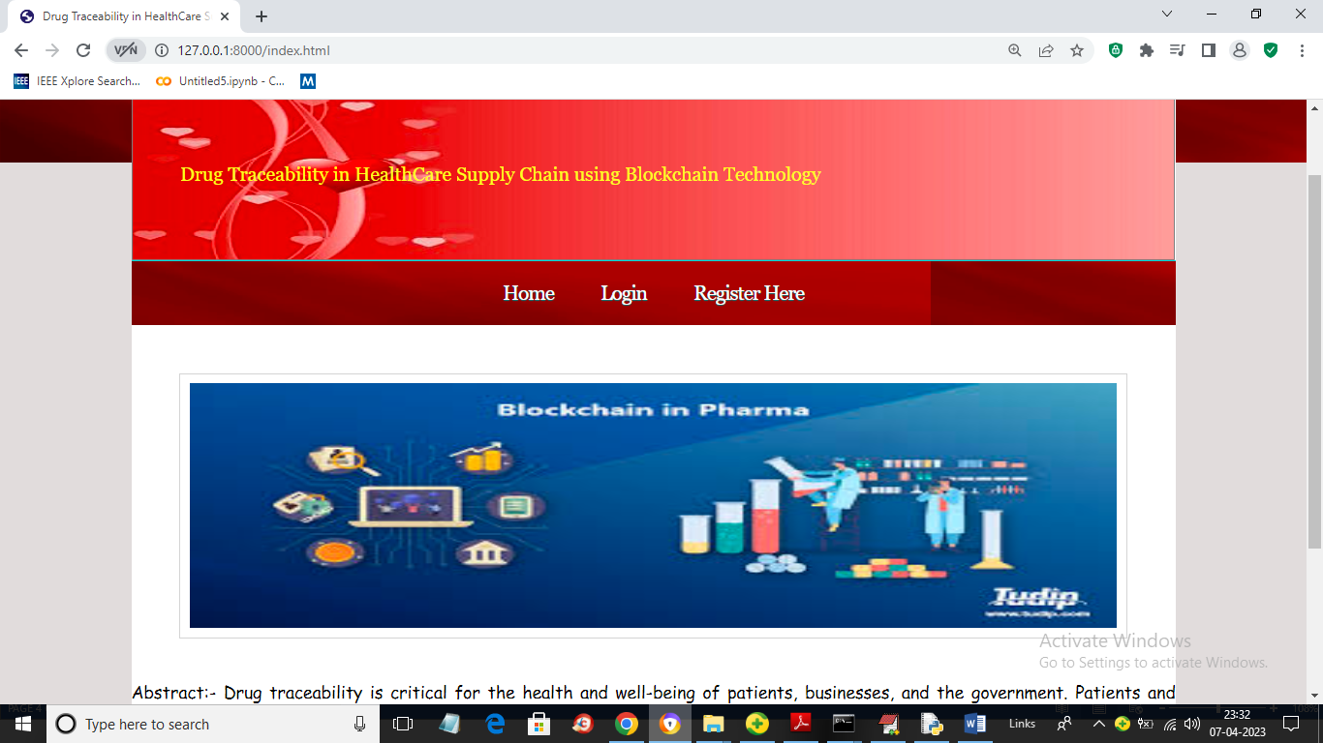

In above screen click on ‘Login’ link and login as admin

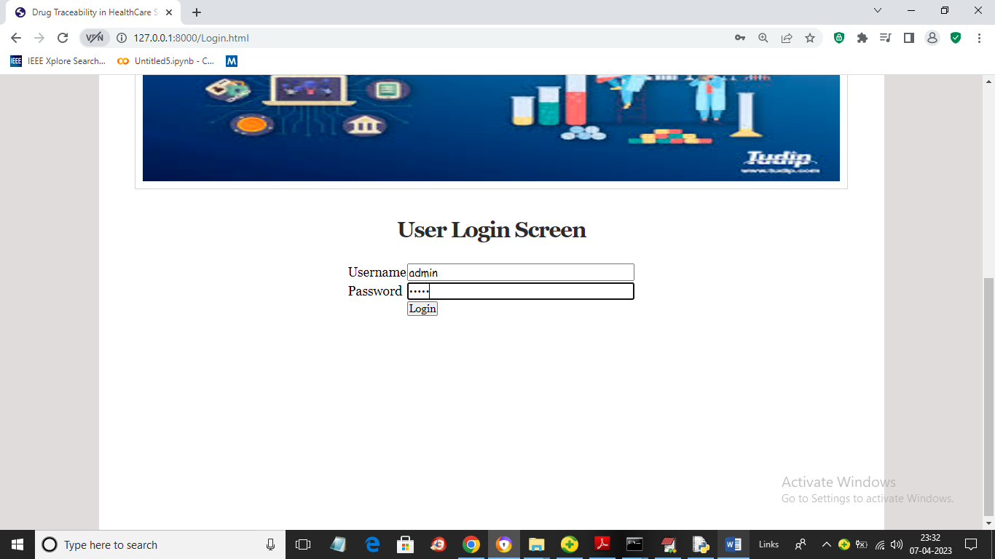

In above screen admin is login and after login will get below output

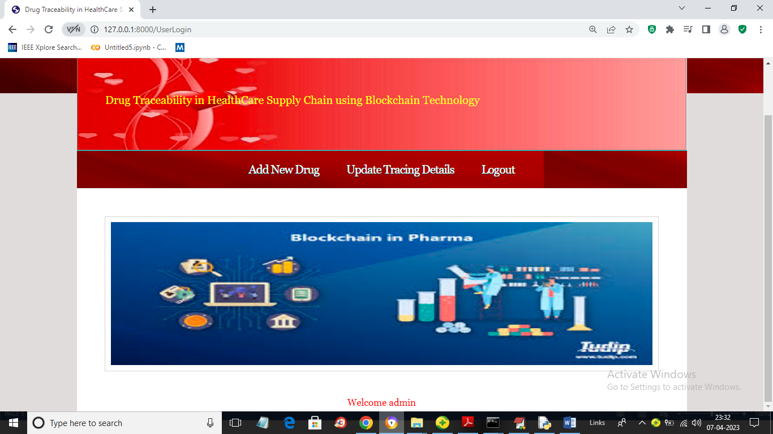

In above screen admin can click on ‘Add New Drug’ link to add new product details

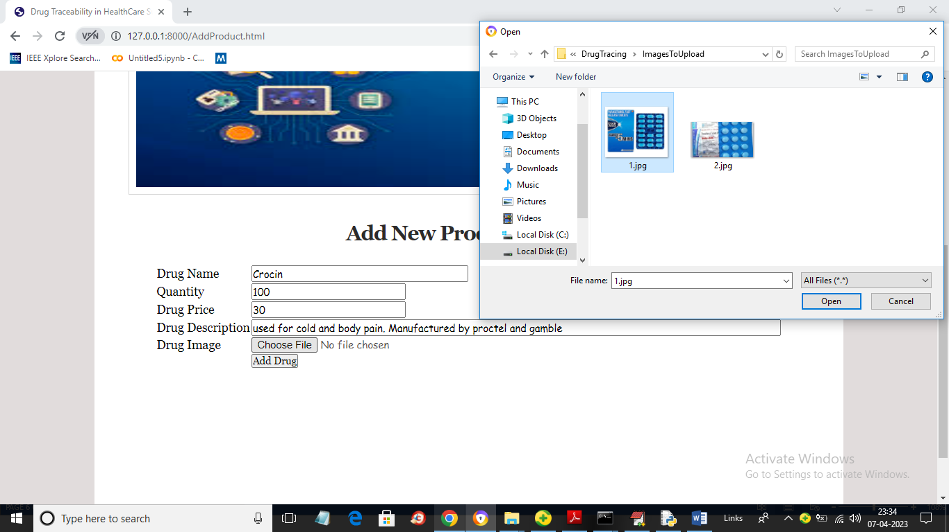

In above screen admin will add all Drug details and then upload image and then press ‘Add Drug’ button to get below output

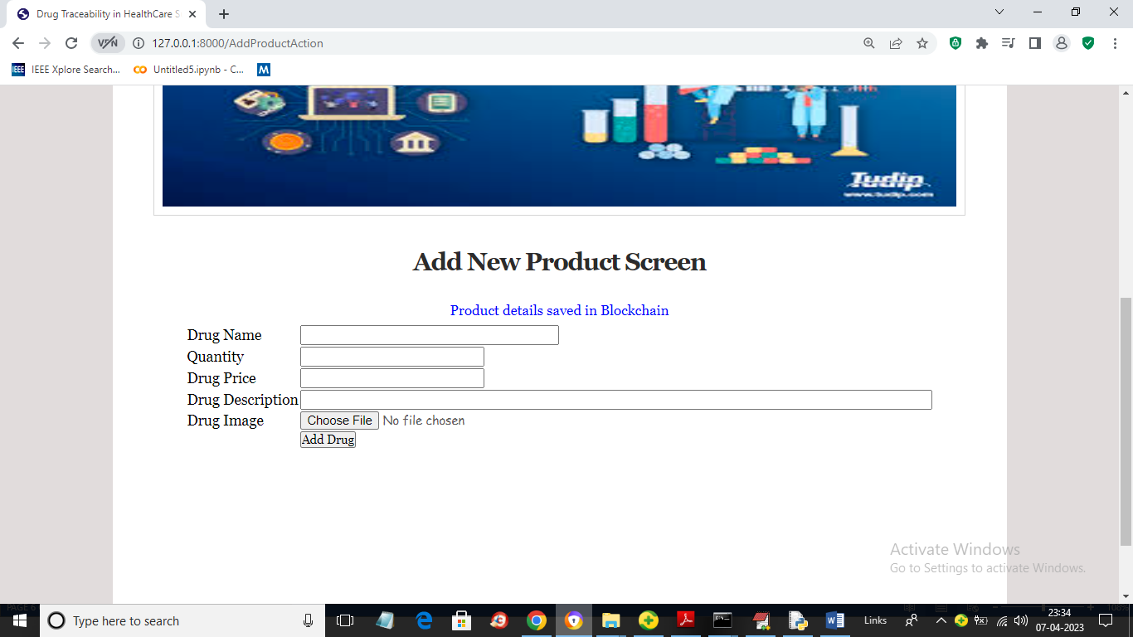

In above screen in blue colour text we can see Drug details added. Similarly you can add any number of drugs to Blockchain. now click on ‘Update Tracing Details’ link to get below output

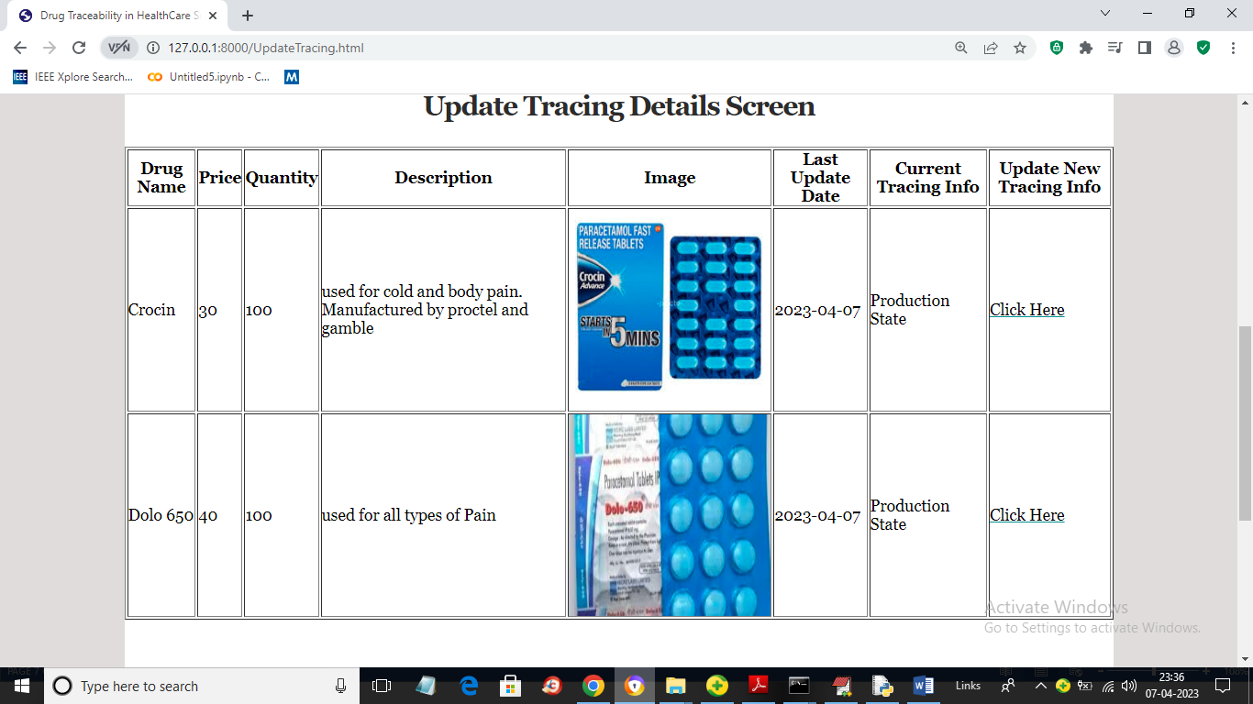

In above screen admin can view all Drug details and to update tracing details from current state, admin will click on ‘Click Here’ link to get below screen

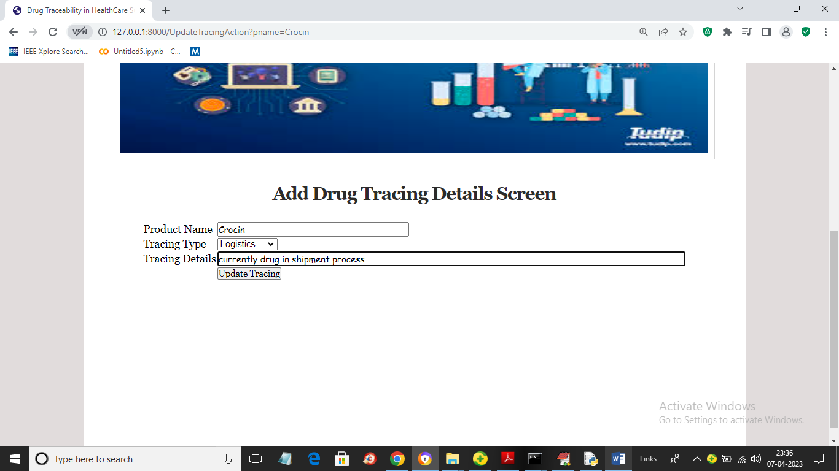

In above screen admin will select Tracing Type and then enter current tracing details and press button to store current tracing data to Blockchain and get below output

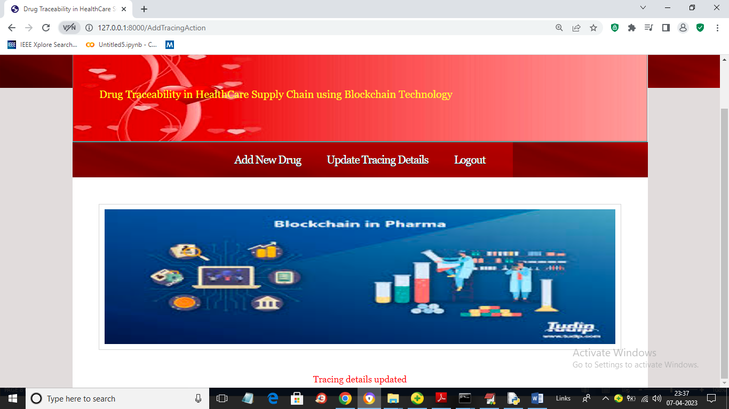

In above screen in red colour text we can see tracing details updated and all users can view this updated trace details. Now logout and signup new user

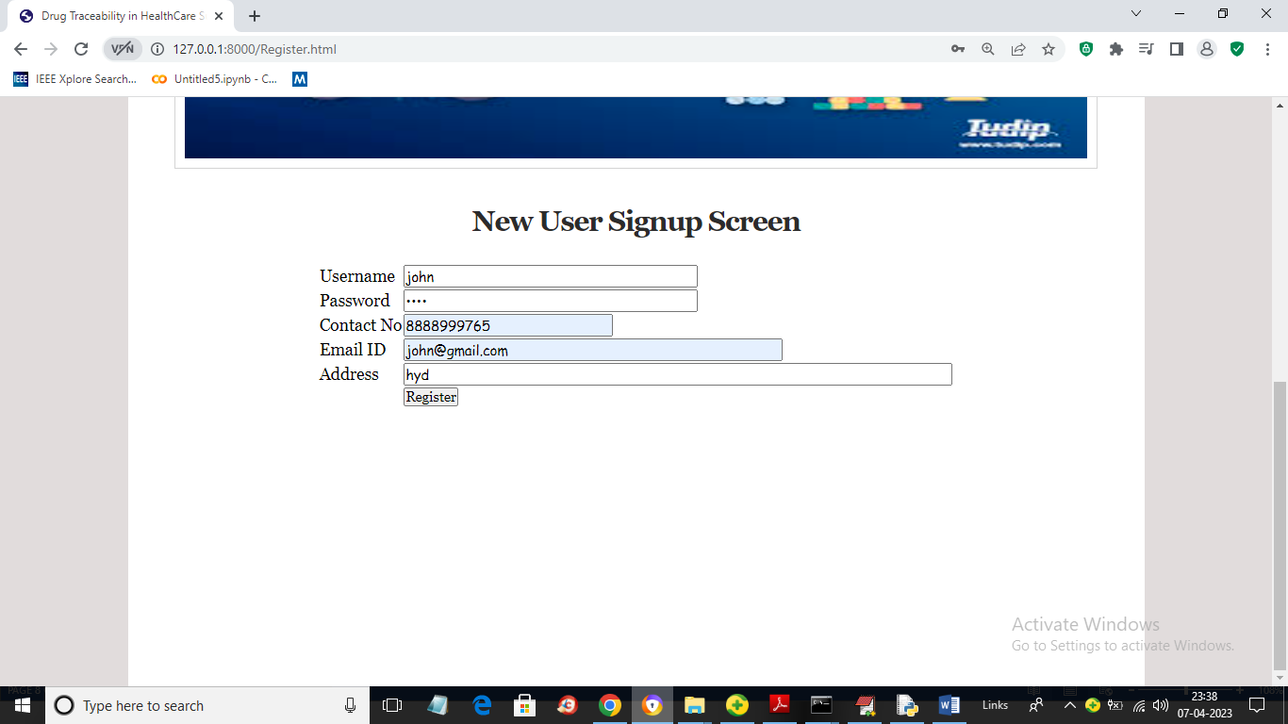

In above screen user is entering signup details and then press button to store user data to Blockchain and get below output

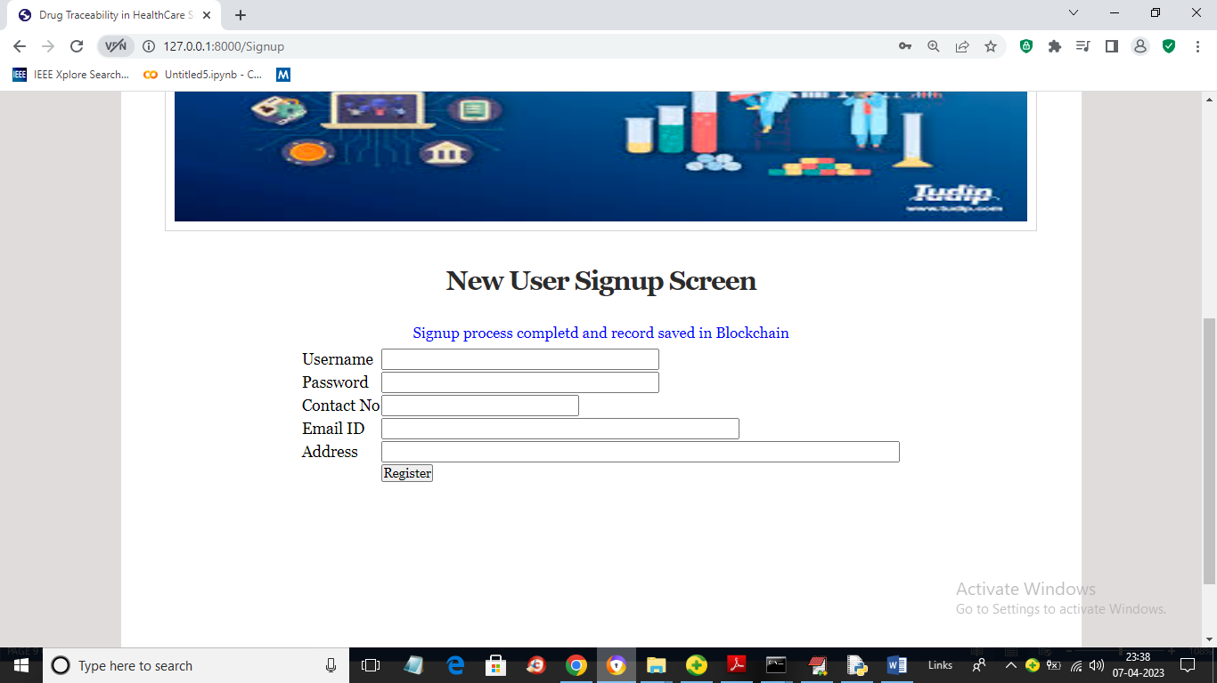

In above screen in blue colour text we can see User details saved in Blockchain and now click on ‘Login’ link to login as user

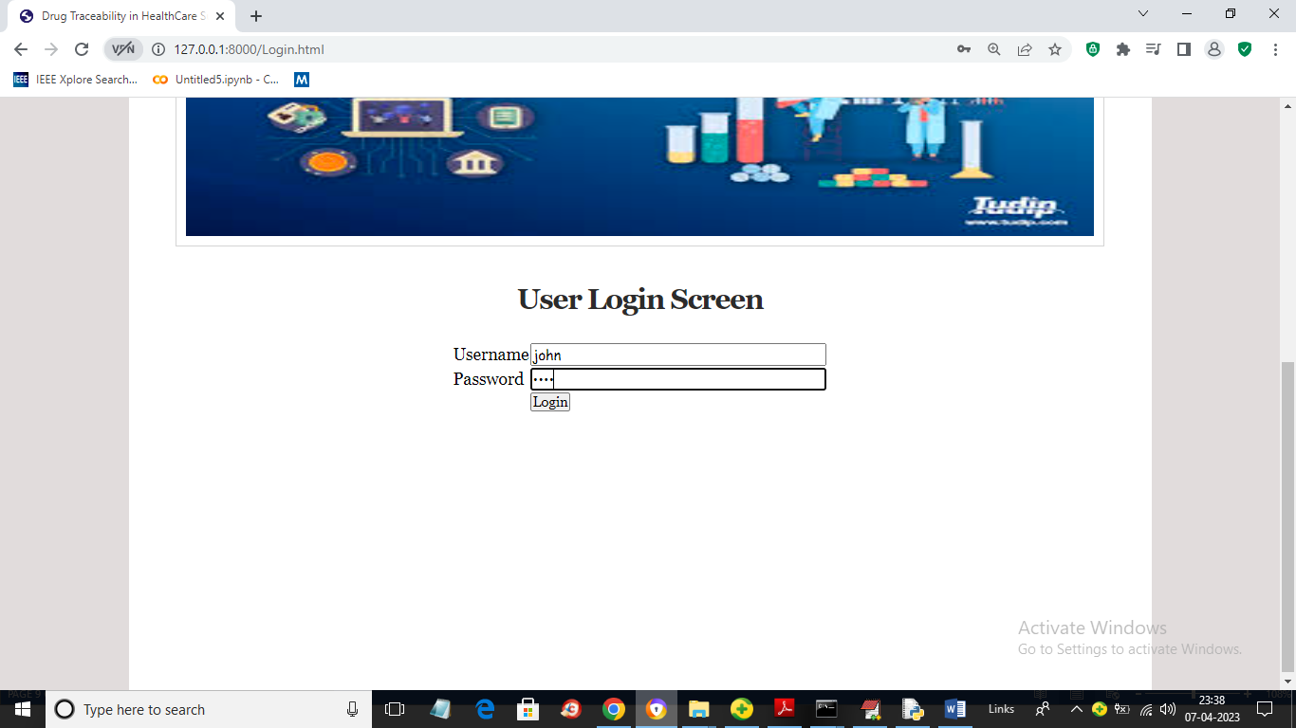

In above screen user is login and after login will get below output

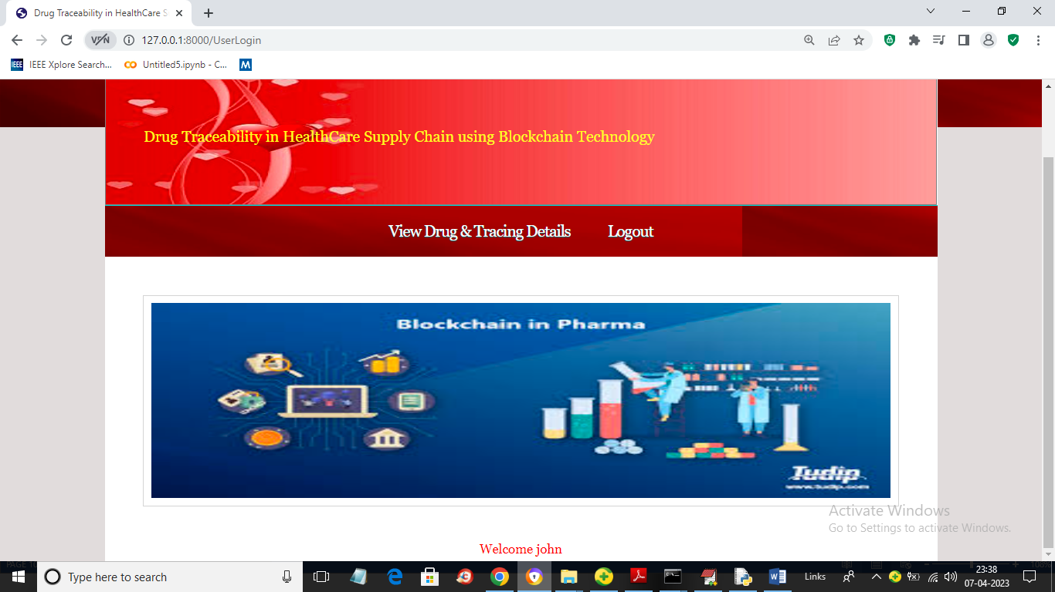

In above screen user can click on ‘View Drug & Tracing Details’ link to get all product details

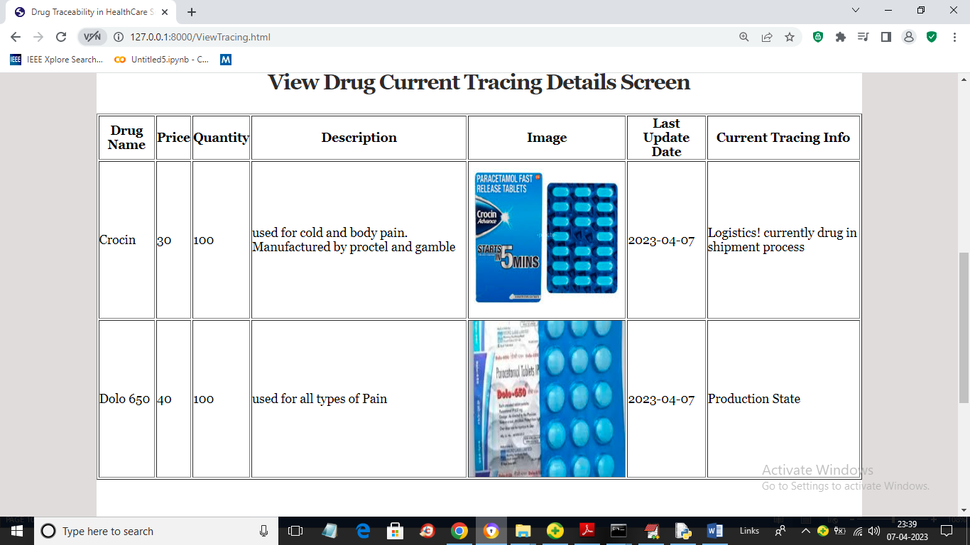

In above screen user can view all product details and in last column user can see current tracing data for each Drug. So by using this application any user can know current tracing and manufacture details of any Drug