**Design Thinking Project Workbook**

**Don't find customers for your product but find products for your customers**

**1. Team**

**Team Name:** **Cancer Cell Segmentation Team**

**Team Logo (if any):**

**Team Members:**

1. S. Karthikeya, 2320030097@klh.edu.in
2. M. Sathvik Reddy, 2320030162@ klh.edu.in
3. D. Mahith, 2320030165@ klh.edu.in

**2. Problem/Opportunity Domain**

**Domain of Interest:** Medical Imaging and Oncology

**Description of the Domain:**The domain involves the analysis of histopathological images for cancer diagnosis. Key challenges include the high variability in manual interpretations, the large volume of images that need analysis, and the need for high accuracy to prevent misdiagnosis. Opportunities exist in automating this process, which can improve diagnostic speed and accuracy.

**Why did you choose this domain?:**The increasing prevalence of cancer and the reliance on accurate histopathological analysis motivated us to address this critical need. We aim to leverage AI to reduce the burden on pathologists and enhance patient care.

**3. Problem/Opportunity Statement**

**Problem Statement:  
Manual analysis of cancer cells in histopathological images is time-consuming, error-prone, and subject to significant variability among pathologists.**

**Problem Description:  
Pathologists must analyze numerous images for accurate cancer cell identification and classification, leading to fatigue and potential misdiagnosis. Automating this process can improve efficiency and accuracy.**

**Context (When does the problem occur):  
The problem arises during routine diagnostic procedures when pathologists analyze a high volume of histopathological images, often leading to inconsistencies and delays.**

**Alternatives (What does the customer do to fix the problem):  
Currently, pathologists rely on manual analysis and existing semi-automated tools, which still require significant human oversight and do not fully address the challenges of accuracy and speed.**

**Customers (Who has the problem most often):  
Primary customers include pathologists, medical institutions, and cancer research facilities that depend on accurate histopathological analysis for cancer diagnosis.**

**Emotional Impact (How does the customer feel):  
Pathologists may feel overwhelmed, stressed, and frustrated due to the workload and the high stakes of accurate diagnosis.**

**Quantifiable Impact (What is the measurable impact):  
Misdiagnoses can lead to inappropriate treatment plans, resulting in increased healthcare costs, prolonged patient suffering, and poor patient outcomes.**

**Alternative Shortcomings (What are the disadvantages of the alternatives):  
Existing solutions often lack accuracy, require extensive training, and do not integrate seamlessly into clinical workflows.**

**Any Video or Images to showcase the problem:  
[Insert link to relevant video/image]**

**4. Addressing SDGs**

**Relevant Sustainable Development Goals (SDGs):**

1. SDG 3: Good Health and Well-being
2. SDG 9: Industry, Innovation, and Infrastructure

**How does your problem/opportunity address these SDGs?:**

Our solution aims to enhance diagnostic accuracy and efficiency, directly contributing to better health outcomes and innovations in medical technology.

**5. Stakeholders**

Answer these below questions to understand the stakeholder related to your project

**• Who are the key stakeholders involved in or affected by this project?**

**Pathologists, medical institutions, patients, cancer research organizations, software developers.**

**• What roles do the stakeholders play in the success of the innovation?**

**Pathologists provide expertise; medical institutions facilitate implementation; patients benefit from improved diagnosis; developers create the technology.**

**• What are the main interests and concerns of each stakeholder?**

**Pathologists: accuracy and efficiency; institutions: cost-effectiveness and patient outcomes; patients: timely and accurate diagnosis.**

**• How much influence does each stakeholder have on the outcome of the project?**

**Pathologists and medical institutions have high influence; patients have moderate influence through feedback; developers have technical influence.**

**• What is the level of engagement or support expected from each stakeholder?**

**Active engagement from pathologists for feedback; support from institutions for testing and implementation; collaborative input from developers.**

**• Are there any conflicts of interest between stakeholders? If so, how can they be addressed?**

**Conflicts may arise over data privacy. Establishing clear protocols and communication can help mitigate these issues.**

**• How will you communicate and collaborate with stakeholders throughout the project?**

**Regular meetings, updates, and feedback sessions through collaborative platforms.**

**• What potential risks do stakeholders bring to the project, and how can these be mitigated?**

**Risks include resistance to change and data privacy concerns. These can be addressed through training and clear data handling policies.**

**6. Power Interest Matrix of Stakeholders**

**Power Interest Matrix: Provide a diagrammatic representation of Power Interest Matrix**

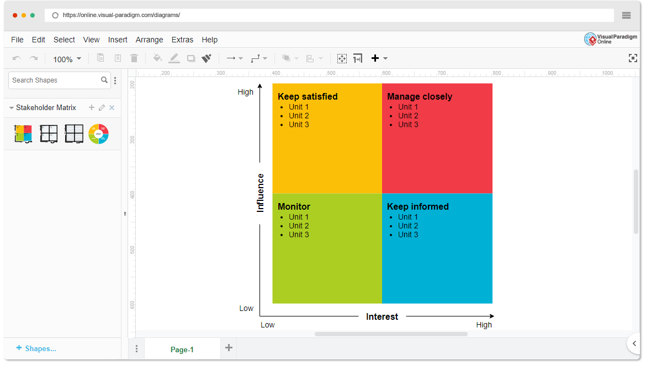

**Power Interest Matrix:**

* **High Power, High Interest:** Pathologists, Medical Institutions
* **High Power, Low Interest:** Software Developers
* **Low Power, High Interest:** Patients, Cancer Research Organizations
* **Low Power, Low Interest:** General Public