Field Name | Data Type | Description | Derivation Logic
AIRPORT_COST | Float | Total airport-related fees per flight or ticket. | Sum of ORIGIN_FEE and DEST_FEE.
BAGGAGE_REVENUE | Float | Estimated revenue generated from checked baggage. | Typically derived from baggage count* average baggage fee.
CANCELLED | Integer | Indicates if a flight was cancelled (1 = Yes, 0 = No). Used for filtering. | From raw data, retained for cleaning steps.
DELAY_COST | Float | Estimated cost incurred due to flight delays. | Based on delay duration* cost per minute.
DELAY_MINUTES | Float | Total delay duration combining departure and arrival delays. | DEP_DELAY + ARR_DELAY.
DEST_FEE | Float | Fee charged by the destination airport. | Extracted or imputed based on airport metadata.
EST_PASSENGERS | Integer | Estimated passengers on board a flight. | Possibly calculated from occupancy*seat count.
ITIN_FARE | Float | Fare per ticketed itinerary. | From ticket dataset, used for revenue estimates.
MILEAGE_COST | Float | Operational cost estimated based on miles flown. | DISTANCE * cost per mile.
ORIGIN_FEE | Float | Fee charged by the airport. | Extracted or imputed from airport metadata.
PASSENGERS | Integer | Total passengers on a round trip or flight segment. | Derived from ticket sales or seat *occupancy rate.
PROFIT | Float | Net profit for a round-trip route. | TOTAL_REVENUE - TOTAL_COST.
ROUNDTRIP | Boolean | Flag to indicate if a flight is a round-trip route. | Based on route pattern or logic matching reverse direction.
ROUNDTRIP_KEY | String | Unique identifier for round trip (e.g., 'JFK-LAX-JFK'). | Standardized key combining ORIGIN and DESTINATION.
ROUTE | String | Concatenated route string represents one-way leg. | ORIGIN + '-' + DESTINATION.
TICKET_REVENUE | Float | Total revenue from ticket sales for a route or period. | Sum of ITIN_FARE × passengers.
TOTAL_COST | Float | Aggregate operational cost for a route or flight. | Sum of delay cost, airport fees, mileage cost, etc.
TOTAL_REVENUE | Float | Total revenue generated for a round trip or route. | Sum of ticket and baggage revenue.
Above is the derived Field Metadata for Airline Data Challenge based upion the changes I made for data cleaning and analysis.

- Address any material data issues that could impact your recommendations--highlight at least 3 data quality insights:
Data Quality Insights from My Analysis
As I worked through the airline data challenge project, I encountered several data quality issues that I needed to address to ensure my recommendations were grounded in reliable information. Here are three of the most identified material issues I resolved during my analysis:
1. Missing or Incomplete Flight Information
One of the first challenges I ran into was missing values in key columns like DEP_DELAY, ARR_DELAY, and AIR_TIME within the flight dataset. These fields are crucial for understanding not just the punctuality of routes but also for estimating costs related to delays and fuel consumption. To address this, I decided to drop rows that had missing values in any of these critical fields. While this improved data integrity, I remained cautious that this might skew the dataset toward better-performing routes and possibly exclude operationally problematic ones.
2. Implausible Occupancy Rates
While validating flight-level metrics, I noticed that some entries had occupancy rates that were either zero, greater than one, or suspiciously close to the boundaries. These anomalies would have seriously distorted revenue calculations since passenger count is typically estimated using occupancy × seat capacity. To clean this, I applied filters to retain only records where occupancy rates were within a realistic range (strictly between 0 and 1). This step helped ensure that downstream revenue and profit metrics were not artificially inflated or deflated.
3. Ambiguities in Route and Roundtrip Definitions
When creating unique keys to analyze round-trip performance, I initially combined origin and destination codes into a ROUNDTRIP_KEY. However, I later realized that assuming all routes are symmetric (e.g., JFK-LAX is the same as LAX-JFK) can be misleading. Demand, pricing, and delays can vary significantly depending on the direction. So, while I still used combined keys for analysis, I made sure to cross-check performance in both legs and flagged this as a consideration for future route-specific investment decisions.
4. Filtered Out Outliers in Delay Columns Using Z-Score Normalization
To reduce the impact of extreme delays that could distort average calculations, I applied a z-score filter to both DEP_DELAY and ARR_DELAY. By retaining only those records within ±3 standard deviations, I effectively removed outliers that could have been caused by exceptional events or data entry errors. This made my delay-related cost estimations and profitability assessments more representative of normal operations.
I’ve also written validation functions to check if the data is cleaned properly without any missing/null values, to ensure the integrity of critical flight data before analysis, considered only round trips, ignored cancelled flights and validated occupancy rates to fall strictly between 0 and 1, etc based upon each dataset. This step was essential to prevent biased results and ensure the accuracy of revenue, cost, and profitability calculations.
These data quality improvements were essential in building a reliable foundation for my final recommendations. By ensuring that outliers, null values, and logic gaps were addressed early in the workflow, I could trust the profitability, breakeven analysis, and investment suggestions I ultimately delivered.
- Top 5 Routes Recommended- Simply explained
I looked at routes that make the most money, have full flights, stay on time, and run often. Based on that, these five routes are the best to invest in:
- Atlanta to Greenville (ATL-GSP) - This one brings in the most profit and has lots of flights with very few delays.
- Atlanta to Pittsburgh (ATL-PIT) - A busy route that makes great profit and runs smoothly.
- Atlanta to Norfolk (ATL-ORF) - Makes solid money and usually runs on time with high passenger numbers.
- Philadelphia to Providence (PHL-PVD) -Not as many flights, but it's efficient and performs well.
- Hartford to Philadelphia (BDL-PHL) -This route is quiet but very profitable and super reliable.
These routes give a good mix of money, efficiency, and passenger demand — smart picks for investment.
- Visualizations:
- Top 10 Busiest Round-Trip Routes by Flight Count
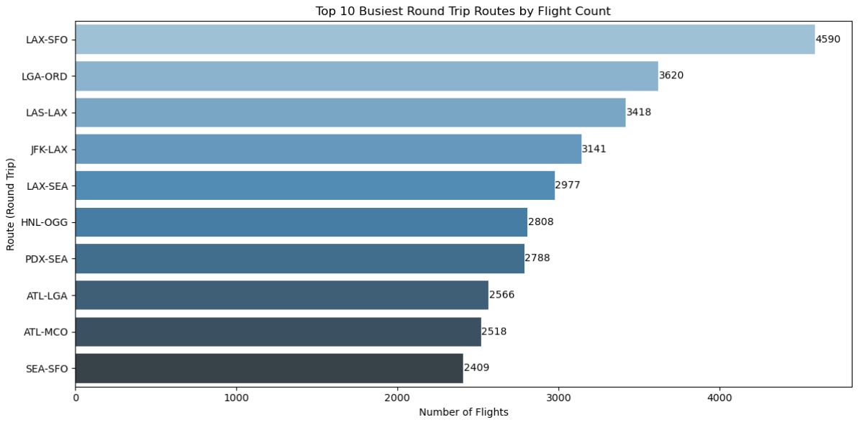
Purpose: To identify routes with the highest operational frequency.
Key Insight: These routes demonstrate strong demand and operational consistency. While flight count alone doesn’t determine profitability, it’s a vital indicator for route viability and scheduling investments.

- Top 10 Most Profitable Round Trip Routes:
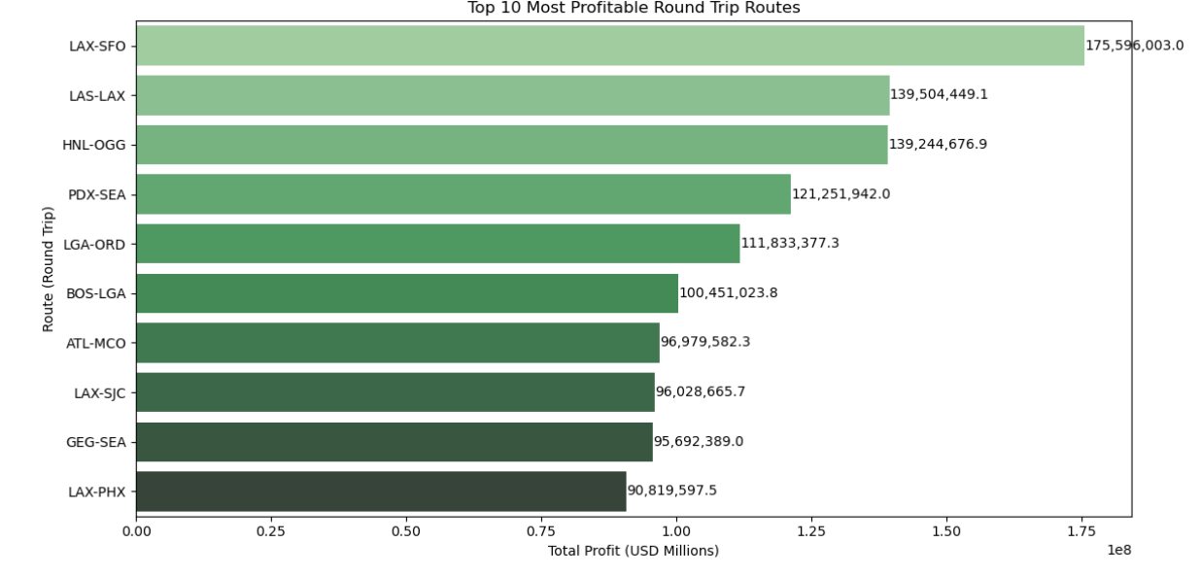
Purpose: To highlight which routes yield the highest net income.
Key Insight: This chart directly influences any investment decisions. Profitability varied significantly even among high-traffic routes, proving that revenue must be weighed against cost, not just volume.
- Profit, Revenue, and Breakeven Metrics for Top 5 Investment Routes
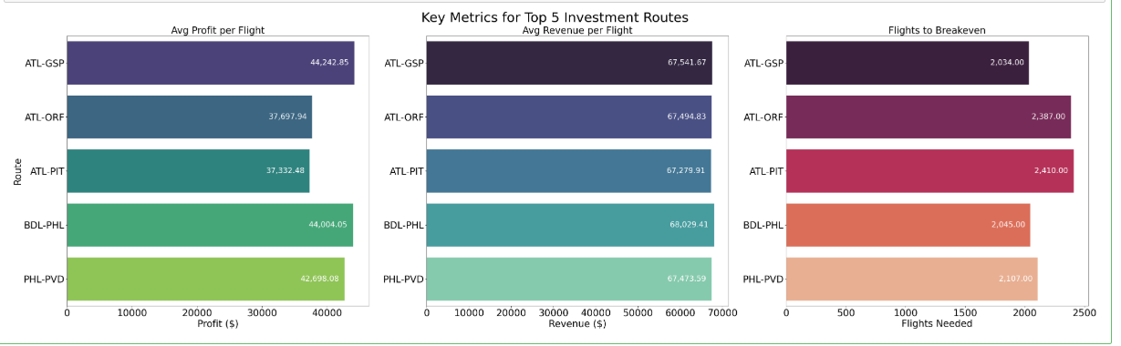
Visualization: Composite plot with three bar charts:
- Profit
- Total Revenue
- Flights Needed to Breakeven
Purpose: To visualize key drivers of financial performance and investment recovery timelines.
Key Insight: Some routes with high revenue still required many flights to break even due to higher operational costs. This view helped me balance short-term gains.

The other visualisations and insights have been mentioned in the python file along with the code, please check it out.
- Final Summary & Recommendations:
My Key Conclusions:
- High flight volume does not always correlate with high profit.
- Delay trends and cost structures are critical in route evaluation—not just ticket revenue.
- Only a handful of routes deliver disproportionately higher ROI, and they should be prioritized.
- Recommended KPIs to Track Going Forward:
- Net Profit per Route (monthly/quarterly): this helps track how much money each route is making over time. It’s important for spotting which routes are consistently profitable and worth continuing.
- Flights-to-Breakeven for New Aircraft Purchases: This tells us how many round trips we need to run before covering the cost of buying a new
plane. It’s useful for deciding if the investment in a route or aircraft is financially smart.
- Delay Frequency and Average Arrival Delay: Frequent delays increase costs and annoy passengers. Keeping an eye on delay trends helps find which routes or airports are causing issues and need improvement.
- Load Factor (Occupancy Rate): This shows how full the flights are. Higher occupancy means we’re using the plane efficiently and generating more revenue per flight.
- Ancillary Revenue per Passenger (e.g., baggage fees): This measures extra earnings from things like baggage or seat upgrades. It’s especially important since these small extras can add up and boost total profits.
- Suggested Improvements to Track Success:
- To Segment data by month to observe seasonality trends.
- Track cancellation and delay reasons to reduce operational costs.
- Monitor market competition on these routes to adjust pricing and service offerings.
- Analyze passenger satisfaction scores (if available) like a survey or something to evaluate service quality.
- Summary of Execution Flow:
Ensured this rough flow is followed:
1)Clean datasets -> flights_df, airport_df, tickets_df etc.
2)Join airport data -> flights_enriched
3)Compute financials and concatenated it with flights_enriched
4)Run route summaries:
a) busiest
b) profitable
c) investment
d) breakeven
5)Passed each output to its respective plot function in matplotlib and seaborn and made other visualizations for analysis and insights in the python code file.

