

A MINI PROJECT REPORT

ON

INTERNATIONALFOOTBALL TOURNAMENT FROM

1872-2019

SUBMITTED TO T&P CELL

In the department of

COMPUTER SCIENCE AND ENGINEERING

Of

CMR ENGINEERING COLLEGE

SUBMITED BY

G.SATHVIKA REDDY (188R1A0513)

B. SNEETHIKA (188R1A0507)

E.SIRI (188R1A0512)

Y.SANGHAVI (188R1A0559)

CH.VARDHINI (188R1A0510)

**ABSTRACT:**

* A tournament is a competition involving a relatively large number of competitors , all participating in a sport or a game. More specifically , the team may be used in either of two overlapping senses: one or more competitions held at a single venue and concentrated into a relatively short time interval.
* Football is a team game similar to rugby, with 11 players on each side. Forward passing is allowed and planned strategies and formations for play are decided during the course of the game. The oval shaped inflated ball used in this game.
* The major aim of this project is to assess the data of international football tournaments ( 1872 – 2019 ) from various sites and categorize them into sub topics. Then after we visualize the data into various graphs such as bar graph, pie graph, scattered graph and line grap



* Source Code: <https://github.com/sathvika777/International-Football-Tournament-results-from-1872-to-2019/blob/master/International%20football%20tournament%20results%20from%201872%20to%202019.ipynb>

|  |
| --- |
| TABLE OF CONTENTS |
| 1.INTRODUCTION  1.1 PROBLEM STATEMENT  1.2 ABOUT |
| 2.HARDWARE USED |
| 3. SOFTWARE USED |
| 4.MODULES USED |
| 5.METHODOLOGY    5.1 DATASETS PREPARATION  5.2 DATA VISUALIZATION |
| 6.CONCLUSION |
| 7. BIBLIOGRAPHY |

**1**. **Introduction**

**1.1 problem statement :**To analyze the international football tournament results from 1872 to 2019

* 1. **About:**

There are many types of football tournaments going on around the world. Few of them are

* FIFA: The most prestigious football tournament in the world that has been held every four years since 1930.
* UEFA: The most prestigious tournament for European football clubs. Has existed since season 1992-1993.
* FA: FA cup or Football association challenge cup is a yearly competition between English football clubs first played in 1871-1872.Known as the oldest tournament in the game of football.
* Coppa Italia: An Italian national football tournament first played in 1922 and still played today.
* Coppa del Rey : The oldest Spanish competition founded in 1903.Now a days, the winner are qualified for the UEFA European league and will also play against the La Liga winner in the Spanish super cup.

**2. Hardware Used:**

* Processor: Intel(R) Core(TM) 7th Geni3-7100U CPU @ 2.4GHz
* RAM**:** 4.00 GB
* Type: 64 –bit operating system

**3. Software Used:**

* Operating System: Windows 10
* Python : version-3.7.4
* IDE: Jupyter Notebook

**4. Modules Used:**

4.1 Numpy:

Numpy is a library for the python programming language, adding support for language, multi-dimensional arrays and matrices, along with a large collection of high – level mathematical function to operate on these arrays.

4.2 Pandas:

Pandas is an open source, BSD-licensed library providing high performance, easy-to-use data structure and data analysis tools for the python programming language. It is a software library written for the python programming language for data manipulation and analysis. In particular, it offers data structures and operation for manipulating numerical tables and time series.

4.3 Matplotlib:

Matplotlib is a Python 2D plotting which produces publication quality figures in a variety of hardcopy formats and interactive environment across platforms . It is a plotting library for the python programming language and its numerical mathematics extension NumPy. It provides an object – oriented API for embedding plots into applications using ,general-purpose GUI toolkits like Tkinter, wxPython , QT ,or GTK+.

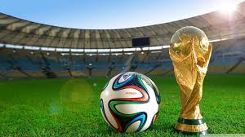

**5. METHODOLOGY:**

5.1 Data Set preparation:

* The dataset is taken from kaggle.
* The data is gathered from several sources including but not limited to Wikipedia, fifa.com , rssf.com and individual football associations websites.

Content:

This dataset includes 40,838 results of international football matches starting from the very first official match in 1872 up to 2019. The matches range from FIFA World Cup to FIFI Wild Cup to regular Friendly matches. The matches are strictly men’s full internationals and the data does not include Olympic games or matches where at least one of the teams was the nation’s B-team , U-23 or a league select team.

5.2 Data Visualization:

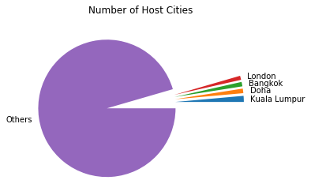

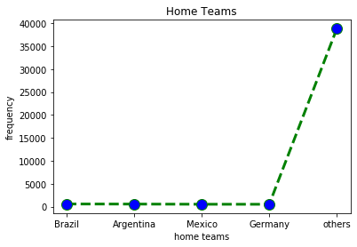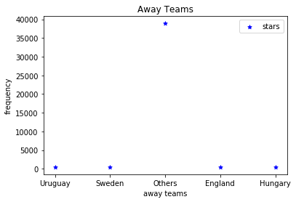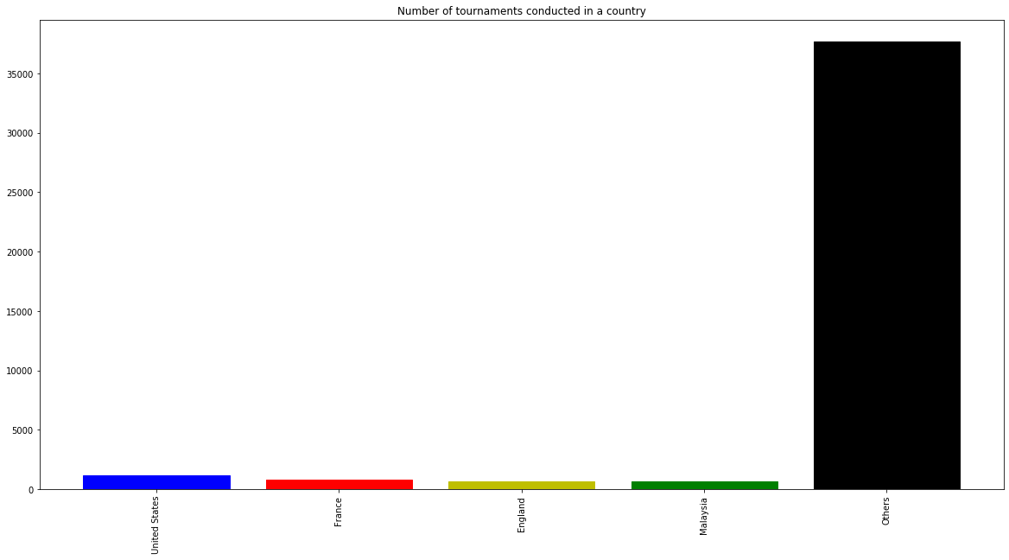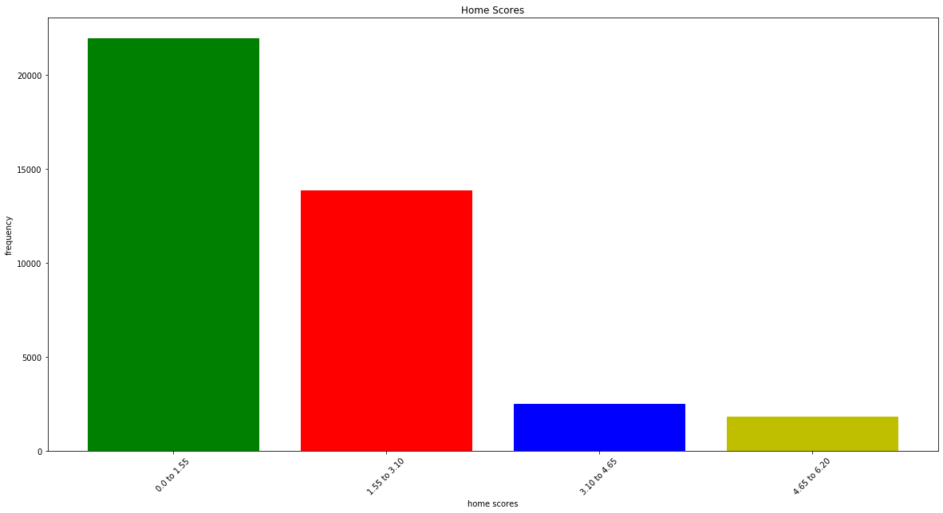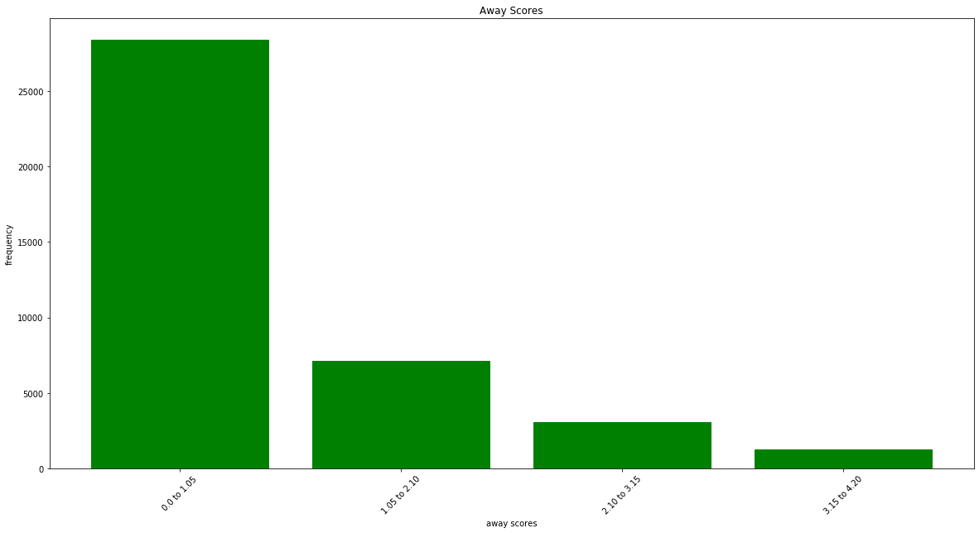

**6. CONCLUSION:**

By working on this project, we came to know about various international tournaments conducted World Wide. By visualization of the above graphs we conclude that United States is the top most hosting country, Kuala Lumpur is the top most hosting city. Brazil, Argentina, Germany, Malaysia plays equal role in participating as Home Teams. Uruguay, Sweden , England, Hungary plays equal role in participating as Away Teams. The maximum score recorded by home team is from 4.65 to 6.20 and by away team is from 3.15 to 4.20.

**7. BIBLIOGRAPHY;**

* <https://github.com/sathvika777/International-Football-Tournament-results-from-1872-to-2019/blob/master/International%20football%20tournament%20results%20from%201872%20to%202019.ipynb>
* <https://github.com/sathvika777/International-Football-Tournament-results-from-1872-to-2019/blob/master/dataset.zip>
* <https://www.kaggle.com/martj42/international-football-results-from-1872-to-2017>