Experiment-1 results

For the following experiment we have used facebook dataset which consist of 4038 nodes and 115 shells. For each node we have applied indipendent cascade model for all the nodes in a network for **10** times. We took the average of all the nodes and again did average of avearges of nodes in a particular shell. Below are the plots which we ploted using that data

* Cascading power vs shell index

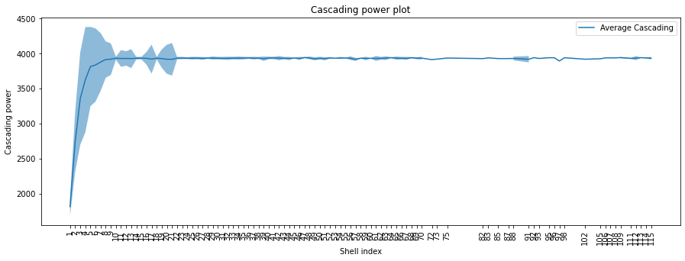

* Number of iterations vs shell index

