DESIGN AND ANALYSIS OF ALGORITHMS
School Bus Route Planner
Efficient pickup routes using Dijkstra's Algorithm,
Breadth-First Search and Greedy Construction
Project Report - Problem 32
Project title | School Bus Route Planner
Core algorithms | Dijkstra, BFS, Greedy
Suggested technologies | Python, Flask, React, PostgreSQL
Submitted by | ______________________________
Roll number / Section | ______________________________
Date | October 2026

1. Abstract
Every school day, transport coordinators must decide which stops each bus should serve, in what order, and by which roads, without exceeding seat capacity and while giving sensible attention to students who need earlier or more careful service. This report describes the design, analysis and evaluation of a School Bus Route Planner that treats this as an algorithmic problem on a weighted road graph.
The planner combines three classical techniques. Dijkstra's algorithm computes least-distance road paths between the school and every stop. Breadth-First Search (BFS) checks that every stop is reachable, finds minimum-hop paths and shows how the network breaks apart when roads close. A greedy construction heuristic then builds capacity-feasible routes one decision at a time, and every decision is logged so that the result can be explained and not just reported.
The approach was tested on a 12-node network with 8 stops, 86 pupils and three buses of capacity 35. Three greedy rules were compared against an exact optimum found by exhaustive search. The nearest-neighbour rule produced routes totalling 43.7 km, only 2.3 km (5.6%) above the optimum of 41.4 km. The priority-aware rules cost more distance (48.9 km and 55.0 km) and, on this instance, gave only a small gain in how early the highest-priority pupils are served. The report discusses why, and what that means for real deployments.

2. Introduction

2.1 Problem statement
Create efficient school-bus pickup routes considering stops, road distances, vehicle capacity and approximate pickup priorities. The system must accept the road network, the stops with their pupil counts and priorities, and the fleet details, and must produce routes that a transport coordinator can read, check and trust.

2.2 Motivation
School routing is a daily, repetitive operation where small inefficiencies add up. Extra kilometres mean more fuel, longer rides for children and later arrivals at school. Capacity is a hard safety limit, not a preference. Some pupils, for example very young children or those with mobility needs, should not be left waiting or riding longer than necessary. A planner that ignores any of these is of limited use, and a planner that cannot show its reasoning will not be trusted by the people who have to run it.

2.3 Objectives
- Minimise the total distance driven by the fleet while respecting the capacity of every bus.
- Serve higher-priority stops earlier where this can be done at a reasonable cost.
- Demonstrate Dijkstra's algorithm, BFS and a greedy strategy, and compare more than one greedy rule.
- Make every decision visible: shortest paths, visit orders, assignments, loads and the objective value.
- Measure how far the heuristic result is from the true optimum on a case small enough to solve exactly.

3. Problem Formulation

3.1 Graph model
The road network is modelled as an undirected weighted graph G = (V, E). Vertices are the school (which also serves as the bus depot), pickup stops and road junctions. Each edge represents a road segment and carries a non-negative weight equal to its length in kilometres. Non-negative weights are what make Dijkstra's algorithm valid.
Each stop s has two attributes: q(s), the number of pupils waiting, and pr(s), an approximate priority from 1 (normal) to 3 (highest). The fleet has K identical buses, each with capacity C.

3.2 Constraints and objective
- Capacity: the pupils assigned to a bus must not exceed C.
- Coverage: every stop is served by exactly one bus.
- Closed route: each bus starts at the school, visits its stops in order and returns, travelling between consecutive stops by the shortest road path.
- Objective: minimise the total distance of all routes. As a secondary measure, record the distance at which each priority-3 stop is reached.

3.3 Assumptions
- Roads are two-way and travel cost is proportional to distance. Travel time, traffic and school bell times are not modelled.
- Buses are identical, all start at the school, and a bus may serve any stop.
- Priority is interpreted as a wish to be served early in a route. The sample data are illustrative and are not taken from a real school.
Combining routing with a capacity limit makes this a capacitated vehicle routing problem (CVRP), which is NP-hard. No fast algorithm is known that always finds the best answer, which is why the project uses heuristics and measures their quality against an exact solution on a small case.

4. System Design

4.1 Data structures
Structure | Used for | Why it fits
Adjacency list | Road network G | Compact for sparse road graphs; visiting neighbours costs time proportional to the degree
Min-heap (priority queue) | Dijkstra frontier | Returns the cheapest unsettled node in O(log V)
Distance and parent maps | Dijkstra and BFS | Tentative costs plus predecessor links, from which paths are rebuilt
FIFO queue | BFS frontier | Guarantees level-by-level exploration
Distance matrix | Greedy scoring | Stop-to-stop shortest distances precomputed once, then looked up in O(1)
Route records | Output | Per bus: stop sequence, load, distance and a decision log

4.2 Architecture
The algorithms are written in Python and are independent of any web framework, so they can be tested on their own. The suggested technology stack wraps them as follows.
- PostgreSQL stores nodes, edges (with distance), stops (pupil count and priority), buses and generated routes.
- Flask exposes endpoints to load a network, run Dijkstra or BFS from a chosen node, and generate routes with a chosen greedy rule.
- React draws the graph, highlights shortest paths, animates the Dijkstra and BFS settle order and lists each route with its load and distance.

4.3 Processing pipeline
- Load the network and stops; validate that weights are non-negative and that no bus-capacity conflict is impossible (largest stop no larger than C).
- Run BFS from the school to confirm that every stop is reachable; report any unreachable stops and the pupils affected.
- Run Dijkstra from every stop and the school to build the shortest-distance matrix and path table.
- Run the selected greedy rule to assign stops to buses and order them, logging each choice.
- Report routes, loads, distances, the total, and the priority-3 pickup distances.

5. Algorithm Design

5.1 Dijkstra's algorithm: least-distance paths
Dijkstra's algorithm maintains a tentative distance for every node, initially infinity except for the source. It repeatedly settles the unsettled node with the smallest tentative distance, then relaxes its outgoing edges. Because weights are non-negative, a settled node's distance is final. The parent links give the path back to the source.
DIJKSTRA(G, source)
dist[v] = INF for all v; dist[source] = 0; parent[v] = NONE
PQ = min-heap containing (0, source)
while PQ is not empty:
(c, u) = PQ.pop_min()
if u is already settled: continue
mark u settled
for each edge (u, v, w):
if dist[u] + w < dist[v]:
dist[v] = dist[u] + w; parent[v] = u
PQ.push((dist[v], v))
return dist, parent

In the planner, Dijkstra is used twice: from the school to give each stop's baseline distance, and from every node to build the matrix that the greedy rules consult.

5.2 Breadth-First Search: reachability and hops
BFS explores the graph in layers: first all nodes one road segment from the source, then two, and so on. It ignores distances, so it finds the route with the fewest road segments, not the shortest distance. That is exactly why it is useful here for a different job: confirming that every stop can be reached and finding which stops are cut off if roads close.
BFS(G, source)
level[source] = 0; parent[source] = NONE
Q = queue containing source
while Q is not empty:
u = Q.dequeue()
for each neighbour v of u:
if v has no level yet:
level[v] = level[u] + 1; parent[v] = u
Q.enqueue(v)
return level, parent // nodes without a level are unreachable

5.3 Greedy route construction
Routes are built one bus at a time. At each step the bus looks at the stops that are still unserved and that fit in its remaining seats, scores them with a rule, and takes the best one. When nothing fits, the bus returns to school and the next bus starts. Three rules were implemented so that their trade-offs could be compared.
Rule | How the next stop is chosen | Intent
A. Nearest-neighbour | Smallest shortest-path distance from the current position | Minimise distance; ignores priority
B. Priority-ratio | Largest priority divided by distance from the current position | Prefer important stops that are also close
C. Priority-seeded | Each bus starts with the highest-priority unserved stop (ties: farthest from school), then continues nearest-neighbour | Guarantee that high-priority stops head a route

GREEDY_ROUTES(stops, K, C, dist, rule)
unserved = all stops
for bus = 1..K while unserved is not empty:
pos = school; load = 0; route = []
loop:
feasible = { s in unserved : load + q(s) <= C }
if feasible is empty: break
s* = argbest over feasible, using rule(pos, s)
log (pos, s*, dist[pos][s*], pr(s*), q(s*))
append s* to route; load += q(s*); pos = s*; remove s*
route length = sum of legs + dist[pos][school]
return routes, unserved // unserved must be empty for a full plan

A greedy rule makes the best local choice and never revisits it. That makes it fast and easy to explain, but there is no guarantee that a series of locally good choices adds up to a globally good plan. The exhaustive benchmark in Section 7 measures exactly how much is lost.

6. Complexity Analysis
Let V be the number of nodes, E the number of roads, n the number of stops and K the number of buses.
Component | Time | Notes
Dijkstra (binary heap) | O((V + E) log V) | One source. Requires non-negative weights
Distance matrix | O(V (V + E) log V) | One Dijkstra run per node of interest
BFS | O(V + E) | Each node and edge handled once
Greedy construction | O(n^2) | Each of n selections scans up to n candidates with O(1) distance lookups
Exhaustive optimum | O(K^n * n!) worst case | Used only to benchmark; infeasible beyond a few dozen stops

Space is O(V + E) for the graph and O(V^2) for the distance matrix. For the sample network (V = 12, E = 17, n = 8) every step is instantaneous, whereas the exhaustive search must examine 3^8 = 6,561 stop-to-bus assignments, each with route orderings. Doubling the stops would make it unusable, while the greedy construction would still finish in a fraction of a second.

7. Worked Example and Experimental Setup
To make the algorithms easy to follow, a small network was designed: the school S, three junctions J1 to J3, and eight stops P1 to P8, connected by 17 roads. There are 86 pupils in total and the fleet is three buses with 35 seats each (105 seats), so capacity is reasonably tight.
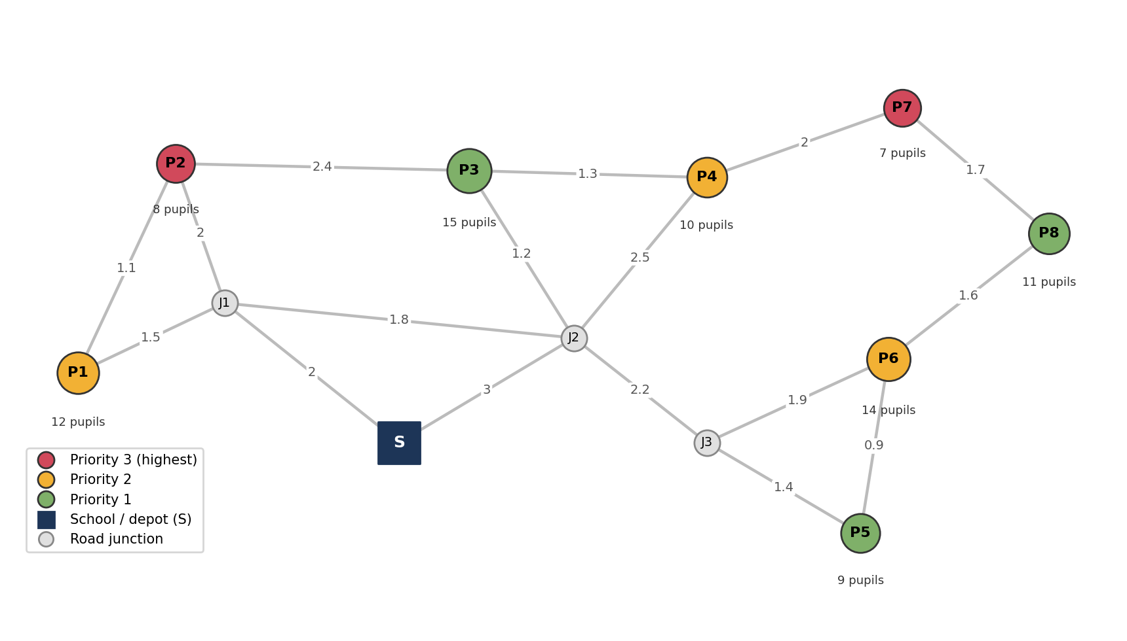
Figure 1. Sample road network. Edge labels are kilometres (drawn schematically, not to scale). Node size shows pupil count and colour shows priority.
Table 1. Stops, pupils and priorities
Stop | Pupils | Priority | Note
P1 | 12 | 2 | Medium
P2 | 8 | 3 | Highest priority
P3 | 15 | 1 | Normal
P4 | 10 | 2 | Medium
P5 | 9 | 1 | Normal
P6 | 14 | 2 | Medium
P7 | 7 | 3 | Highest priority
P8 | 11 | 1 | Normal

Table 2. Road segments (km)
Road | Length | Road | Length
S - J1 | 2.0 | J3 - P6 | 1.9
S - J2 | 3.0 | P1 - P2 | 1.1
J1 - P1 | 1.5 | P3 - P4 | 1.3
J1 - P2 | 2.0 | P5 - P6 | 0.9
J1 - J2 | 1.8 | P4 - P7 | 2.0
J2 - P3 | 1.2 | P6 - P8 | 1.6
J2 - P4 | 2.5 | P7 - P8 | 1.7
J2 - J3 | 2.2 | P2 - P3 | 2.4
J3 - P5 | 1.4

8. Results

8.1 Dijkstra: shortest paths from the school
Table 3 shows the order in which Dijkstra settles nodes, the final distance and the tentative costs that were improved at each step. The furthest stop, P8, is 8.7 km from school by road.
Table 3. Dijkstra trace from S
Step | Settled | Distance (km) | Tentative costs improved
1 | S | 0.0 | J1=2, J2=3
2 | J1 (via S) | 2.0 | P1=3.5, P2=4
3 | J2 (via S) | 3.0 | P3=4.2, P4=5.5, J3=5.2
4 | P1 (via J1) | 3.5 | none
5 | P2 (via J1) | 4.0 | none
6 | P3 (via J2) | 4.2 | none
7 | J3 (via J2) | 5.2 | P5=6.6, P6=7.1
8 | P4 (via J2) | 5.5 | P7=7.5
9 | P5 (via J3) | 6.6 | none
10 | P6 (via J3) | 7.1 | P8=8.7
11 | P7 (via P4) | 7.5 | none
12 | P8 (via P6) | 8.7 | none

8.2 BFS: levels, hops and reachability
BFS from the school reaches J1 and J2 in one hop; P1, P2, P3, P4 and J3 in two; P5, P6 and P7 in three; and P8 in four. All eight stops are reachable, so a complete plan is possible.
BFS and Dijkstra agree for seven of the eight stops, but they differ for P8. Both reach it in four hops, yet BFS happens to follow S - J2 - P4 - P7 - P8, which is 9.2 km, while Dijkstra finds S - J2 - J3 - P6 - P8, which is 8.7 km. This is a useful reminder that the fewest road segments does not mean the shortest distance, and that BFS must not be used to cost routes.
BFS was also used as a what-if tool. If the roads J2-J3, P4-P7 and P6-P8 were closed together, the nodes J3, P5, P6, P7 and P8 would become unreachable from the school, stranding 41 pupils (9 + 14 + 7 + 11). Closing J1-J2 and S-J2 instead leaves everything reachable, which shows that the western part of the network has a usable alternative path through P2-P3.

8.3 Greedy routes
Table 4 lists the routes produced by each rule, together with the exact optimum. Every strategy served all 86 pupils within capacity.
Table 4. Routes by strategy
Strategy | Bus | Route | Load | Distance (km)
Nearest-neighbour greedy | Bus 1 | S - P1 - P2 - P3 - S | 35 / 35 | 11.2
 | Bus 2 | S - P4 - P7 - P8 - S | 28 / 35 | 17.9
 | Bus 3 | S - P5 - P6 - S | 23 / 35 | 14.6
Priority-seeded greedy | Bus 1 | S - P7 - P8 - P6 - S | 32 / 35 | 17.9
 | Bus 2 | S - P2 - P1 - P3 - S | 35 / 35 | 12.8
 | Bus 3 | S - P4 - P5 - S | 19 / 35 | 18.2
Priority-ratio greedy | Bus 1 | S - P2 - P1 - P7 - S | 27 / 35 | 19.4
 | Bus 2 | S - P4 - P3 - P5 - S | 34 / 35 | 18.2
 | Bus 3 | S - P6 - P8 - S | 25 / 35 | 17.4
Exact optimum | Bus 1 | S - P1 - P2 - S | 20 / 35 | 8.6
 | Bus 2 | S - P3 - P4 - P7 - S | 32 / 35 | 15.0
 | Bus 3 | S - P5 - P6 - P8 - S | 34 / 35 | 17.8

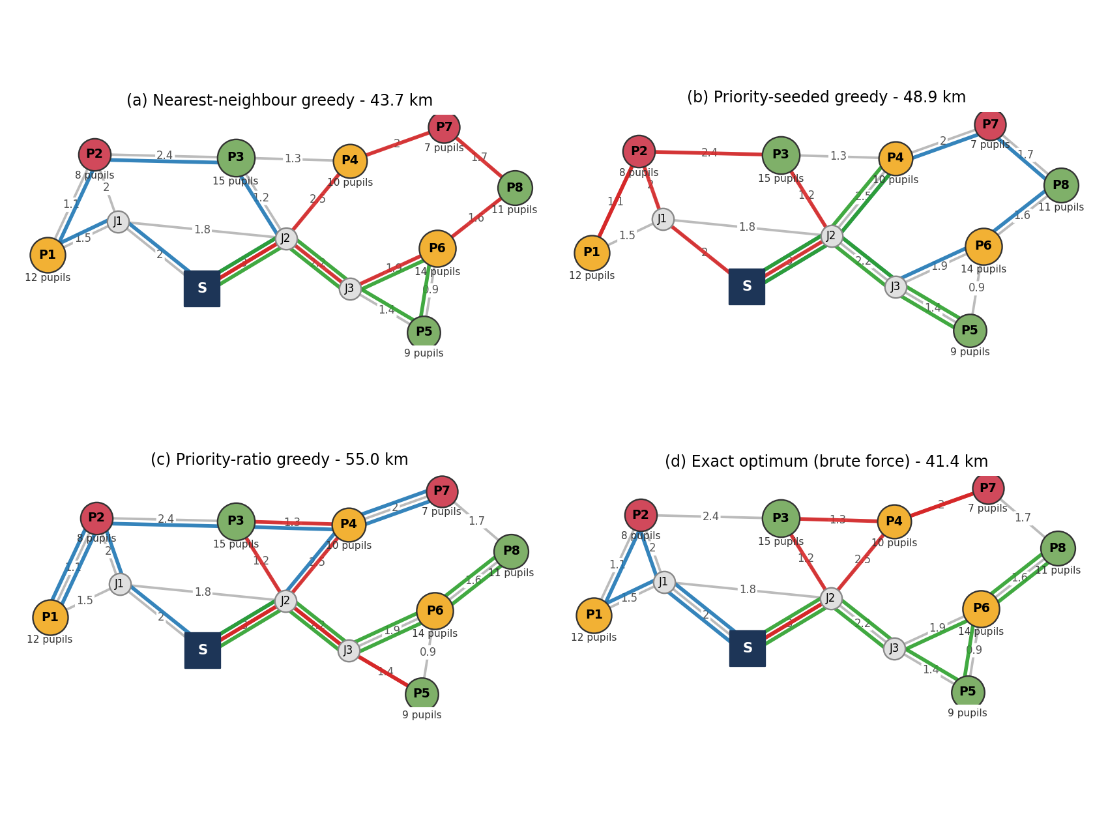
Figure 2. Routes produced by each strategy. Each colour is one bus; paths follow Dijkstra shortest roads between consecutive stops.

8.4 Why a route was chosen: decision log
The priority-ratio rule shows clearly how a local choice can hurt overall cost. The log for Bus 1 is shown below.
Table 5. Decision log, priority-ratio rule, Bus 1
From | To | Distance (km) | Priority | Pupils | Score (priority / km)
S | P2 | 4.0 | 3 | 8 | 0.750
P2 | P1 | 1.1 | 2 | 12 | 1.818
P1 | P7 | 6.8 | 3 | 7 | 0.441

From S, stop P2 wins because it has the highest priority and is only 4.0 km away. P1 is then an obvious next step at 1.1 km. But after P1 the only stop with room left that scores best is P7 (priority 3), reached by a 6.8 km leg. The score is correct by its own definition, yet the detour costs far more than visiting P7 as part of a route that passes close to it, which the exact solution does by pairing P7 with P3 and P4.

8.5 Comparison
Table 6. Objective values and priority service
Strategy | Total (km) | Gap to optimum | P2 reached (km) | P7 reached (km) | Priority-weighted km*
Nearest-neighbour greedy | 43.7 | +5.6% | 4.6 | 7.5 | 92.1
Priority-seeded greedy | 48.9 | +18.1% | 4.0 | 7.5 | 106.7
Priority-ratio greedy | 55.0 | +32.9% | 4.0 | 11.9 | 110.2
Exact optimum | 41.4 | - | 4.6 | 7.5 | 89.2
* Sum over stops of priority x distance travelled on that route before reaching the stop; lower is better. P2 and P7 are the two priority-3 stops; the shortest possible road distances from school are 4.0 km and 7.5 km.
Four observations stand out:
- Nearest-neighbour is close to optimal here. At 43.7 km it is 5.6% above the optimum. Small, well-clustered networks are where this rule works best.
- Priority-seeded guarantees early service, at a price. Both priority-3 stops are reached at their minimum possible distances (4.0 km and 7.5 km). Compared with nearest-neighbour this moves P2 forward by only 0.6 km but adds 5.2 km of driving, which is a poor exchange on this particular network.
- Priority-ratio is the weakest. It is 32.9% above optimum and actually serves P7 later (11.9 km) than nearest-neighbour does, because the ratio rule is blind to the cost of a long final leg.
- Priority weighting did not pay off in the weighted measure either. The nearest-neighbour routes also have the lowest priority-weighted distance among the heuristics. This is because here the high-priority stops are not far from school, so short routes already serve them early.
These findings come from one small hand-built network and should not be generalised too far. They show that the effect of priorities depends on the geography and on how strict the priorities are.

9. Limitations and Future Work
- Priorities are soft weights. Real deployments often need hard rules, such as a maximum ride time for particular pupils, which would turn priority into a constraint instead of a scoring term.
- Travel time, traffic, one-way streets, stop dwell time and school start times are not modelled; adding time windows would make the problem a CVRP with time windows.
- Greedy rules never reconsider earlier choices. A local-improvement pass such as 2-opt (reversing part of a route) or moving a stop between buses would likely close much of the gap to the optimum.
- The optimum was found by brute force and only works for very small instances. For larger networks, bounds from an integer-programming model or a metaheuristic would be needed for benchmarking.
- The data are synthetic. The next step is to test on a real map with measured distances and pupil addresses.

10. Conclusion
The project turned the school-bus routing requirement into a working, explainable prototype built on three complementary algorithms. Dijkstra supplied trustworthy road distances, BFS confirmed reachability and exposed the effect of road closures, and greedy construction produced capacity-feasible routes with a full decision log.
On the sample network, the simplest rule, nearest-neighbour, delivered routes of 43.7 km against an exact optimum of 41.4 km, and is the best practical choice for this instance. The priority-aware rules showed that priorities are not free: honouring them in a naive greedy way can increase distance noticeably while giving only a modest gain in service. The main lesson is that the explanation matters as much as the number. Because every choice is logged, a coordinator can see exactly why a route was built and decide whether the trade-off between distance and priority is acceptable.

References
- Dijkstra, E. W. (1959). A note on two problems in connexion with graphs. Numerische Mathematik, 1, 269-271.
- Cormen, T. H., Leiserson, C. E., Rivest, R. L. and Stein, C. (2022). Introduction to Algorithms (4th ed.). MIT Press.
- Kleinberg, J. and Tardos, E. (2006). Algorithm Design. Pearson.
- Dantzig, G. B. and Ramser, J. H. (1959). The truck dispatching problem. Management Science, 6(1), 80-91.
- Toth, P. and Vigo, D. (Eds.) (2002). The Vehicle Routing Problem. SIAM.

