GENERAL FITNESS AND COMPONENTS OF FITNESS

Submitted by :

PHYSICAL EDUCATION ACTIVITY REPORT
Submitted to :
Visvesvaraya Technological University

BELAGAVI – 590018

Name: Sangam KK
USN: 4SU23CS085
Under the guidance of
Mr. Prabhakar A Physical Education Director

In partial fulfilment of the requirements for the award of the degree of
Bachelor of Engineering



DEPARTMENT OF ARTIFICIAL INTELLEGENCE & DATA SCIENCE SDM INSTITUTE OF TECHNOLOGY
UJIRE - 574240
2024-202

TABLE OF CONTENTS

HOCKEY

OVERVEIW

ORIGIN AND HISTORY

OBJECTIVE OF THE GAME

COURT AND EQUIPMENT

TEAM COMPOSITION

RULES AND GAMEPLAY

SKILLS REQUIRED

POPULARITY AND COMPETITIONS

BENEFITS OF PLAYING HOCKEY

CONCLUSION

JAVELIN

OVERVEIW

ORIGIN AND HISTORY

COURT AND EQUIPMENT

RULES AND GAMEPLAY

SKILLS REQUIRED

POPULARITY AND COMPETITIONS

BENEFITS OF PLAYING JAVELIN THROW

CONCLUSION

HOCKEY
An Overview
Hockey is a fast-paced team sport played on a field, ice, or synthetic surface. The objective is to score goals by hitting a ball or puck into the opponent's net using a stick. It is known for its speed, skill, and teamwork, and is played at both amateur and professional levels worldwide.
Origin and History
Hockey's origins date back to ancient civilizations where stick-and-ball games were common. Modern field hockey was formalized in England in the late 19th century. Ice hockey, a popular variation, originated in Canada during the same period. Both forms of hockey are now globally recognized and have become staples of international sports competitions such as the Olympics and World Championships.
Objective of the Game
The primary goal in hockey is to outscore the opponent by maneuvering the ball or puck into their net. Teams must also defend their own goal to prevent the opposition from scoring. Success requires a combination of offensive strategies, defensive tactics, and quick transitions.
Court and Equipment
- Field Dimensions: A standard field hockey pitch is 100 yards by 60 yards, with a goal at each end. Ice hockey is played on a rink measuring approximately 200 feet by 85 feet.
- Equipment:
  - Stick: Used to hit or guide the ball/puck.
  - Ball/Puck: The object players aim to score with.
  - Protective Gear: Includes helmets, shin guards, gloves, and mouthguards to ensure player safety.
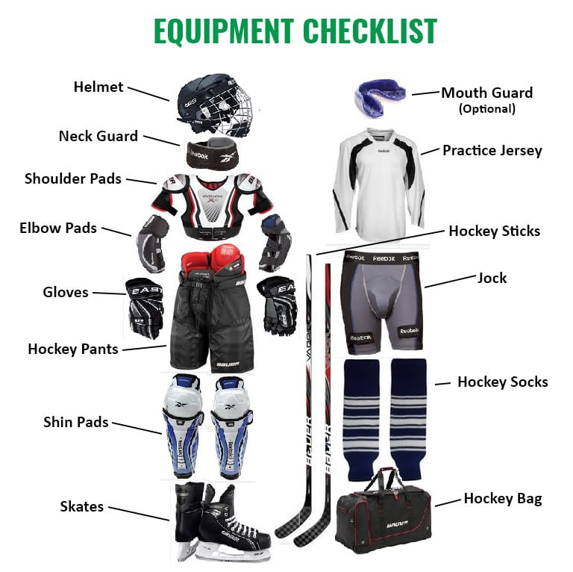

Team Composition
Each hockey team typically consists of 11 players (field hockey) or 6 players (ice hockey), including:
- Forwards: Responsible for scoring goals.
- Midfielders (field hockey): Link the defense and offense.
- Defenders: Prevent the opposition from scoring.
- Goalkeeper: Protects the goal and blocks shots.
Rules and Gameplay
- Time Duration: Matches are usually divided into two halves (field hockey) or three periods (ice hockey).
- Basic Rules:
  - Players cannot use their feet or hands to control the ball/puck (except the goalkeeper).
  - Goals are scored only from within specific zones.
  - Fouls include high sticks, tripping, and dangerous play.
- Penalty System: Includes free hits, penalty corners, or penalty strokes (field hockey), and penalty shots (ice hockey).
Skills Required
- Dribbling: Control over the ball/puck while moving.
- Passing: Precision in delivering the ball/puck to teammates.
- Shooting: Accuracy and power in scoring attempts.
- Defensive Skills: Blocking and tackling.
- Teamwork: Coordinated play among teammates.
Popularity and Competitions
Hockey enjoys immense popularity in countries like India, the Netherlands, Canada, and the United States. Major tournaments include:
- Field Hockey: Hockey World Cup, Olympic Games.
- Ice Hockey: Stanley Cup, IIHF World Championships.
Benefits of Playing Hockey
- Physical Fitness: Enhances stamina, speed, and strength.
- Mental Agility: Improves decision-making and concentration.
- Team Skills: Develops communication and collaboration.
- Discipline: Encourages focus and strategic thinking.
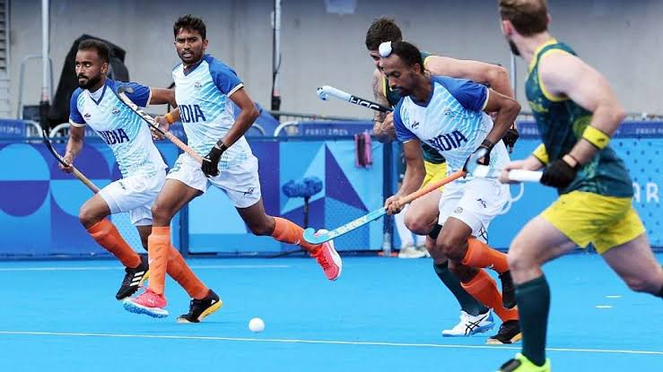

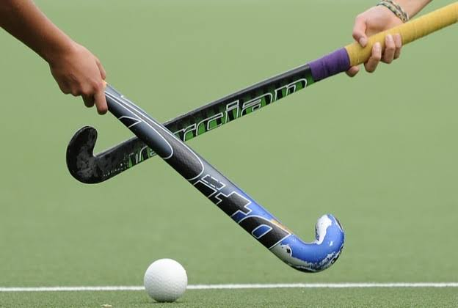

Conclusion
Hockey is a dynamic and thrilling sport that combines athleticism, strategy, and teamwork. Its global appeal and diverse variations ensure its enduring popularity across cultures and generations.

JAVELIN THROW
An Overview
Javelin throw is a track-and-field event where athletes hurl a spear-like implement called a javelin as far as possible. It requires a combination of strength, speed, and technique to achieve maximum distance. The sport is part of the modern Olympic Games and various athletic championships.
Origin and History
The origins of javelin throw date back to ancient times when spears were used for hunting and warfare. It became a competitive sport in ancient Greece as part of the pentathlon. Javelin throw was included in the modern Olympics for men in 1908 and for women in 1932.
Objective of the Game
The goal in javelin throw is to achieve the greatest possible distance while adhering to specific rules. Athletes must throw the javelin from within a designated runway and ensure it lands tip-first within marked boundaries.
Court and Equipment
- Runway: A straight path of at least 30 meters (98 feet) in length and 4 meters (13 feet) in width.
- Throwing Arc: A curved line marking the end of the runway.
- Javelin:
  - Material: Typically made of metal or carbon fiber.
  - Dimensions: 2.5 to 2.7 meters (8.2 to 8.9 feet) in length for men; slightly shorter for women.Weight: 800 grams for men and 600 grams for women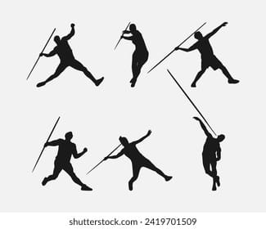men.

Rules and Gameplay
- Throwing Technique:
  - The javelin must be thrown overhand.
  - The thrower cannot cross the throwing arc.
- Valid Throws:
  - The javelin must land tip-first.
  - It must fall within the designated sector (typically 28.96 degrees).
- Fouls:
  - Exceeding the runway limits.
  - Throwing improperly or landing outside the sector.
Skills Required
- Strength and Power: Essential for a forceful throw.
- Speed: Helps generate momentum during the run-up.
- Technique: Proper grip, angle, and release.
- Coordination: Synchronizing body movements.
- Focus: Concentration during the run-up and release.
Popularity and Competitions
Javelin throw is widely practiced at national and international levels. Prominent events include:
- Olympic Games.
- World Athletics Championships.
- Diamond League.
- Continental Games.
Benefits of Javelin Throw
- Physical Fitness: Builds strength, agility, and endurance.
- Discipline: Teaches focus and persistence.
- Confidence: Boosts self-esteem through skill mastery.
- Competitive Spirit: Encourages sportsmanship and determination.

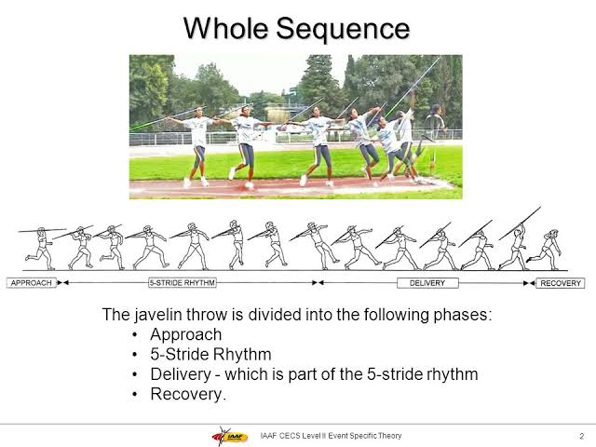

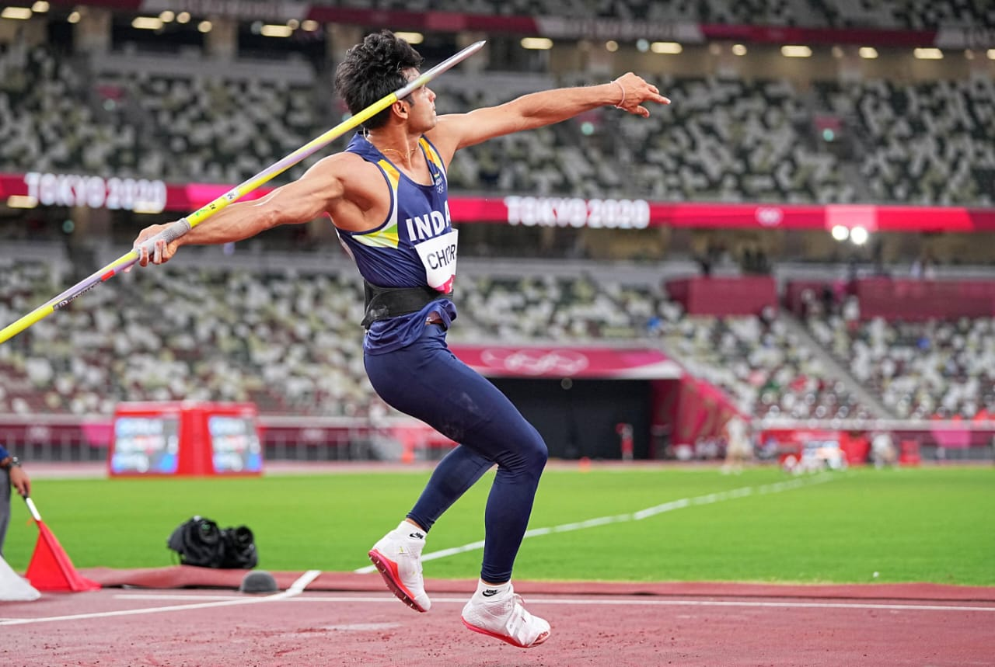

Conclusion
Javelin throw is a captivating event that combines raw power, precision, and technique. Its rich history and presence in global athletic competitions make it a celebrated discipline in track and field. Beyond competition, it promotes physical and mental growth, inspiring athletes to push their limits.

