FACILITATING DIGITIZED MONEY

TRANSACTIONS

SOCIAL ACTIVITY REPORT-3
Submitted to

Visvesvaraya Technological University
BELAGAVI – 590018
By
Raghavendra Oppari
USN:4SU23CS072

Under the guidance of

Dr. Thyagaraju G S
Professor and Head of Department
in partial fulfilment of the requirements for the award of the degree of

Bachelor of Engineering

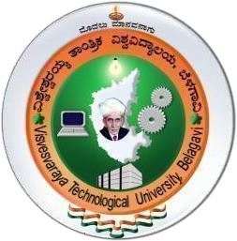

Department of Computer Science and Engineering

SDM INSTITUTE OF TECHNOLOGY

UJIRE - 574240

2025-2026

Facilitating Digitized Money Transactions

1.Introduction
The advent of the digital era has revolutionized financial transactions, shifting them from traditional cash-based payments to fully digitized transactions. A cashless economy, characterized by the complete digitization of financial exchanges, aims to replace physical cash with electronic transactions.
The transition is driven by advancements in digital banking, mobile payment platforms, blockchain technology, and government initiatives promoting financial inclusion.
The benefits of digitized transactions include enhanced security, increased transparency, speed, and convenience. Digital transactions eliminate the risks associated with theft, counterfeiting, and corruption, while providing an efficient and cost-effective method for businesses and individuals to manage their finances.

Importance of Facilitating Digitized Money Transactions 1. Increased Convenience and Speed
However, the path to achieving 100% digitization is fraught with challenges, including cybersecurity threats, infrastructure limitations, and ensuring accessibility for all socioeconomic groups.
This report delves into the key aspects of digitized money transactions, including technological enablers, security considerations, global trends, and implementation challenges. It also examines the impact on businesses, consumers, and financial institutions, highlighting the necessary steps to achieve a seamless and fully digital financial ecosystem.

2. Transparency and Reduced Corruption
Digital transactions eliminate the need for physical cash handling, allowing instant and seamless payments via online banking, mobile wallets, and UPI systems. This enables individuals and businesses to conduct transactions anytime, anywhere, independent of cash availability.

3. Financial Inclusion

Electronic transactions create an automatic record, ensuring transparency and traceability. This helps governments and financial institutions track money flow, reducing illegal activities such as money laundering, tax evasion, and corruption.

4. Cost Reduction for Businesses and Banks
A fully digitized financial system facilitates access to banking services for remote and rural areas through mobile phones and internet-based platforms. This inclusion empowers small businesses, farmers, and daily wage earners to participate in the formal economy without needing physical bank branches.

5. Economic Growth and Efficiency
Cash handling involves operational costs such as printing currency, managing ATMs, and security expenses. Digital transactions lower these costs for banks, businesses, and consumers, leading to more efficient financial services.

6. Global Integration and Cross-Border Transactions
A cashless economy accelerates economic growth by reducing transaction costs, improving tax collection, and increasing revenue for businesses. Governments can also implement better financial policies based on real-time transaction data, improving overall economic planning.

7. Government Efficiency and Digital Governance
Digital payment systems facilitate smooth cross-border trade, e-commerce, and international transactions. Technologies like blockchain and fintech innovations provide secure and instant global money transfers without high transaction fees.

2. Feedback
Digital transactions help governments efficiently distribute subsidies, pensions, and welfare benefits directly to beneficiaries, eliminating middlemen and ensuring funds reach the intended recipients without leakage.


Figure 2.1: Feedback

3. Conclusion
Participants' feedback highlights their growing awareness of the benefits and significance of a fully digitized financial system. Many expressed a deeper understanding of how digital transactions enhance security, convenience, and economic efficiency, and enthusiasm for adopting cashless payment methods in their daily lives and businesses.
Facilitating digitized money transactions is a transformative step toward a more efficient, secure, and transparent financial ecosystem. By eliminating cash dependence, digital transactions enhance financial accessibility, reduce corruption, and promote economic growth, contributing to a more inclusive society.
Achieving a fully digitized financial system requires addressing key challenges such as cybersecurity threats, infrastructure development, and digital literacy. Collaboration among governments, financial institutions, and technology providers is essential to ensure secure, reliable, and user-friendly digital payment systems.

3. Experience Gained
With continuous advancements in fintech, blockchain, and artificial intelligence, the future of digital transactions looks promising. A 100% digitized economy can pave the way for a more sustainable, resilient, and globally connected financial landscape, benefiting individuals, businesses, and governments alike.
A hands-on learning experience observed in a small shop where digital transactions had just started provided valuable insights into the real-world implementation of cashless payments. The experience highlighted both the benefits and challenges of transitioning from cash-based transactions, enhancing communication and problem-solving skills.

4. Social Activity Photos
The experience in the small shop demonstrated the importance of digital literacy and problem-solving skills in implementing digital payments. It also underscores the need for addressing issues such as technical difficulties and customer hesitation in using digital payments

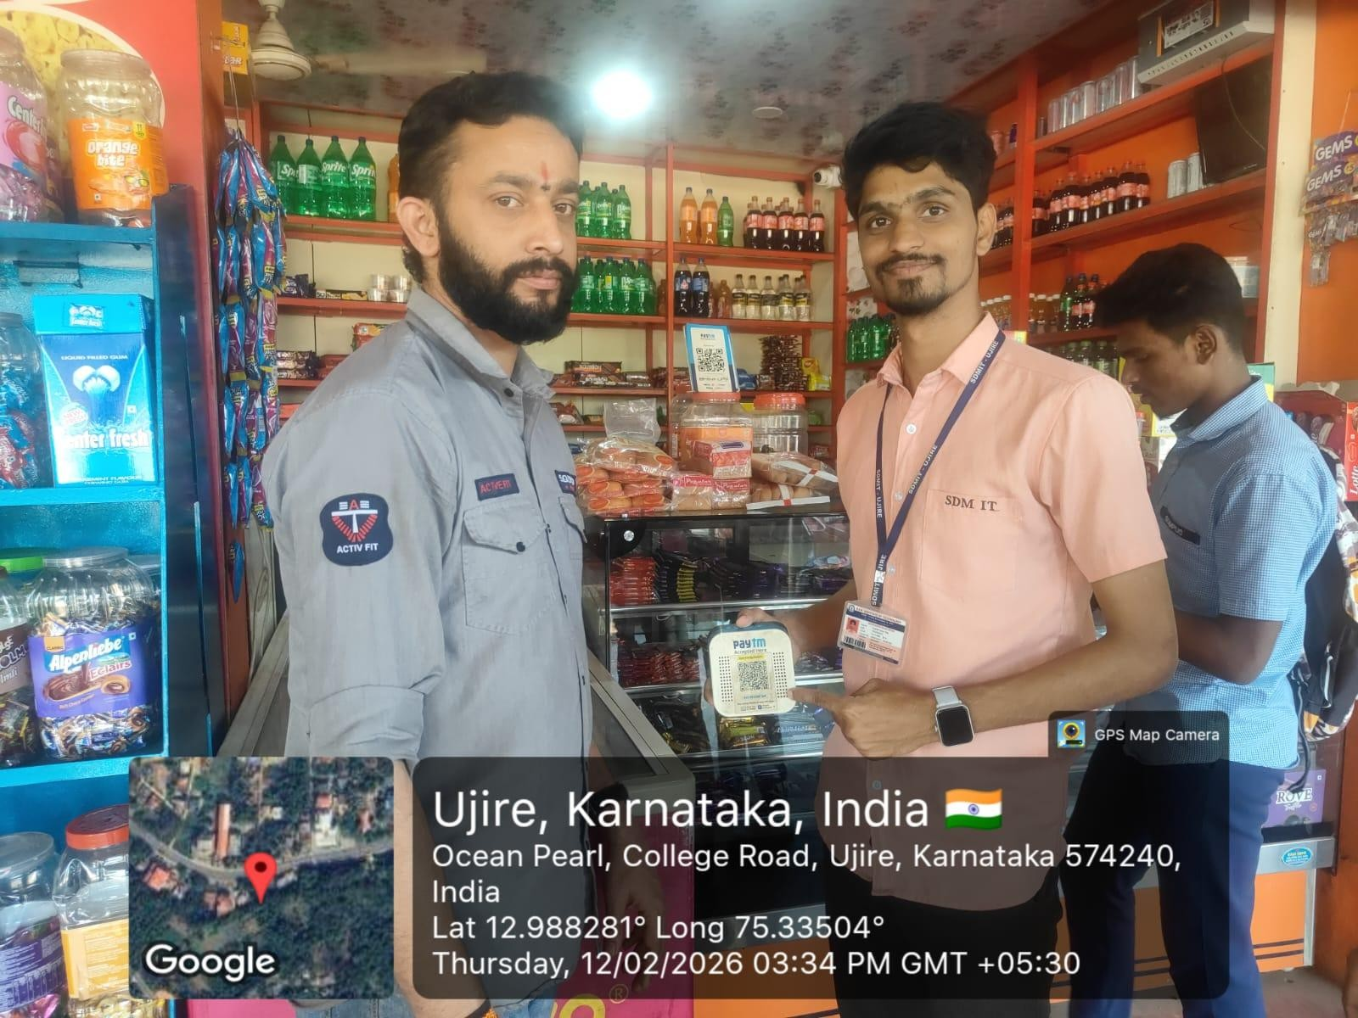

Figure 5.1: Presenting the topic

DECLARATION
I hereby declare that the above social activity “Facilitating Digitized Money Transactions” has been carried out as a part of AICTE Social Activity Program.

Date: 14-05-2026 Signature:
Name: Raghavendra Oppari
USN: 4SU23CS072

SDM INSTITUTE OF TECHNOLOGY
(Affiliated to Visvesvaraya Technological University, Belagavi)
UJIRE– 574240

Department of Computer Science and Engineering

CERTIFICATE

Certified that the social activity work titled “Facilitating Digitized Money Transactions” is carried out by Mr. Raghavendra Oppari., USN:4SU23CS072,bonafide student of SDM Institute of Technology, Ujire, in partial fulfilment for the award of the degree of Bachelor of Engineering in Computer Science and Engineering of Visvesvaraya Technological University, Belagavi during the year 2024-2025. It is certified that all the corrections/ suggestions indicated for Internal Assessment have been incorporated in the report deposited in the departmental library.

Dr. Thyagaraju G S
Professor, Guide and Head of Dept.

