INDIAN KNOWLEDGE SYSTEMS (BIKS609)

Seminar on

The Concept of Dharma in
Knowledge Transmission


by

Sangam K K
4SU23CS085

6th SEM CSE

Department of Computer Science and
Engineering SDM Institute of Technology,
Ujire – 574 240
2025-26
The Concept of Dharma in Knowledge Transmission
Introduction
The concept of Dharma plays an important role in the transmission of knowledge in Indian traditions. Dharma refers to duty, righteousness, moral values, ethical conduct, and responsibilities that guide individuals and society. In the context of knowledge transmission, Dharma emphasizes that knowledge should be acquired, preserved, and shared responsibly for the welfare of society. Ancient Indian education systems considered knowledge not only as information but also as a path toward wisdom, discipline, and ethical living. Humans once believed knowledge carried responsibility instead of just LinkedIn certificates. Strange and ambitious civilization.
Understanding Dharma in Knowledge Transmission
Dharma in knowledge transmission refers to the ethical and moral principles followed while teaching, learning, and preserving knowledge. Ancient Indian traditions believed that knowledge must serve truth, justice, harmony, and social welfare.
1. Knowledge as a Sacred Responsibility
In Indian traditions, knowledge was treated as sacred and valuable. Teachers and students were expected to use knowledge for righteous purposes and not for harmful activities.
2. Guru-Shishya Tradition
Knowledge transmission mainly occurred through the Guru-Shishya system, where the teacher (Guru) guided the student (Shishya) not only academically but also morally and spiritually.
3. Ethical Learning and Teaching
Dharma emphasized honesty, discipline, humility, respect, and self-control during the learning process. Education focused on character development along with intellectual growth.
4. Oral Transmission of Knowledge
Ancient scriptures, philosophies, and traditions were passed orally from one generation to another through memorization, recitation, and practice while maintaining accuracy and purity.
5. Knowledge for Social Welfare
Knowledge was meant to benefit society by promoting justice, harmony, peace, and sustainable living rather than personal greed or misuse of power.

Principles of Dharma in Knowledge Transmission
1. सत्य (Satya) – Truthfulness
Knowledge should be based on truth and honesty. Teachers and learners were expected to avoid false information and maintain intellectual integrity.
2. अहिंसा (Ahimsa) – Non-Violence
Knowledge should not be used for destruction or harm. Dharma encouraged peaceful and ethical applications of learning.
3. सेवा (Seva) – Service to Society
Education was considered meaningful when used for helping society, improving lives, and supporting community welfare.
4. अनुशासन (Anushasan) – Discipline
Discipline and dedication were considered essential for acquiring and preserving knowledge effectively.

5. श्रद्धा (Shraddha) – Respect and Devotion
Students were expected to show respect toward teachers, scriptures, and the learning process.

Methods of Knowledge Transmission in Ancient India
1. Oral Tradition
Vedas, Upanishads, epics, and philosophical teachings were memorized and orally transmitted across generations.
2. Gurukul System
Students lived with teachers in Gurukuls where they learned academics, ethics, spirituality, and life skills together.
3. Storytelling and Discussions
Knowledge was shared through stories, debates, dialogues, and practical examples to improve understanding and moral thinking.
4. Observation and Practice
Students learned skills through direct observation, participation, and practical experience in daily activities.
5. Scriptural Studies
Ancient texts such as the Vedas, Upanishads, Bhagavad Gita, and Dharmashastras guided educational and ethical practices.

Importance of Dharma in Knowledge Transmission
1. Preservation of Cultural Values
Dharma helped preserve Indian cultural traditions, ethics, philosophies, and spiritual practices across generations.
2. Development of Moral Character
Education based on Dharma focused on building responsible, disciplined, and ethical individuals.
3. Promotion of Social Harmony
Knowledge transmission encouraged unity, respect, compassion, and cooperation within society.
4. Responsible Use of Knowledge
Dharma ensured that knowledge was used wisely for constructive and peaceful purposes. An idea modern internet comment sections continue to resist with heroic consistency.
5. Lifelong Learning
Ancient Indian traditions considered learning as a continuous process connected to self-improvement and spiritual growth.

Relevance in Modern Society
1. Ethical Education Systems
Modern education can adopt Dharmic values such as honesty, discipline, empathy, and responsibility to improve learning environments.
2. Responsible Technology Use
Dharma can guide ethical use of modern technologies like Artificial Intelligence, biotechnology, and digital communication.
3. Value-Based Learning
Educational systems increasingly recognize the importance of combining technical skills with moral and ethical education.
4. Cultural Preservation
Traditional methods of knowledge transmission help preserve languages, literature, arts, and historical traditions.
5. Global Peace and Sustainability
Dharmic principles encourage environmental care, social justice, and peaceful coexistence, which are important for global sustainability.

Challenges in Modern Times
1. Decline of Traditional Learning Systems
Modernization and commercialization of education have reduced the influence of traditional Gurukul-based learning.
2. Loss of Oral Traditions
Many ancient teachings and local knowledge systems are disappearing due to lack of documentation and changing lifestyles.
3. Ethical Concerns in Technology
Rapid technological advancement sometimes prioritizes profit and efficiency over ethics and social responsibility.

4. Reduced Teacher-Student Bond
Modern educational systems often lack the close personal guidance found in traditional Guru-Shishya relationships.
5. Cultural Disconnect
Younger generations may become disconnected from traditional values and cultural heritage due to globalization and digital influence.

Government and Global Recognition
UNESCO recognizes the importance of preserving traditional educational practices and intangible cultural heritage.
In India, the Ministry of Education promotes Indian Knowledge Systems (IKS) to preserve traditional philosophies, ethical education, and ancient methods of knowledge transmission.

Snapshots from the seminar:

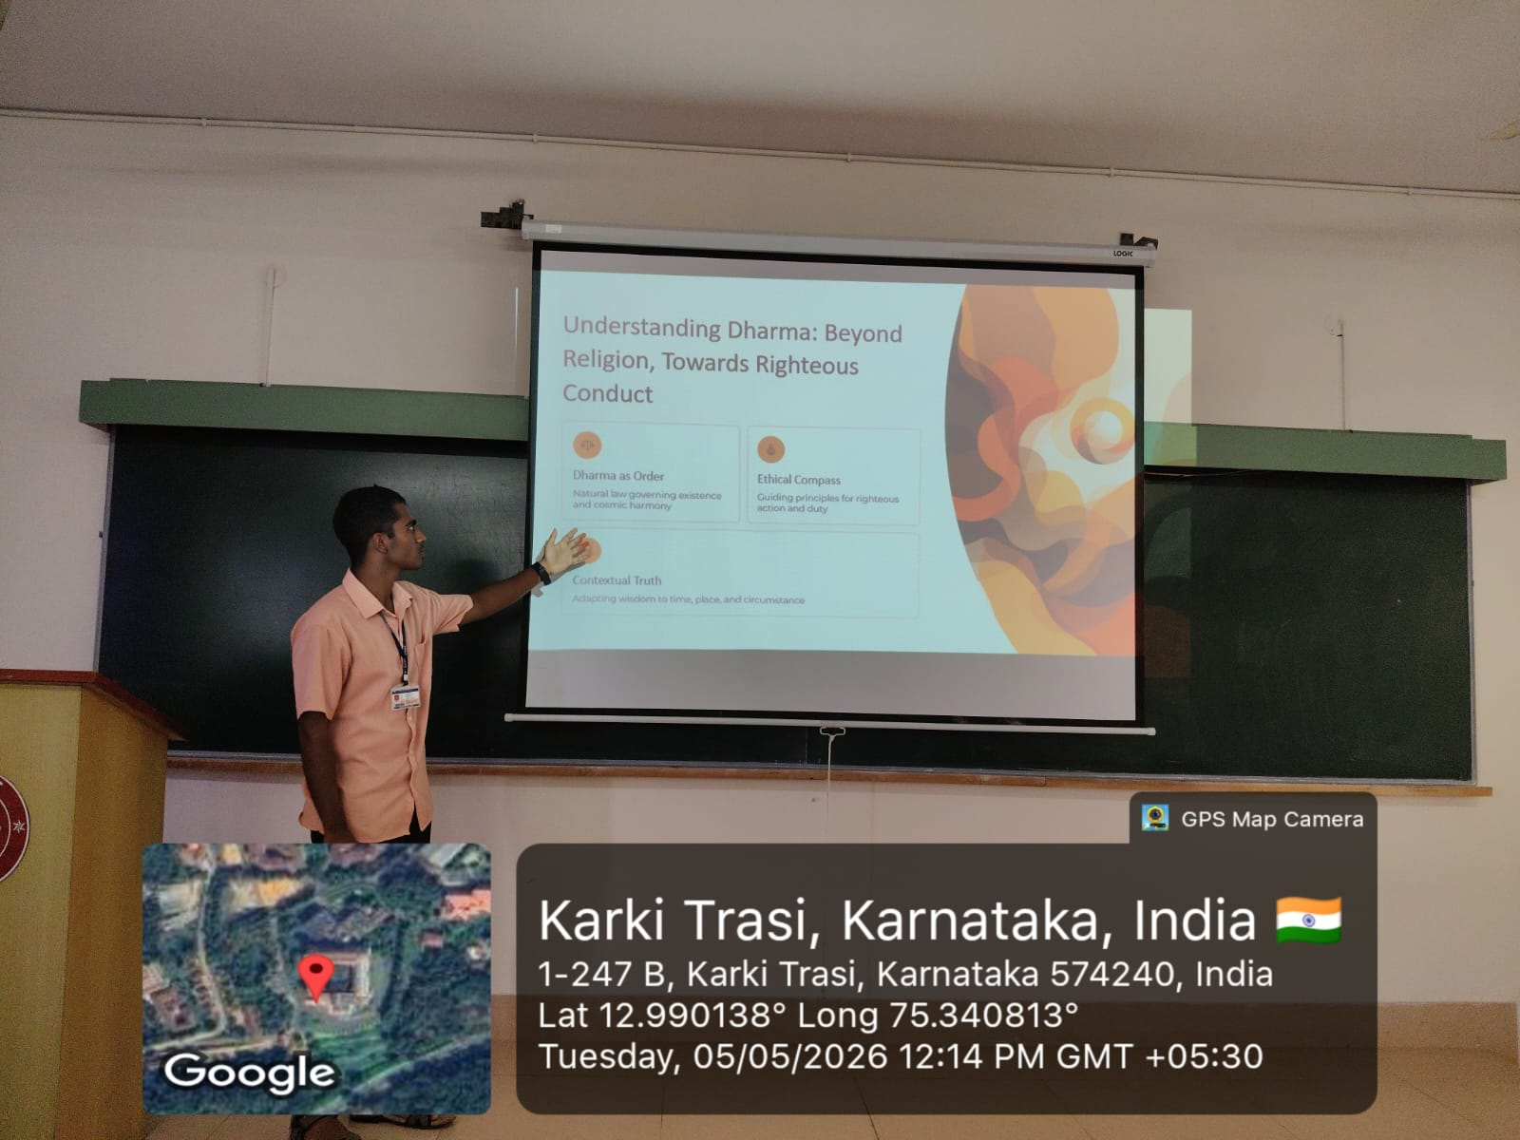

Conclusion

The concept of Dharma in knowledge transmission highlights the importance of ethics, responsibility, discipline, and social welfare in education. Ancient Indian traditions viewed knowledge as a sacred tool for personal growth and societal harmony. Even in the modern technological era, Dharmic principles remain relevant for promoting ethical education, responsible innovation, and preservation of cultural heritage.

References

Introduction to Indian Knowledge System: Concepts and Applications - Mahadevan B., Vinayak Rajat Bhat, Nagendra Pavana R.N.

IKS: The Knowledge System of Bharata - Bhag Chand Chauhan

Bhagavad Gita

Upanishads

Vedas

Research Articles on Guru-Shishya Tradition and Knowledge Transmission

UNESCO Reports on Cultural Heritage and Traditional Education

NCERT Indian Knowledge System Materials

Ministry of Education Publications on Indian Knowledge Systems (IKS)

Research Papers on Ethics, Dharma, and Ancient Indian Educational Philosophy

