BUSINESS STRATEGY & INVESTMENT REPORT
D2C Stationery — India

Prepared for: Sathvik
Source of Truth: Customer & MVP Blueprint
Market: India | Date: July 2026
CONFIDENTIAL — Prepared by AI Co-Founder & Growth Strategy Analysis. For internal decision-making, not a substitute for legal, financial, or investment advice.

Table of Contents
Executive Summary 3
Business Reality Check 4
Business Model Canvas 5
Revenue & Pricing Strategy 6
Go-To-Market Strategy 6
Customer Acquisition Strategy 7
First 100 Users Plan 7
Competitive Position & Moat 8
Reverse SWOT Analysis 8
Investor One-Liner & Founder Pitch 9
Investment Scorecard 9
Visual Dashboard 10
Founder Action Sheet 11
Sustainability Verdict 11

Executive Summary
The Startup in 8 Bullets
- A D2C stationery brand in India, targeting Tier-1 new parents (primary segment) and journaling/note-taking enthusiasts (secondary segment).
- Core MVP: a single "First Stationery Starter Kit" — 3-5 SKUs (notebook, safety-certified crayons, sketchbook).
- Positioning: trustworthy, BIS-safety-certified, aesthetically crafted stationery — versus generic mass-market (Classmate, Navneet) and costly, unreliable imports.
- Go-to-market: organic Instagram content, parenting communities, and a small paid ad pilot, driving to a prepaid-only D2C checkout.
- Pricing hypothesis: ₹499-₹799 per kit, positioned as a gifting/keepsake purchase rather than a commodity notebook.
- Day-30 success bar: 50+ waitlist signups, 10+ real prepaid pre-orders, <20% RTO, CAC under ₹300.
- Sourcing model: small-batch, BIS-compliant manufacturing partner — no owned inventory or logistics infrastructure yet.
- Explicitly framed as a sustainable small business / side project, run alongside a full-time role — not a venture-scale bet.
Assumptions Extracted from the Blueprint
Dimension | Assumption
Customer | Urban new parents, 28-38, ₹15-40 LPA household, Instagram-active, will treat stationery as a gifting/trust decision
MVP | A narrow 3-5 SKU starter kit is sufficient to test demand before any broader catalog or inventory investment
Value Proposition | Safety certification + aesthetics command a premium that mass-market and imported alternatives do not offer
Pricing | ₹499-₹799 is an acceptable price for a gifting-positioned kit, 5-8x a standard notebook
Revenue | A one-time D2C kit purchase is viable as a starting revenue stream, with no proven repeat/subscription model yet
GTM | Organic content + parenting communities can generate qualified demand at low CAC (under ₹300) without heavy paid spend

These are the assumptions this report stress-tests. None are validated with real transaction data yet — the analysis below treats them as hypotheses, not facts.

Business Reality Check
Who Pays?
New parents in Tier-1 Indian metros, purchasing a stationery starter kit as a gift or keepsake for their young child. Secondary: journaling/note-taking enthusiasts buying for themselves. In both cases, the payer is also the end user or a close gift-giver — there is no separate B2B buyer yet.
Why Do They Pay?
Not because existing stationery is functionally broken — mass-market notebooks work fine. They pay for trust signaling (child safety), aesthetics (something "worth posting"), and emotional value (instilling creativity/mindfulness in a child, or a personal journaling identity). This is a low-urgency, high-discretion purchase — closer to a gifting decision than a problem-solving one.
How Will They Discover the Product?
Primarily through organic Instagram/Pinterest content, parenting Facebook/WhatsApp communities, and festive-occasion search — supplemented by a small paid ad pilot and (eventually) referral from existing buyers. There is no proven content engine or community relationship yet; this is planned, not built.
Biggest Growth Risks
- Low category urgency: stationery is a low-frequency, low-consideration purchase — growth cannot rely on repeat necessity the way food or personal care can.
- Unproven organic engine: the entire early GTM plan leans on organic reach and community goodwill, which is unpredictable and slow to compound without a proven content/creator strategy.
- Narrow addressable niche: "new parents who want a trustworthy stationery brand" is a real but small slice of the broader stationery/journaling market — growth beyond early adopters may require expanding positioning, diluting focus.
Biggest Monetization Risks
- Thin AOV (₹499-₹799) on a one-time purchase means high customer volume is needed to reach meaningful revenue — this works against a low-budget, organic-led acquisition strategy.
- India D2C COD/RTO rates (25-39% industry-wide) can quietly erode margin on an already low-ticket item if not controlled from day one.
- No proven repeat-purchase or subscription mechanism yet — lifetime value is currently capped at a single kit purchase unless gifting-occasion repeat behavior is demonstrated.
Weak Assumptions to Validate
- That parents will pay a 5-8x premium for stationery specifically, versus toys or books which carry higher perceived developmental stakes.
- That "BIS safety certification" is a strong enough purchase driver to overcome price sensitivity in a low-stakes category.
- That engagement in parenting communities converts into actual paying customers, not just passive interest or likes.
- That a single-purchase gifting kit — without a repeat or subscription mechanism — can sustain a viable, ongoing business.

Business Model Canvas
Block | Detail
Customer Segments | Primary: new parents (Tier-1 India). Secondary: journaling/note-taking enthusiasts
Value Propositions | Safety-certified, aesthetically crafted stationery positioned as a gifting/keepsake purchase
Channels | Instagram, parenting Facebook/WhatsApp communities, D2C landing page, (later) Amazon marketplace
Customer Relationships | Community-led trust building, UGC, micro-influencer collaboration, referral
Revenue Streams | One-time kit purchase now; gifting bundles, personalization, and subscription as future upsells
Key Activities | Product sourcing/QC, BIS compliance, content creation, community engagement, D2C fulfillment
Key Resources | Manufacturing partner relationship, brand/content assets, founder's PM/ops discipline
Key Partners | Small-batch BIS-compliant manufacturer, 3PL/courier partner, micro-influencers
Cost Structure | COGS, packaging, paid ads (small), courier/RTO losses, platform/payment fees

Revenue & Pricing Strategy
- Now: Starter kit at ₹499-₹799 — A/B test both price points on the landing page before committing to manufacturing volume.
- Near-term: Festive/gifting bundles (birth, naming ceremony, birthday) at a higher AOV than the base kit.
- Future: Personalization (name printing, milestone journals) as a premium upsell with better margin than the base product.
- Future, unproven: Age-appropriate subscription/refill box — do not build until base-kit repeat-purchase behavior is demonstrated.
Pricing anchor: position against gifting categories (toys, personalized gifts), not against commodity notebooks — the ₹499-₹799 range only makes sense if the customer perceives this as a gift, not a school supply.

Go-To-Market Strategy
Phase | Focus | Primary Channels
Phase 1 (Days 1-30) | Validate demand, build waitlist | Organic Instagram, parenting communities, personal network
Phase 2 (Days 31-60) | Convert waitlist, test paid channels | Small paid ad pilot, micro-influencer collabs, referral incentive
Phase 3 (Days 61-90+) | Expand if validated | Marketplace listing (Amazon), journaling-segment content, bundles

Customer Acquisition Strategy
- Organic content: safety + aesthetics-led Instagram/Pinterest content, founder-led storytelling on the "why" behind the brand.
- Community seeding: authentic (non-spammy) participation in 3-5 parenting Facebook/WhatsApp groups.
- Micro-influencer collaboration: 3-5 parenting micro-influencers for authentic UGC and trust transfer.
- Small paid ad pilot: ₹5,000-10,000 Instagram/Meta spend to pressure-test CAC beyond organic reach.
- Referral loop: incentivize existing buyers to refer friends — critical given the low organic virality of a gifting-occasion product.

First 100 Users Plan
Source | Target Users | Approach
Personal network | 10 | Friends/family with young children — fastest, most trusted first cohort
Parenting communities | 30 | Organic engagement across 3-5 groups, not paid promotion
Micro-influencer collabs | 30 | Gifted kits + authentic review/UGC from 3-5 parenting creators
Small paid ad pilot | 20 | ₹5,000-10,000 spend directed at the landing page
Referral incentive | 10 | Discount/gift for existing buyers who refer a friend

Competitive Position & Moat
Today, this business has essentially no defensible moat. Aesthetic design and even safety-certification claims are replicable within a few months by better-resourced players (Scooboo's marketplace breadth, Doodle Collection's design capability, Origin One's subscription infrastructure). The moat has to be built deliberately — it will not emerge from the product alone.
Potential Moat | How It's Built | Durability
Safety-certification trust | Being first and most visible with transparent BIS compliance in this niche | Medium — copyable, but first-mover trust is sticky
Parenting-community relationships | Genuine, sustained engagement (not one-off promotion) in the same 3-5 communities over time | Medium-High — hard to fake or replicate quickly
Personalization / milestone lock-in | Name printing, growth journals tied to a specific child over years | High — creates switching cost and emotional attachment

Reverse SWOT Analysis
A conventional SWOT lists strengths and opportunities at face value. This reverse SWOT asks: what hidden weakness does each strength mask, and what hidden opportunity does each threat contain?
Conventional View | Reverse / Critical View
Strength: Founder's strong PM/ops discipline | Hidden weakness: no retail, manufacturing, or D2C growth experience — operational discipline doesn't substitute for domain instinct
Strength: Clear niche (new parents wanting trust) | Hidden weakness: niche may be too narrow and too low-urgency to fund meaningful growth alone
Opportunity: Under-served new-parent segment | Hidden risk: under-served may mean under-demanded, not just under-supplied
Threat: Crowded design-led D2C tier | Hidden opportunity: crowding proves category demand exists — validates that consumers already pay a premium for design-led stationery
Threat: India's high D2C RTO/COD rates | Hidden opportunity: prepaid-first discipline from day one becomes a structural cost advantage over slower-moving incumbents

Investor One-Liner & Founder Pitch
Investor One-Liner
"A D2C stationery brand bringing safety-certified, beautifully designed creative supplies to Indian parents raising the next generation of makers."
30-Second Founder Pitch
"Every Indian parent wants their child's first brush with creativity to feel special and safe — but today they're choosing between generic mass-market notebooks or expensive, unreliable imports. We're building a D2C stationery brand that's BIS-certified, beautifully designed, and priced as a gift, not a commodity. We're starting with a single starter kit, testing real demand with real pre-orders before we scale — because this only works if parents actually pay for trust and craft, not just like it on Instagram."

Investment Scorecard (0-100)
Business Viability ██████████░░░░░░░░░░░░ 45/100
Plausible as a small business; low category urgency and thin AOV cap upside without a repeat-purchase mechanism.
Revenue Potential ████████░░░░░░░░░░░░░░ 35/100
Low AOV, one-time purchase model, and a narrow SAM slice limit revenue ceiling unless bundling/subscription is proven.
GTM Strength █████████░░░░░░░░░░░░░ 40/100
Sound channel logic (community + organic) but entirely unproven — no real conversion data yet, and paid budget is minimal.
Competitive Strength ████████░░░░░░░░░░░░░░ 38/100
Real white space today, but no durable moat; well-funded design-led D2C players could replicate the angle quickly.
Investor Readiness █████░░░░░░░░░░░░░░░░░ 22/100
Pre-traction, no revenue, explicitly framed as a side project — appropriately not investor-ready at this stage.

Visual Dashboard
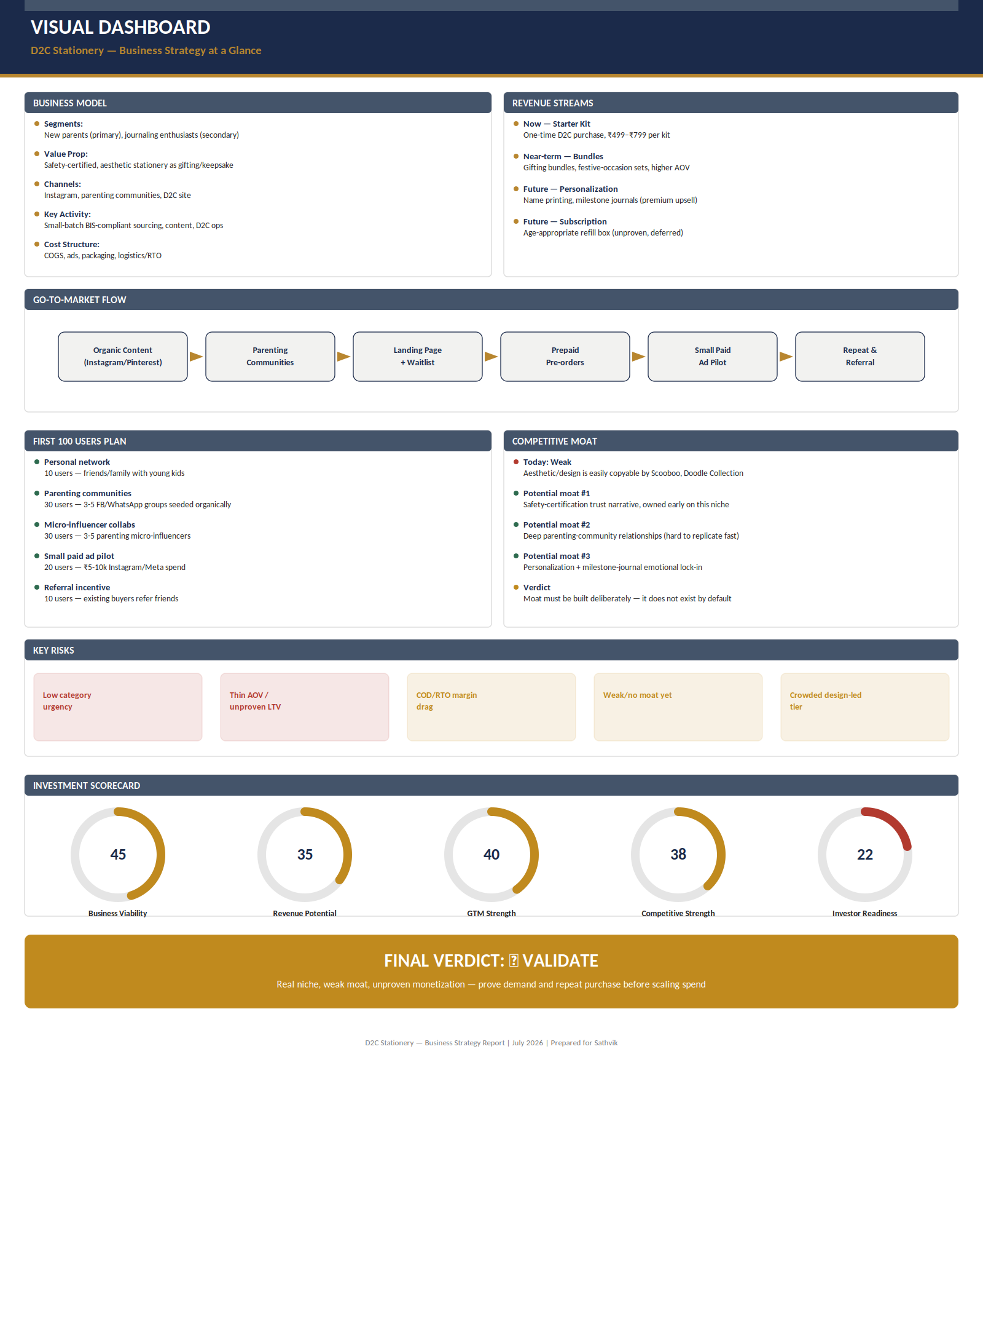

Founder Action Sheet — Top 10 Actions
1. Run 15-20 parent interviews specifically testing willingness to pay ₹499-799 (not just interest in the concept).
2. Launch the landing page with 2 price points and real prepaid checkout — not just an email waitlist.
3. Lock in 1 BIS-compliant small-batch manufacturer and get real sample costing before any further spend.
4. Seed 3-5 parenting communities organically for 2 weeks before any paid promotion.
5. Secure 3-5 micro-influencer collaborations in exchange for product, tracked with unique discount codes.
6. Run the ₹5,000-10,000 paid ad pilot only after organic channels are tested — isolate what's actually driving CAC.
7. Set a hard prepaid-only checkout policy from day one — do not offer COD, even if it costs early conversions.
8. Track waitlist-to-pre-order conversion rate weekly — this is the single most important number in the first 30 days.
9. Design one gifting bundle (e.g., birth/naming-ceremony set) to test higher AOV before investing in subscription infrastructure.
10. Hold a Day-30 Go/No-Go review strictly against real pre-order numbers and CAC — not against engagement or vanity metrics.

Sustainability Verdict
🟡 VALIDATE — Real niche, no durable moat, monetization unproven
This can become a sustainable small business, but not yet a defensible one: the niche is genuine and the operator has the discipline to run it, but pricing power, repeat-purchase economics, and any real competitive moat are all still assumptions. Prove real prepaid demand at the stated price point and a repeatable acquisition channel before committing to inventory scale — if those two things hold up after 30-60 days of real transactions, this graduates from "validate" to a genuinely investable small business.

