

Send job with User

dna seqence

Generated DNA sequence

 

Authenticate the key

 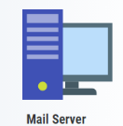

Upon

Registration

User registration interface

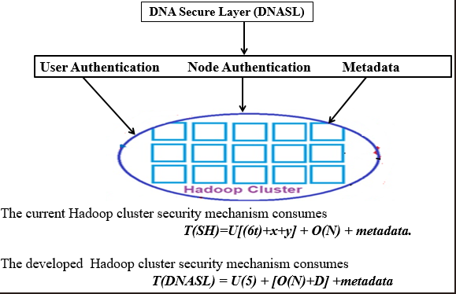

**SEAL (Spark E-Authentication Layer)**

**User Authentication Node Management**

**Spark Cluster**

The current spark cluster security mechanism consumes

**T(SC)=U[(6t)+x+y] +O(N)**

The developed Spark Cluster security mechanism consumes

**T(SAI)=U(5) +[O(N)+D]**

|  |  |  |  |
| --- | --- | --- | --- |
| **Author(s)** | **Strategies** | **Advantages** | **Disadvantages** |
| **Nan Zhang, Et al.** | **Kerberos Authentication** | **• Strong security: Kerberos is a well-established and widely used authentication protocol.**  **• Centralized authentication: It uses a centralized Key Distribution Center (KDC) for secure authentication.** | **• Complexity: Setting up and maintaining a Kerberos infrastructure can be complex.**  **• Overhead: Introduces computational overhead due to the need for ticket requests and validations.** |

**User Authentication computation existing and proposed.**

**No.of sessions Total Number of times Total**

**Authentications Computations Authenticated/Day Computations**

**/Day (Existing) (proposed)**

User 5 50 2 8