

AI-Powered Medical Prescription Handwriting Recognition: An End-to-End Deep Learning Pipeline for Drug Identification and Interaction Detection

Name:
Student Id:
Word Count: 2410

Table of Contents
Part A: Introduction 3
A.1 Problem Statement 3
A.2 Aim and Objectives 4
Part B: Technical Review 4
B.1 Handwriting Recognition Approaches 4
B.2 Transformer-Based OCR 5
B.3 Drug Name Normalisation and Interaction Detection 5
B.4 Justification of Chosen Approach 6
Part C: Design and Implementation 7
C.1 System Architecture 7
C.2 Data Pipeline 8
C.3 Model Configuration 10
C.4 Medicine Identification and Interaction Module 10
C.5 Web Application Deployment 10
Part D: Technical and Critical Evaluation 12
D.1 Technical Evaluation 12
D.2 Critical and Social Impact Evaluation 14
Part E: Project Proposal and Management 16
E.1 Project Management Review 16
E.2 Future Work 16
Part F: Conclusion 17
References 18

Part A: Introduction

A.1 Problem Statement
Despite advances in electronic prescribing and other technological solutions, medication errors resulting from illegible handwriting persist as a worldwide problem that can harm patients. Often, a pharmacist receives a prescription in which the intended medication is unclear. Such a scenario can lead to a medication error of varying significance. Such errors may range from a near miss to a life-threatening adverse event. This problem is more severe in developing countries where e-prescribing capabilities are poor and handwritten prescriptions are still the predominant communication medium between doctors and pharmacists. The challenge worsens as the drug names look and sound alike. Thus, a single error or misreading of characters could lead to the dispensing of an incorrect drug.

A.2 Aim and Objectives
The project presented is about creating an end-to-end artificial intelligence pipeline that will handle the digitization of drug names by reading doctor prescriptions that have been handwritten. Subsequently, this project will also identify the drugs from the digitized names and will also flag drug-drug interactions. The system uses computer vision-enabled OCR and pharmacological knowledge accessed through an API to link the prescriptions handwritten by a clinician with codified clinical data.

Part B: Technical Review

B.1 Handwriting Recognition Approaches
There has been considerable evolution in handwriting recognition. According to Ahmad and Fink (2019), character sequences using statistical sub-word units typically rely on HMMs, which addressed limited vocabularies but struggled with cursive and informal handwriting. The advent of Convolutional Neural Networks (CNNs) tackled automatic feature extraction by learning spatial hierarchies directly from pixels (Altwaijry and Al-Turaiki, 2021). The CRNN approach proposed by Shi, Bai, and Yao (2017) integrated a CNN-based feature extractor, recurrent layers, and CTC loss to produce an end-to-end solution for sequence identification without character segmentation, and became the prevailing paradigm for several years. Shahade et al. (2023) recently utilized CNN-based pipelines for medical prescription recognition and achieved moderate accuracy but noted strong difficulty in generalization across handwriting styles.

B.2 Transformer-Based OCR
Transformer architectures have recently advanced handwriting recognition. Kang et al. (2022) demonstrated that attention-based non-recurrent models outperform LSTM-based ones on handwritten text-line recognition by better capturing long-range dependencies. Dan et al. (2022) adapted the Swin Transformer for handwritten Chinese characters with reduced computational cost, and Hamza et al. (2024) introduced ET-Network, a lightweight transformer for Urdu handwritten text. Momeni and BabaAli (2024) validated transformer-based approaches for Arabic offline handwriting, confirming cross-script applicability. Microsoft’s TrOCR combines a ViT/BEiT encoder with a RoBERTa decoder, enabling domain-specific fine-tuning, and Bilgin Tasdemir (2023) showed synthetic data augmentation significantly improves OCR accuracy on historical scripts.

B.3 Drug Name Normalisation and Interaction Detection
On the pharmacological side, RxNorm provides a standardized nomenclature for clinical drugs in the United States that allows for interoperability between different health information systems (Nelson et al., 2011). Le et al. (2024) used it for drug name normalization of adverse events. Lester et al. (2022) revealed challenges of variance when matching electronic prescription data against RxNorm product descriptions. Wang et al. (2018) extended the RxNorm model to clinical drugs in China, proving the model is adaptable to non-US pharmacopoeias. Several DDI tools have been proposed: Böttiger et al. (2009) developed the SFINX database for clinical decision support, and Fung et al. (2017) compared three commercial knowledge bases for DDI detection, identifying significant coverage differences. Hsu et al. (2022) presented a deep-learning NLP pipeline that extracts structured information from scanned EHR documents, demonstrating feasibility for automating clinical document processing.

B.4 Justification of Chosen Approach
The system uses TrOCR because it has a proprietary end-to-end architecture and a strong backbone pre-trained on handwriting prior data. This is coupled to RxNorm for drug normalization and interaction checking. The reason for the preference for this combination over traditional CNN-CTC pipelines was the capability of transformer-based models to capture contextual dependencies better across variable-length medicine names. The reason for the preference over commercial OCR engines, like Tesseract, was that having domain-specific fine-tuning gives substantially better accuracy on medical handwriting.

Part C: Design and Implementation

C.1 System Architecture
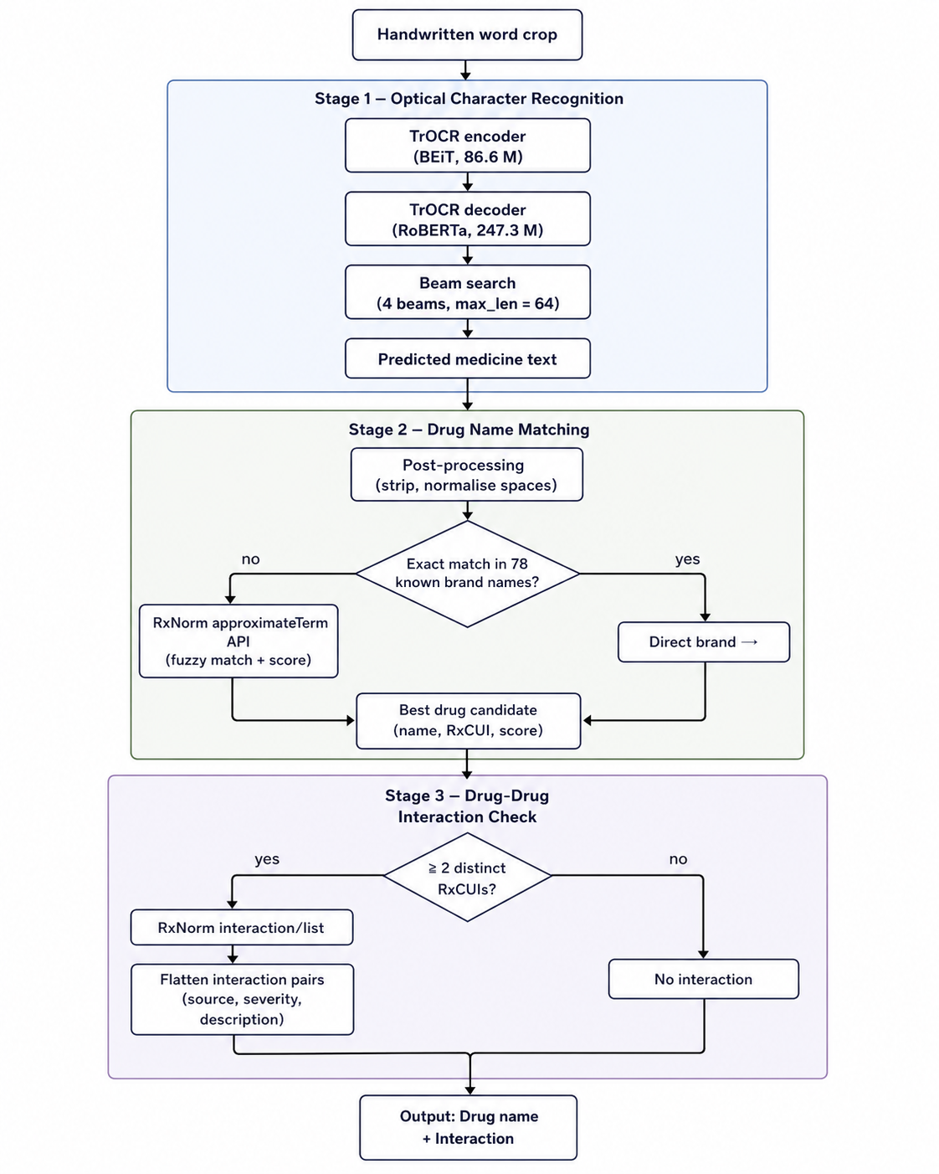
Figure 1: End-to-end three-stage pipeline segmentation, TrOCR, RxNorm matching and interaction check.
The system functions in a 3-stage pipeline (see Figure 1). During stage 1, word images of handwritten prescription scripts are passed through a fine-tuned TrOCR model to get text predictions using beam search decoding. In stage 2, the post-processed prediction is matched against a database of 78 known medicine brand names, and unmatched predictions are resolved through the RxNorm approximate term API, which performs fuzzy matching to absorb minor OCR errors. In stage 3, drug candidates are passed through the RxNorm interaction API, which alerts any drug-drug interaction and produces safety warnings. The Mermaid version of this architecture is provided alongside this report.

C.2 Data Pipeline
The Doctor’s Handwritten Prescription BD Dataset was utilized, consisting of word-level images of handwritten medicine names 4,680 images covering 78 brand names mapped to 15 generic drug categories (see Figure 2 for representative samples and Figure 3 for the per-class image count). The dataset comes pre-split, with 3,120 training images (66.7%), 780 validation samples (16.7%), and 780 testing samples (16.7%); each medicine has a balanced 60 samples. Image dimension, aspect-ratio, brightness, and sharpness statistics were profiled during EDA (dimension_distribution, aspect_ratio_distribution, brightness_distribution, sharpness_distribution, samples_per_category, generic_name_frequency).
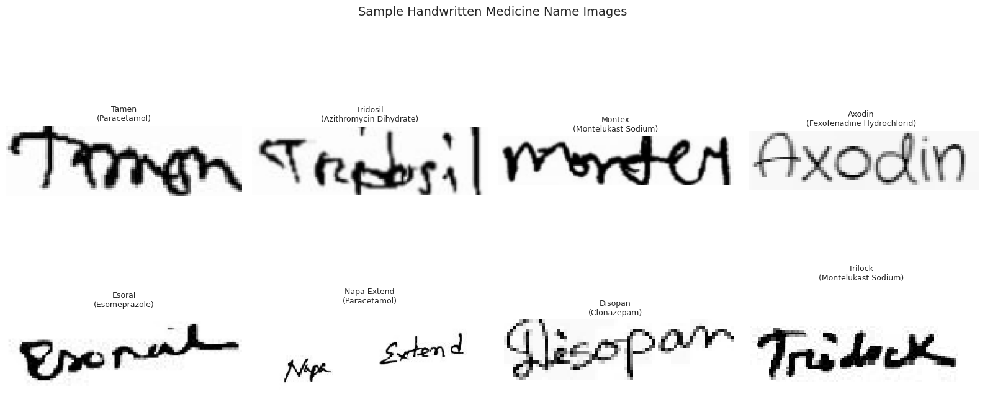
Figure 2: Sample word crops from the dataset with their ground-truth medicine labels.
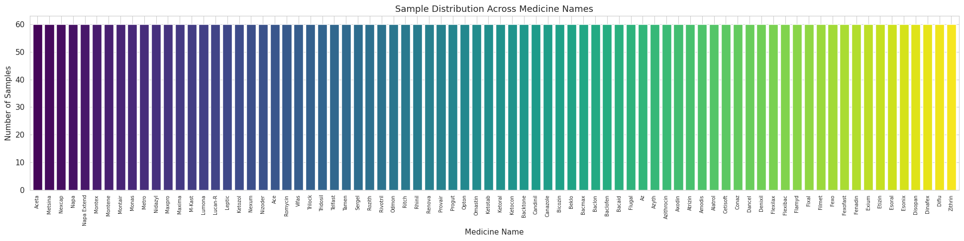
Figure 3: Image count per medicine brand the dataset is balanced at 60 samples per class.
To enhance the contrast of text against varied backgrounds, noise removal was carried out using non-local means denoising, alongside adaptive Gaussian thresholding (see Figure 4 and the supplementary grayscale_demo, preprocessing_demo). During training, augmentations were applied with probability 0.5 random rotation (±5°), contrast (0.8–1.3), brightness (0.9–1.1), and Gaussian blur (radius 0.3–1.0); examples are shown in Figure 5. Final resizing to 384×384 pixels and pixel normalization were handled internally by TrOCRProcessor.
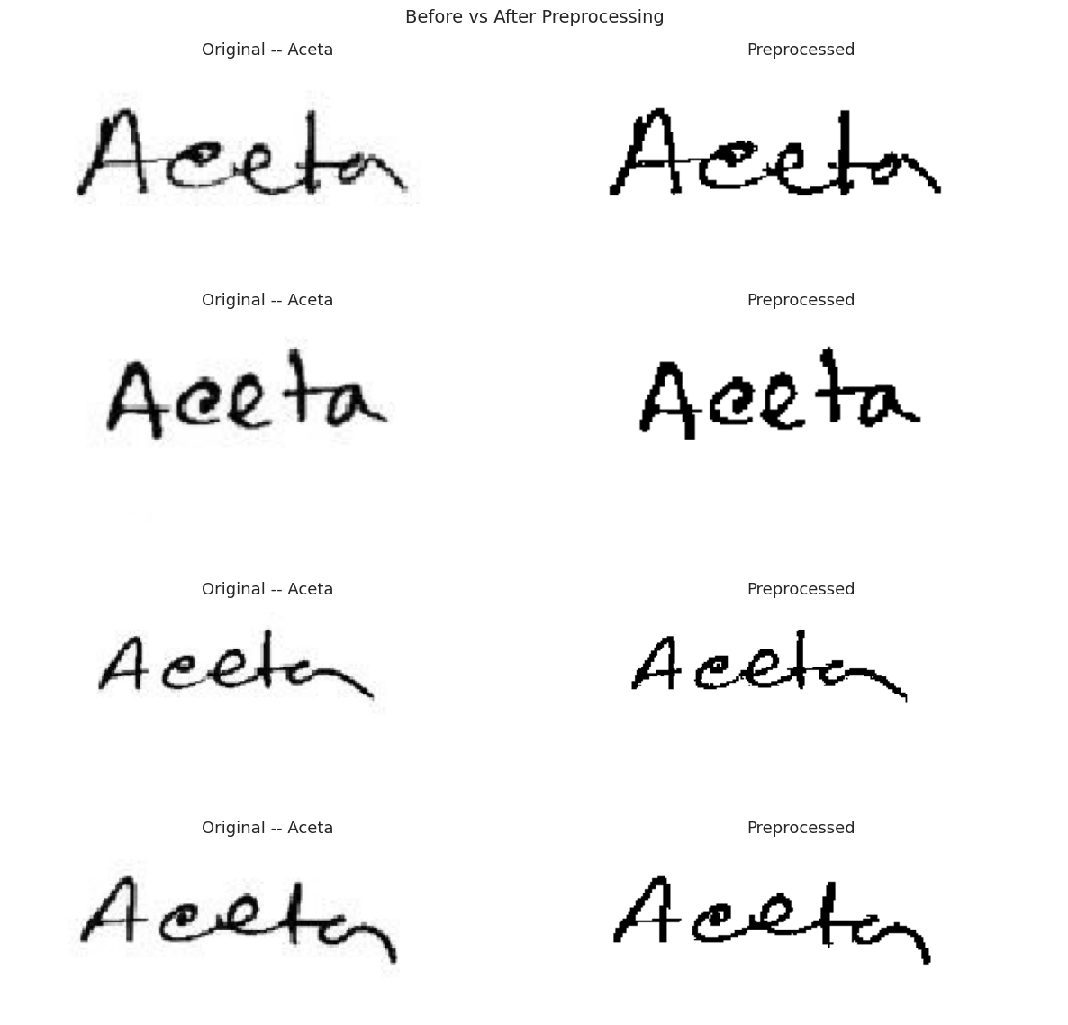
Figure 4: Before/after view of denoising and adaptive Gaussian thresholding on a sample crop.
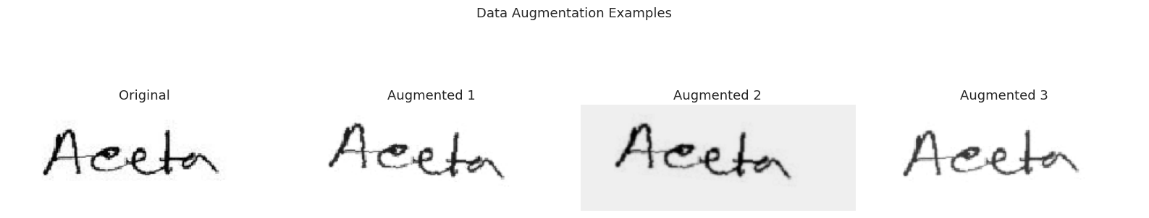
Figure 5: Training-time augmentations rotation, brightness/contrast jitter, and Gaussian blur.

C.3 Model Configuration
The chosen microsoft/trocr-base-handwritten model includes a BEiT-based vision encoder with 86.6 million parameters and a RoBERTa-based autoregressive decoder with 247.3 million parameters, giving a total of 333.9 million trainable parameters. To balance accuracy with the GPU’s memory constraints, the base variant was selected. Fine-tuning used the AdamW optimizer with a learning rate of 5e-5 and weight decay of 0.01, a linear warmup scheduler over 97 steps followed by linear decay across 975 total steps, a batch size of 8 with 2-step gradient accumulation (effective batch size of 16), and gradient clipping at max-norm 1.0. Generation used beam search with 4 beams, length penalty 2.0, and a maximum sequence length of 64 tokens.

C.4 Medicine Identification and Interaction Module
The predicted text was tidied up by removing special characters and normalizing white space. A two-stage matching process was employed. In the first stage, exact case-insensitive matching against the 78 known brand names was attempted. If nothing matched, the RxNorm approximateTerm endpoint was queried for the closest concept. All 15 generic drugs in the dataset were mapped to their RxNorm Concept Unique Identifiers (RxCUIs) and can subsequently be queried for drug-drug interactions through the RxNorm REST API.

C.5 Web Application Deployment
The trained pipeline was packaged as a Flask web application (app.py) so it could be used outside the notebook. The app loads both the fine-tuned checkpoint and the stock microsoft/trocr-base-handwritten model at startup and runs every input through both; for each word, the candidate with the higher RxNorm approximateTerm score is retained the fine-tune dominates on in-vocabulary brand names while the base model is more robust to unseen tokens. Three routes are exposed: /predict accepts pre-cropped word images, /predict-page runs an OpenCV segmentation pass (adaptive threshold, horizontal morphology, contour ordering) that converts a full prescription page into word crops in reading order before OCR, and /evaluate runs a seeded random sample of the test split for reproducible benchmarking. The codebase is split into src/preprocessing.py, src/ocr_pipeline.py, src/drug_matching.py, and src/interaction_checker.py so each stage can be tested in isolation, with templates/ providing the Jinja-based UI. RxNorm calls fail safely network errors are caught and the result page still renders with a “no match” status, so a flaky public API never breaks a user-facing demo.
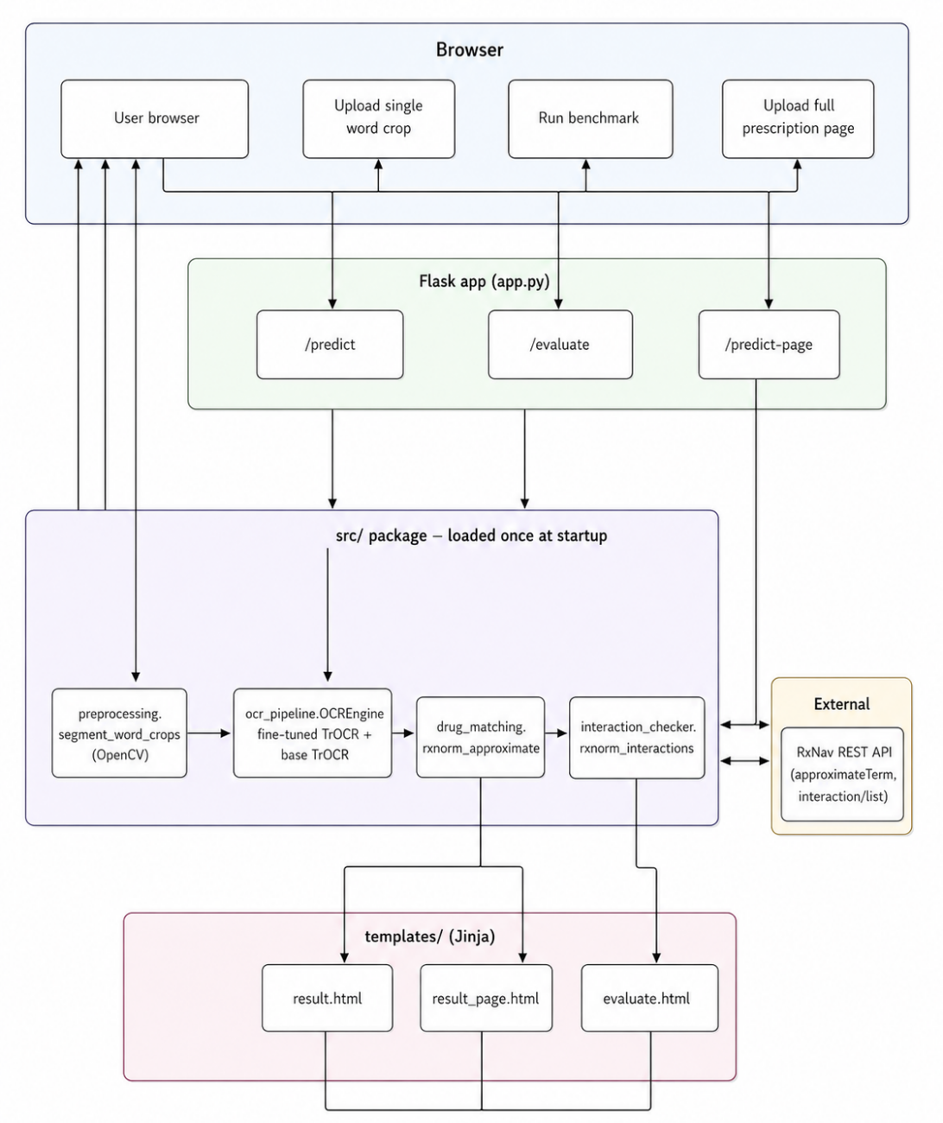

Part D: Technical and Critical Evaluation

D.1 Technical Evaluation

D.1.1 Experimental Setup
Experiments were performed on a Quadro RTX 5000 GPU with 15.73 GB VRAM, powered by CUDA 12.1 and PyTorch 2.1.1. All frameworks were fixed with random seed 42 for reproducibility. After loading, the model occupied 1.25 GB of GPU memory, leaving approximately 14.42 GB for training.

D.1.2 Training Convergence
Training ran for 5 epochs at roughly 258 seconds each. The training loss fell from 0.9654 in epoch 1 to 0.0018 in epoch 5, while validation loss decreased from 0.1182 to 0.0415 (see Figure 6). Because validation loss improved every epoch, the early-stopping mechanism (patience 3) never triggered. The consistent downward trend of both losses without divergence implies effective fine-tuning and no overfitting, likely due to the strong representations from the pre-trained weights and the regularisation provided by augmentation and weight decay.
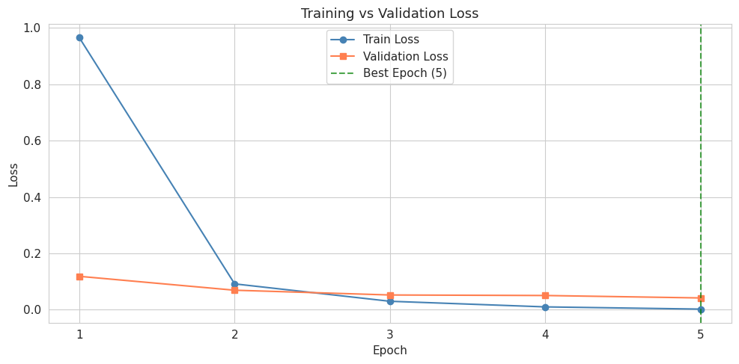
Figure 6: Training and validation loss across the five fine-tuning epochs.

D.1.3 OCR Performance
The fine-tuned model achieved a mean CER of 3.13% and WER of 3.65% on the 780-image test set, with median CER and WER of 0.00% (i.e. most predictions were exactly correct). Exact-match accuracy was 96.28%, with 751/780 test images recognised perfectly (see Figure 7 and the consolidated metrics). Achieving this from only 3,120 training images demonstrates the effectiveness of TrOCR’s pre-trained weights.
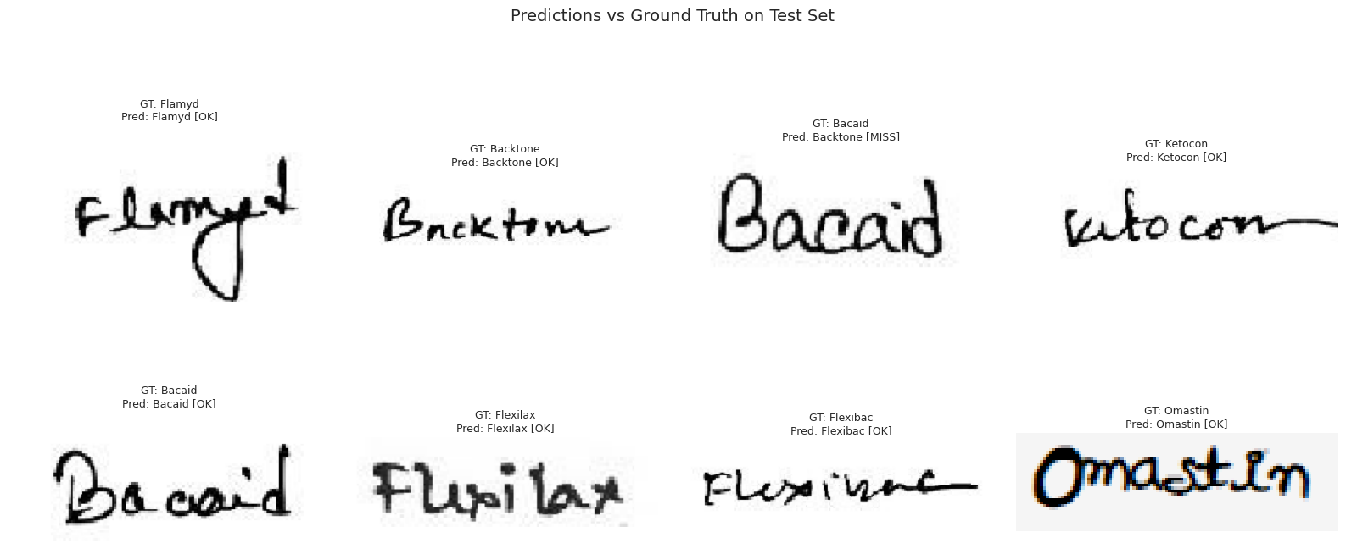
Figure 7: Side-by-side comparison of model predictions and ground-truth labels on test images.

D.1.4 Error Analysis
The 29 misrecognised samples were analysed for character-level confusion and showed systematic patterns. Most visual confusions occurred between e and a, n and m, and o and a, each appearing three times. Word-level errors such as “Bacaid” predicted as “Backtone” and “Fenadin” predicted as “Fexo” indicate the model occasionally confuses medicine names from similar generic categories, plausibly because character-level ambiguity compounds across the sequence; the autoregressive decoder is known to suffer from this, where an early incorrect choice propagates through the rest of beam search.

D.1.5 Inference Performance
The full pipeline averaged 0.147 seconds per image on the GPU, with a maximum of 0.180 seconds (see Figure 8). This sub-second latency, including OCR and drug identification, makes the system suitable for real-time clinical decision support.
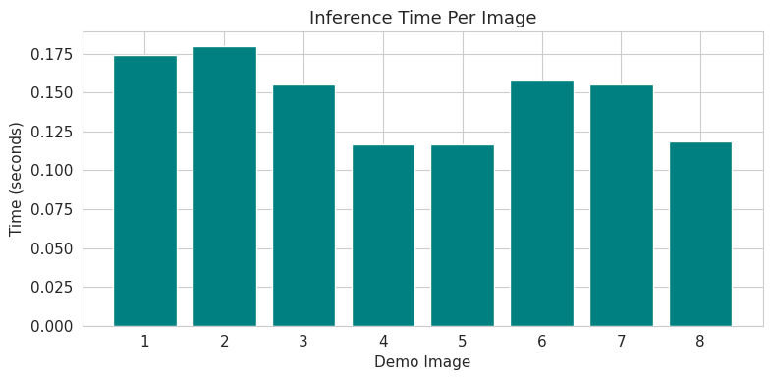
Figure 8: Per-image inference time across the test set; the bulk of calls finish in under 0.16s.

D.1.6 Strengths and Limitations
TrOCR’s end-to-end architecture eliminates separate detection modules, while handwriting-specific pretraining enables strong results with limited data, and RxNorm integration adds clinical utility. Limitations include word-level training requiring segmentation for deployment, only 78 medicines covered, missing RxNorm equivalents for Bangladeshi brands (US-only coverage), and connectivity issues causing 404 errors.

D.2 Critical and Social Impact Evaluation

D.2.1 Social Impact
Automated prescription reading could have significant social impact. Medication errors due to misunderstood prescriptions cause preventable harm worldwide, and a trustworthy digitisation tool can act as a decision-support aid for pharmacists in resource-poor settings without electronic prescribing. Patients particularly older people and those with visual impairments may also benefit from a reliable readout of their own medication.

D.2.2 Bias and Fairness
The dataset originates from a single geographic region (Bangladesh), encoding handwriting styles and brand names from that market and creating a clear geographic and cultural bias the model is unlikely to generalise to other countries without additional fine-tuning data. Class balance is good (60 samples per medicine), but the 78-drug vocabulary is far smaller than real clinical practice, and prescriptions from clinicians with particularly poor handwriting are likely under-represented.

D.2.3 Ethical Considerations
Prescription images contain sensitive patient health data, requiring patient consent and anonymisation under regulations such as GDPR. The 3.72% word-level error rate translates to roughly 29 misreads per 780 prescriptions; in a clinical setting a single misrecognised drug name could trigger an incorrect dispense, so the system must augment rather than replace pharmacist judgment. Scheife et al. (2015) argue that systematic evaluation is essential when applying drug-interaction evidence to clinical decision support, and Payne et al. (2015) warn that poorly designed alerts cause fatigue that erodes clinical usefulness. Phansalkar et al. (2012) and Tilson et al. (2016) further insist on prioritising high-impact interactions over low-severity ones a principle reflected in our interaction module.

D.2.4 Responsible Deployment
Safe deployment requires a human-in-the-loop workflow where pharmacists verify every AI output, confidence thresholds that flag uncertain predictions rather than asserting them, and regulatory approval before any clinical use. Robust handling of external API failures is also necessary, as observed with the RxNorm endpoint.

Part E: Project Proposal and Management

E.1 Project Management Review
The modular pipeline architecture allowed individual components OCR, drug matching, interaction checking, and the Flask web layer to be developed and tested independently. Training took only 21.5 minutes over 5 epochs thanks to the pre-trained backbone. The main challenges were the dataset’s narrow geographic coverage, the 78-medicine vocabulary, and the unreliable free-tier RxNorm interaction endpoint.

E.2 Future Work
Several extensions would improve practical value. The current OpenCV segmentation handles a fixed range of scan qualities; replacing it with a learned text-line detector would broaden the input distribution. Multilingual support for Arabic, Hindi, and Bangla scripts would extend reach via cross-script approaches (Momeni and BabaAli, 2024; Ahmad and Fink, 2019). Compression through ONNX or TensorFlow Lite would enable mobile deployment for pharmacists. Substituting or supplementing RxNorm with regional drug knowledge bases (Wang et al., 2018) would extend coverage beyond US markets. Multi-hospital data collection and synthetic augmentation following Bilgin Tasdemir (2023) would broaden vocabulary and handwriting diversity, and integration with Electronic Health Records (Hsu et al., 2022) would embed the system within existing clinical workflows.

Part F: Conclusion
The project presents an end-to-end AI pipeline for handwritten prescription recognition using a fine-tuned TrOCR model to predict drugs and detect interactions based on RxNorm, wrapped in a Flask web application that exposes the pipeline through a simple browser UI. Across 780 test images, the system achieved 96.28% exact-match accuracy and a CER of 3.13%, with sub-second inference per image. By integrating pharmacologic knowledge through RxNorm, the system adds practical value beyond raw OCR, enabling drug normalisation and safety alerts. The results show that transformer-based transfer learning is a viable solution for automating prescription digitisation, even under constraints of dataset size, vocabulary, and API reliability. Future deployments must keep a human in the loop to ensure patient safety, regulatory compliance, and bias mitigation.

References
Ahmad, I. and Fink, G.A. (2019) ‘Handwritten Arabic text recognition using multi-stage sub-core-shape HMMs’, International Journal on Document Analysis and Recognition, 22(3), pp. 329-349.
Altwaijry, N. and Al-Turaiki, I. (2021) ‘Arabic handwriting recognition system using convolutional neural network’, Neural Computing and Applications, 33(7), pp. 2249-2261.
Bilgin Tasdemir, E.F. (2023) ‘Printed Ottoman text recognition using synthetic data and data augmentation’, International Journal on Document Analysis and Recognition, 26(3), pp. 273-287.
Bottiger, Y. et al. (2009) ‘SFINX-a drug-drug interaction database designed for clinical decision support systems’, European Journal of Clinical Pharmacology, 65(6), pp. 627-633.
Dan, Y., Zhu, Z., Jin, W. and Li, Z. (2022) ‘Simplified Swin Transformer for handwritten Chinese character recognition’, PeerJ Computer Science, 8, e1093.
Fung, K.W. et al. (2017) ‘Comparison of three commercial knowledge bases for detection of drug-drug interactions in clinical decision support’, Journal of the American Medical Informatics Association, 24(4), pp. 806-812.
Hamza, A. et al. (2024) ‘ET-Network: A novel efficient transformer deep learning model for automated Urdu handwritten text recognition’, PLOS ONE, 19(5), e0302590.
Hsu, E. et al. (2022) ‘Deep learning-based NLP data pipeline for EHR-scanned document information extraction’, JAMIA Open, 5(2), ooac045.
Kang, L., Riba, P., Rusinol, M., Fornes, A. and Villegas, M. (2022) ‘Pay attention to what you read: non-recurrent handwritten text-line recognition’, Pattern Recognition, 129, 108766.
Le, H. et al. (2024) ‘RxNorm for drug name normalization: a case study of prescription opioids in the FDA adverse events reporting system’, Frontiers in Bioinformatics, 3, 1328613.
Lester, C.A. et al. (2022) ‘Comparing the variability of ingredient, strength, and dose form information from electronic prescriptions with RxNorm drug product descriptions’, Journal of the American Medical Informatics Association, 29(9), pp. 1471-1479.
Momeni, S. and BabaAli, B. (2024) ‘A transformer-based approach for Arabic offline handwritten text recognition’, Signal, Image and Video Processing, 18(4), pp. 3053-3062.
Nelson, S.J., Zeng, K., Kilbourne, J., Powell, T. and Moore, R. (2011) ‘Normalized names for clinical drugs: RxNorm at 6 years’, Journal of the American Medical Informatics Association, 18(4), pp. 441-448.
Payne, T.H. et al. (2015) ‘Recommendations to improve the usability of drug-drug interaction clinical decision support alerts’, Journal of the American Medical Informatics Association, 22(6), pp. 1243-1250.
Phansalkar, S. et al. (2012) ‘High-priority drug-drug interactions for use in electronic health records’, Journal of the American Medical Informatics Association, 19(5), pp. 735-743.
Scheife, R.T. et al. (2015) ‘Consensus recommendations for systematic evaluation of drug-drug interaction evidence for clinical decision support’, Drug Safety, 38(2), pp. 197-206.
Shahade, M., Kulkarni, M., Pawar, V., Chaudhari, J., Lakade, Y. and Kotkar, D. (2023) ‘Convolutional neural networks for handwritten text recognition of medical prescription’, Journal of Digital Information Management, 21(4), pp. 117-124.
Shi, B., Bai, X. and Yao, C. (2017) ‘An end-to-end trainable neural network for image-based sequence recognition and its application to scene text recognition’, IEEE Transactions on Pattern Analysis and Machine Intelligence, 39(11), pp. 2298-2304.
Tilson, H. et al. (2016) ‘Recommendations for selecting drug-drug interactions for clinical decision support’, American Journal of Health-System Pharmacy, 73(8), pp. 576-585.
Wang, L. et al. (2018) ‘Toward a normalized clinical drug knowledge base in China-applying the RxNorm model to Chinese clinical drugs’, Journal of the American Medical Informatics Association, 25(7), pp. 809-818.

