# CLASS TEST 3

2403A52136

**Set E14**

Q1:  
Scenario: In the Hospitality sector, a company faces a challenge related to data structures with ai.  
Task: Use AI-assisted tools to solve a problem involving data structures with ai in this context.  
Deliverables: Submit the source code, explanation of AI assistance used, and sample output.

**USE CASE:** **predicting hotel occupancy and pricing**

**SOURCE CODE:**

**OUTPUT:**

**Sample Data:**

|  | month | year | average_daily_rate | occupancy_rate |
| --- | --- | --- | --- | --- |
| 0 | 1 | 2018 | 232.120325 | 0.611868 |
| 1 | 2 | 2018 | 255.083378 | 0.497616 |
| 2 | 3 | 2018 | 198.410326 | 0.542477 |
| 3 | 4 | 2018 | 236.323480 | 0.696626 |
| 4 | 5 | 2018 | 238.601684 | 0.712088 |

**EXPLAINATION:**

**Q2:**Scenario: In the Education sector, a company faces a challenge related to backend api development.  
Task: Use AI-assisted tools to solve a problem involving backend api development in this context.  
Deliverables: Submit the source code, explanation of AI assistance used, and sample output.

**USE CASE: Student Performance Analytics System**

**SOURCE CODE:**

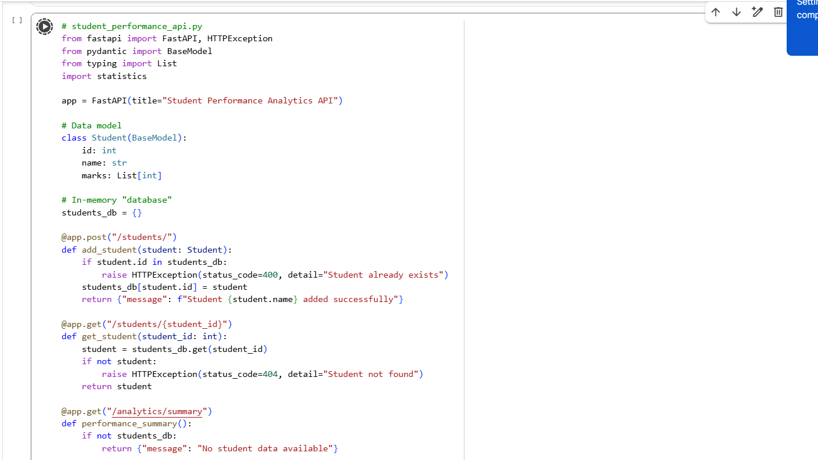**

**OUTPUT:**

{ "id": 1

"name": "Alice",

"marks": [85, 90, 78] }

{

"message": "Student Alice added successfully"

}

**EXPLAINATION:**

