**AI ASSISSTED CODING:7**

**TASK-1:**

Paste a function with a missing colon (add(a, b)), and let AI fix the syntax error.

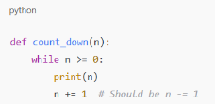

=>

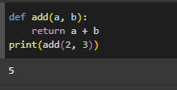

EXPLANATION:

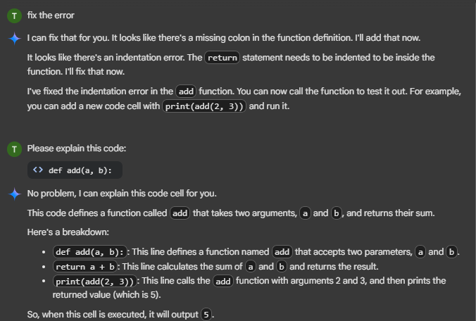

**TASK-2:**

Identify and fix a logic error in a loop that causes infinite iteration

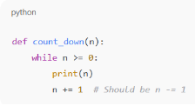

**=>**

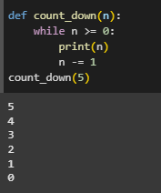

EXPLANATION:

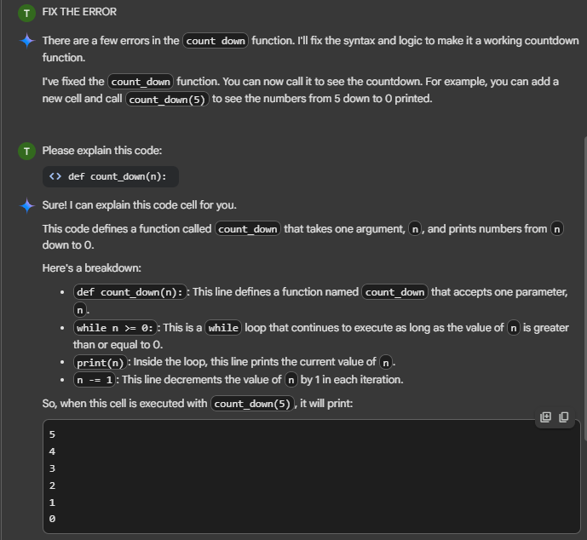

**TASK-3:**

Debug a runtime error caused by division by zero. Let AI insert try-except

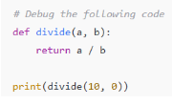

**=>**

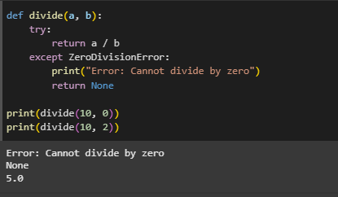

EXPLANATION:

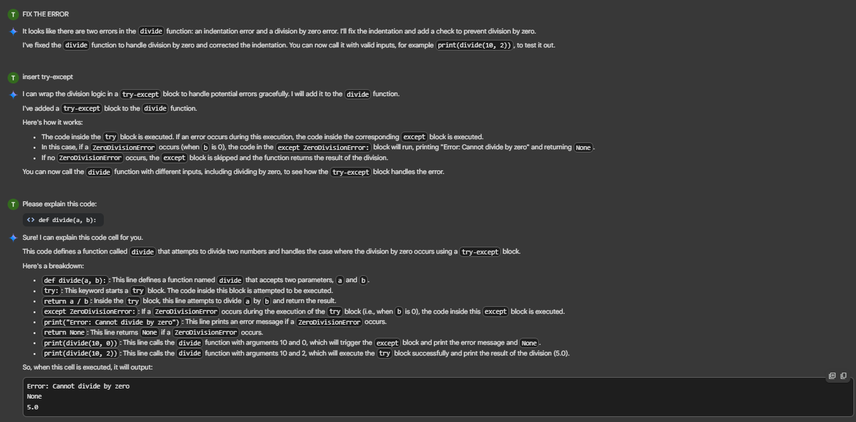

**TASK-4:**

Provide a faulty class definition (missing self in parameters). Let AI fix it

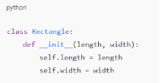

**=>**

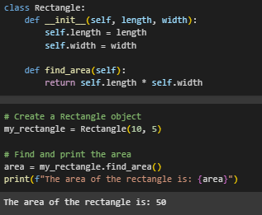

EXPLANATION:

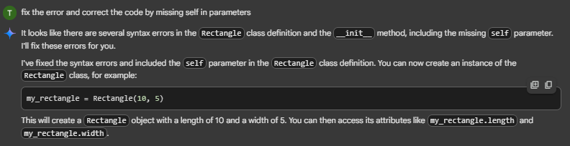

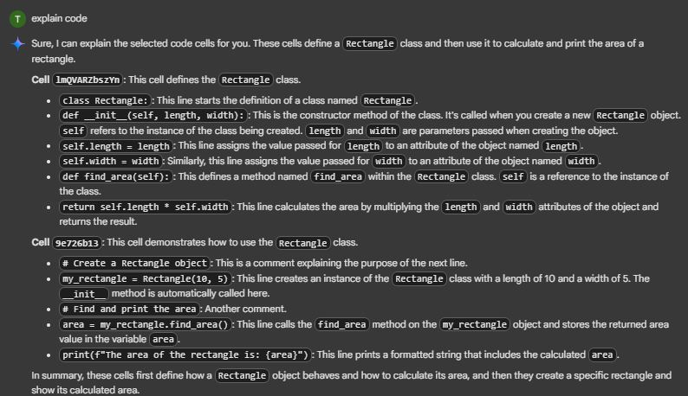

**TASK-5:**

Access an invalid list index and use AI to resolve the Index Error

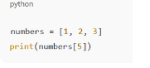

**=>**

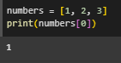

EXPLANATION:

