Task Description#1
- Write Python function with the help of GitHub Copilot and VS Code to classify the people based on Age Group. And explain the code with required comments
Prompt: Generate a python Age_Classifies function to classify people based on their age[0-12 child,13-19 teen ,20-59 adult .above 60 senior] with user defined input and with loop

Code:
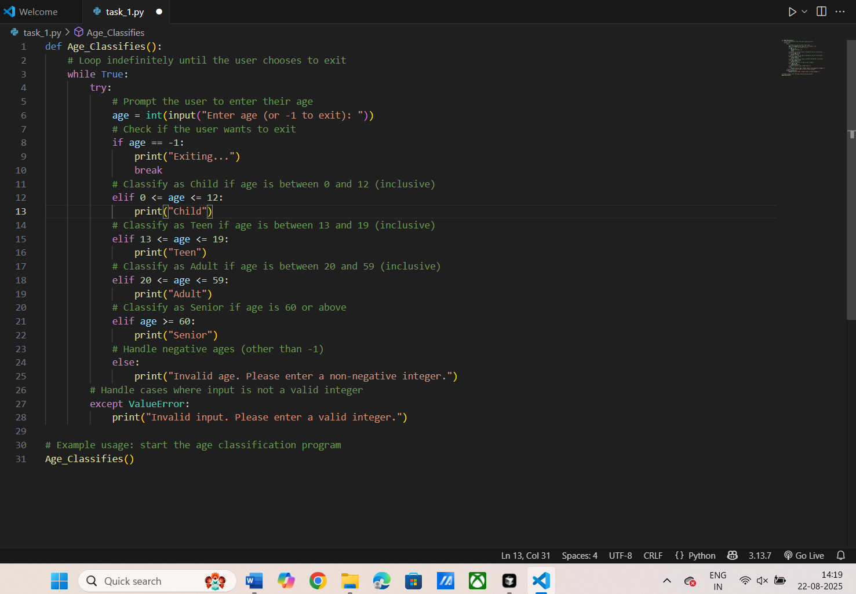

Output:
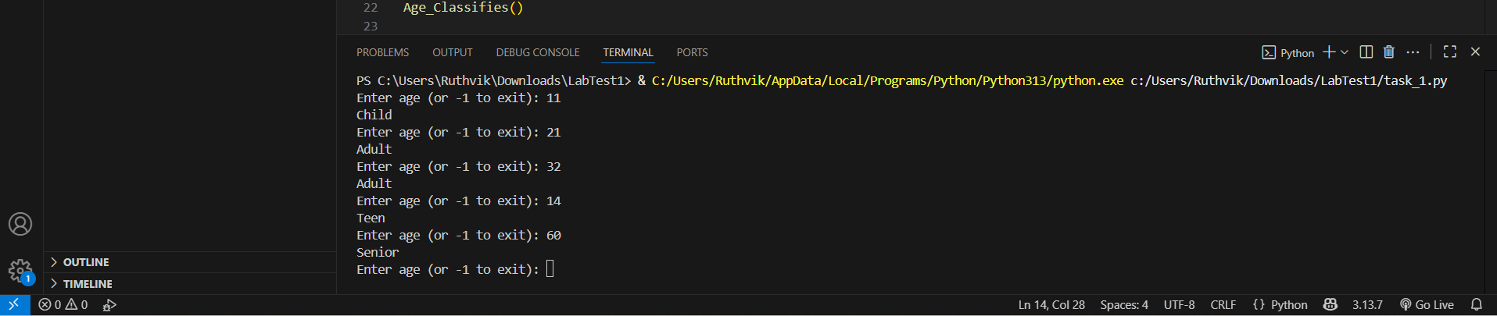
Explanation:
This Python code defines a function called Age_Classifies() that repeatedly prompts the user to enter their age and classifies them into one of four categories: Child, Teen, Adult, or Senior. The function uses a while True loop to keep asking for input until the user enters -1, which triggers the program to print "Exiting..." and break out of the loop. The input is converted to an integer, and based on its value, the code checks which age range it falls into using a series of elif statements. If the age is between 0 and 12, it prints "Child"; if between 13 and 19, it prints "Teen"; if between 20 and 59, it prints "Adult"; and if 60 or above, it prints "Senior". If the user enters a negative age (other than -1), it prints an error message.The function also includes error handling using a try-except block to catch cases where the user enters a non-integer value. If a ValueError occurs (for example, if the user enters a string or a float), the program prints "Invalid input. Please enter a valid integer." This ensures that the program does not crash due to invalid input and guides the user to enter a correct value. The function is called at the end of the script, so when the script is run, it immediately starts prompting the user for age input and classifies each entry until the user decides to exit.
Task Description#2
Write Python program in cursor AI for student class with attributes like Name, Roll no, Marks and also construct a method i.e., display_details to display name, rollno and marks
Prompt: Generate a python program for student class with attributes name,roll no, marks and also construct a method display_details to display name, roll no and marks with user defined input using loop
Code:
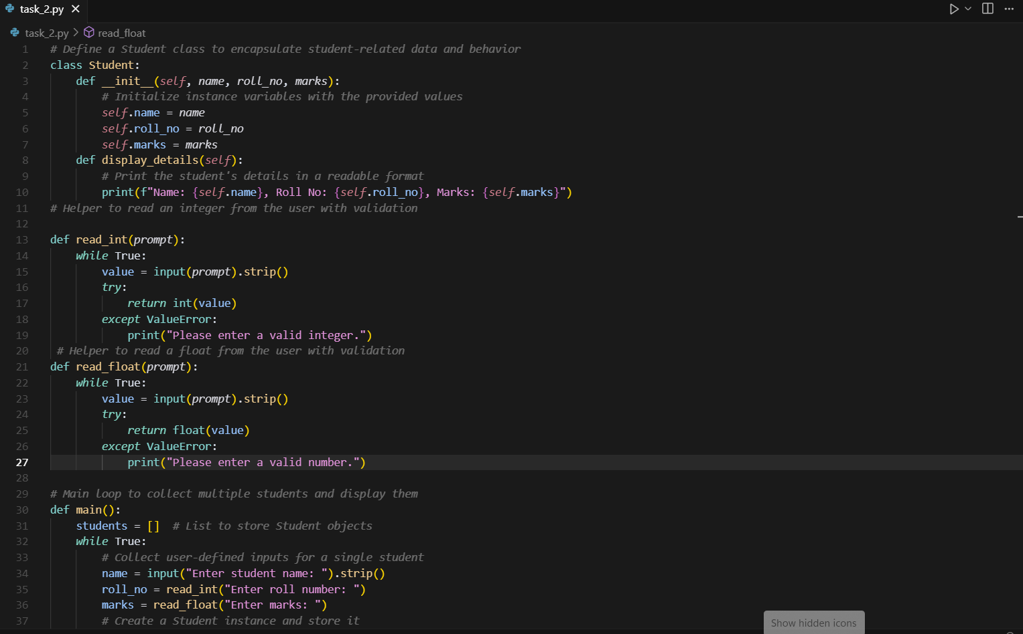
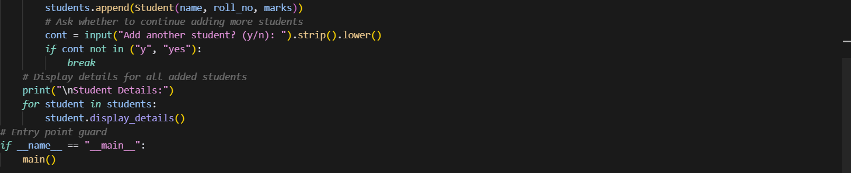
Output:
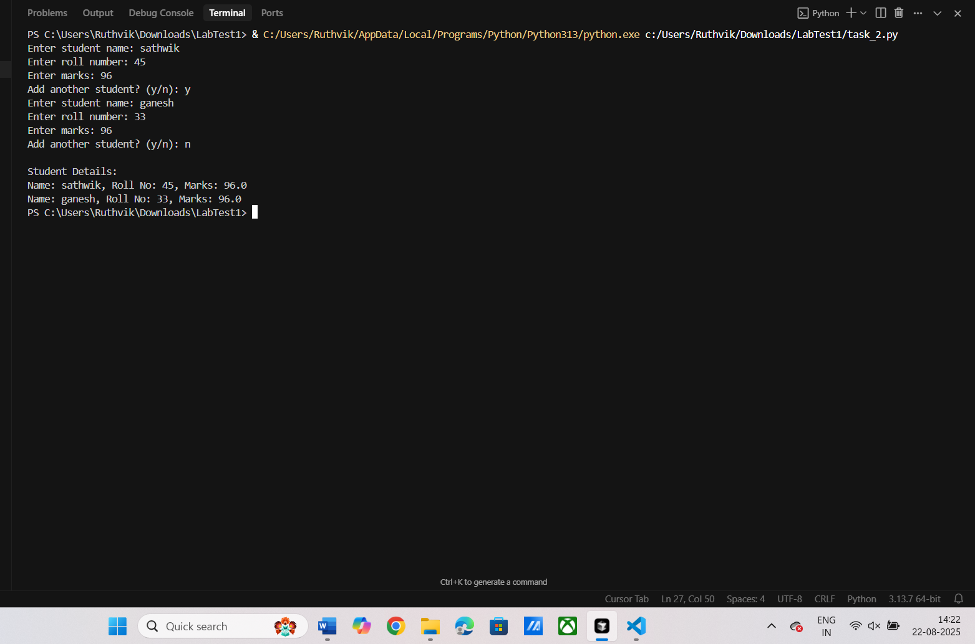
Explanation:
This program defines a Student class to model each student with name, roll_no, and marks, and provides a display_details method to print those attributes in a readable format. Two helper functions, read_int and read_float, safely collect numeric input by repeatedly prompting the user until valid integers or floats are entered. In main, the code loops to gather user-defined inputs for multiple students, creating a Student object for each and appending it to a students list; the loop continues as long as the user answers y/yes. After input ends, the program iterates over the list and calls display_details on each student to display all collected records.

