SCHOOL OF COMPUTER SCIENCE AND ARTIFICIAL INTELLIGENCE |  |  |  |  | DEPARTMENT OF COMPUTER SCIENCE ENGINEERING
ProgramName:B. Tech |  |  |  | Assignment Type: Lab |  |  | AcademicYear:2025-2026
CourseCoordinatorName |  |  |  | Venkataramana Veeramsetty
Instructor(s)Name |  |  |  | 1. Dr. Mohammed Ali Shaik  2. Dr. T Sampath Kumar  3. Mr. S Naresh Kumar  4. Dr. V. Rajesh  5. Dr. Brij Kishore  6. Dr Pramoda Patro  7. Dr. Venkataramana  8. Dr. Ravi Chander  9. Dr. Jagjeeth Singh
CourseCode |  |  | 24CS002PC215 | CourseTitle |  | AI Assisted Coding
Year/Sem |  |  | II/I | Regulation |  | R24
Date and Day  of Assignment |  |  |  | Time(s)
Duration |  |  | 2 Hours | Applicableto  Batches
AssignmentNumber:3.3(Present assignment number)/24(Total number of assignments)
 | Q.No. | Question |  |  |  |  |  | ExpectedTime  to complete
 | 1 | Lab 3: Prompt Engineering – Improving Prompts and Context Management  Lab Objectives:  - To understand how prompt structure and wording influence AI-generated code.  - To explore how context (like comments and function names) helps AI generate relevant output.  - To evaluate the quality and accuracy of code based on prompt clarity.  - To develop effective prompting strategies for AI-assisted programming.  Lab Outcomes (LOs):  After completing this lab, students will be able to:  - Generate Python code using Google Gemini in Google Colab.  - Analyze the effectiveness of code explanations and suggestions by Gemini.  - Set up and use Cursor AI for AI-powered coding assistance.  - Evaluate and refactor code using Cursor AI features.  - Compare AI tool behavior and code quality across different platforms.  Task Description#1  - Try 3 different prompts to generate a factorial function.  Expected Output#1  - Comparison of AI-generated code styles  Prompt 1: Generate a Python Program to print factorial of a number.  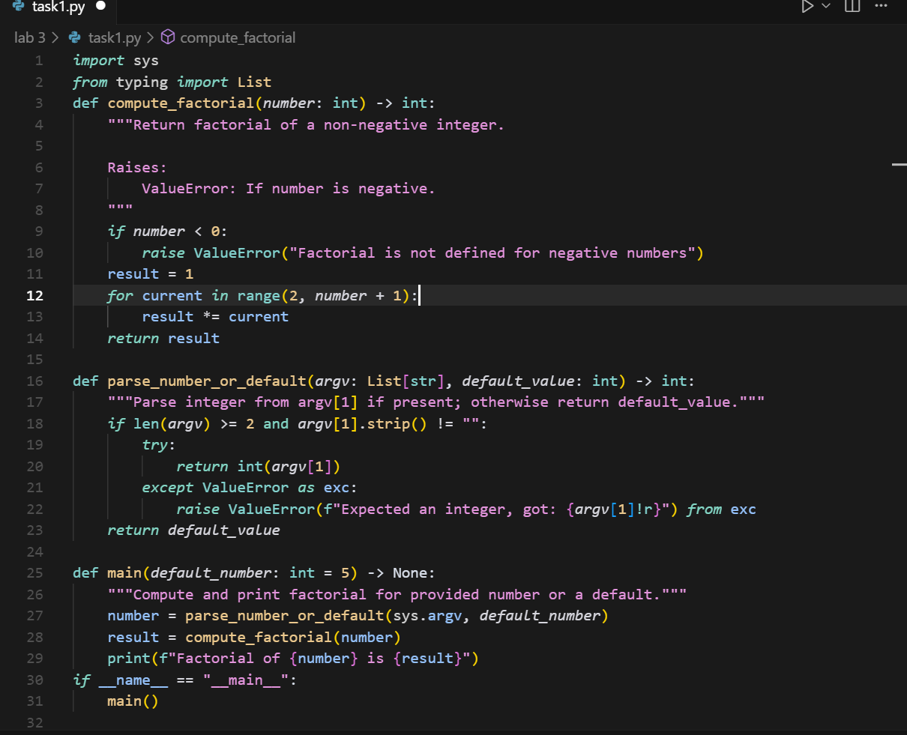  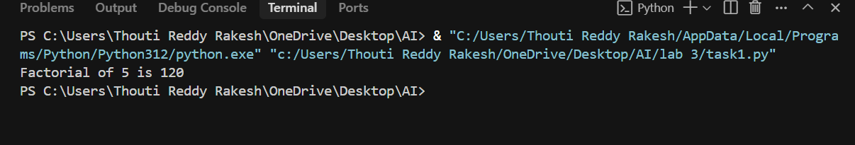  Prompt2:Write a Python Program to print factorial of a given number.  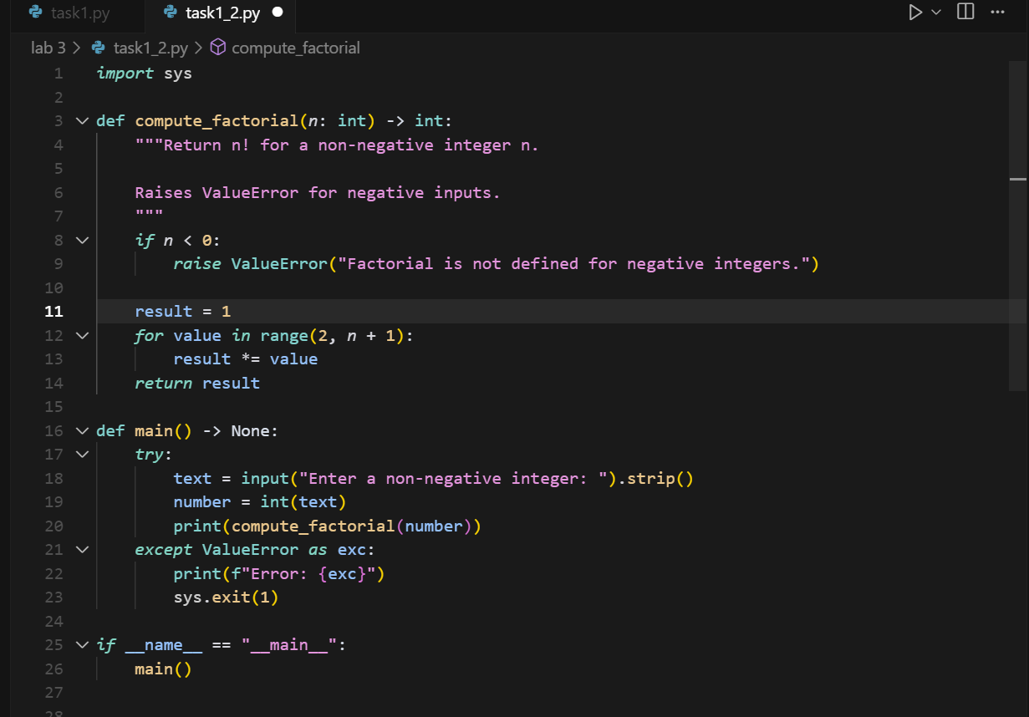  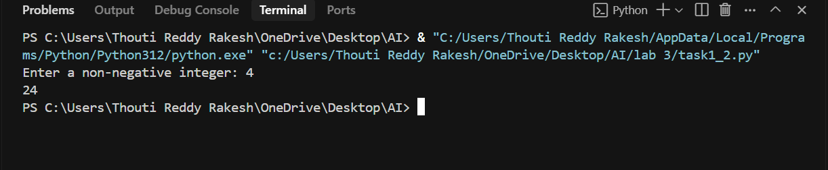  Prompt 3: Generate a efficient python program to print factorial of a number.  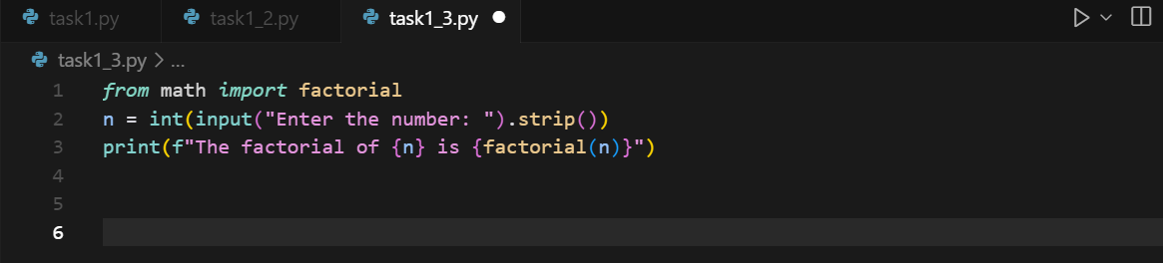  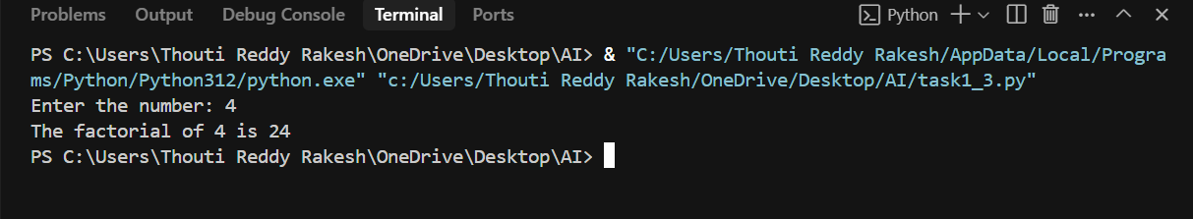  Comparison : prompt 1:it takes the input by default and print the factorial.  Prompt 2:it takes the input from the user and print the factorial.  Prompt 3:The code is more efficient then code 1 and code 2.  Task Description#2  - Provide a clear example input-output prompt to generate a sorting function.  Expected Output#2  - Functional sorting code from AI  Prompt: Write a python function to sort numbers with example input and output.  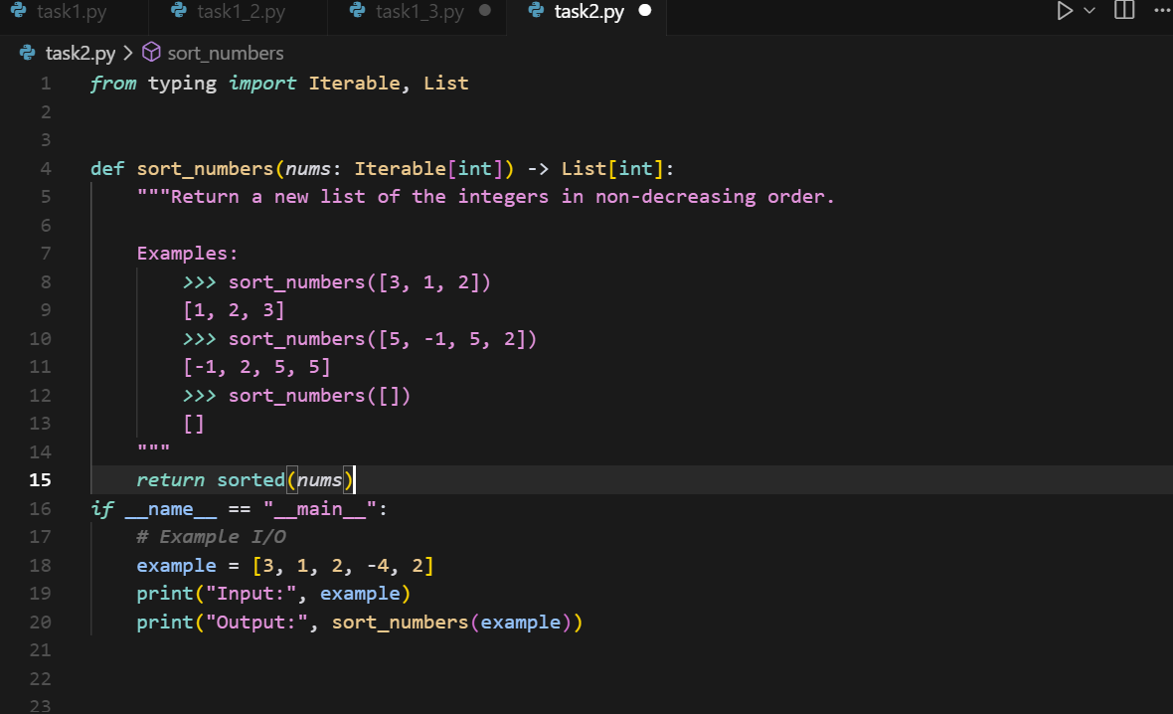  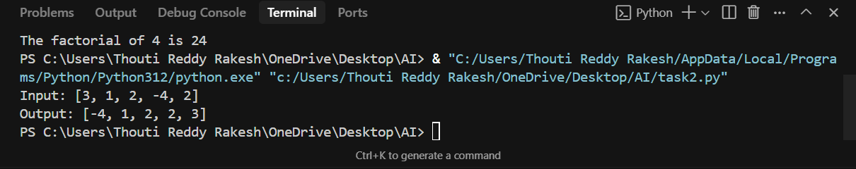  Task Description#3  - Start with the vague prompt “Generate python code to calculate power bill” and improve it step-by-step  Expected Output#3  - Enhanced AI output with clearer prompts  Prompt 1: Write a python program to calculate power bill.  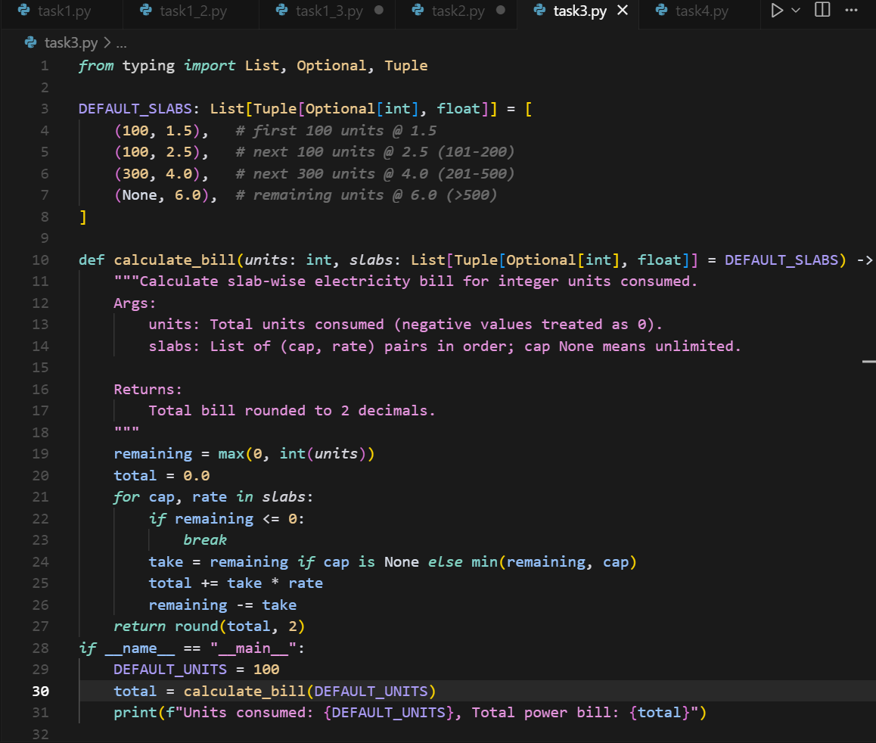  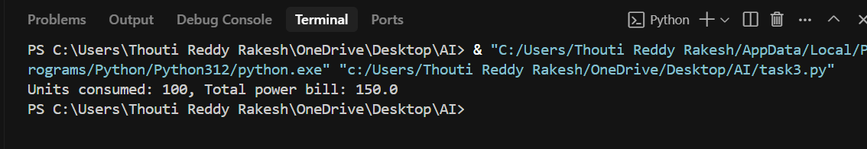  Prompt 2: Write a python program to calculate power bill using user input.  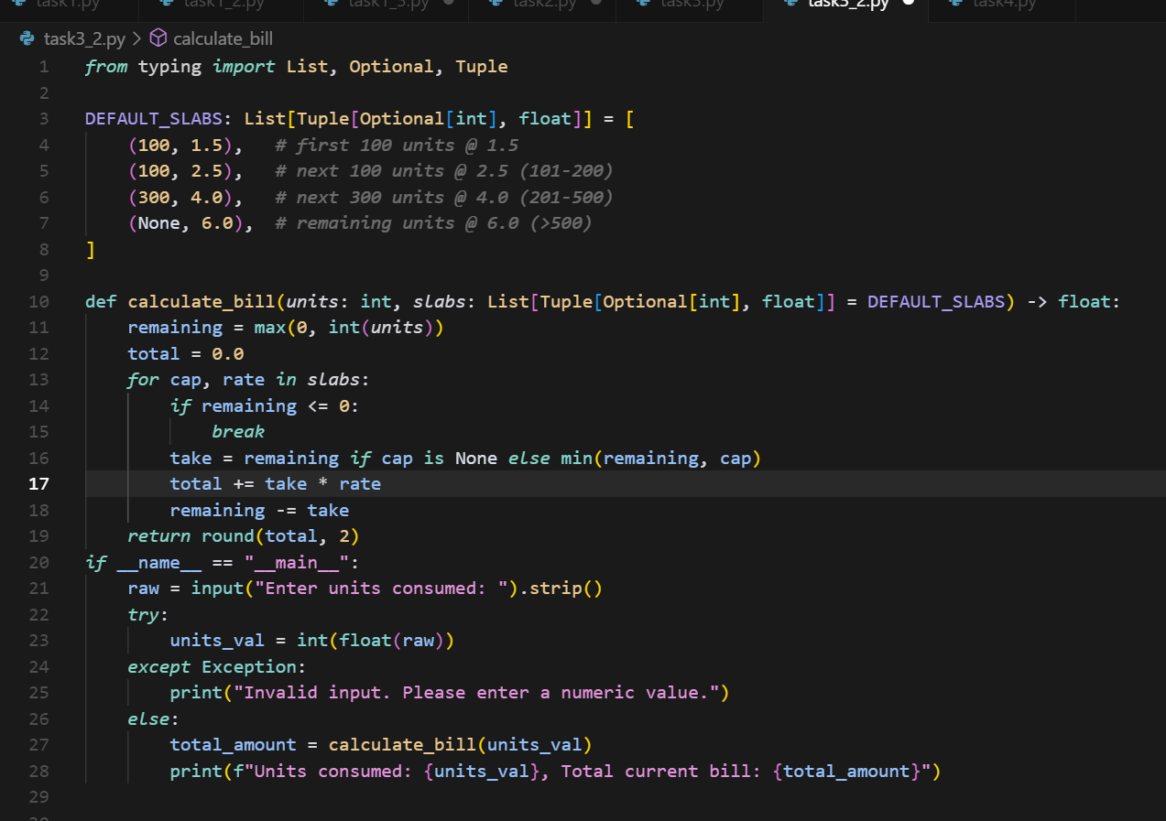  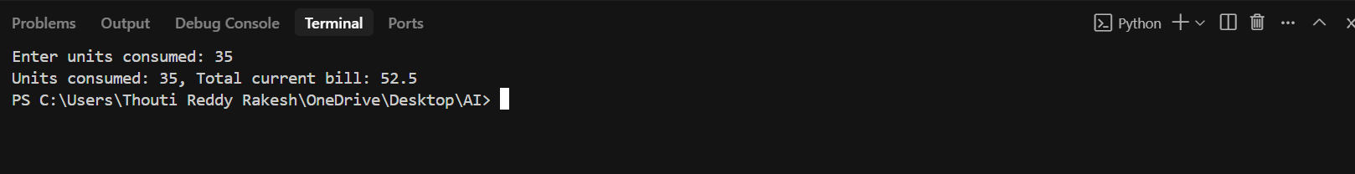  Prompt 3: Write a python code to calculate power bill.  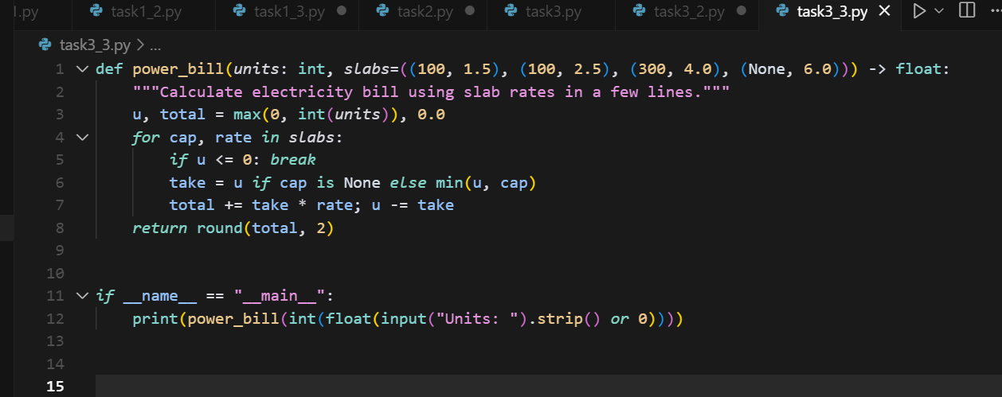  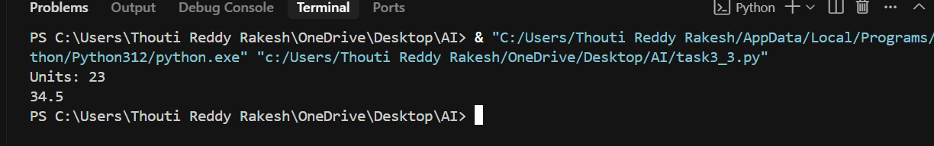  Comparison: : prompt 1:it takes the input by default and print the power bill.  Prompt 2:it takes the input from the user and print the power bills.  Prompt 3:The code is more efficient then code 1 and code2.  Task Description#4  - Write structured comments to help AI generate two linked functions (e.g., login_user() and register_user()).  Expected Output#4  - Consistent functions with shared logic  Prompt: Write a Python program of login user function and register user function.  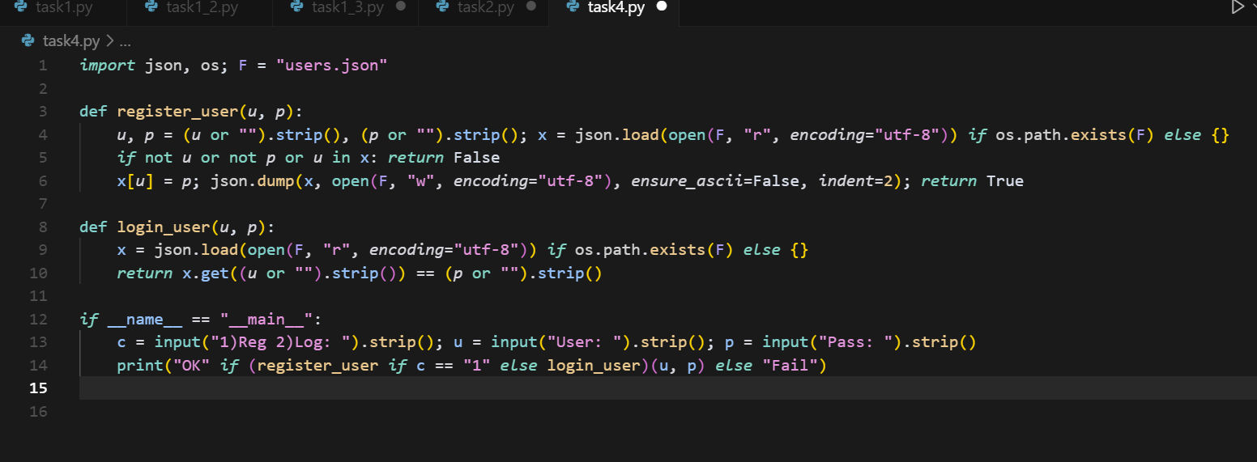  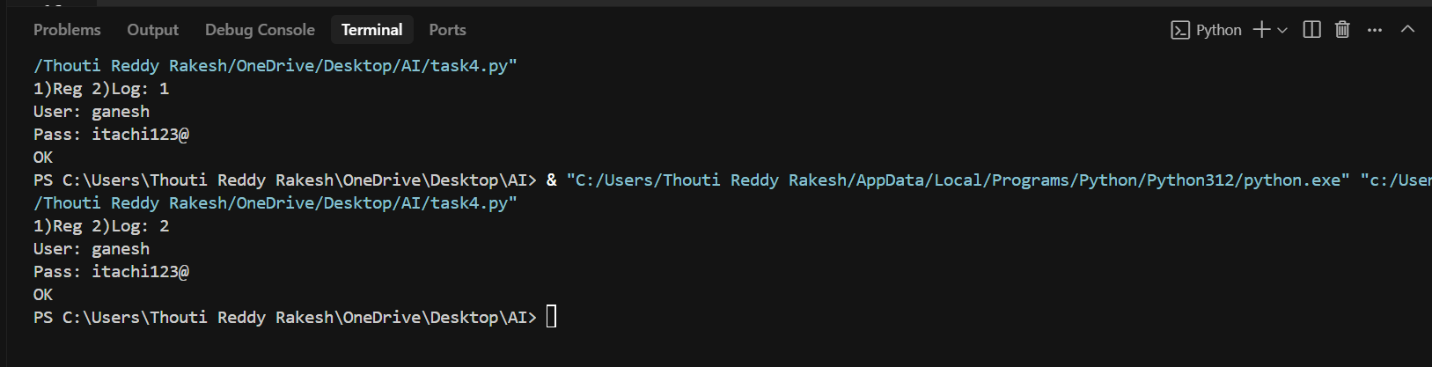  Task Description#5  - Analyzing Prompt Specificity: Improving Temperature Conversion Function with Clear Instructions  Expected Output#5  - Code quality difference analysis for various prompts  Prompt 1: Write Python program to convert temperature.  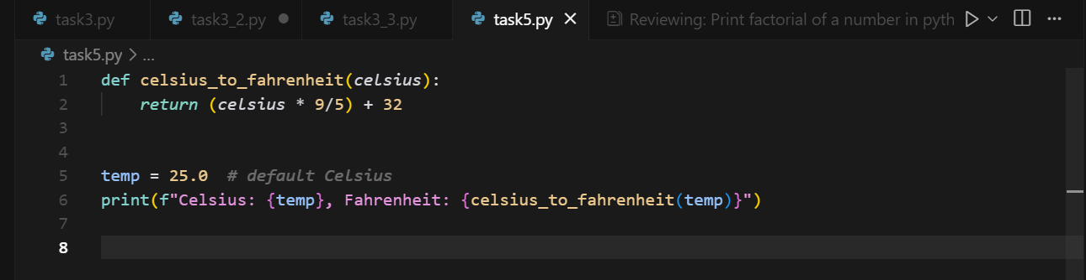  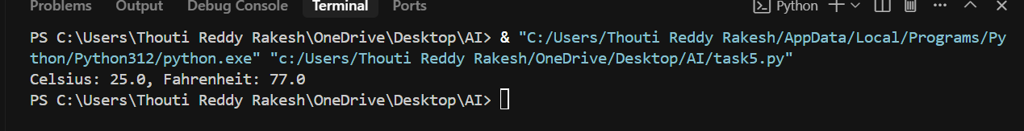  Prompt 2: Generate a Python code to convert Celsius to Fahrenheit and allow user input.  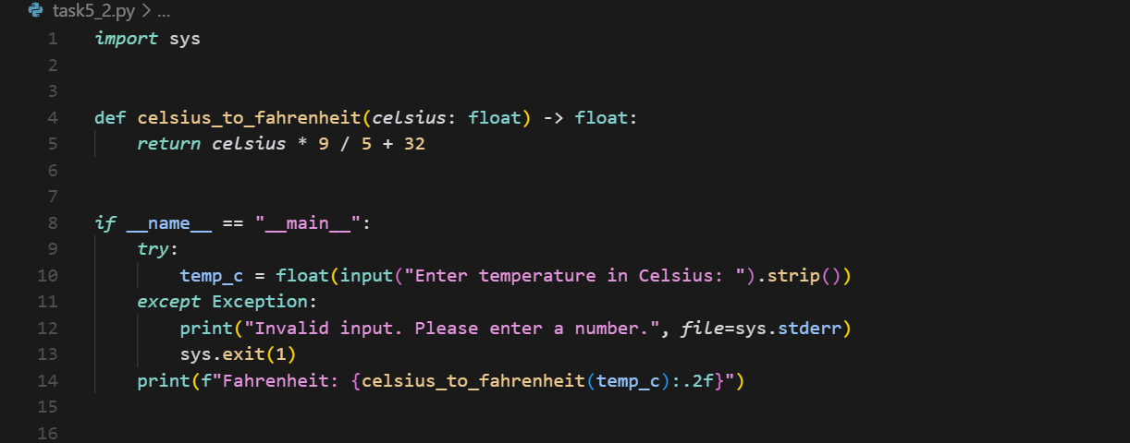  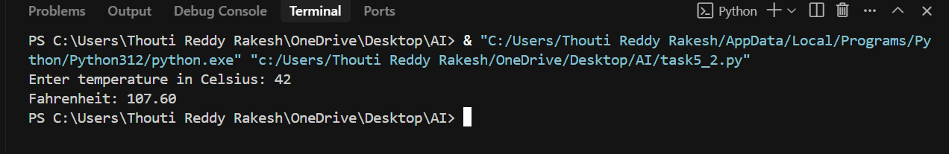  Prompt 3: Generate a efficient Python function to convert Celsius to Fahrenheit and allow user  Input.  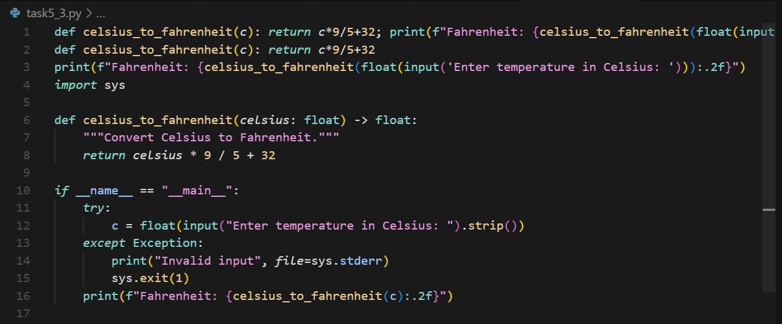  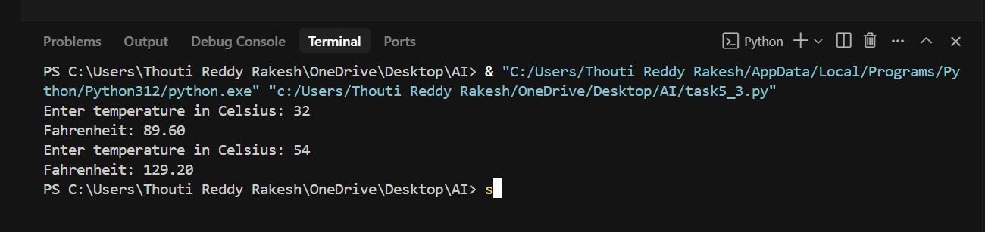  Comparison: : prompt 1:it takes the input by default and convert the temperature.  Prompt 2:it takes the input from the user and convert Celsius to  Fahrenheit.  Prompt 3:The code is more efficient then code 1 and code2. |  |  |  |  |  | 03.08.2025 EOD

