Task #1 – Zero-Shot Prompting with Conditional Validation
Objective
Use zero-shot prompting to instruct an AI tool to generate a function
that validates an Indian mobile number.
Requirements
• The function must ensure the mobile number:
o Starts with 6, 7, 8, or 9
o Contains exactly 10 digits
Prompt:Generate a python function to validate an indian mobile number that starts with 6,7,8,9 and contains exactly 10 digits with user defined input.
Vs-code(code):
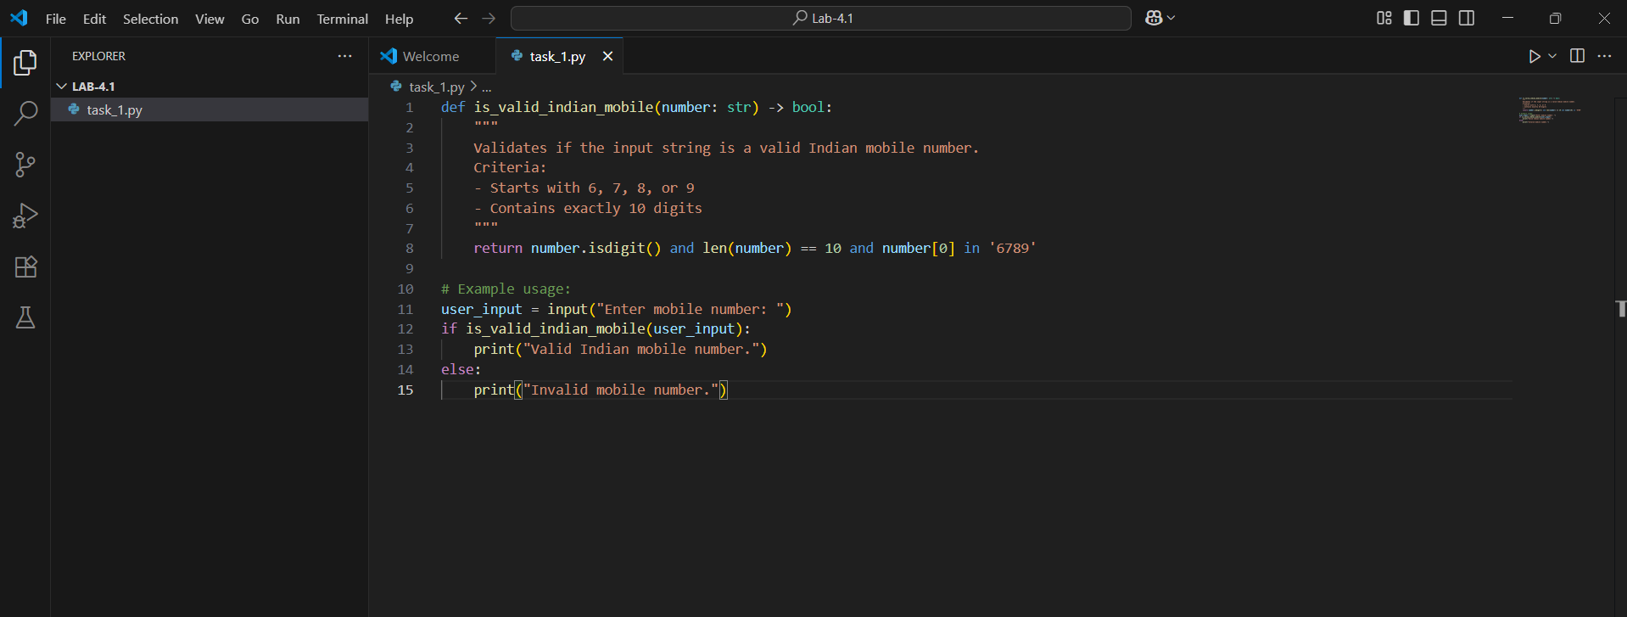
Output:
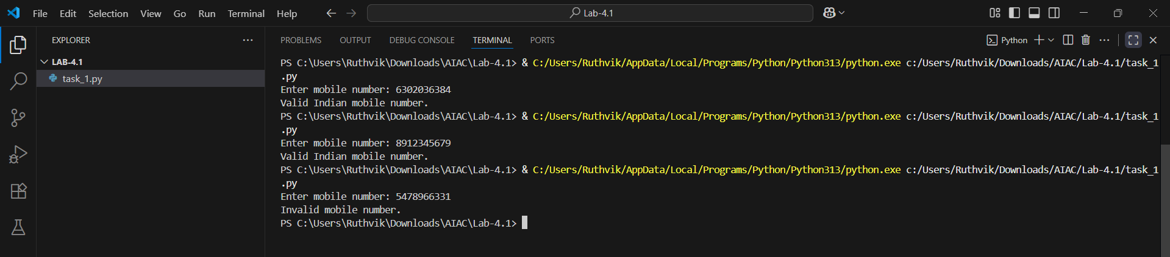
Cursor ai:
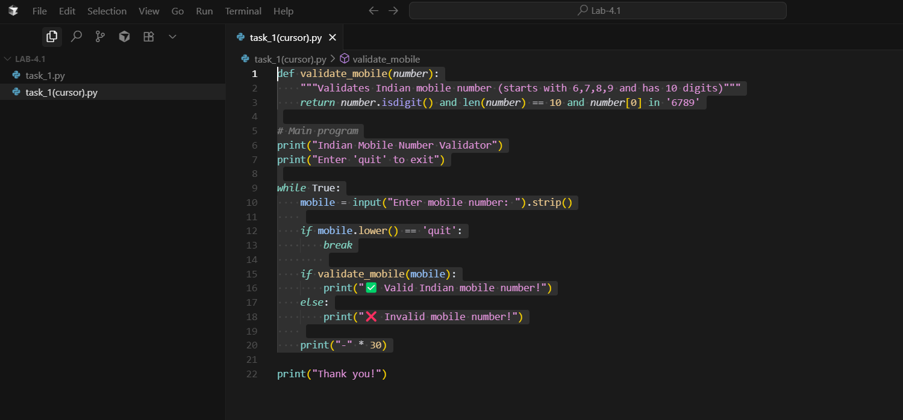
Output:
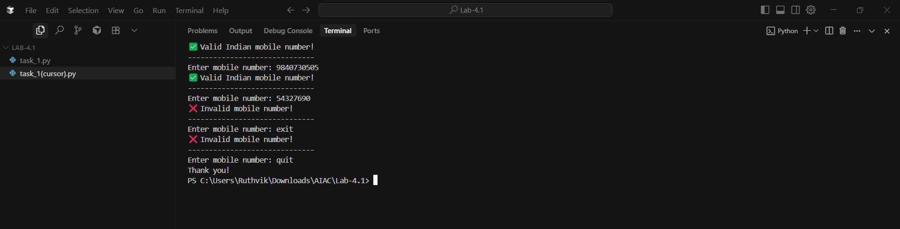
Task #2 – One-Shot Prompting with Edge Case Handling
Objective
Use one-shot prompting to generate a Python function that calculates
the factorial of a number.
Requirements
• Provide one sample input-output pair in the prompt to guide the
AI.
• The function should handle:
o 0! correctly
o Negative input by returning an appropriate message
Prompt: generate a python function to calculate factorial of a given number(user defined) for negative input it should return appropriaate message example: 5 factorial is 5*4*3*2*1
Vs-code(code):
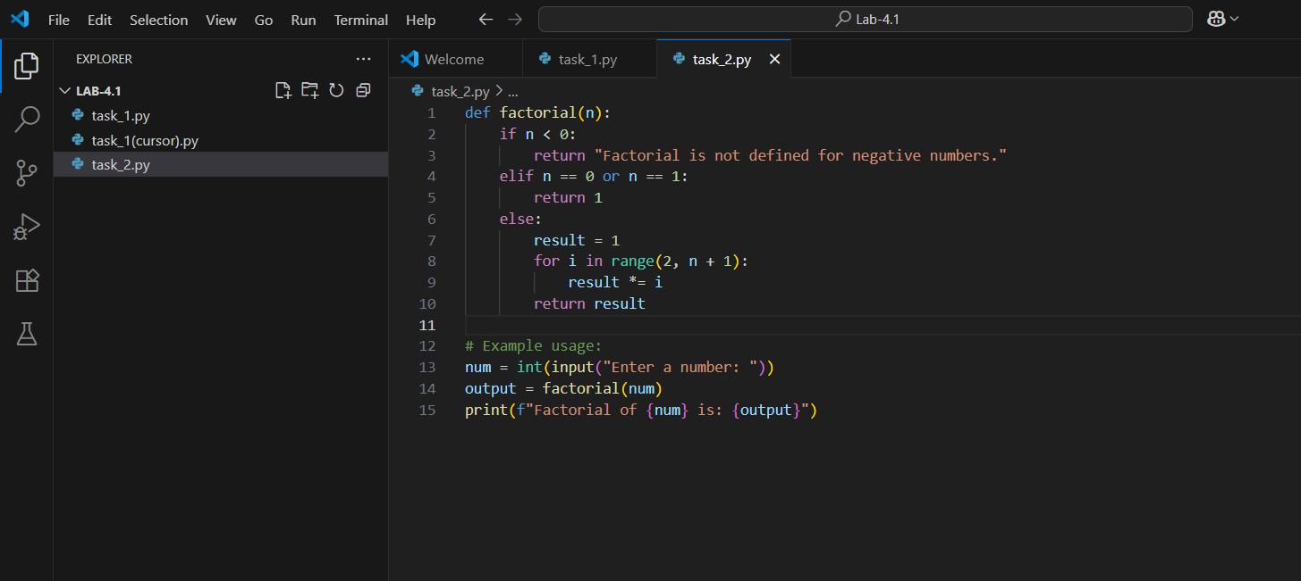
Output:
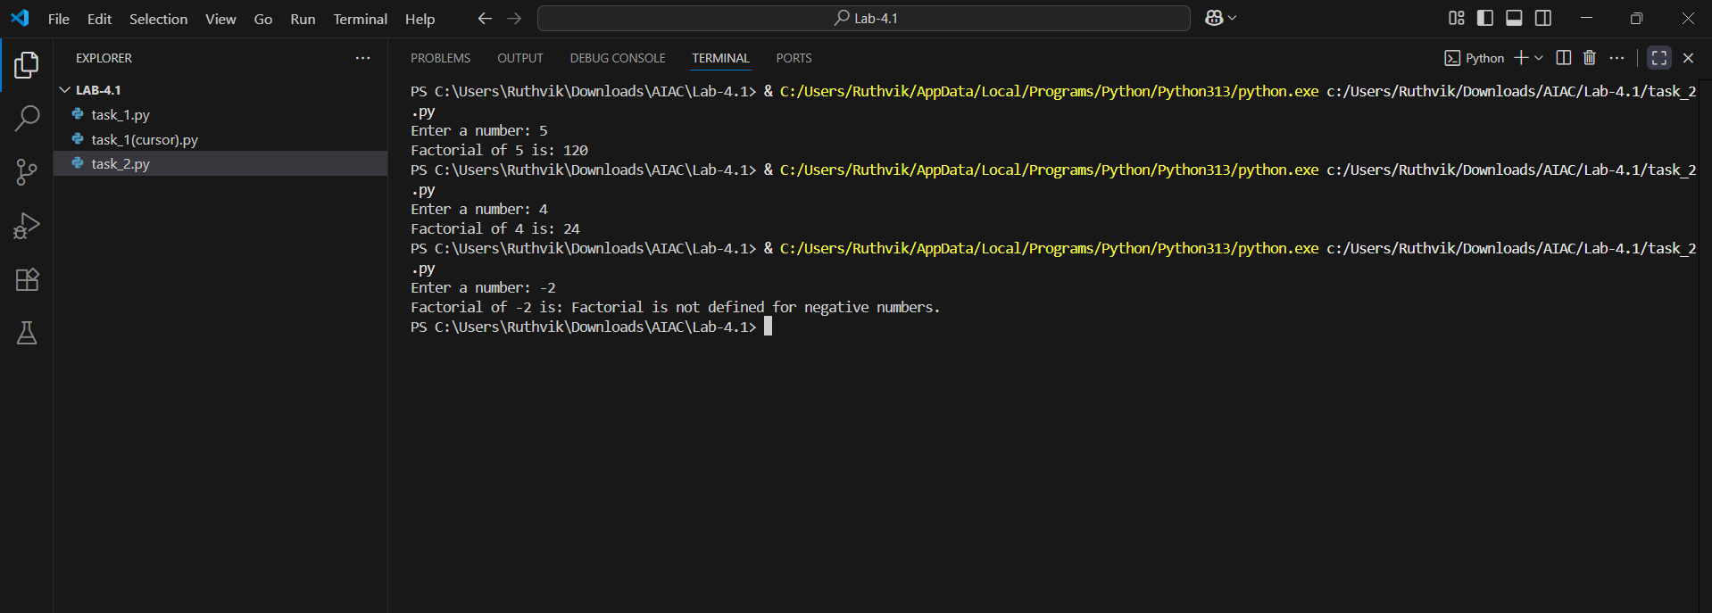

Cursor:
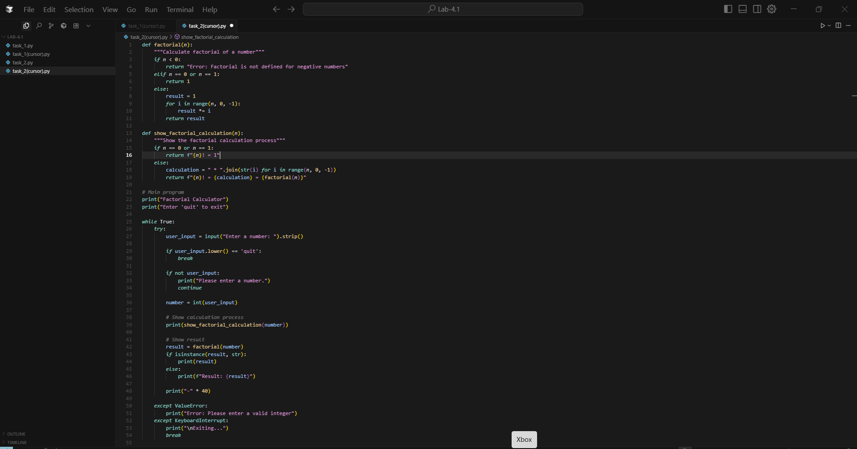
Output:
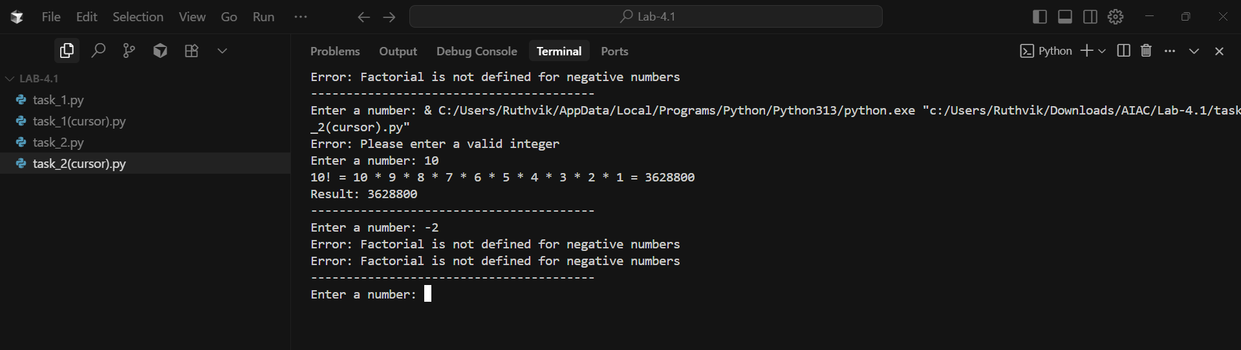
Task #3 – Few-Shot Prompting for Nested Dictionary Extraction
Objective
Use few-shot prompting (2–3 examples) to instruct the AI to create a
function that parses a nested dictionary representing student
information.
Requirements
• The function should extract and return:
o Full Name
o Branch
o SGPA
prompt Write a Python program that parses a nested dictionary containing student information and extracts the student’s full name, branch, and SGPA. Take user input.
Example 1: Input: first name: Ganesh
Last name: Reddy
Branch: CSE
SGPA:9.4
Output: student information:
Full name: Ganesh Reddy
Branch: CSE
SGPA:9.4
Example 2 : Input: first name: Sadam
Last name:sathwik
Branch: EEE
SGPA:9.6
Output: student information:
Full name: Sadam sathwik
Branch: EEE
SGPA:3
Vs-code(code):
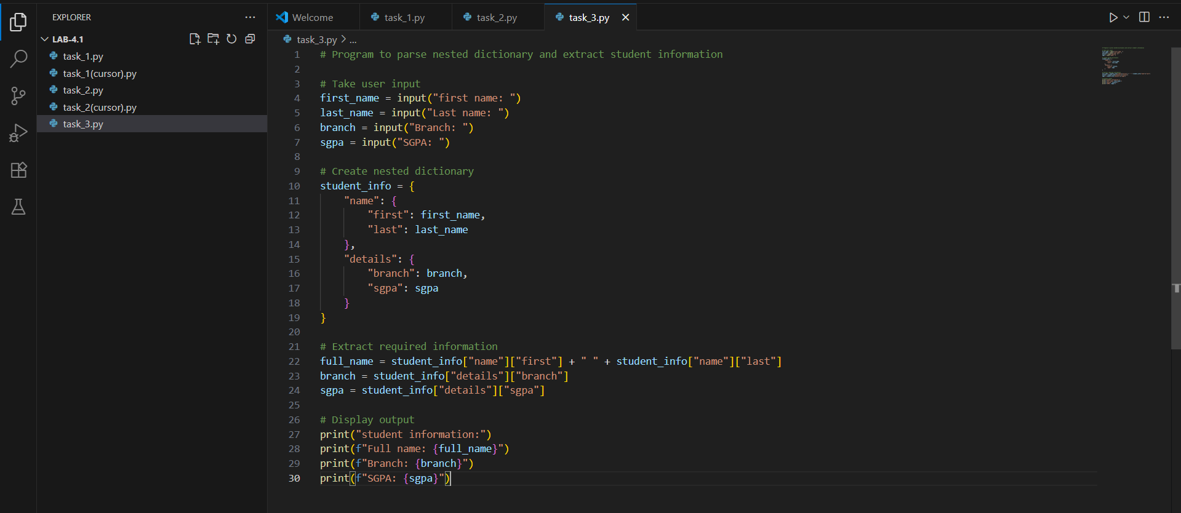
Output:
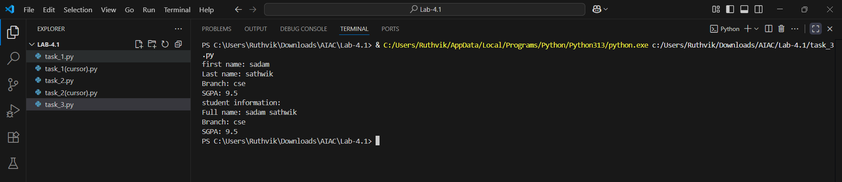

Cursor:
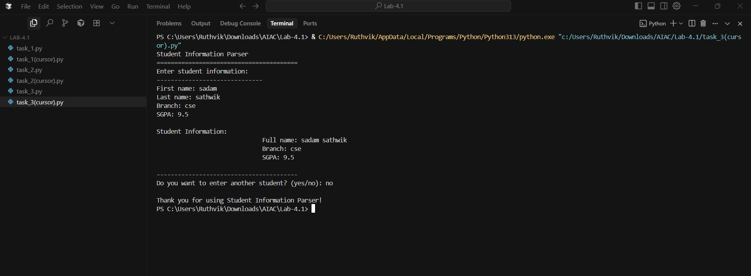
Output:
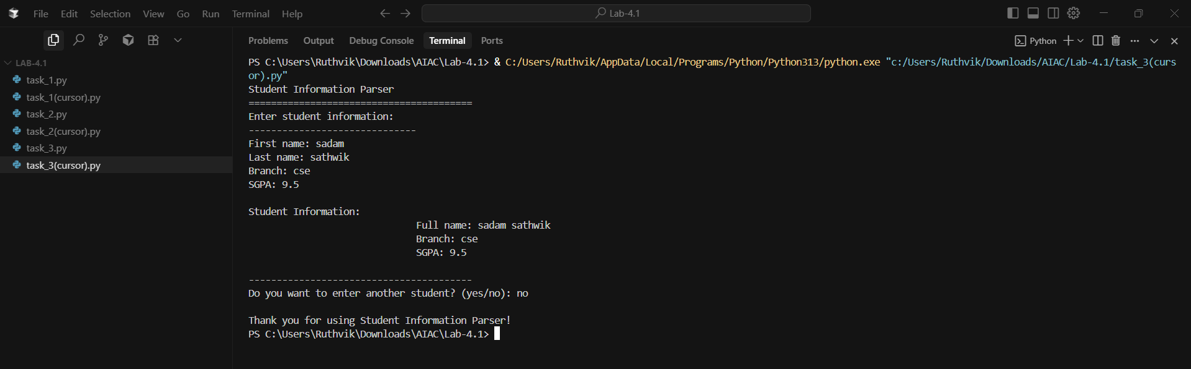
Task #4 – Comparing Prompting Styles for File Analysis
Objective
Experiment with zero-shot, one-shot, and few-shot prompting to
generate functions for CSV file analysis.
Requirements
• Each generated function should:
o Read a .csv file
o Return the total number of rows
o Count the number of empty rows
o Count the number of words across the file
Prompt: generate a Python function that reads a .csv file, returns the total number of rows, counts the number of empty rows, and counts the total number of words across the file."
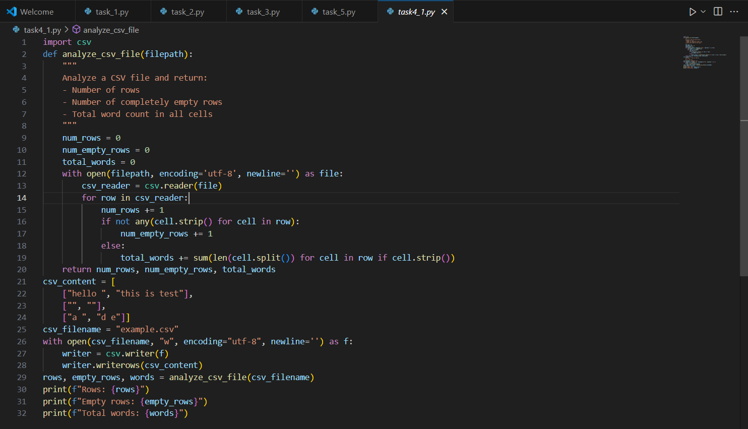
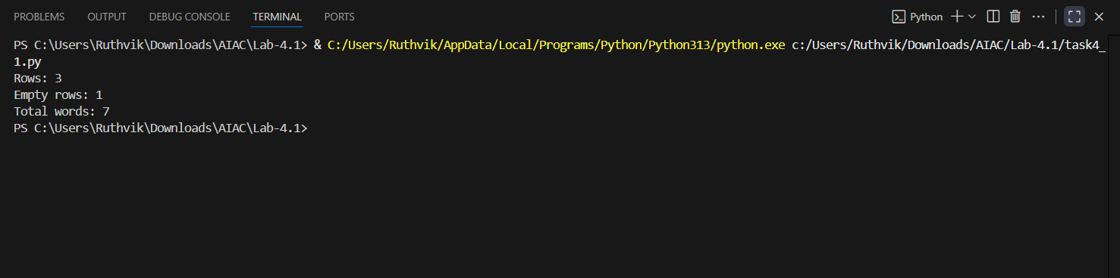
Cursor:
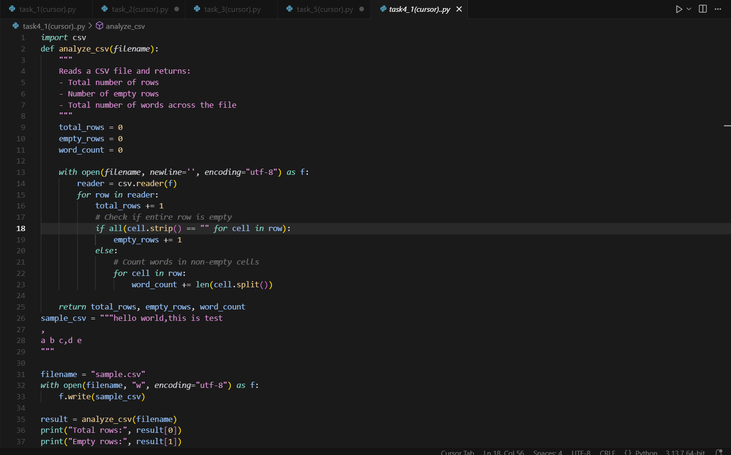
Output:
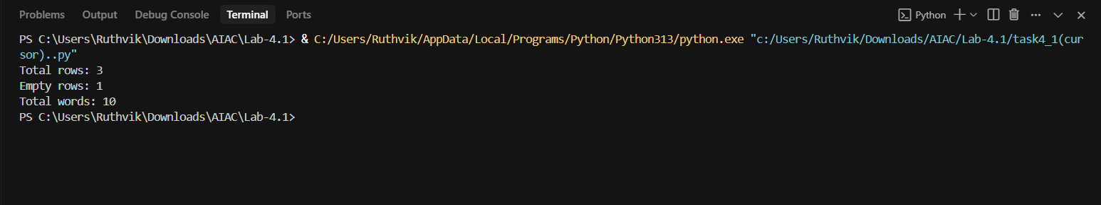
Prompt2: one-shot: Write a python program for CSV file analysis and it should Read a .csv file, Return the total number of rows, Count the number of empty rows and Count the number of words across the file.
Example: Input: hello world, this is test
,
a b c, d e
Output: Total rows in file : 3
Number of empty rows : 1
Total words in file : 10

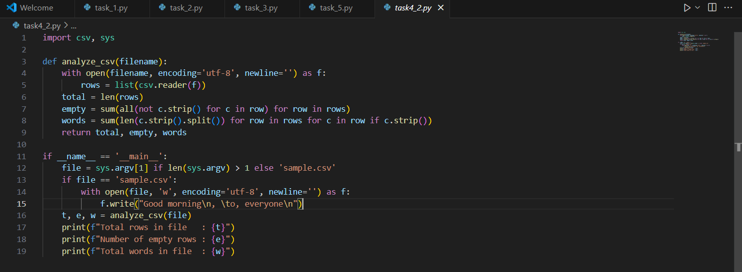
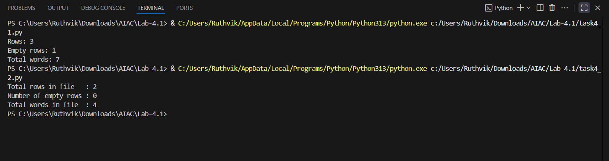
Cursor:
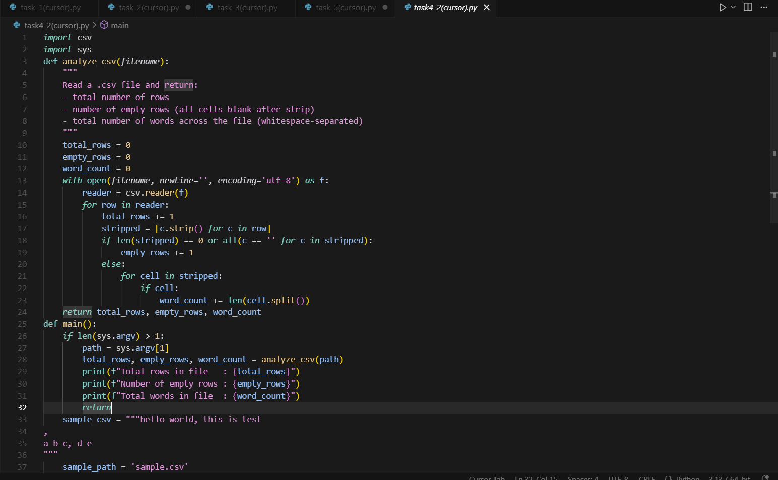
Output:
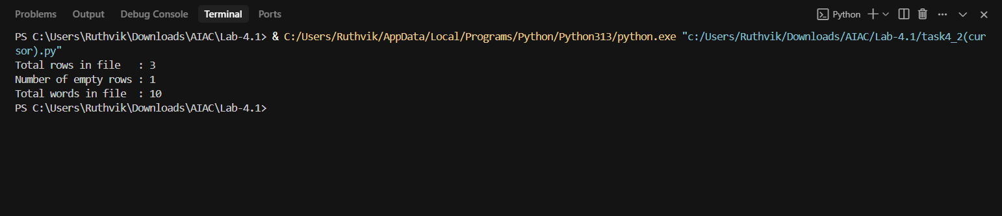
Prompt3: few-shot: Write a python program for CSV file analysis and it should Read a .csv file, Return the total number of rows, Count the number of empty rows and Count the number of words across the file.
Example1: Input: ,
,
,
Output: Total rows in file : 3
Number of empty rows : 3
Total words in file : 0
Example2: Input: welcome
To
AI lab
Output: Total rows in file : 3
Number of empty rows : 0
Total words in file : 4

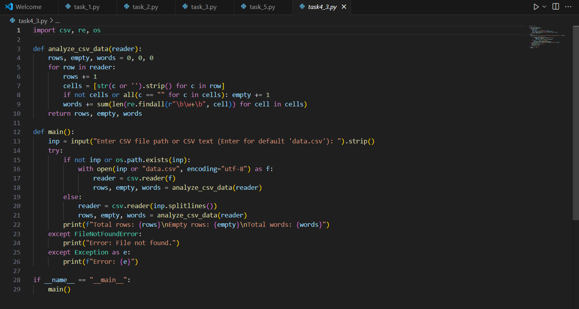
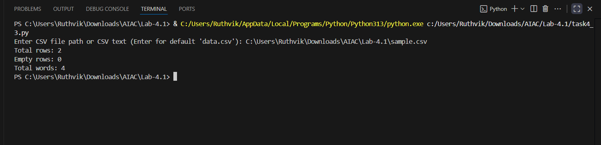
Cursor:
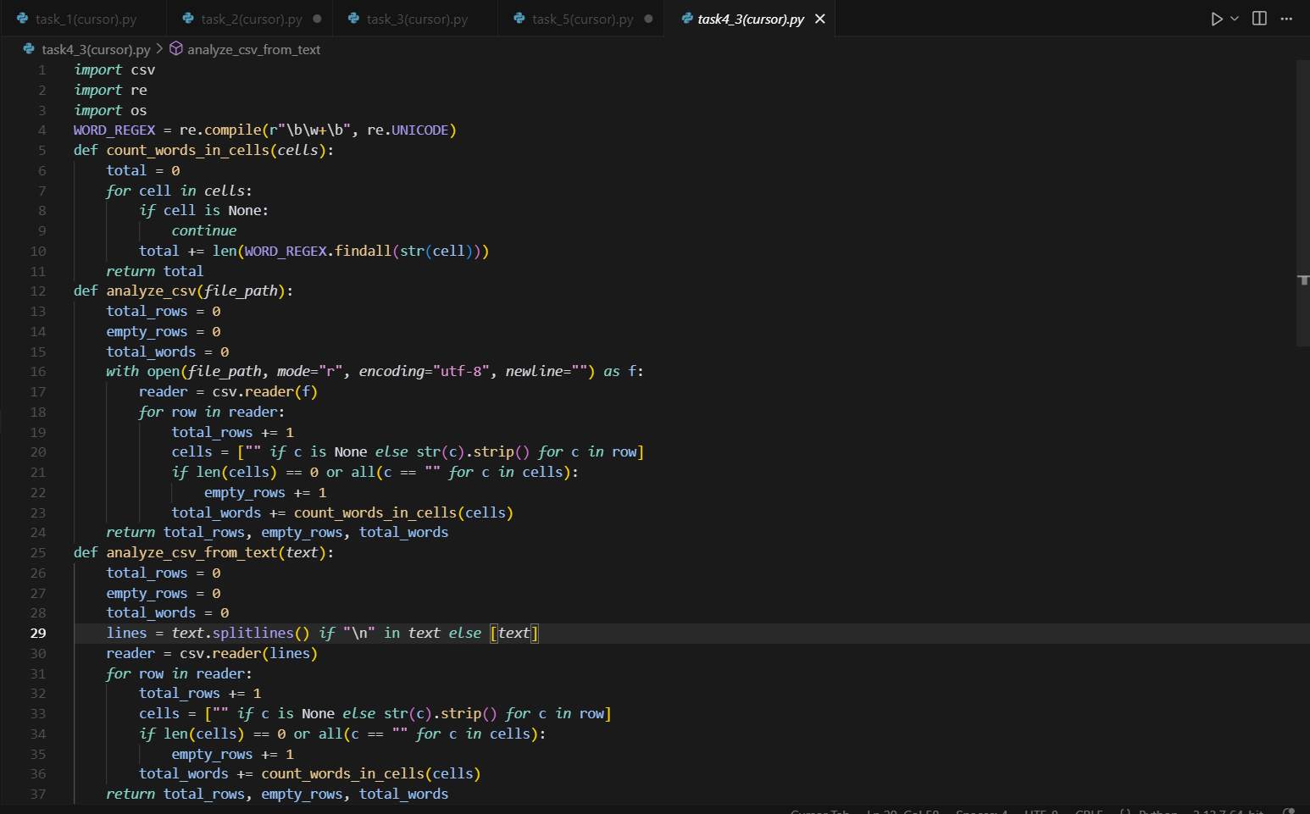
Output:
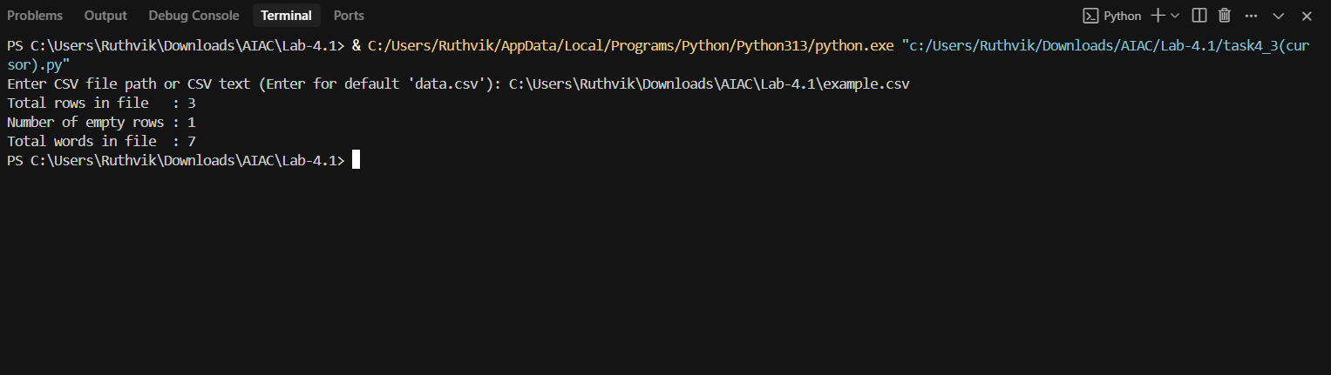

Task #5 – Few-Shot Prompting for Text Processing and Word
Frequency
Objective
Use few-shot prompting (with at least 3 examples) to generate a
Python function that processes text and analyzes word frequency.
Requirements
The function must:
• Accept a paragraph as input
• Convert all text to lowercase
• Remove punctuation
• Return the most frequently used word

Prompt: Write a Python program to find the word frequency and the program must contain a paragraph as input, Convert all text to lowercase, Remove punctuation , tokenization ,Return the most frequently used word.
Example 1: Input : hi HI “hello to EVERyone.”
Output: hi
Example 2: Input :the “SCHOOL” the “collage”.
Output: the
Example 3: Input : bye! To EVERYONE “Bye”.
Output: bye
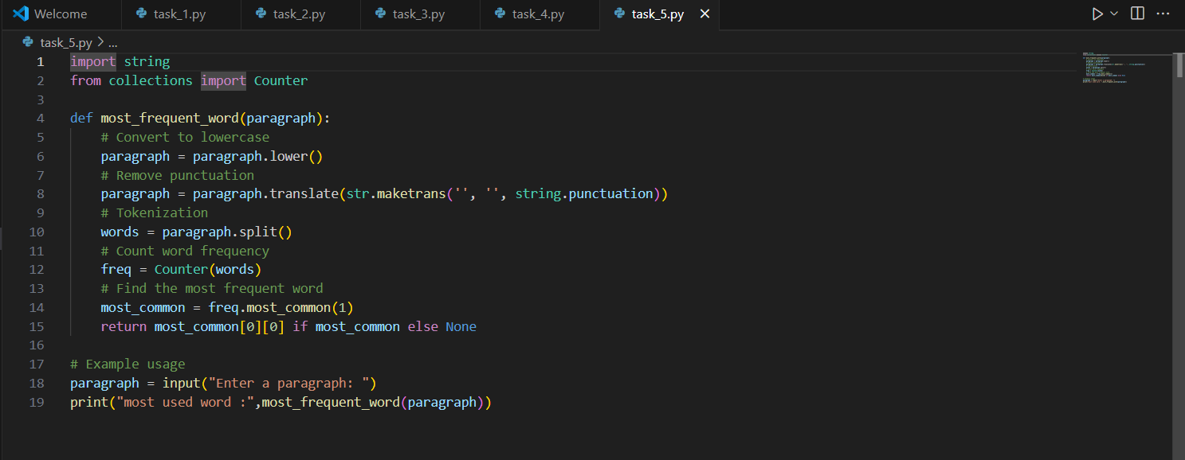

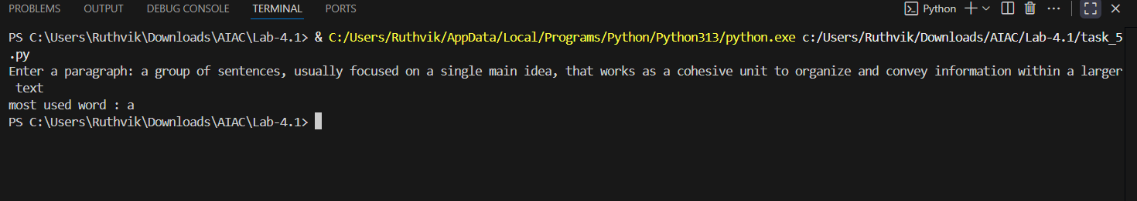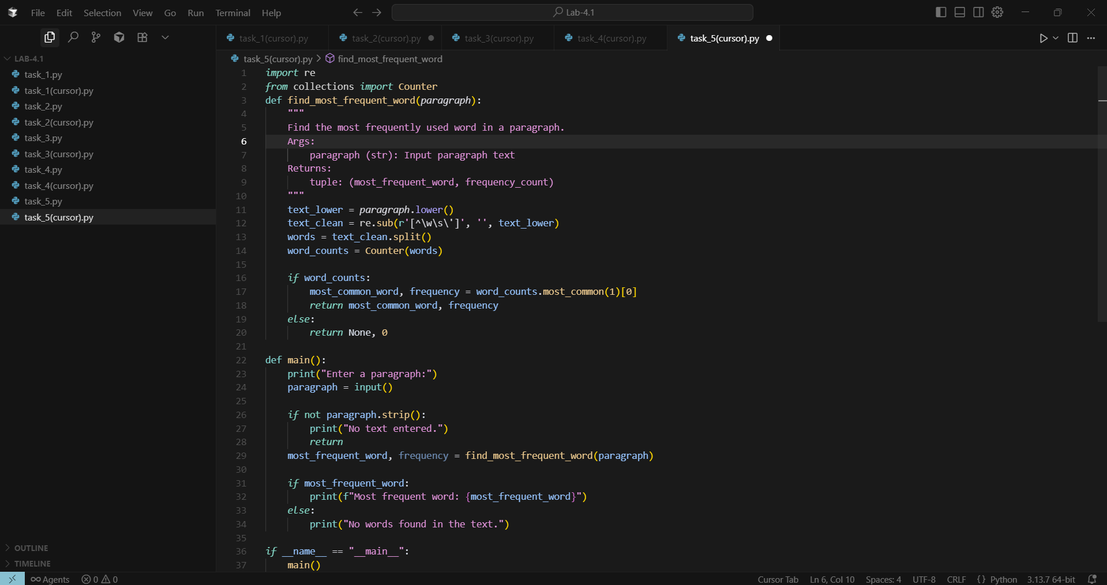
Output:
