SCHOOLOFCOMPUTER SCIENCE AND ARTIFICIAL INTELLIGENCE |  |  |  |  | DEPARTMENTOFCOMPUTER SCIENCE ENGINEERING
ProgramName:B. Tech |  |  |  | AssignmentType: Lab |  |  | AcademicYear:2025-2026
CourseCoordinatorName |  |  |  | Venkataramana Veeramsetty
Instructor(s)Name |  |  |  | Dr. V. Venkataramana (Co-ordinator)  Dr. T. Sampath Kumar  Dr. Pramoda Patro  Dr. Brij Kishor Tiwari  Dr.J.Ravichander  Dr. Mohammand Ali Shaik  Dr. Anirodh Kumar  Mr. S.Naresh Kumar  Dr. RAJESH VELPULA  Mr. Kundhan Kumar  Ms. Ch.Rajitha  Mr. M Prakash  Mr. B.Raju  Intern 1 (Dharma teja)  Intern 2 (Sai Prasad)  Intern 3 (Sowmya)  NS_2 ( Mounika)
CourseCode |  |  | 24CS002PC215 | CourseTitle |  | AI Assisted Coding
Year/Sem |  |  | II/I | Regulation |  | R24
DateandDay  of Assignment |  |  | Week4 - Thursday | Time(s)
Duration |  |  | 2 Hours | Applicableto  Batches
AssignmentNumber:7.4(Presentassignmentnumber)/24(Totalnumberofassignments)
 | Q.No. | Question |  |  |  |  |  | ExpectedTime  to complete
 | 1 | Lab 7: Error Debugging with AI – Systematic Approaches to Finding and Fixing Bugs  Lab Objectives:  - To identify and correct syntax, logic, and runtime errors in Python programs using AI tools.  - To understand common programming bugs and AI-assisted debugging suggestions.  - To evaluate how AI explains, detects, and fixes different types of coding errors.  - To build confidence in using AI to perform structured debugging practices.  Lab Outcomes (LOs):  After completing this lab, students will be able to:  - Use AI tools to detect and correct syntax, logic, and runtime errors.  - Interpret AI-suggested bug fixes and explanations.  - Apply systematic debugging strategies supported by AI-generated insights.  - Refactor buggy code using responsible and reliable programming patterns.  Task Description #1:  • Introduce a buggy Python function that calculates the factorial of a number using recursion. Use Copilot or Cursor AI to detect and fix the logical or syntax errors.  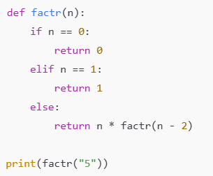  Expected Outcome #1:  •Copilot or Cursor AI correctly identifies missing base condition or incorrect recursive call and suggests a functional factorial implementation.  Vs code correct code:  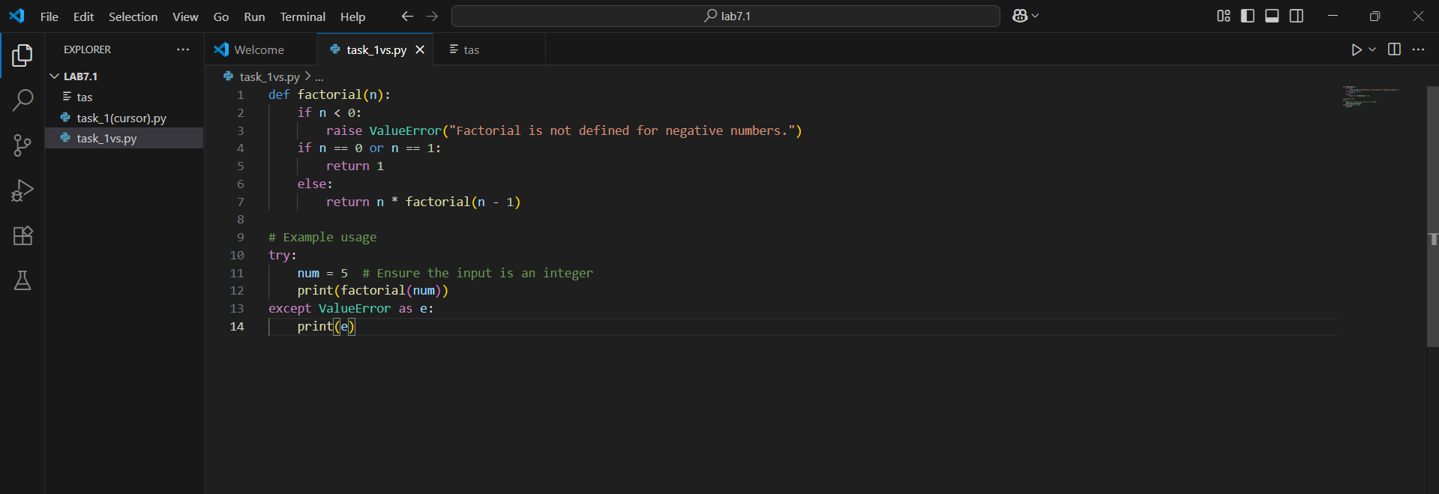  Output(vs code):  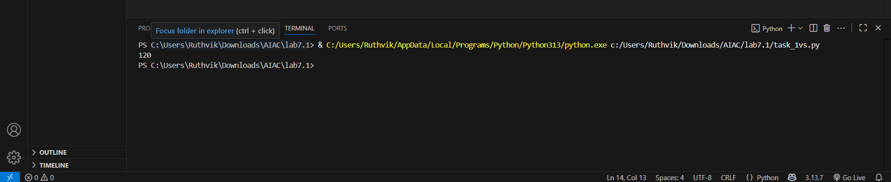  Cursor code:  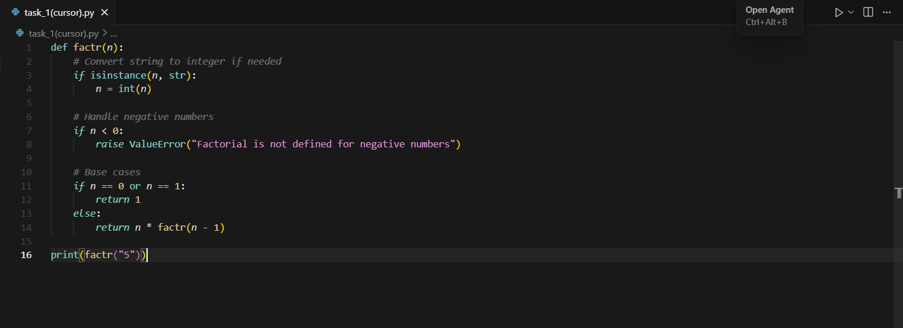  Output:  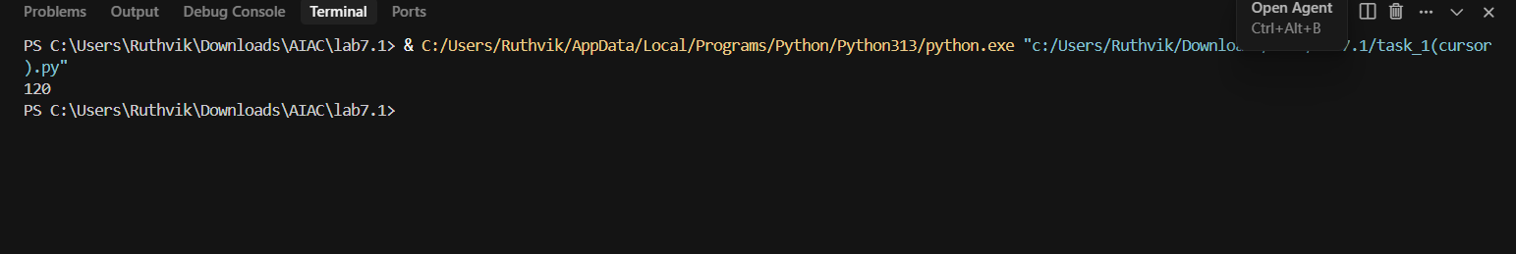  Task Description #2:  •Provide a list sorting function that fails due to a type error (e.g., sorting list with mixed integers and strings). Prompt AI to detect the issue and fix the code for consistent sorting.  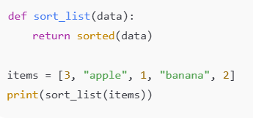  Expected Outcome #2:  •AI detects the type inconsistency and either filters or converts list elements, ensuring successful sorting without a crash.  Vs -code code:  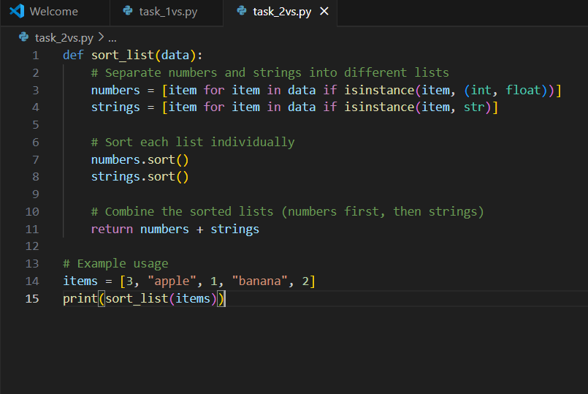  Output:  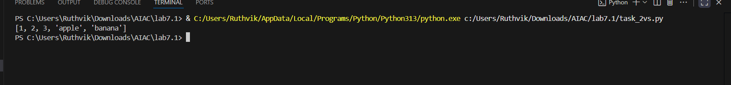  Cursor code:  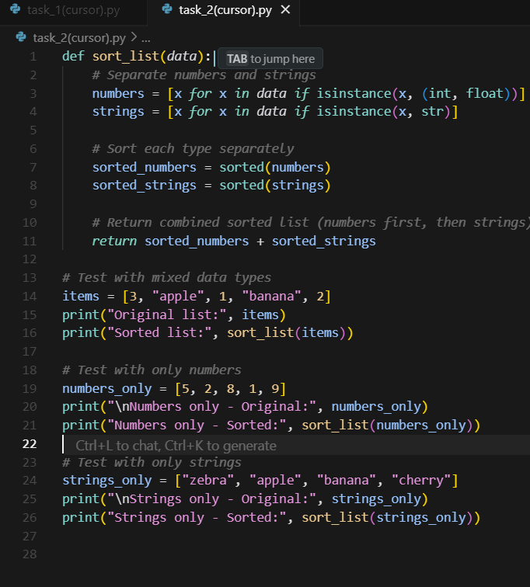  Output:  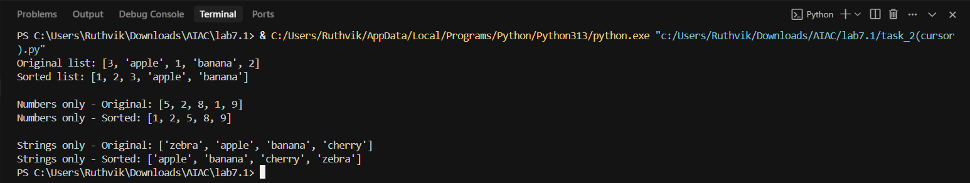  Task Description #3:  • Write a Python snippet for file handling that opens a file but forgets to close it. Ask Copilot or Cursor AI to improve it using the best practice (e.g., with open() block).  Code1  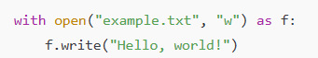  Vs code :  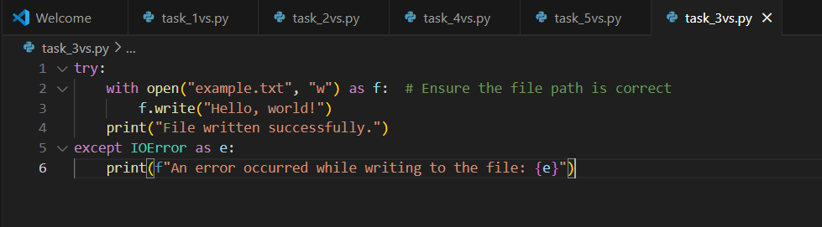  Output:  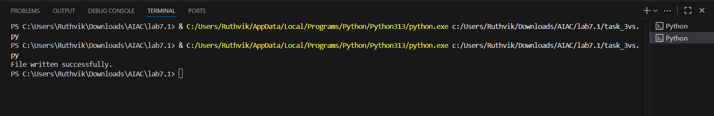  Cursor code  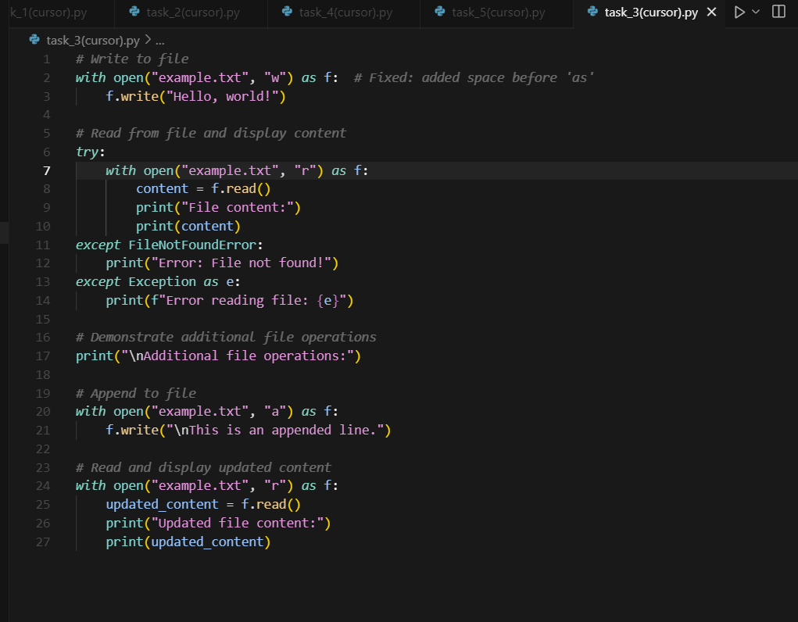  Output: 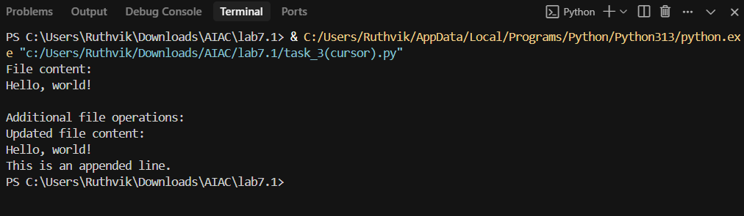  Code2  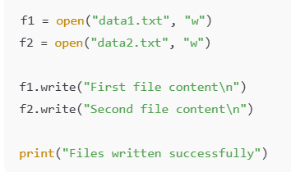  Vs code:  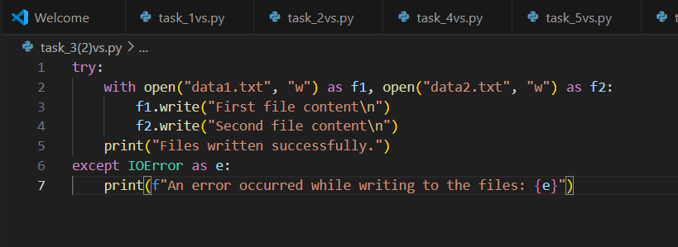  Output:  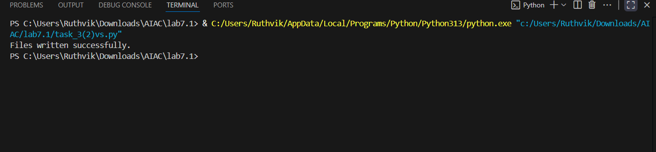  Cursor code:  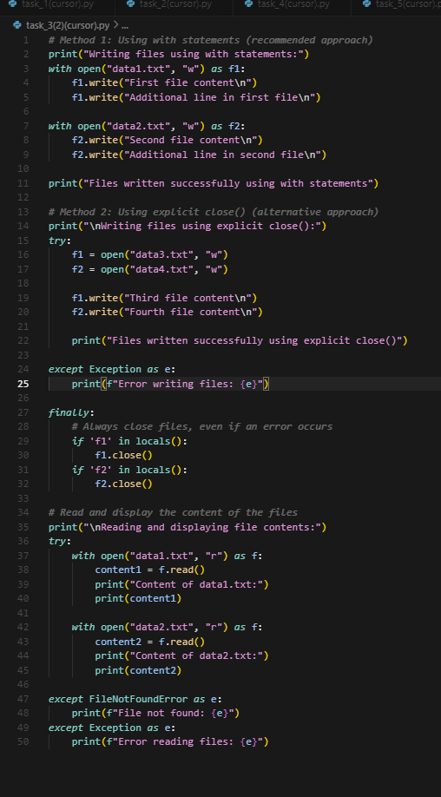  Output:  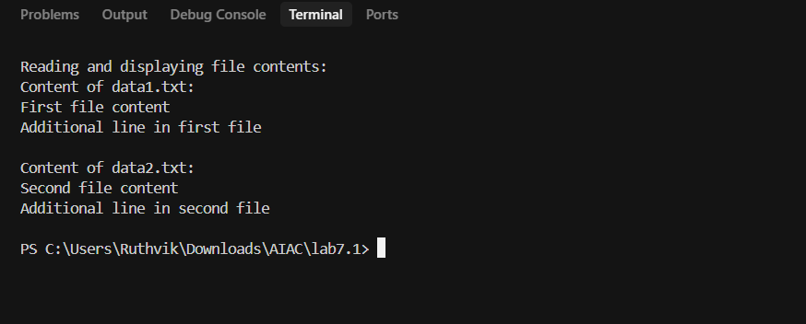  Code3  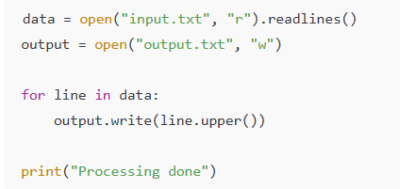  Vs code :  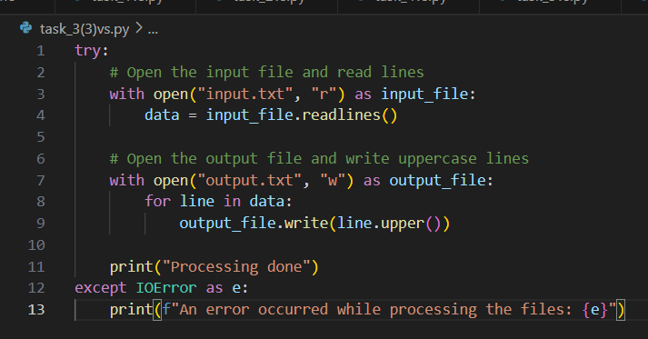  Output:  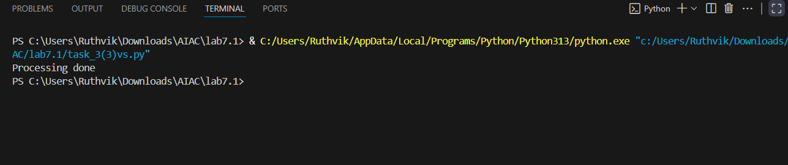  Cursor code:  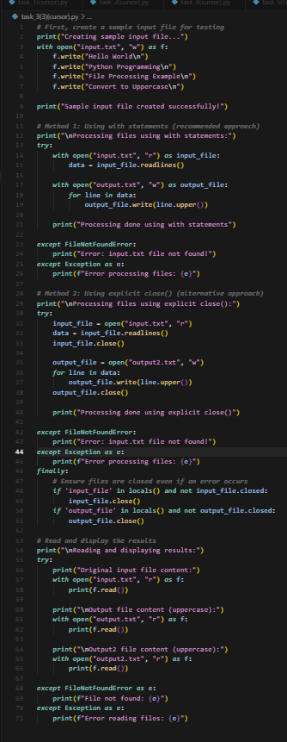  Output:  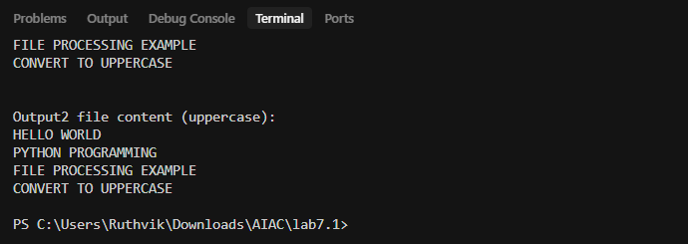  Code4:  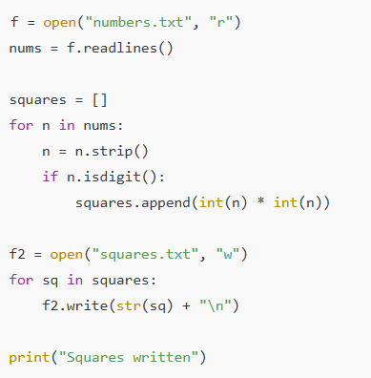  Expected Outcome #3:  • AI refactors the code to use a context manager, preventing resource leakage and runtime warnings  Vs code code: 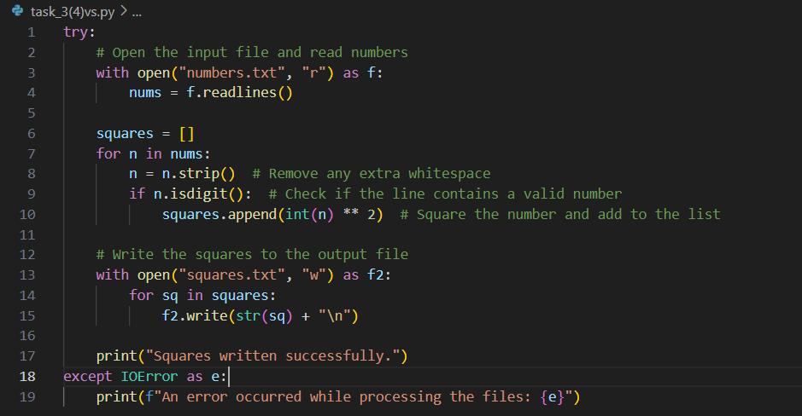  output:  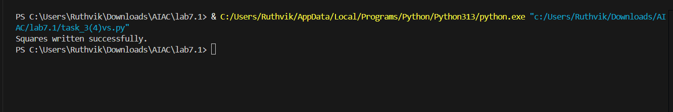  Cursor code:  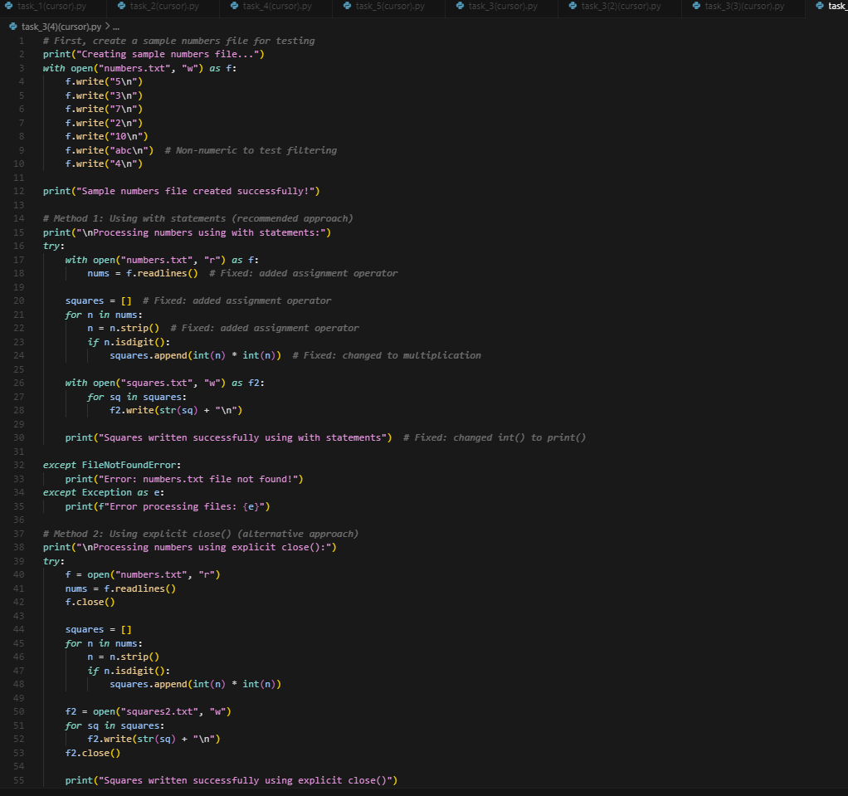  Output:  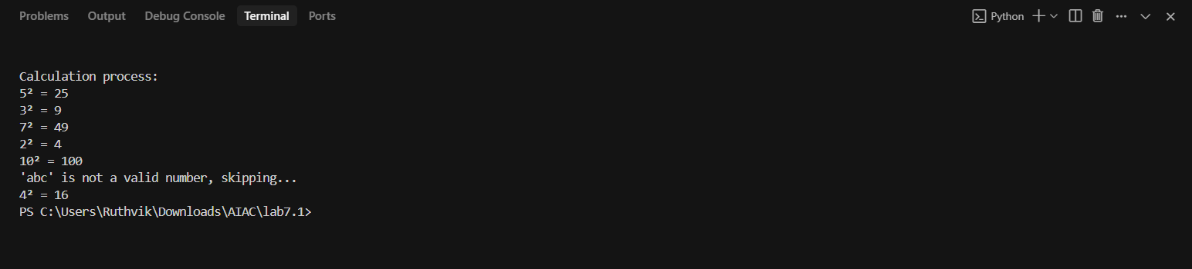  .  Task Description #4:  • Provide a piece of code with a ZeroDivisionError inside a loop. Ask AI to add error handling using try-except and continue execution safely.  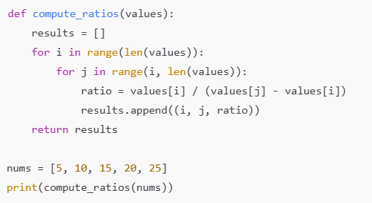  Vs-code code:  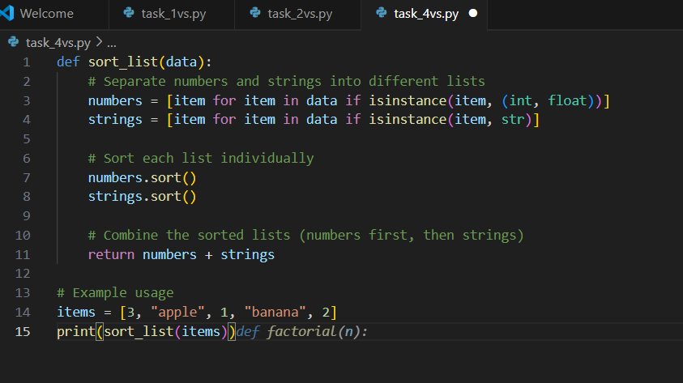  Output:  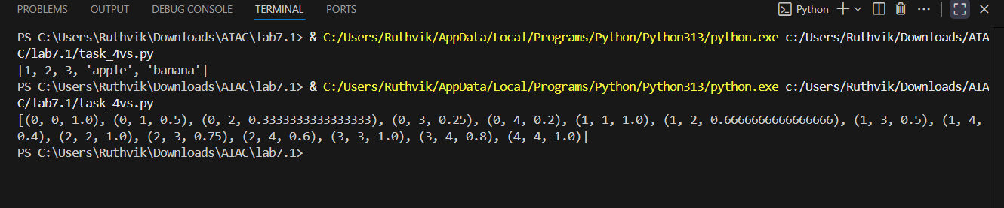  cursor(code):  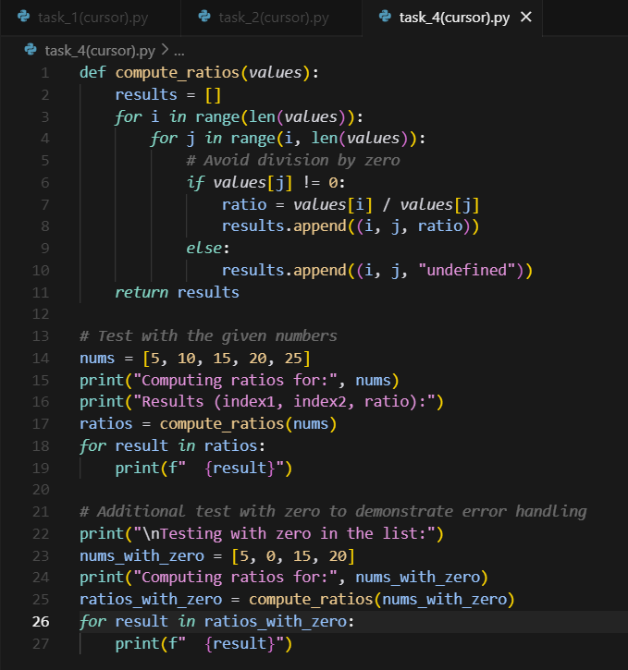  Output: 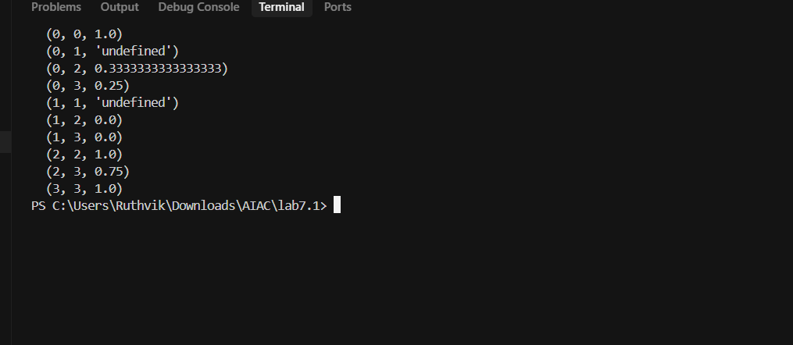  Expected Outcome #4:  • Copilot adds a try-except block around the risky operation, preventing crashes and printing a meaningful error message.  Task Description #5:  • Include a buggy class definition with incorrect __init__ parameters or attribute references. Ask AI to analyze and correct the constructor and attribute usage.  class StudentRecord:  def __init__(self, name, id, courses=[]):  self.studentName = names  self.student_id = id  self.courses = courseList  def add_course(self, course):  self.courses.append(course)  def get_summary(self):  return f"Student: {self.studentName}, ID: {self.student_id}, Courses: {', '.join(self.courses)}"  class Department:  def __init__(self, deptName, students=None):  self.dept_name = deptName  self.students = students  def enroll_student(self, student):  self.students.append(student)  def department_summary(self):  return f"Department: {self.dept_name}, Total Students: {len(self.student)}"  s1 = StudentRecord("Alice", 101, ["Math", "Science"])  d1 = Department("Computer Science")  d1.enroll_student(s1)  print(s1.get_summary())  print(d1.department_summary())  Expected Outcome #5:  • Copilot identifies mismatched parameters or missing self references and rewrites the class with accurate initialization and usage.  Vs code code: |  |  |  |  |  | Week4 - Thursday
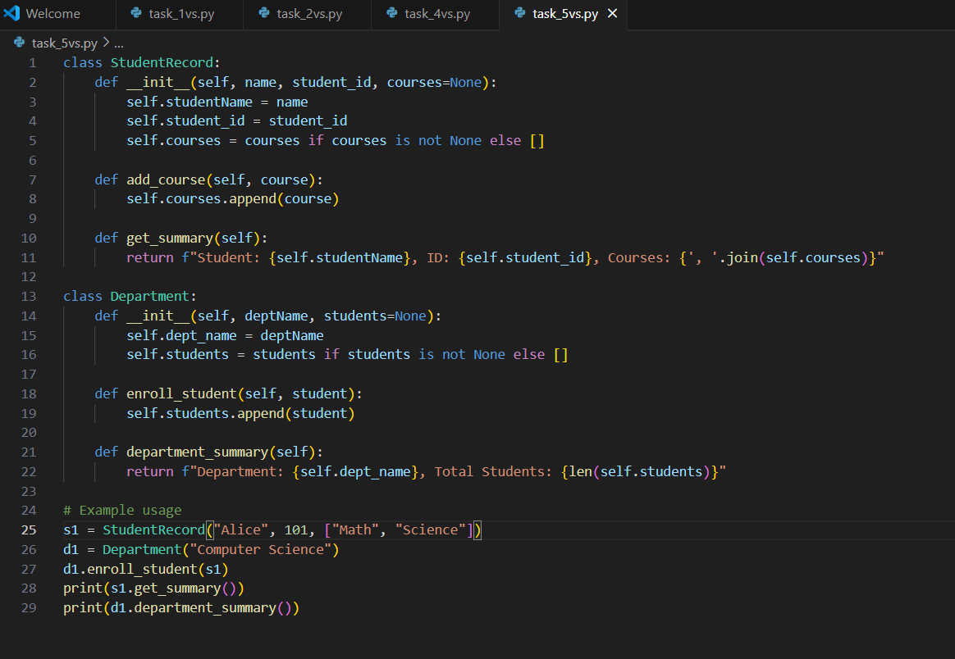output:
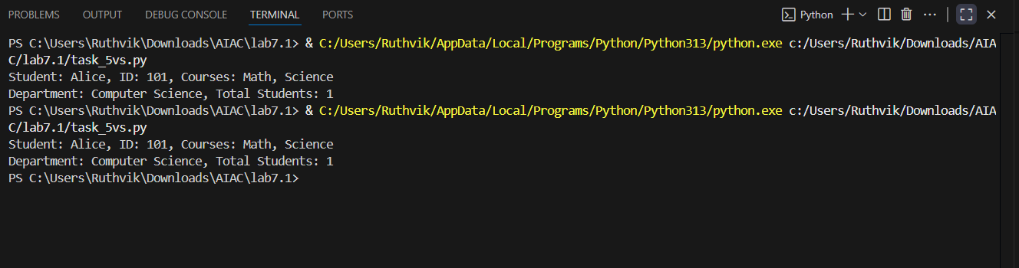
Cursor code:
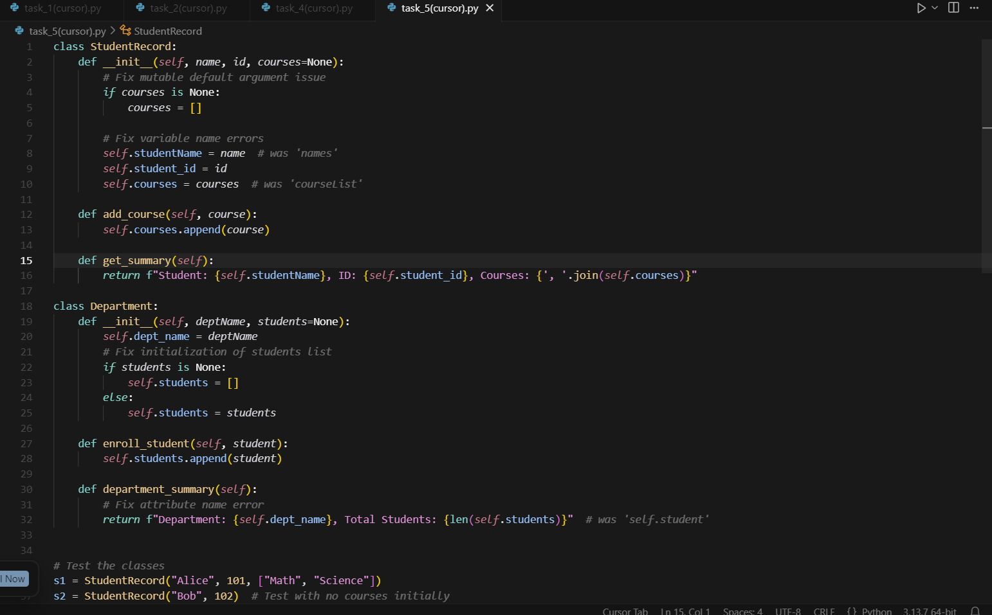
Output:
