SORTING VISUALIZER



A Minor Project Report

in partial fulfillment of the degree

Bachelor of Technology
in
Computer Science & Artificial Intelligence

By

Roll.No 2003A51004 Name DUBASI POOJITHA

Roll.No 2003A51015 Name ADEPU SATHWIKA

Roll.No 2003A51054 Name JULA DEEKSHITH

Under the Guidance of

Mr.S.Jagadish

Submitted to





SCHOOL OF COMPUTER SCIENCE & ARTIFICIAL INTELLIGENCE

SR UNIVERSITY, ANANTHASAGAR, WARANGAL
April, 2023.

SCHOOL OF COMPUTER SCIENCE & ARTIFICIAL INTELLIGENCE

CERTIFICATE

This is to certify that this project entitled “SORTING VISUALIZER" is the bonafied work carried out by D.Poojitha, A.Sathwika, J.Deekshitha as a Minor Project for the partial fulfillment to award the degree BACHELOR OF TECHNOLOGY in COMPUTER SCIENCE & ARTIFICIAL INTELLIGENCE during the academic year 2022-2023 under our guidance and Supervision.

Mr.S.Jagadish Dr. M.Sheshikala
Designation, Assoc. Prof. & HOD (CSE),
SR University, SR University, Ananthasagar, Warangal. Ananthasagar, Warangal.

External Examiner

ACKNOWLEDGEMENT

We owe an enormous debt of gratitude to our project guide Mr.Jagadish sir, Assistant Professor as well as Head of the CSE Department Dr. M.Sheshikala, Associate Professor for guiding us from the beginning through the end of the Minor Project with their intellectual advices and insightful suggestions. We truly value their consistent feedback on our progress, which was always constructive and encouraging and ultimately drove us to the right direction.

We express our thanks to project co-ordinators Dr. P Praveen, Assoc. Prof., and Dr. Mohammed Ali Shaik, Asst. Prof. for their encouragement and support.

We wish to take this opportunity to express our sincere gratitude and deep sense of respect to our beloved Dean, Dr. C.V. Guru Rao, for his continuous support and guidance to complete this project in the institute.

Finally, we express our thanks to all the teaching and non-teaching staff of the department for their suggestions and timely support.

Dubasi Poojitha

Adepu Sathwika

Jula Deekshitha

TABLE OF CONTENTS

Topic Pgno.
- INTRODUCTIO 5-6
- LITERATURE SURVEY 7-14
  - RELATED WORK
  - SYSTEM STUDY
- DESIGN 15-16
  - REQUIREMENT SPECIFICATION(S/W & H/W)
  - UML DIAGRAMS OR DFDs
- IMPLEMENTATION 17-22
  - MODULES
  - OVERVIEW TECHNOLOGY
- TESTING 23-27
  - TEST CASES
  - TEST RESULTS
- RESULTS 28-30
- CONCLUSION 31-32
- FUTURE SCOPE 32-34
BIBLIOGRAPHY 35

INTRODUCTION

Sorting algorithms are one of the fundamental topics in computer science, and understanding how they work is essential for any developer. Sorting algorithms are used to organize data in a particular order, and there are several different types of sorting algorithms, each with its unique approach to sorting data.

The "SORTING VISUALISER" project is basically a web development project which is used to visualize the sorting algorithms and performs the operation of algorithms step by step as the algorithms works like Bubble sort, Selection Sort, Merge Sort etc.

This Sorting Visualizer project is a software tools that allow users to visualize the process of sorting data using different algorithms. These visualizers are used to teach computer science students and enthusiasts about sorting algorithms and their complexity, as well as to help developers optimize their code for efficiency.

In this report, we will discuss sorting visualizer projects in detail, including their benefits, how they work, and how to build one. We will also discuss the importance of sorting algorithms in computer science and give some examples of popular sorting algorithms.

The importance of sorting algorithms:
Sorting algorithms are essential in computer science, and they are used in various applications, including databases, file systems, and search engines. Efficient sorting algorithms are critical for optimizing the performance of these applications, which can have a significant impact on user experience.

Sorting algorithms are also used in data analysis and machine learning. In data analysis, sorting algorithms are used to sort large datasets, and in machine learning, sorting algorithms are used to preprocess data before training models.

How sorting Visualizer project works:
Sorting visualizer project works by generating a randomized array and choosing a sorting algorithm to visualize. The project then displays the dataset as a graphical representation, such as bars on a graph, and animates the sorting algorithm as it sorts the data. The animation shows how the sorting algorithm works, step by step, allowing the user to see how the data is being sorted. They can be built using libraries or frameworks that provide graphical user interfaces (GUIs) for displaying the data and animating the sorting algorithm.

Graphics provides one of the most natural means of communicating with a computer, since our highly developed 2D and 3D pattern recognition abilities allow us to perceive and process pictorial data rapidly and efficiently. Interactive computer graphics is the most important means of producing pictures since the invention of photography and television. It has the added advantage that, with the computer, we can make pictures not only of concrete real-world objects but also of abstract, synthetic objects, such as mathematical surfaces and of data that have no inherent geometry, such as survey results.

Benefits of sorting visualizer Project:
Better Understanding of Sorting Algorithms Sorting visualizer projects provide a more interactive and visual way of understanding how sorting algorithms work. Students and enthusiasts can see how different algorithms sort data in real-time, making it easier to understand how they work and their complexity.

Enhanced Problem-Solving Skills Sorting algorithms are an essential part of computer science and are used in various applications. By using sorting visualizer projects, students and enthusiasts can improve their problem-solving skills by understanding how to use different algorithms to solve various problems

This project discusses a study performed on animating sorting algorithms as a learning aid for classroom instruction. The web-application animation tool was created to visualize six common sorting algorithms: Selection Sort, Bubble Sort, Insertion Sort, Heap Sort, Quick Sort and Merge Sort. The animation tool would represent data as a bar-graph and dot plot. After selecting a data ordering and algorithm, the user can run an automated animation or step through it at their own pace.

As we all know that learning through visual diagrams is proven to be better approach. Teaching basic algorithmic concepts to novices is not an easy task. Existing research has given considerable information about students’ alternative conceptions and faulty mental models about abstract programming concepts and constructs, as well as their difficulties in solving programming problems. Various algorithm visualization systems are proposed as alternative and efficient instructional environments for introductory programming courses.

Algorithmic thinking and programming skills play a central role in computing education. Students typically need to become familiar with a great number of different algorithms and data structures. The ability to design an algorithm for a given problem is one of the most important and challenging tasks in computer science education. However, literature shows that novices face serious difficulties in using abstract programming concepts like data structures (array, graphs, lists) and lack the skills necessary to function abstractively, to consolidate an algorithm as a single entity, to comprehend its main parts and the relations among them, and to compose new algorithms by using their previous programming knowledge.

LITERATURE SURVEY

Related work
This section describes algorithms included to the software served as sources of information for this section.

Sorting
As was already said that sorting is used for solving a wide range of problems. It may be used for further searching or, for example, as part of different complex tasks. We were talking about sorting. But what actually sorting is?

Simply said, sorting is a process of rearranging of items, which are possible to compare, in ascending or descending order. In the text we are meaning only ascending order if not stated in a different way.

Ascending order means that items in a sequence are arranged from the smallest to the largest item. On the contrary, descending order means positioning from the largest to the smallest item.
Sorting algorithms are divided into two main types:

- Algorithms of internal sorting – all the data to sort is stored in the internal memory during the sorting process. It is used when the amount of data to sort is known.

2. Algorithms of external sorting – all the data to sort is stored outside the internal memory (e.g. on a hard disk). These algorithms usually combine sorting in the internal memory, merging of sorted parts and saving them to the external memory.

The Complexity of Sorting Algorithms
The complexity of sorting algorithm calculates the running time of a function in which 'n' number of items are to be sorted. The choice for which sorting method is suitable for a problem depends on several dependency configurations for different problems.

The most noteworthy of these considerations are:
● The length of time spent by the programmer in programming a specific sorting program
● Amount of machine time necessary for running the program
● The amount of memory necessary for running the program.

The Efficiency of Sorting Algorithms
Sorting algorithms are an essential part of computer science and are used in various applications, such as data processing, search engines, and computer graphics. The efficiency of sorting algorithms is critical, as it affects the speed and performance of these applications.

The efficiency of sorting algorithms is measured in terms of time complexity and space complexity.
- Time complexity refers to the amount of time it takes for an algorithm to sort a dataset.
- Space complexity refers to the amount of memory the algorithm requires to sort the data.

Algorithms with higher time complexity may take significantly longer to sort the data, which can lead to slow and unresponsive visualizations. However, it's important to note that the efficiency of the algorithm is not the only consideration in a sorting visualizer project. Other factors, such as ease of implementation and readability of the code, may also be important considerations when choosing a sorting algorithm.

In conclusion, the efficiency of sorting algorithms is an essential consideration when choosing an algorithm for a specific application. It is important to understand the time and space complexities of different algorithms and choose the most appropriate one for the specific dataset and performance requirements.

To get the amount of time required to sort an array of 'n' elements by a particular method, the normal approach is to analyze the method to find the number of comparisons (or exchanges) required by it. Most of the sorting techniques are data sensitive, and so the metrics for them depends on the order in which they appear in an input array.
Various sorting techniques are analyzed in various cases and named these cases as follows:
- Best case
- Worst case
- Average case

Hence, the result of these cases is often a formula giving the average time required for a particular sort of size 'n.' Most of the sort methods have time requirements that range from O(nlog n) to O(n2).

Types of Sorting Techniques
- Bubble Sort
- Selection Sort
- Merge Sort
- Insertion Sort
- Quick Sort

Insertion Sort
Insertion Sort algorithm has a simple idea. Assume an array with items to be sorted. We divide the array into two parts: sorted one and unsorted one. At the beginning sorted part consists of the first element (Figure 6). Then, for each item that we have in the unsorted part, we take element and insert it into the right place among the sorted items.

The steps involved in the Insertion sort algorithm are as follows:
- Assume the first element of the array to be sorted is already sorted.
- Iterate through the remaining elements of the array, starting from the second element.
- Compare each element with the elements that come before it.
- If an element is smaller than the element that precedes it, swap the two elements.
- Continue comparing and swapping elements until the current element is in its correct sorted position.
- Repeat steps 2 to 5 for all remaining elements in the array.

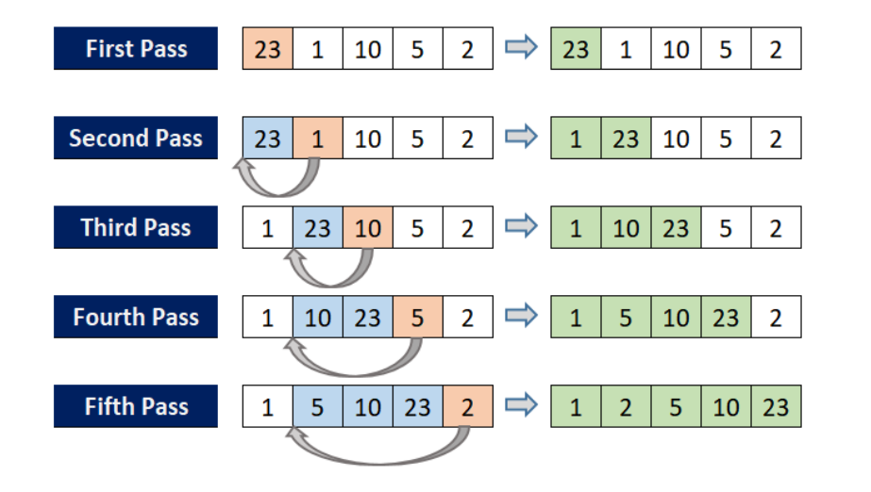

In order to insert element into the right place in the sorted part, we compare selected item from the unsorted part with each item from the sorted part in the direction from right to left. Comparing continues until smaller or equal element is found or no elements to compare left. After each comparison, if current item in the sorted part is greater, we move that current item one position right. Finally, when the right position is found, we insert an item into the sorted part. Complexity of Insertion Sort is Θ(n 2 ). However its advantage lies in its simplicity and ease of implementation, making it useful for sorting small data sets or as a sub-routine in more complex algorithms.

Selection Sort
Selection Sort algorithm is based on the repeated selection. Here we consider finding minimal key from the unsorted part and swapping it with the first unsorted key. As well as in the Insertion Sort, sorted part grows from the beginning of the sequence.

Here are the steps of the selection sort algorithm:
- Find the minimum element in the unsorted part of the array
- Swap it with the first element of the unsorted part
- Move the boundary of the sorted part one position to the right
These steps are repeated until the boundary of the sorted part reaches the end of the array.

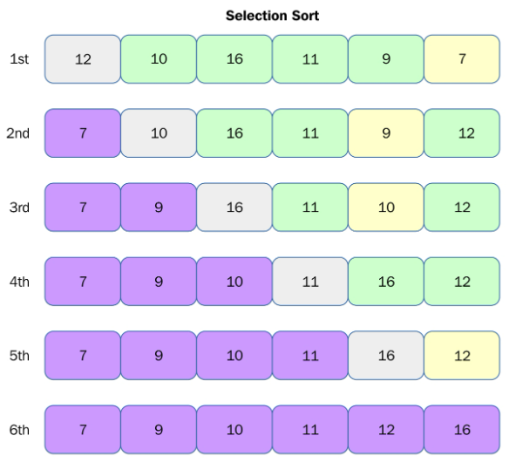

Assume an array of items to sort. At the beginning of the sorting process unsorted part is represented by the whole array. Then, the first item of the unsorted part is set as the smallest item and is compared with the follow-up elements. When smaller item is found, it is set as a new smallest key. After the end of the array is reached the smallest item is swapped with the first element of the unsorted part and it becomes the sorted part of the array. This step is repeated till the array is sorted. Complexity of this sorting algorithm is Θ(n 2 ). However, selection sort has the advantage of having a small code footprint and being easy to understand and implement. It can also be useful for sorting small arrays or for situations where memory is limited.

Bubble Sort
Bubble Sort is based on the idea of exchanging two adjacent elements if they have the wrong order. The algorithm works stepping through all elements from left to right, so the largest elements tend to move or "bubble" to the right.

The Bubble Sort algorithm works as follows:
- Start by comparing the first two elements of the list. If the first element is greater than the second element, swap them.
- Move to the next pair of adjacent elements and repeat step 1. Continue this process until the end of the list is reached.
- At this point, the largest element will be at the end of the list. Repeat the above steps, but ignore the last element (since it is already in its correct position) and continue until the second-to-last element is reached.
- Continue this process until the entire list is sorted.

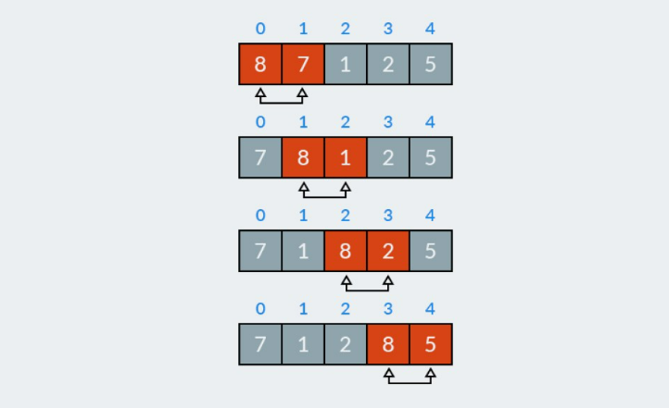

That is why the algorithm is called Bubble Sort. Now we are going to the details. Let us have an unsorted array.

The algorithm does iterations through the unsorted part which is the whole array at the beginning. And with each iteration through the array the range of inspected items is decreased by one till only two elements left. After this two elements are compared and possibly swapped, the array is considered as sorted. Bubble Sort complexity is Θ(n 2 ).

Merge Sort
Merge Sort as well as Quick Sort is an algorithm of type "divide and conquer". Its logic is simple: divide data into two parts, sort the left part, sort the right part, then "merge" the parts back. The algorithm works by the recursive application itself on the unsorted parts.

The basic idea of the merge sort algorithm is as follows:
- Divide the unsorted array into n sub-arrays, each containing one element (a single element is considered sorted)
- Repeatedly merge sub-arrays to produce new sorted sub-arrays until there is only one sub-array remaining.

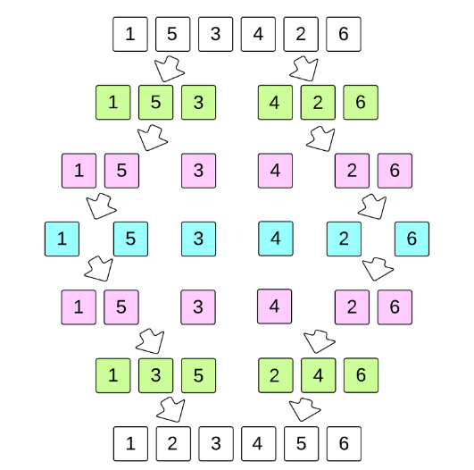

In the beginning, it selects the middle item, which becomes the rightmost element of the left part. Then, it recursively sorts both parts. Finally, the algorithm "merges" two sorted parts. Merging procedure itself takes items from each of two sorted parts one by one, compares them and moves the smallest to the output, repeats the previous step. Merge Sort complexity is Θ(n log n).

Quick Sort
Quick Sort works on the principle "divide and conquer". It recursively applies itself on smaller parts of array until it is not sorted.

Algorithm takes one item at unsorted array or its part, usually it is the leftmost or the rightmost element of array. Then this item, also known as pivot, is moved to its final position in the array that is should occupy. While determining pivot’s position, other elements of array are rearranged the way that no bigger elements are on the right and no smaller elements are on the left.

This way, it is enough to apply Quick Sort on each part of array not including pivot until array is not sorted.
There are several methods of partitioning of array into two parts, here I want to describe one that is demonstrated in the software part of this work.

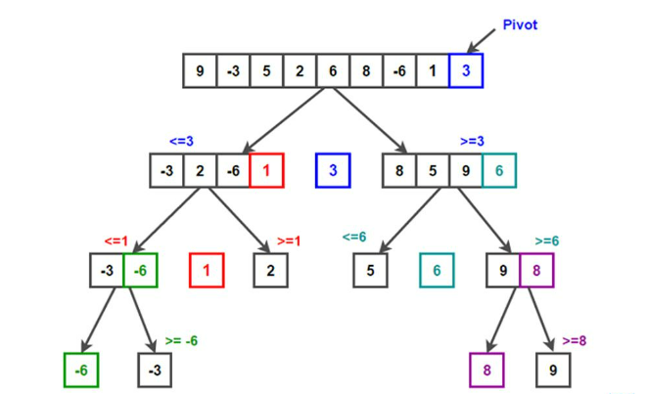

Firstly, a pivot and index item are selected on the unsorted array or its part. Assume pivot is the rightmost item and index is the leftmost. Next, each item of the array except pivot is compared with the pivot. If a current item is less or equal to the pivot, it is swapped with the index item, next in order item becomes an index. Finally, index and pivot are swapped and this way pivot is on its final position.
Quick Sort is counted as an effective algorithm because its average complexity is Θ(n log n). However, when array is maximally unbalanced it may show worst performance. Worst case complexity is Θ(n 2 ).

SYSTEM STUDY
The sorting visualizer project involves visualizing the different sorting algorithms in action. As a system, the project can be broken down into several components, including the front-end interface, the sorting algorithm implementations, and the back-end server.

Front-end Interface:
The front-end interface is responsible for rendering the sorting visualization and handling user interactions. It may use HTML, CSS, and JavaScript to create a user-friendly interface for users to interact with. The interface should allow users to select a sorting algorithm, input an array of numbers to be sorted, and start the sorting process. It may also display a bar graph representation of the array and highlight the elements being swapped during the sorting process.

Sorting Algorithm Implementations:
The sorting algorithms implemented in this project include bubble sort, selection sort, insertion sort, quicksort, mergesort, heapsort, and radix sort. Each of these algorithms is responsible for sorting the input array in a specific way. The algorithm implementations should be modular and easily extensible to support future sorting algorithms.

Back-end Server:
The back-end server is responsible for receiving user input, processing the input, and returning the sorted array to the front-end interface. It may use a server-side scripting language such as Python, Node.js, or PHP to handle the server-side logic. The server should communicate with the front-end interface using HTTP requests and responses.
Overall, the system should provide a seamless user experience, allowing users to interact with the interface and observe the sorting algorithms in action. The system should also be reliable and scalable, able to handle a large number of users and input arrays without crashing or slowing down. Proper error handling and security measures should be implemented to ensure the safety and security of user data.

DESIGN

REQUIREMENT SPECIFICATION:
HARDWARE REQUIREMENTS:
- Minimum 128 MB of RAM.
- 256 MB recommended.
- 110 MB of hard disk space required.
- 40 MB additional hard disk space required for installation (150 MB total).

SOFTWARE REQUIREMENTS:
This sorting algorithms visualizer has been designed for WINDOWS and other platforms.
Development Platform: WINDOWS
LANGUAGES USED:
Back End:
- Java Script
Front End:
- Html
- CSS

JAVA SCRIPT:
JavaScript is the Programming Language for the Web,JavaScript can update and change both HTML and CSS. JavaScript can calculate, manipulate and validate data.

HTML:
HTML is the standard markup language for creating Web pages
HTML describes the structure of a Web page
HTML elements tell the browser how to display the content

CSS:
CSS is the language for describing the presentation of Web pages, including colors, layout, and fonts. It allows one to adapt the presentation to different types of devices, such as large screens, small screens, or printers. CSS is independent of HTML and can be used with any XML-based markup language.

UML DIAGRAMS
Sequence Diagram:
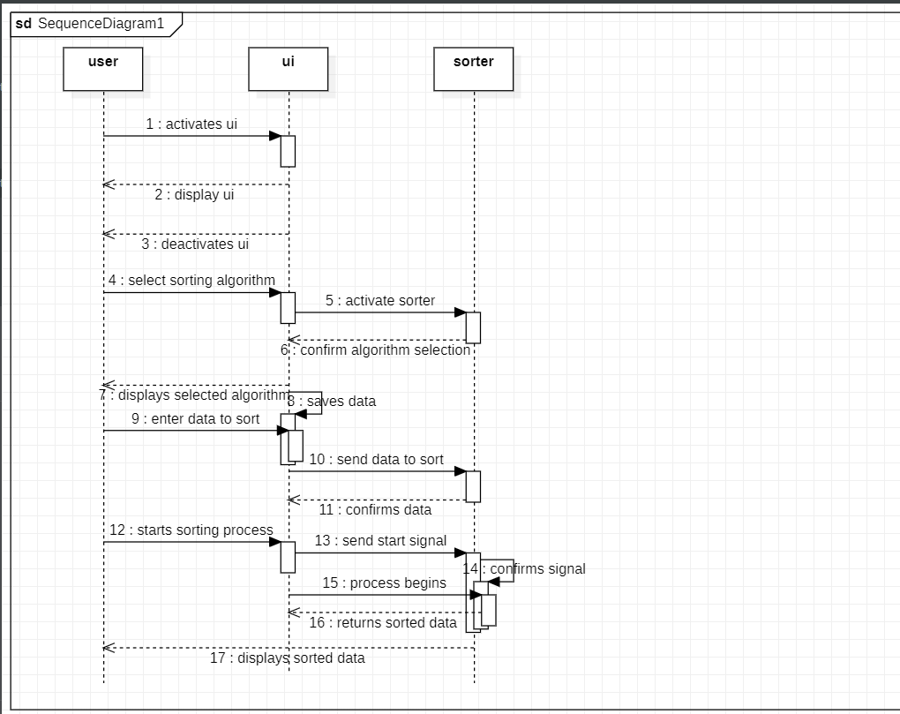

UseCase Diagram:

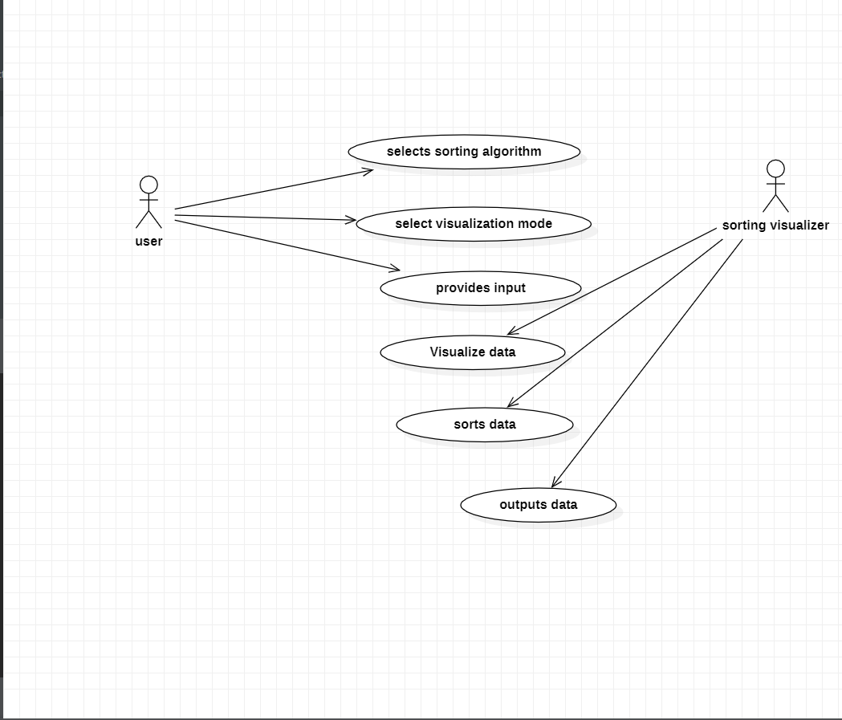

IMPLEMENTATION

MODULES
The specific modules required for implementing a sorting visualizer will depend on the programming language and framework being used. However, here are some common modules that may be used:

The sorting visualizer project involves visualizing the different sorting algorithms in action. As a system, the project can be broken down into several components, including the front-end interface, the sorting algorithm implementations, and the back-end server.

Sorting visualizers are a great way to visualize how sorting algorithms work and to better understand their performance. The process of implementing a sorting visualizer typically involves several modules, each of which plays a critical role in the overall functionality of the visualizer. In this article, we will discuss each of these modules in detail, outlining their purpose and the steps involved in implementing them.

User Interface Module
The user interface (UI) module is responsible for providing a user-friendly interface that allows users to interact with the sorting visualizer. This module typically consists of buttons, sliders, and other user input elements that allow users to select different sorting algorithms, set input parameters (e.g., array size, random or pre-defined input), and visualize the sorting process.
The UI module should also provide feedback to the user during the sorting process, such as showing the current state of the array being sorted and displaying performance metrics like time complexity and space complexity.

Sorting Algorithm Module
The sorting algorithm module is responsible for implementing the actual sorting algorithms used in the visualizer. This module typically consists of several sorting algorithm implementations, such as bubble sort, insertion sort, selection sort, merge sort, quicksort, and heap sort, among others.
The module should also provide support for choosing different sorting algorithms dynamically, based on user input.

Array Generator Module
The array generator module is responsible for generating input arrays for sorting. This module should allow users to select the size of the input array, whether to use randomly generated input or pre-defined input, and the range of values to be included in the input array.

Array Visualization Module
The array visualization module is responsible for visualizing the sorting process in real-time. This module typically consists of a graphical representation of the input array, with each element represented as a bar or point on the graph. During the sorting process, the bars or points move to represent the current state of the array. The array visualization module should also provide options for customizing the appearance of the graph, such as color schemes, animations, and labels.

Data Storage Module
The data storage module is responsible for storing performance metrics and other data generated during the sorting process. This module should provide support for storing data in a database or other storage system, as well as for exporting data to other formats for analysis and visualization.

Performance Metrics Module
The performance metrics module is responsible for measuring the performance of the sorting algorithms used in the visualizer. This module should provide support for measuring metrics like time complexity, space complexity, and stability, as well as for comparing the performance of different sorting algorithms.

Debugging and Error Handling Module
The debugging and error handling module is responsible for handling errors that occur during the sorting process and providing debugging information to help diagnose and resolve issues. This module should also provide support for logging and analyzing errors to help identify and resolve common issues.

Optimization and Scaling Module
The optimization and scaling module is responsible for optimizing the sorting visualizer for performance and scalability. This module should provide support for optimizing the sorting algorithms used in the visualizer, as well as for optimizing the UI, data storage, and other modules for performance and scalability.

Testing and Quality Assurance Module
The testing and quality assurance module is responsible for testing the sorting visualizer to ensure that it works correctly and meets user require…

Sorting Algorithm Module:
The Sorting Algorithm module is responsible for implementing the actual sorting algorithms that are to be visualized. This module contains various sorting algorithms such as bubble sort, insertion sort, selection sort, quick sort, merge sort, and heap sort, among others. The algorithms implemented in this module are the backbone of the sorting visualizer. They take the input data generated by the Data Generation module and sort it based on the user's choice.
Animation Module:
The Animation module is responsible for animating the sorting algorithm as it runs. It visualizes the sorting process step by step, highlighting the elements being compared and swapped at each iteration. This module makes use of various animation techniques su…

Data Generation Module:
The Data Generation module is responsible for generating the input data that is to be sorted. This module creates random data sets of various sizes and types, such as integers, floating-point numbers, and strings. It also allows the user to load pre-existing data sets from files. The Data Generation module is crucial to the sorting visualizer as it provides the raw material for the sorting algorithms to work on.

Graphics libraries:
These are used for creating a visual interface for the sorting algorithm. Examples include Pygame, Tkinter, and JavaFX.

Sorting algorithms:
These are the core of the visualizer and are responsible for the actual sorting. Examples include bubble sort, selection sort, insertion sort, quicksort, and mergesort.

Data generation:
The visualizer needs data to sort, so a module to generate random data can be useful.

Timing and animation:
The sorting process should be timed so that it can be visualized in real-time. Additionally, animation can make the sorting process more engaging and easier to follow.

Output:
The final sorted data must be outputted in some way, such as in a text box or graphically.

Error handling:
It is important to handle errors and exceptions that may occur during the sorting process, such as when the user inputs incorrect data or when the algorithm encounters unexpected data.

OVERVEIW TECHNOLOGY
Front-end Technologies:
The front-end interface of a sorting visualizer project is typically built using HTML, CSS, and JavaScript. HTML provides the structure of the webpage, while CSS is used for styling and layout. JavaScript is used to implement the interactive elements of the interface, such as user input and animation.
A popular framework for building front-end interfaces is React. React is a JavaScript library that allows developers to build user interfaces using reusable components. React provides a simple and efficient way to manage the state of the interface, handle user interactions, and update the interface in real-time.
Another important technology for building the front-end interface is D3.js. D3.js is a JavaScript library for creating dynamic and interactive data visualizations in the browser. D3.js can be used to create bar charts, line charts, scatter plots, and other types of visualizations that are useful for visualizing sorting algorithms.

Back-end Technologies:
The back-end server of a sorting visualizer project is responsible for processing user input, running the sorting algorithm, and returning the sorted array to the front-end interface. The server is typically built using a server-side scripting language such as Python, Node.js, or PHP.
A popular framework for building back-end servers is Flask. Flask is a lightweight and flexible web framework for Python that allows developers to quickly build web applications. Flask provides a simple and easy-to-use interface for handling HTTP requests and responses, and can be easily extended with additional libraries and tools.
Another important technology for building back-end servers is MySQL. MySQL is a popular open-source relational database management system that is widely used for web applications. MySQL can be used to store user data, input arrays, and sorted arrays in a secure and scalable way.

Sorting Algorithm Implementations:
The sorting algorithms implemented in a sorting visualizer project can be implemented in any programming language. Some popular programming languages for implementing sorting algorithms include C, C++, Java, Python, and JavaScript.

A popular library for implementing sorting algorithms in JavaScript is Sort.JS. Sort.JS is a lightweight library that provides implementations of common sorting algorithms, including bubble sort, selection sort, insertion sort, quicksort, merge sort, heapsort, and radix sort.

A sorting visualizer project using JavaScript can be built using a range of technologies, tools, and frameworks. In this section, we will provide an overview of the technologies commonly used in sorting visualizer projects using JavaScript.

HTML/CSS:
HTML (Hypertext Markup Language) and CSS (Cascading Style Sheets) are the foundational technologies used for building web applications. HTML is used to structure the content of the web page, while CSS is used for styling and formatting the content. Sorting visualizer projects using JavaScript can use HTML and CSS to structure and style the user interface of the application.

JavaScript:
JavaScript is a scripting language used for building dynamic and interactive web applications. Sorting visualizer projects using JavaScript utilize JavaScript to implement sorting algorithms and to create dynamic visualizations of the sorting process. JavaScript can be used to manipulate the Document Object Model (DOM) of the web page to update the visualizations in real-time.

React:
React is a JavaScript library for building user interfaces. Sorting visualizer projects using JavaScript can utilize React to create reusable components for the user interface, which can simplify the development process and improve the maintainability of the code.

D3.js:
D3.js is a JavaScript library for data visualization. Sorting visualizer projects using JavaScript can utilize D3.js to create advanced and interactive visualizations of the sorting process. D3.js can be used to create animations, charts, and graphs to visualize the sorting process.

Bootstrap:
Bootstrap is a CSS framework that provides a set of pre-designed CSS styles and JavaScript plugins. Sorting visualizer projects using JavaScript can use Bootstrap to create responsive and mobile-friendly user interfaces. Bootstrap can be used to implement responsive design techniques, such as using a grid system for layout, and can also be used to create custom styles for buttons, forms, and other UI elements.

Node.js:
Node.js is a JavaScript runtime built on Chrome's V8 JavaScript engine. Sorting visualizer projects using JavaScript can utilize Node.js to run the application server-side. Node.js can be used to handle data storage, process data, and communicate with external APIs.

Express.js:
Express.js is a Node.js web framework that provides a set of tools and utilities for building web applications. Sorting visualizer projects using JavaScript can use Express.js to create a RESTful API for the application. Express.js can be used to handle HTTP requests, route requests to the appropriate handlers, and send responses back to the client.

MongoDB:
MongoDB is a NoSQL document-based database. Sorting visualizer projects using JavaScript can utilize MongoDB to store and manage data. MongoDB can be used to store user data, sort algorithm parameters, and application configuration data.

In conclusion, a sorting visualizer project using JavaScript can be built using a range of technologies, including HTML/CSS, JavaScript, React, D3.js, Bootstrap, Node.js, Express.js, and MongoDB. These technologies can be used to create a dynamic and interactive user interface, implement sorting algorithms, handle data storage and processing, and communicate with external APIs.

TESTING

Bubble Sort:

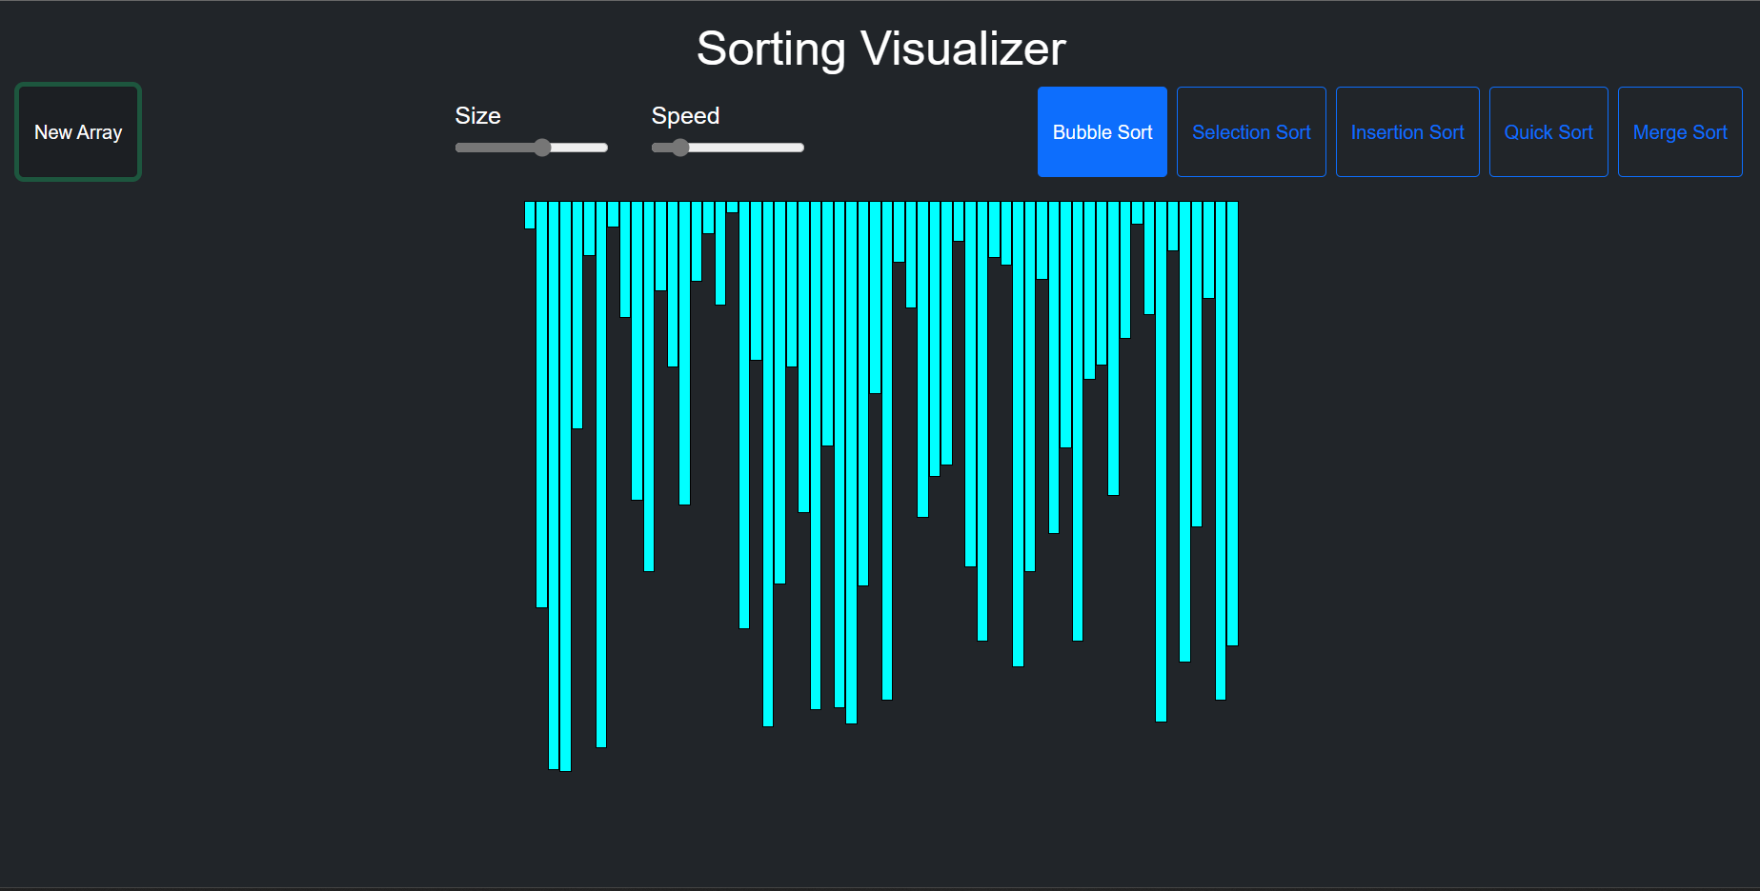

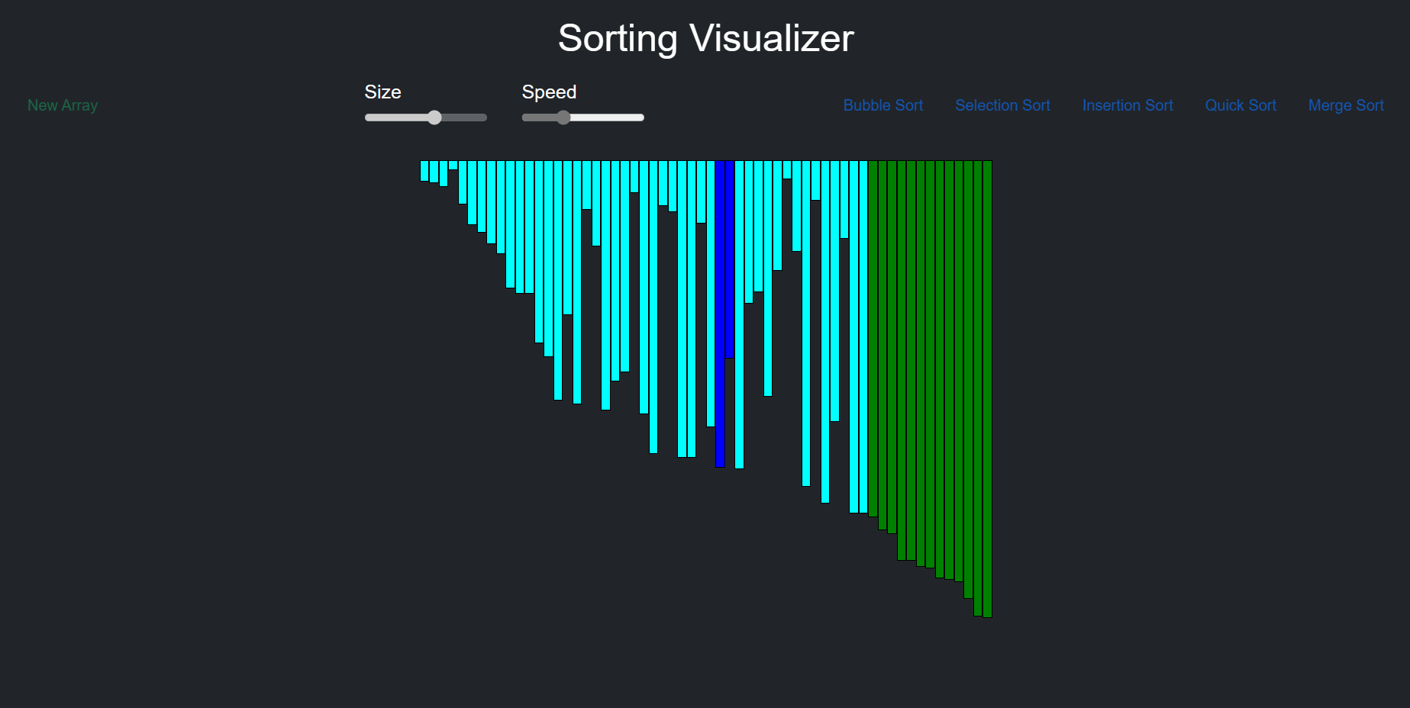

Selection Sort:

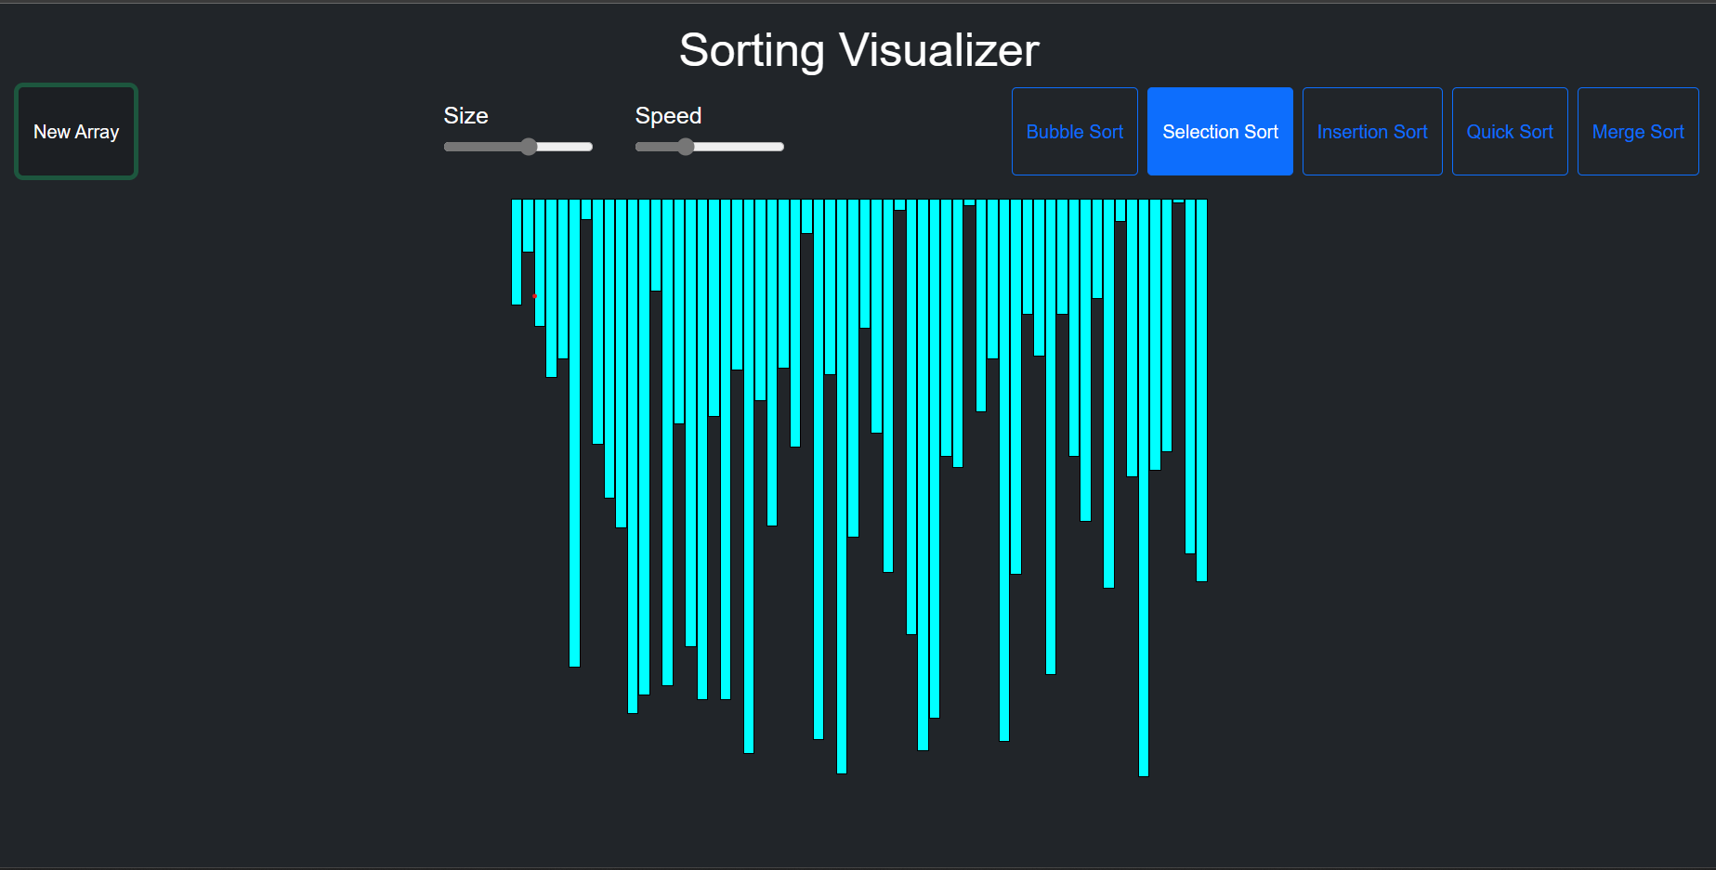

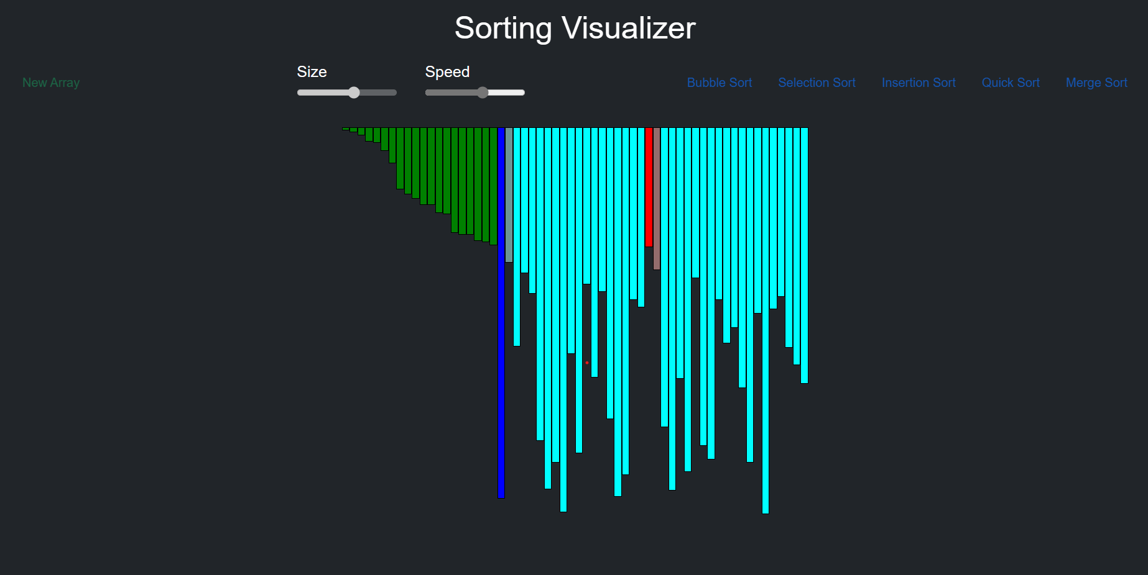

Insertion Sort:

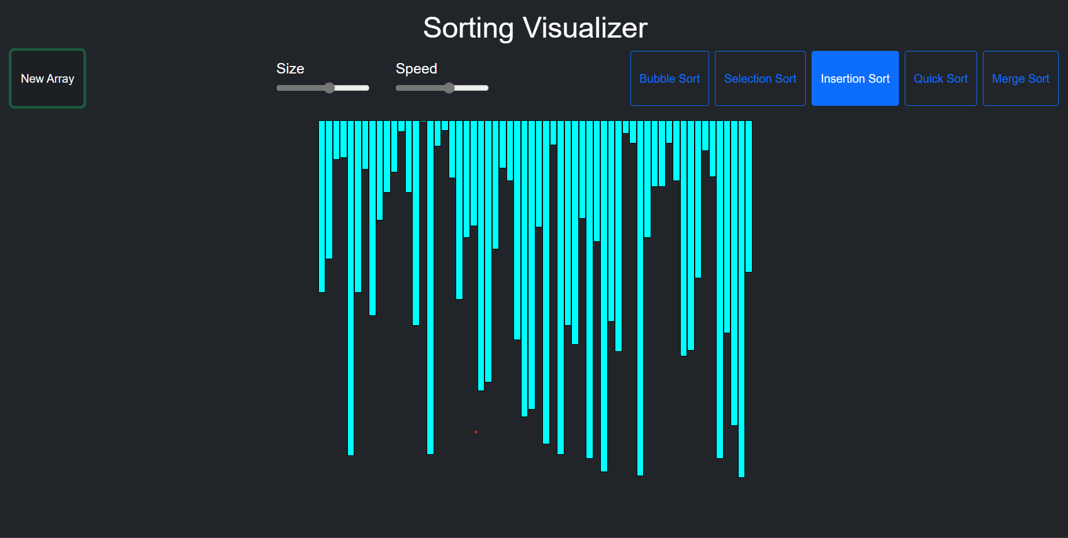

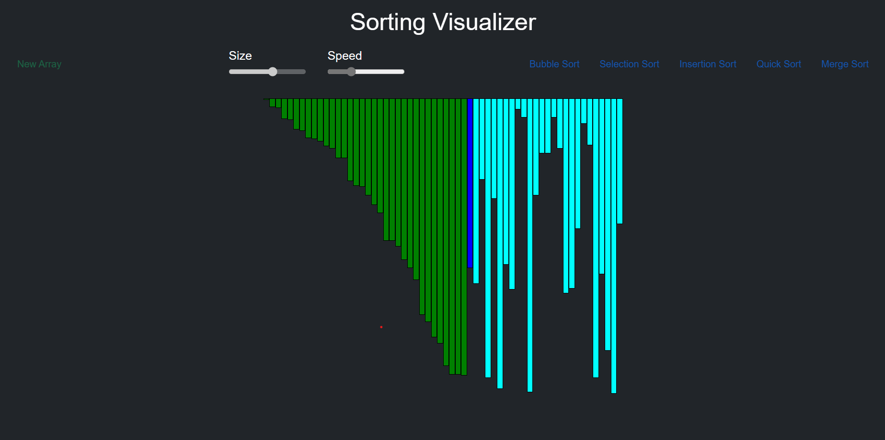

Quick Sort:

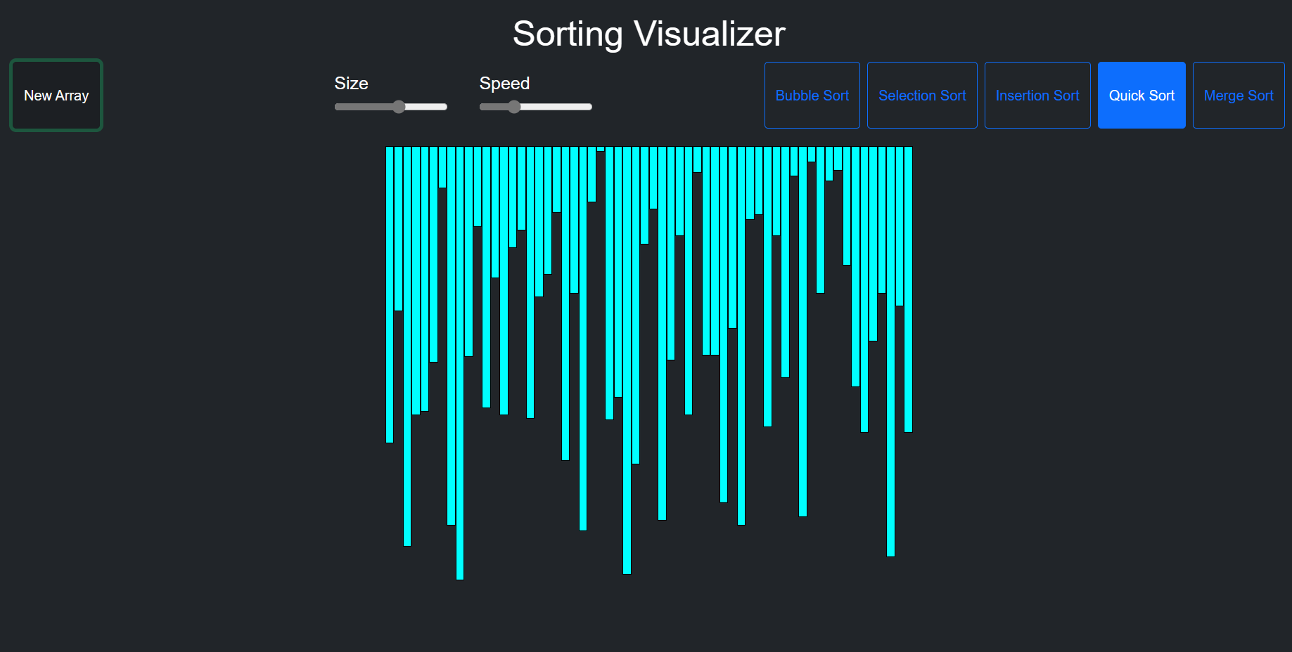

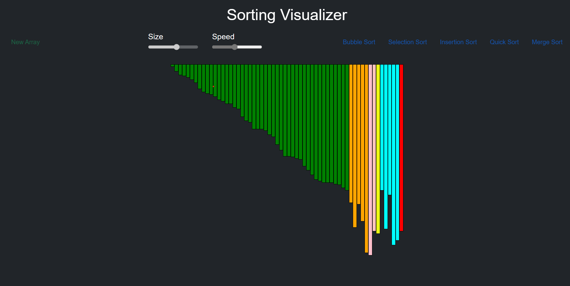

Merge Sort:

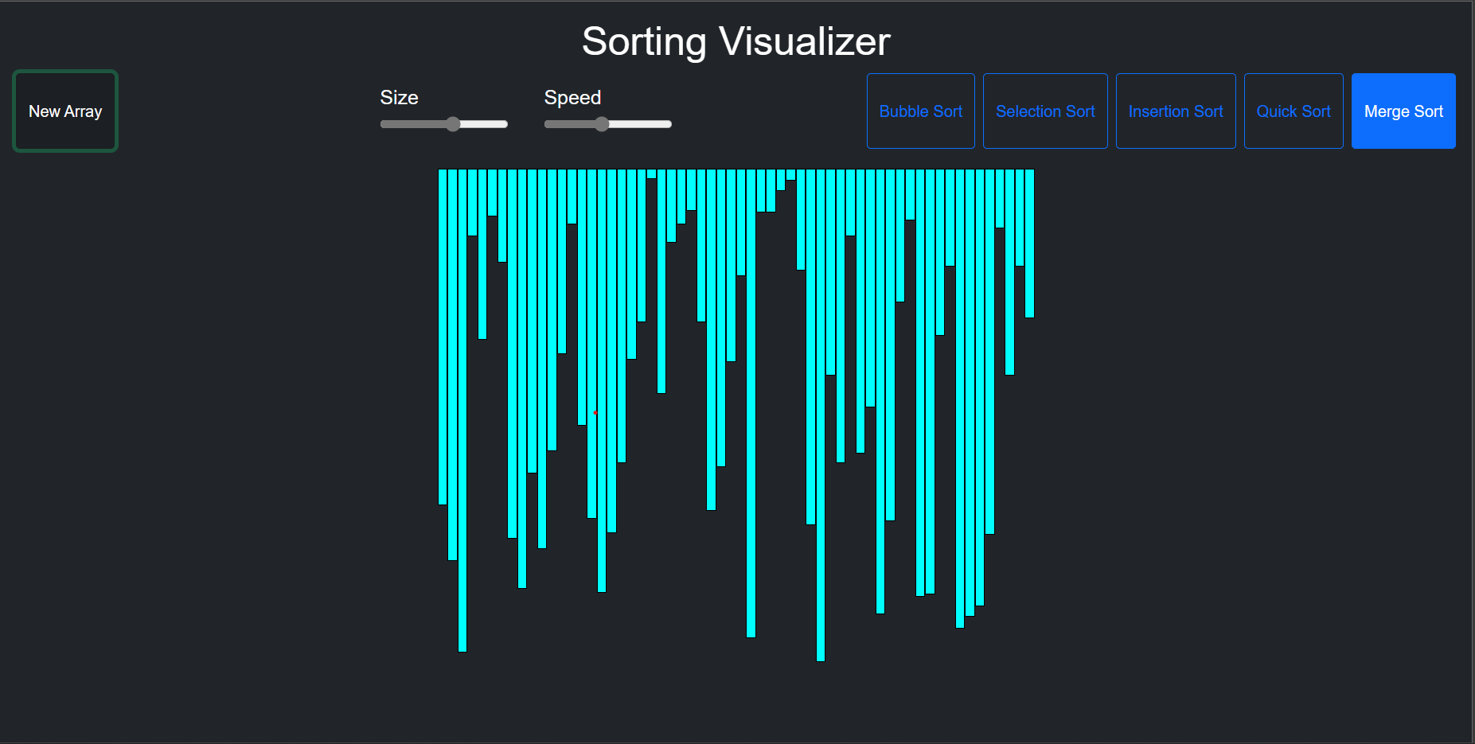

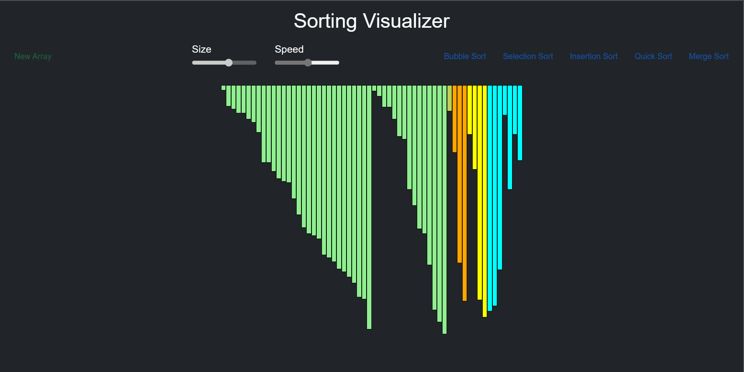

RESULT

WEB PAGE FORMAT:

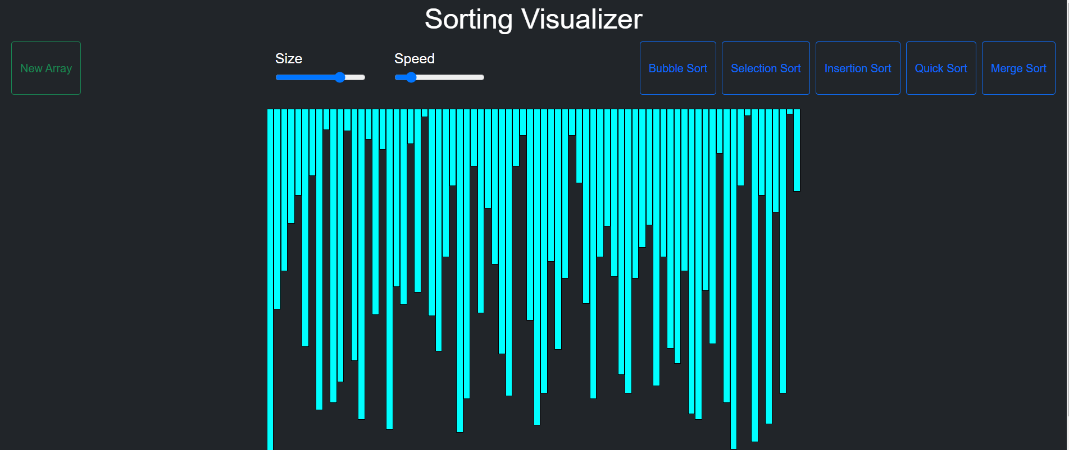

BUBBLE SORT

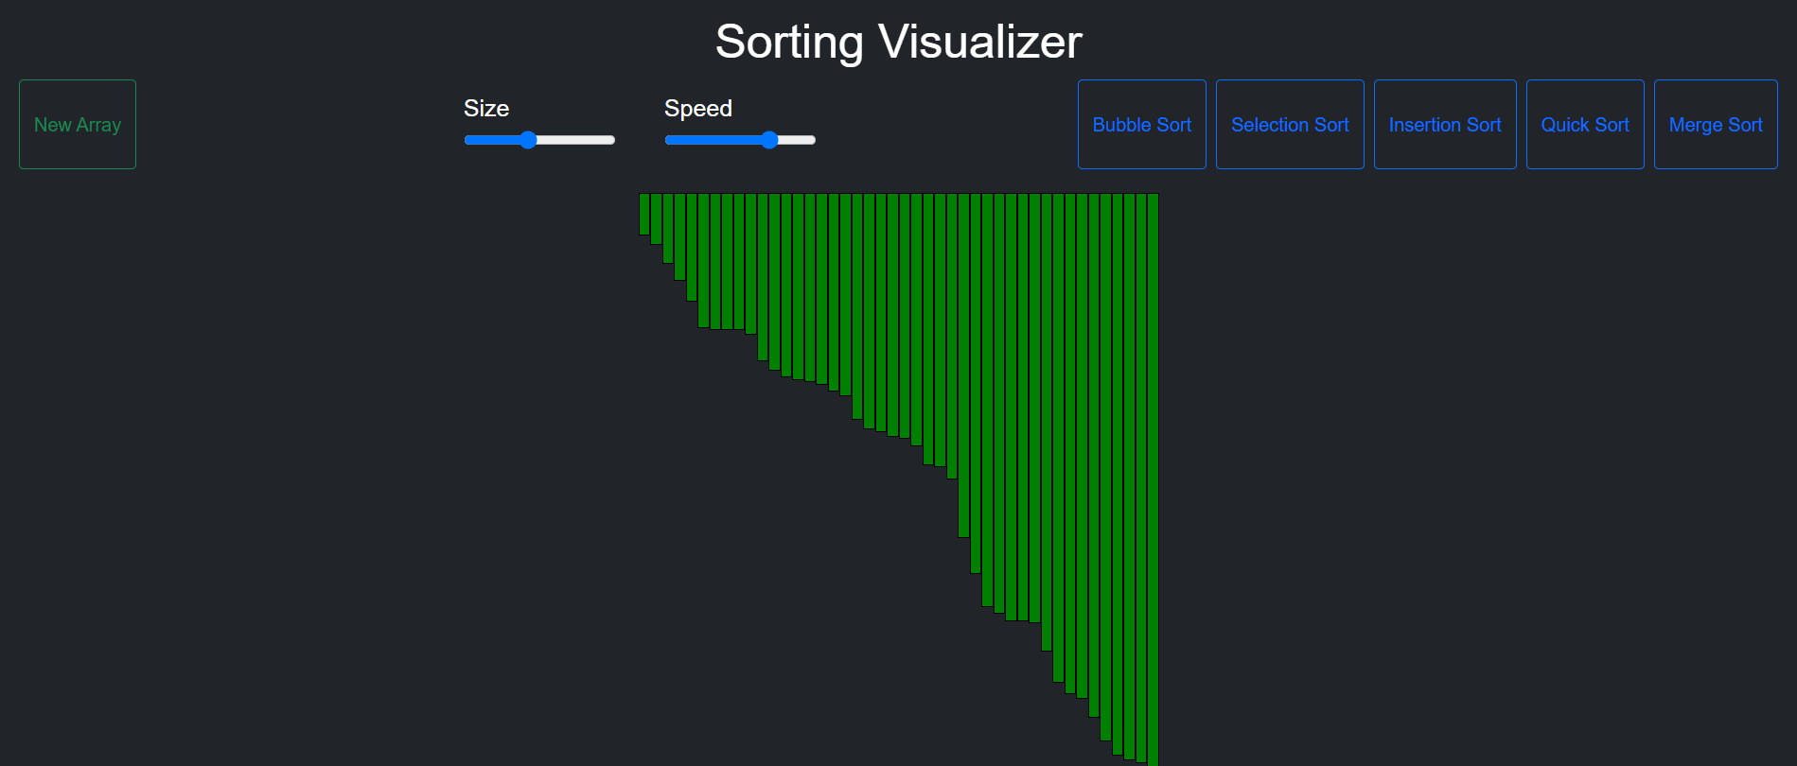

SELECTION SORT

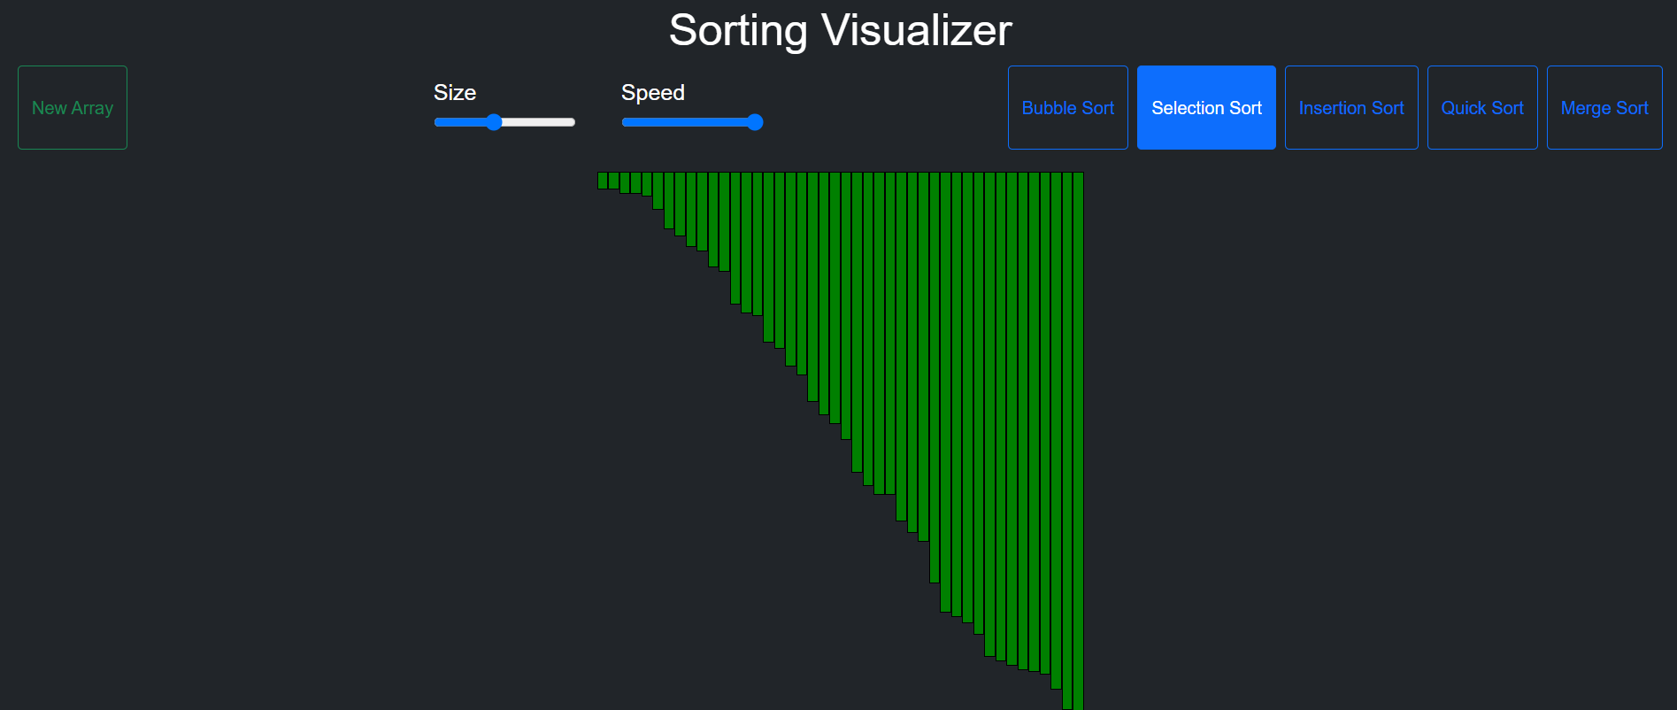

INSERTION SORT

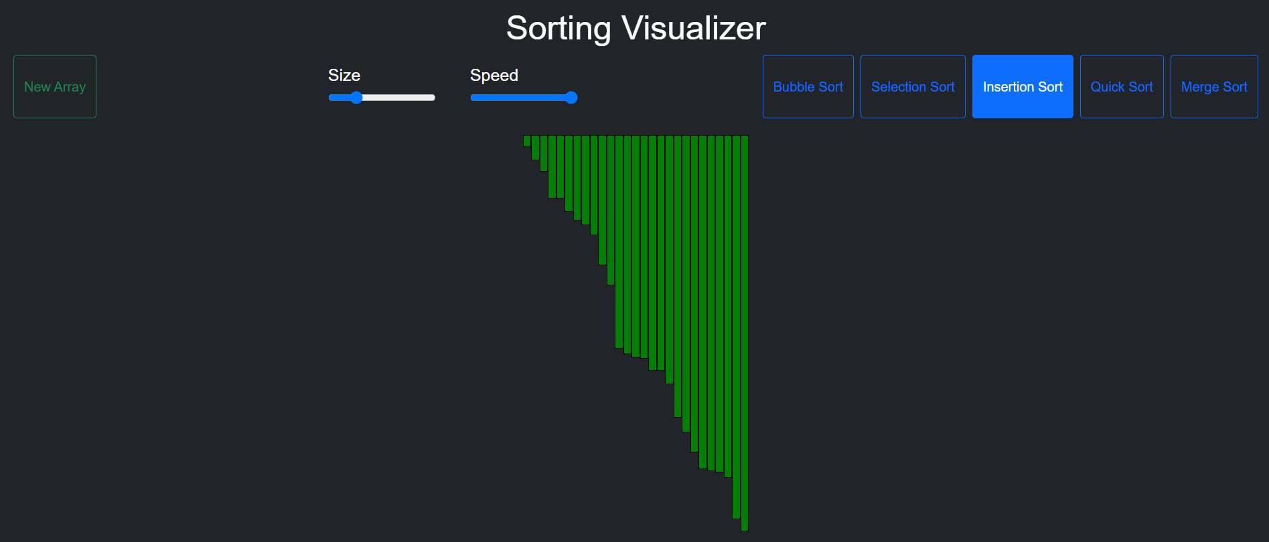

QUICK SORT

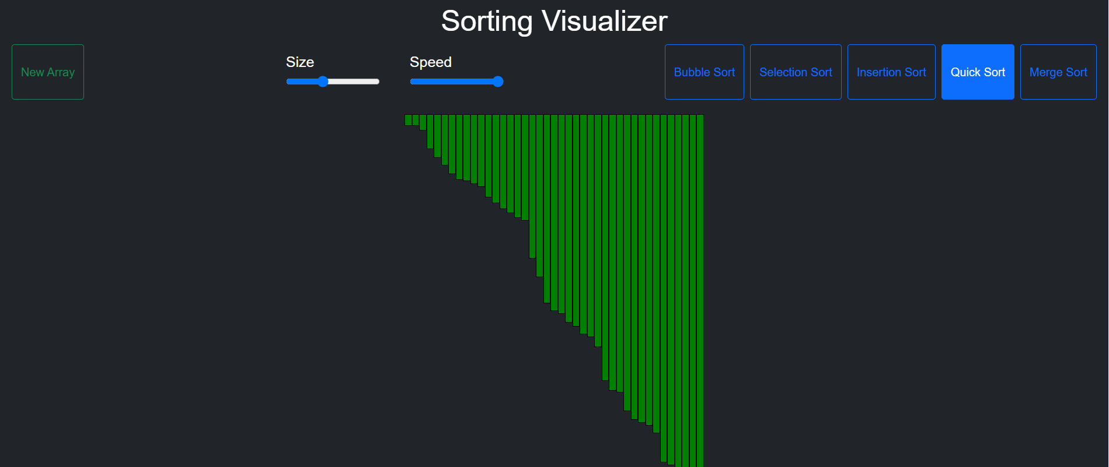

MERGE SORT

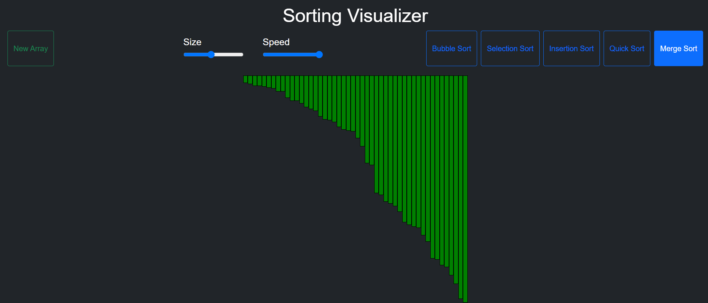

CONCLUSION

This ‘Sorting visualizer’ project is an excellent way to learn about and visualize various sorting algorithms. This project can help improve one's understanding of the underlying algorithms and their efficiency in sorting different types of datasets.
In this conclusion, we will summarize the key points of a sorting visualizer project using JavaScript and highlight some of the benefits and challenges of such projects.

Firstly, a sorting visualizer project typically involves building a web application that allows users to visualize various sorting algorithms. The user can input a dataset, and the web application will display the sorting algorithm's step-by-step process, including comparisons and swaps. The project can be built using various front-end technologies such as HTML, CSS, and JavaScript.

Secondly, the choice of sorting algorithm can significantly impact the efficiency of the project. Some sorting algorithms, such as bubble sort and selection sort, have a worst-case time complexity of O(n^2), while others, such as quicksort and merge sort, have an average-case time complexity of O(n log n). Quick sort and merge sort are often preferred for sorting visualizer projects as they are efficient at sorting large datasets.

Thirdly, implementing the chosen sorting algorithm in JavaScript requires a thorough understanding of the algorithm's underlying principles. The implementation must be efficient and accurate, and it should allow for visualization of each step of the algorithm's process.

Fourthly, a sorting visualizer project using JavaScript can help improve one's understanding of various sorting algorithms and their efficiency. It can also help improve programming skills, particularly in JavaScript and web development.

Lastly, a sorting visualizer project using JavaScript also poses some challenges. For instance, the web application must be responsive and provide users with a seamless experience. This requires optimizing the project's code and ensuring it works well with various browsers and devices.

In conclusion, sorting visualizer projects using JavaScript are an excellent way to learn about and visualize various sorting algorithms. These projects can improve one's understanding of the efficiency of different sorting algorithms and improve one's programming skills. While such projects can pose some challenges, the benefits far outweigh the challenges.

The project typically involves implementing different sorting algorithms and displaying the sorting process visually in a graphical user interface. The efficiency of the algorithms is a crucial factor in determining the speed and responsiveness of the visualization.

Quicksort and merge sort are generally good choices for sorting large datasets in a sorting visualizer project due to their average-case time complexity of O(n log n). Bubble sort, insertion sort, and selection sort may be less efficient choices due to their worst-case time complexity of O(n^2).

However, the specific requirements of the project may also play a role in determining the most appropriate algorithm to use. For small datasets or nearly sorted datasets, insertion sort may be a good choice, despite its higher time complexity, due to its simplicity and ease of implementation.

In addition to the choice of algorithm, the design and implementation of the graphical user interface is also an important consideration in a sorting visualizer project. The user interface should be intuitive and responsive, allowing users to interact with the sorting process in real-time.

Overall, a sorting visualizer project is a valuable tool for learning and understanding sorting algorithms. It provides a hands-on approach to learning, allowing users to see and interact with the sorting process in real-time. By implementing and visualizing different sorting algorithms, users can gain a deeper understanding of how these algorithms work and the trade-offs between them.

FUTURE SCOPE
This Sorting visualizer project is an excellent way to learn about and visualize various sorting algorithms. As technology continues to advance, there are numerous future scope and possibilities for this project sorting visualizer.

In this section, we will discuss some of the future scope for sorting visualizer project.

Improved Visualization Techniques:
Sorting visualizer projects can be extended to include more advanced and interactive visualization techniques. For instance, the project can use various animation techniques to visualize the sorting process, such as morphing and color transitions. The visualization techniques can be further enhanced by incorporating 3D rendering and virtual reality technologies.

Integration with Other Technologies:
Sorting visualizer projects can be integrated with various other technologies such as artificial intelligence, machine learning, and natural language processing. For instance, a sorting visualizer project can be integrated with a natural language processing algorithm to enable users to sort datasets using voice commands.

Real-time Sorting:
Real-time sorting is another area where sorting visualizer projects can be extended. Real-time sorting refers to sorting datasets as they arrive, rather than waiting for the entire dataset to be collected before sorting. This can be useful in various applications such as online marketplaces and social media platforms, where datasets are constantly updated.

Cloud Computing:
Cloud computing provides a scalable and cost-effective way to store and process large datasets. Sorting visualizer projects using JavaScript can be hosted on cloud platforms such as Amazon Web Services and Google Cloud, allowing users to sort and analyze datasets of any size.

Mobile Optimization:
Sorting visualizer projects using JavaScript can be optimized for mobile devices, enabling users to access the application from their mobile devices. This can be achieved by optimizing the project's code, using responsive web design techniques, and testing the project on various mobile devices.

Multi-language Support:
Sorting visualizer projects can be extended to include support for multiple languages. This can be achieved by providing language translation options or by using machine learning algorithms to automatically translate the application into different languages.

Education and Training:
Sorting visualizer projects using JavaScript can be used as a tool for education and training. These projects can be used to teach students about various sorting algorithms and their efficiency. Sorting visualizer projects can also be used to train developers on various programming languages and tools.

Gamification:
Gamification is another area where sorting visualizer projects can be extended. Sorting visualizer projects using JavaScript can be gamified by incorporating various game elements such as scoring, levels, and achievements. This can make the application more engaging and increase user retention.

Benchmarking and Performance Testing:
Sorting visualizer projects using JavaScript can be extended to include benchmarking and performance testing capabilities. These capabilities can enable developers to compare the efficiency of different sorting algorithms and identify areas for optimization.

Big Data Analytics:
Sorting visualizer projects using JavaScript can be extended to include big data analytics capabilities. These capabilities can enable developers to analyze large datasets and gain insights into patterns and trends.

In conclusion, sorting visualizer projects using JavaScript offer numerous future scope and possibilities. The projects can be extended to include more advanced and interactive visualization techniques, integration with other technologies, real-time sorting capabilities, cloud computing, mobile optimization, multi-language support, education and training, gamification, benchmarking and performance testing, and big data analytics capabilities. These future scope and possibilities can help improve the efficiency, scalability, and functionality of sorting visualizer projects using JavaScript.

BIBLIOGRAPHY

- CORMEN, T. H.; LEISERSON, C. E.; RIVEST, D. L.; STEIN, C. Introduction to algorithms. Second Edition. 2001. ISBN 0-262-03293-7.
- KNUTH, D. The Art of Computer Programming: Fundamental Algorithms. ThirdEdition. 2004. ISBN 0-201-89683-4.
- SIPSER, M. Introduction to the Theory of Computation. Boston, MA: PWSPublishing Company, 1997. ISBN 0-534-94728-X.
- BĚLOHLÁVEK, R. Algoritmická matematika 1: část 2. Available also from:
http://belohlavek.inf.upol.cz/vyuka/algoritmicka-matematika-1-2.pdfi.
- KNUTH, D. The Art of Computer Programming: Sorting and Searching. SecondEdition. 2004. ISBN 0-201-89685-0.
- SEDGEWIK, R. Algorithms in C : Fundamentals, data structures, sorting, searching. Third Edition. 2007. ISBN 0-201-31452-5.
- GeeksforGeeks. Available from: h https://www.geeksforgeeks.org/i .[8] BĚLOHLÁVEK, R. Algoritmická matematika 1 : část 1. Available also from:
http://belohlavek.inf.upol.cz/vyuka/algoritmicka-matematika-1-1.pdfi.
- Stackoverflow. Available from: h https://stackoverflow.com/i.

