Lab 7: Code and Branch Coverage Analysis

Objective
- Understand the difference between code coverage and branch coverage.
- Use coverage to measure, analyse, and improve test coverage.
- Interpret coverage reports and identify untested paths in code.
- Practice writing test cases that cover edge cases and decision branches.

Duration:
90 minutes

Software Requirements
- Python 3.x
- coverage (install via pip)
- Any code editor (VS Code / PyCharm / Sublime / etc.)
- pytest or unittest (either is fine)
💡 Coverage can be used standalone or with test frameworks.

Learning Outcomes
- Understand Code Coverage Concepts: You will differentiate between line coverage, branch coverage, path coverage, and function coverage to measure test completeness.
- Apply Coverage Analysis Tools: You will use Python's coverage library to generate reports, interpret coverage metrics, and identify untested code paths.
- Design Comprehensive Test Cases: You will write targeted test cases to achieve minimum 90% coverage by addressing edge cases and decision branches.

NOTE: Students may be randomly called for a presentation after completing the lab. Please be prepared to discuss your code, bugs you found, and how you fixed them.

Introduction
What is Code Coverage?
Code coverage measures how much of your source code is executed during testing.
Types of coverage:
Type | Meaning
Line Coverage | How many lines of code were executed
Branch Coverage | How many branches (e.g., if, else) were followed
Path Coverage | How many unique paths through code were tested
Function Coverage | How many functions were invoked during tests
Why It Matters:
- High coverage improves confidence in correctness.
- Helps catch untested paths and dead code.
Encourages test completeness, especially in critical systems

Folder Structure:
PES1UG23CSXXX/
├── order_processor.py # Main code to test
├── test_processor_CSXXX.py # Incomplete starter test file, replace XXX with SRN
└── Instructions Manual

RENAME FOLDER and test_processor file TO YOUR SRNS BEFORE RUNNING.

Deliverables:
- Coverage analysis & report (Screenshots)
- Test_processor.py (after completing the test cases)
- Reflection answers in the same document

Steps:
- Install dependencies:
pip install coverage

- Run the original test file given to you
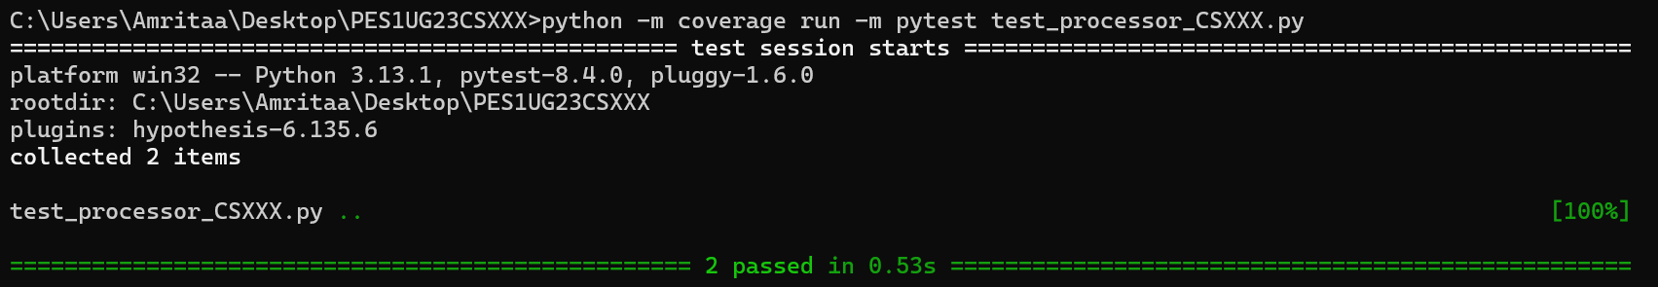
python -m coverage run -m pytest test_processor_CSXXX.py

- python -m coverage report -m
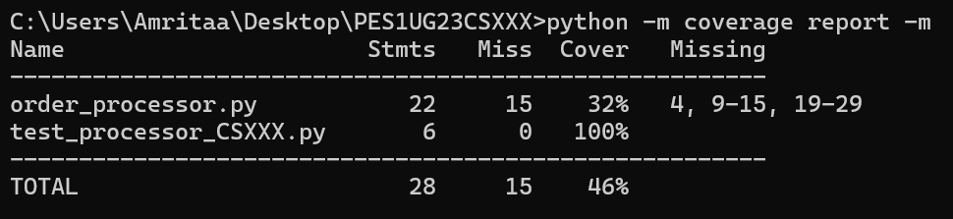
- python -m coverage html
Note: After running python -m coverage html, you might see a file path printed in the terminal (e.g., htmlcov/index.html) instead of a clickable link. This path points to a folder named htmlcov, which contains the generated coverage report. To view the report, open the index.html file from the htmlcov folder located in your current directory manually.
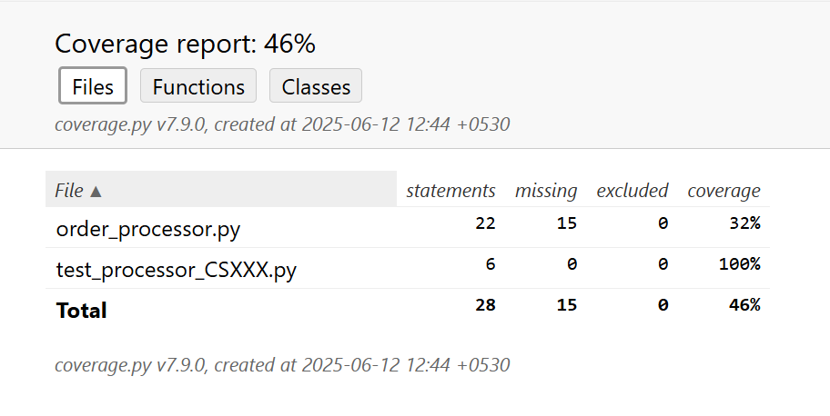

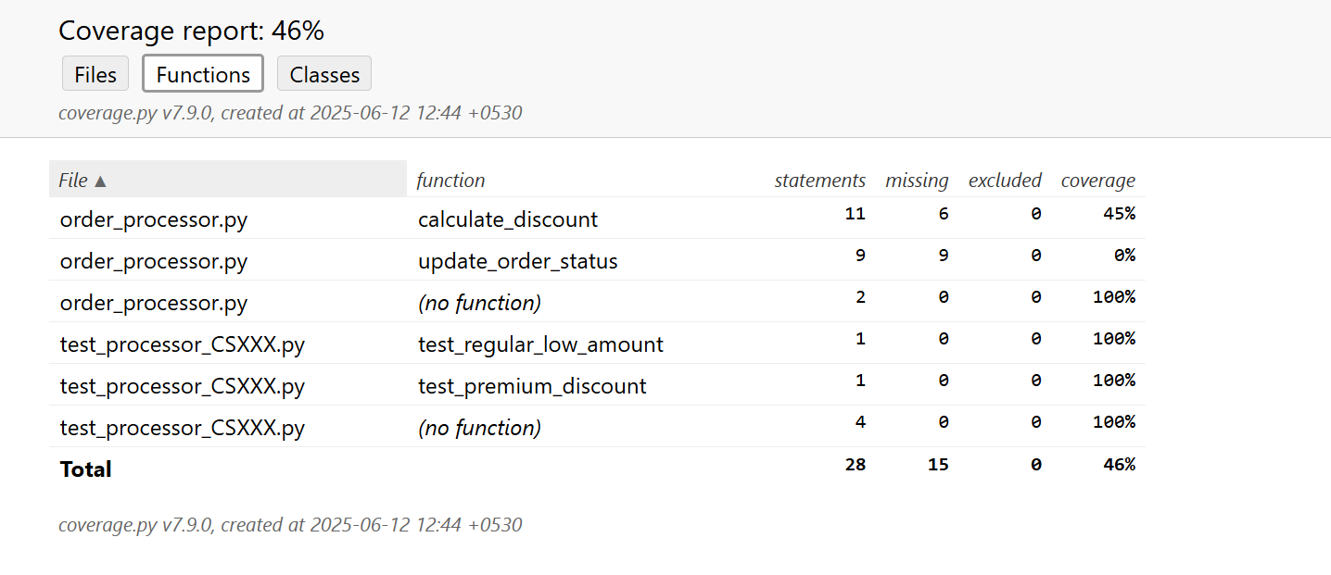

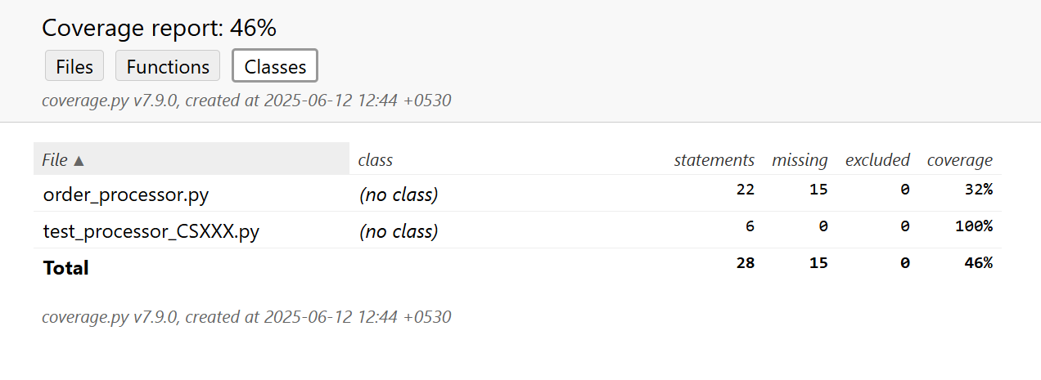

Note (for some Python 3 users):
If your coverage report includes too many files or shows files outside your lab folder, it means coverage is tracking more than just your code. You can fix this by telling it exactly which files to check using the --source option.
Use this command instead of the regular one:
python -m coverage run --source=order_processor.py,test_processor_CSXXX.py -m pytest test_processor_CSXXX.py
This keeps the coverage report focused only on the files you’re working with.
- Write more test cases in the test file to achieve atleast 90% coverage. Re-run steps 2-4 and provide similar screenshots as above for the results. Give screenshots ONLY for results after achieving atleast 90% coverage.
(Please make sure to change your SRNs wherever needed)

Reflection:
- If the logic in order_processor.py changes, what’s your strategy to ensure tests and coverage stay updated?
- What are the trade-offs between writing more tests for coverage vs writing fewer high-quality tests?

