1. **ReactJS-HOL**

**Commands used:**

# Install Create React App

npm install -g create-react-app

# Create new React app

npx create-react-app myfirstreact

# Navigate into app

cd myfirstreact

# Open in VS Code

code .

# Run the app

npm start

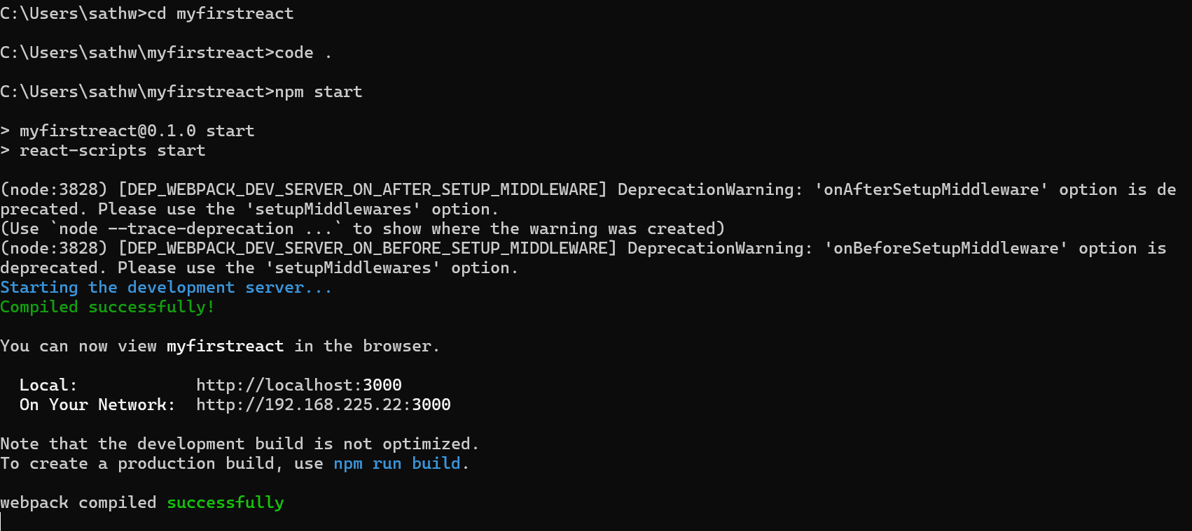

**App.js:**

import React from 'react';

function App() {

  return (

    <div>

      <h1>welcome to the first session of React</h1>

    </div>

  );

}

export default App;

**Output:**

