**Predicting Ticket Prices for Big Mountain Resort**

**Sathwik Kesappragada**

*Introduction*

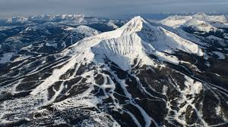Big Mountain Resort, being one of the 12 resorts in Montana, is a highly visited snow summit located near two extremely popular tourist attractions, Glacier National Forest, and Flathead National Forest. On average every year approximately 350,000 visitors of all ages come to this mountain that contains over 100 runs, 14 chairs, 2354 feet vertical drop, and a whopping 3000 acres of skiable terrain to ride and explore. Recently, management expressed that BMR had not been earning as much as it possibly could. Due to the lack of gains, executives are pushing for a new strategy in determining a proper ticket price that will not only keep in mind operational costs, but also ensure that all facilities are being used to its potential. Data regarding all snow summits in the United States has been given from the database manager.

*Data & Preprocessing*

The dataset consisted of 330 resorts across America with 27 features such as number of runs, size of snowmaking terrain, number of fast quads, area for night skiing that will help us get a better idea of where BMR is situated amongst its competitors. The cost of the ticket can be established simply by comparisons and narrowing our focus to key aspects that should be prioritized. After tidying up the information and retrieving pivotal results, the data was partitioned into 70% for the training set and 30% for the test set. This step is crucial for evaluating which metric to pinpoint and understand its impact. Using scikitlearn functions, both training and test sets had missing values imputed and scaled before observing model performances.

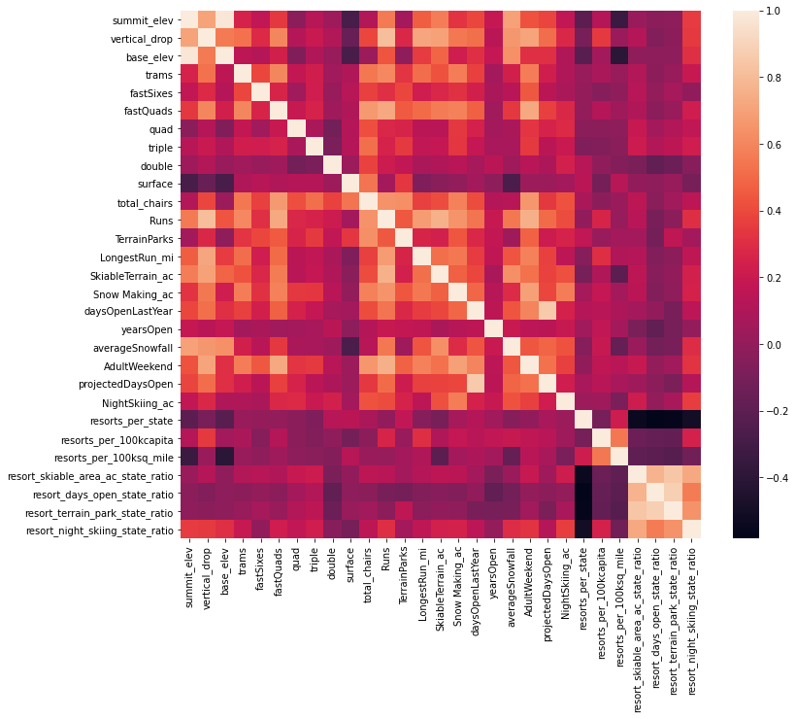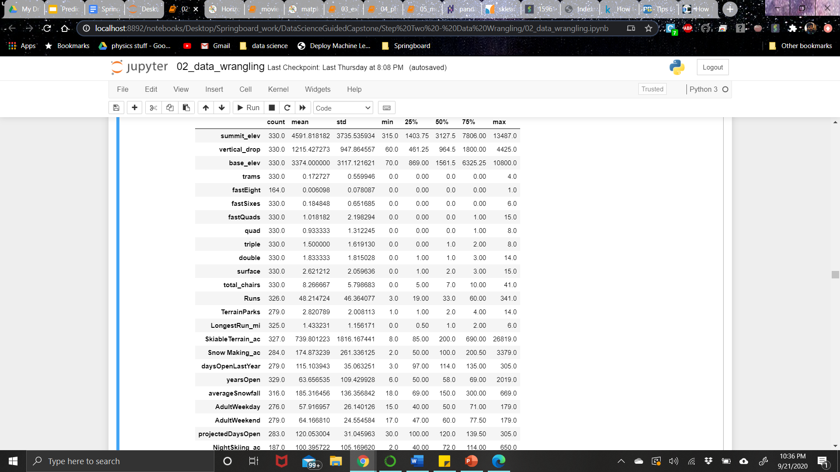

*Models*

Beginning with a simple linear regression, we aim to identify features that will better help predict ticket prices. To assess models, we need to inspect the r2 and mean absolute error values. The linear regression model performed covers over 80% of the variance on the train set and over 70% on the test set. Additionally, we can refine the model by using cross validation and a hyperparameter, GridSearchCV, to pick the k value that delivers the best performance. Cross validation method cycles through k times and calculates k estimates on how well the model performs at each instance. By using the best estimator, we get that k=8 is a good value that yields the best model. Furthermore, applying the Random Forest model, we get slightly better cv results because of more adjustable hyperparameters. Moreover, common features that stood out in both models were number of fast quads, number of runs, snow making area, and vertical drop.

|  |  |  |
| --- | --- | --- |
|  | **Linear Regression** | **Random Forest** |
| Mean Absolute Error | 11.793465668669327 | 9.537730050637332 |
| Mean, Standard Deviation | (10.49903233801529, 1.6220608976799664) | (9.644639167595688, 1.3528565172191818) |

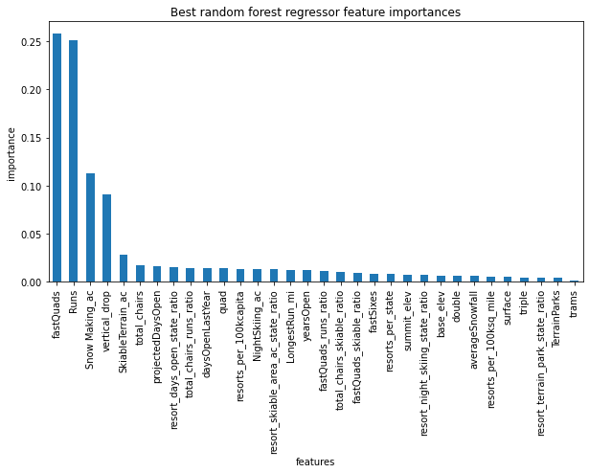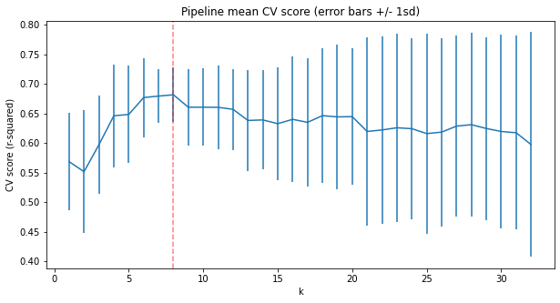

*Results & Discussion*

After removing Big Mountain Resort from the dataset, we refitted the model to train on all the other summits to determine how our resort of interest is doing compared to its competition. The whole objective is to adjust our prices accordingly. Using prominent features that have an impact on ticket pricing, we can conclude that BMR is above the mean in adult weekend price and vertical drop as well as very high up in sections such as snow making area, number of chairs, fast quads, number of runs, longest run, and skiable terrain. Moving forward, on the other side of increasing revenue BMR is considering of reviewing potential scenarios to cut costs such as the closure of at least 10 runs. There is no difference in price and revenue if one run was closed however, the more 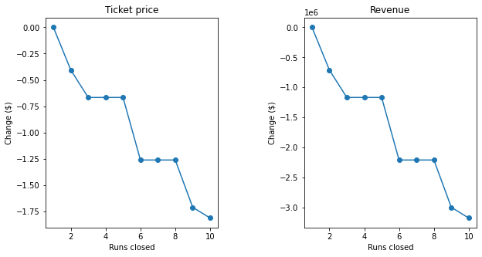runs closed the bigger the drop is meaning closing runs yields to cheaper tickets and a loss. In like manner, if we tweaked features by adding one more run, 150 feet to the vertical drop, and one more chair it supports an increase in ticket price of $1.99 yielding to $3,474,638 in revenue over the course of a season. Since we have noticed a gain, we added a couple more features with changes such as extending the longest run by 0.2 miles and snow making area by 4 acres to detect any positive influence however, concluded with no difference whatsoever.

*Suggestions*

The main goal for the project was to establish a reasonable ticket price for Big Mountain Resort while evaluating which features boost the snow summit. BMR currently charges $81 for adult weekend tickets and is among the topmost expensive resorts. The model suggests by adding one more run, 150 more feet to the vertical drop, and one more chair can make up for a $1.99 increase in ticket price which in turn yields to $3,474,638 for the whole season. Keeping in mind that 44% of the revenue increase will be directed towards operational costs, BMRs purpose to capitalize on all its facilities has been achieved. The modeled ticket price was much higher than the actual ticket price because there exists a possibility that BMR is undercharging its customers. This mismatch is surprising because it demonstrates how BMR is doing when compared to its competitors.

*Conclusion*

Big Mountain Resort is struggling to reach its potential by profiting off of its current state and is stressing on a new strategy to determine a fair ticket price. After thorough research, we found that developing three sectors is a feasible solution. It’s surprising to see where BMR is positioned in key areas compared to its opposition. The results point out that in order for the summit to sustain an increase in ticket prices, it needs to expand on a couple of its facilities. By doing so, BMR has the potential rise in visitors and definite gain in revenue.

*Future Work/Remarks*

Although the number of visitors that come to Big Mountain was given, having information such as the average number of visitors per season and on average how many days customers purchase those tickets for every resort would've been very beneficial in developing a better model. Additionally, keeping in mind that usually there are more visitors at a resort on weekends, information about how many tickets are purchased during weekends compared to the weekday (specifically days, if possible) would be helpful. A breakdown of total operating costs can inform how much machinery is used and stress the resort to efficiently use their equipment to avoid a loss.