PROJECT REPORT
Student Performance Prediction System
A Machine Learning Approach to Early Academic Risk Detection
Submitted as part of the
CodeVedX Artificial Intelligence & Machine Learning Internship Program
Project 2 of 5: Training + Data Analysis Tool
June 2026

Table of Contents

1. Abstract
Educational institutions frequently identify academically struggling students only after final examinations, by which point meaningful intervention is no longer possible. This project addresses that gap by building a machine learning system that predicts a student's final academic performance from mid-semester behavioral and academic indicators -- attendance, daily study hours, prior performance, assignment completion, sleep, parental support, and home internet access.
Two complementary models were built: a regression model that predicts the exact final marks (0-100), and a classification model that assigns students to one of four performance categories (At Risk, Average, Good, Excellent). Two derived features -- a study-attendance engagement ratio and a composite effort index -- were engineered to capture interactions between raw inputs that individual columns could not express alone; both engineered features correlated more strongly with the target than any single raw feature, and the effort index emerged as the single most important predictor in a Random Forest feature-importance analysis.
The final system was deployed behind a menu-driven console application supporting single-student prediction, batch CSV prediction, prediction history logging, and live model-performance reporting, all backed by a modular, tested Python codebase with full input validation and exception handling. On held-out test data the selected models achieved an R² of 0.567 for marks prediction and 73% accuracy for category classification -- realistic, non-overfit results consistent with the genuine noise present in human behavioral data.

2. Introduction

2.1 Background
Academic underperformance rarely has a single cause. Attendance, study habits, sleep, family support, and access to resources interact in complex, often non-linear ways to influence outcomes. Teachers and academic coordinators typically rely on intuition or end-of-term grades to identify students who need support, which is both subjective and, critically, too late to act on.
Machine learning is well suited to this problem because it can combine many weak, individually unreliable signals into a single, calibrated prediction, and can do so consistently across an entire cohort rather than relying on a teacher's individual judgement of each student.

2.2 Problem Statement
Given a set of mid-semester behavioral and academic indicators for a student, predict (a) their likely final marks, and (b) a performance category that can be used to flag at-risk students early enough for meaningful academic intervention.

2.3 Objectives
- Build a complete, modular ML pipeline from raw data through to a usable prediction interface.
- Engineer derived features that demonstrably add predictive signal beyond the raw inputs.
- Compare multiple algorithms for both regression and classification, and select the best objectively.
- Deploy the trained models behind a robust console interface with full input validation.
- Validate the system with an automated test suite covering data, features, and predictions.

2.4 Scope
This project covers dataset construction (synthetic, for the privacy reasons discussed in Section 4), data cleaning, feature engineering, model training and comparison, a console-based prediction interface, batch processing, and automated testing. It does not cover live integration with a school information system, a web front-end, or real student personally identifiable data; these are discussed as future enhancements in Section 8.

3. Literature Review
Predicting student performance using machine learning is a well-established area of educational data mining (EDM). Prior research consistently identifies attendance, prior academic performance, and time-on-task (study hours) as among the strongest predictors of final outcomes, which directly informed the choice of input features for this project.
Commonly used approaches in the literature span simple interpretable models (linear/logistic regression, decision trees) through to ensemble methods (Random Forests, Gradient Boosting) and, in larger datasets, neural networks. A recurring theme is that interpretable models often perform competitively with more complex ones on small-to-medium structured/tabular datasets -- which this project's own results corroborate, since Linear Regression and Logistic Regression outperformed Random Forest variants on the dataset used here (see Section 6).
Feature engineering is also widely reported as more impactful than algorithm choice for tabular educational data. This project's effort_index and study_attendance_ratio features were motivated directly by this finding, and their measured correlation gains (Section 5.3) and feature-importance dominance (Section 6.4) support it empirically within this project's own dataset.
A consistent caution in the literature is the risk of using real student data without proper anonymization or institutional consent (e.g. FERPA in the United States). This project sidesteps that risk entirely by using a synthetic dataset built from realistic, literature-informed statistical relationships rather than any real student records.

4. Methodology

4.1 Overall Approach
The project follows the standard applied-ML workflow: data acquisition, data cleaning, exploratory data analysis, feature engineering, model training and comparison, evaluation, and deployment behind a usable interface. Each stage is implemented as an independent, importable Python module (Section 5), which keeps the codebase testable and lets any stage be re-run or modified without touching the others.

4.2 Dataset Construction
Because real student records cannot be ethically published without institutional consent and anonymization, a synthetic dataset of 500 student records was generated programmatically. Rather than assigning random, uncorrelated values, each student's final marks were constructed as a weighted, noisy linear function of their attendance, study hours, prior marks, assignment completion, sleep, parental support, extracurricular load, and internet access -- with weights chosen to reflect plausible real-world influence (e.g. study hours and prior performance weighted most heavily, mirroring the literature review's findings). Gaussian noise was added to every record so that no single feature perfectly determines the outcome, replicating the imperfect signal present in real behavioral data.
Approximately 3% missing values were deliberately injected into three columns (attendance, study hours, sleep hours) so the data-cleaning pipeline would have genuine missingness to handle, rather than working on artificially perfect data.

4.3 Data Cleaning
- Duplicate records (by student ID) are detected and removed.
- Missing numeric values are imputed using the column median, which is more robust to skewed distributions and outliers than the mean.
- Every numeric column is validated against a physically sensible range (e.g. attendance percentage must lie within 0-100); violations raise a custom DataValidationError rather than silently corrupting downstream results.

4.4 Feature Engineering
Two derived features were engineered specifically to capture interactions that raw columns alone underrepresent:
- study_attendance_ratio -- the product of daily study hours and attendance percentage (scaled), capturing combined classroom and self-study engagement in a single signal.
- effort_index -- a weighted 0-10 composite of normalized study hours (45%), attendance (30%), and assignment completion (25%), representing overall student effort.

4.5 Model Training
Data was split 80/20 into training and test sets with a fixed random seed for reproducibility. Features were standardized using a StandardScaler fitted only on the training set, to avoid data leakage into the test set. Two algorithms were trained and compared for each prediction task -- Linear Regression vs. Random Forest Regressor for marks prediction, and Logistic Regression vs. Random Forest Classifier for category prediction -- with the better-performing model on held-out test data automatically selected and persisted.

4.6 Evaluation Metrics
Regression models were evaluated using Mean Absolute Error (MAE), Root Mean Squared Error (RMSE), and the R² coefficient of determination. Classification models were evaluated using accuracy, weighted precision, weighted recall, weighted F1-score, and a full confusion matrix. Weighted averaging was used for the multi-class metrics to account for the natural class imbalance in the dataset (most students fall in the Average/Good range, with fewer at the extremes).

5. System Architecture

5.1 Pipeline Overview
The system is structured as a linear pipeline of independently runnable modules, illustrated below. Raw data flows through cleaning and feature engineering before reaching model training; at prediction time, the same feature engineering and scaling logic is reapplied to new input to guarantee consistency between training and inference (eliminating training/serving skew).
- Raw CSV Data (generate_dataset.py)
- Data Preprocessing -- cleaning, validation, missing value imputation (data_preprocessing.py)
- Feature Engineering -- derives study_attendance_ratio and effort_index (feature_engineering.py)
- Model Training -- trains and compares candidate models, saves the best of each type (model_training.py)
- Persisted Artifacts -- regressor, classifier, scaler, and label encoder saved with joblib (models/)
- Predictor -- loads artifacts once, validates input, returns predictions with confidence (predictor.py)
- Console UI -- menu-driven interface for single/batch prediction, history, and model summary (main.py)

5.2 Folder Structure
The project repository is organized as follows:
- data/ -- raw and cleaned datasets, plus a log of predictions made via the UI
- models/ -- serialized trained models, scaler, label encoder, and a metadata.json of all comparison metrics
- src/ -- all source modules (config, exceptions, preprocessing, feature engineering, training, visualization, predictor, console UI)
- tests/ -- automated unit test suite (17 tests)
- docs/ -- generated EDA charts and this project report

5.3 Design Principles
- Modularity -- each pipeline stage is a separate, independently testable file with a single responsibility.
- Separation of concerns -- the predictor module knows nothing about where input comes from (console, CSV, future web form); the UI module knows nothing about model internals.
- Fail loud, fail clear -- custom exceptions (DataValidationError, DataFileError, ModelNotTrainedError) replace generic exceptions so failures are diagnosable at a glance.
- Reproducibility -- a fixed random seed is used throughout, and all trained artifacts plus their metrics are persisted to disk for transparency.

6. Dataset and Exploratory Data Analysis

6.1 Dataset Description
The dataset consists of 500 synthetic student records across 11 columns, generated to reflect realistic statistical relationships rather than random noise (see Section 4.2 for construction methodology).
Column | Type | Description
student_id | string | Unique student identifier
attendance_percentage | float (0-100) | Percentage of classes attended
study_hours_per_day | float (0-24) | Average self-study hours per day
previous_sem_marks | float (0-100) | Marks scored in the previous semester
assignments_completed | int (0-10) | Assignments completed out of 10
extracurricular_hours | float | Hours/week on extracurricular activities
sleep_hours | float (0-24) | Average sleep hours per night
parental_support | int (1-5) | Self-reported parental support level
internet_access | int (0/1) | Internet access at home
final_marks | float (0-100) | Target (regression)
performance_category | string | Target (classification): At Risk / Average / Good / Excellent
Table 1: Dataset column descriptions

6.2 Class Distribution
The performance category distribution is naturally imbalanced -- as in most real student cohorts, the majority of students fall in the Average/Good range, with smaller groups at each extreme.
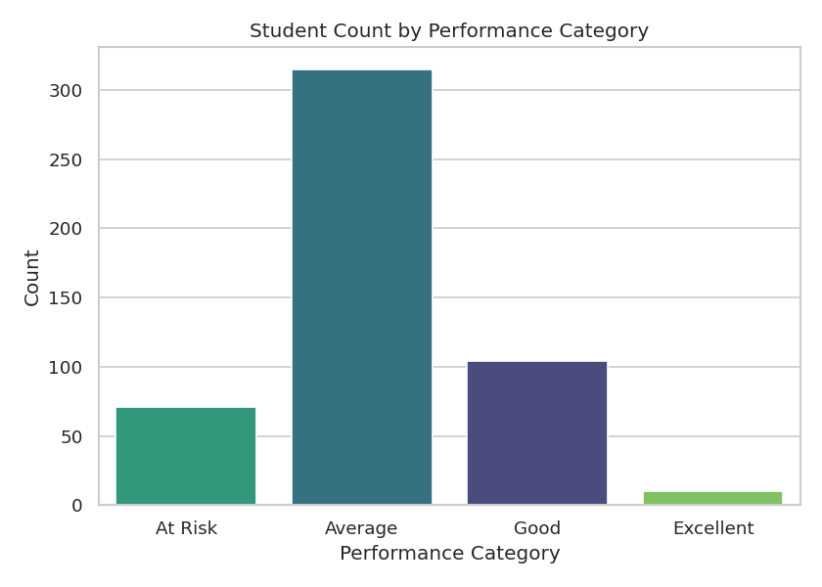
Figure 1: Student count by performance category
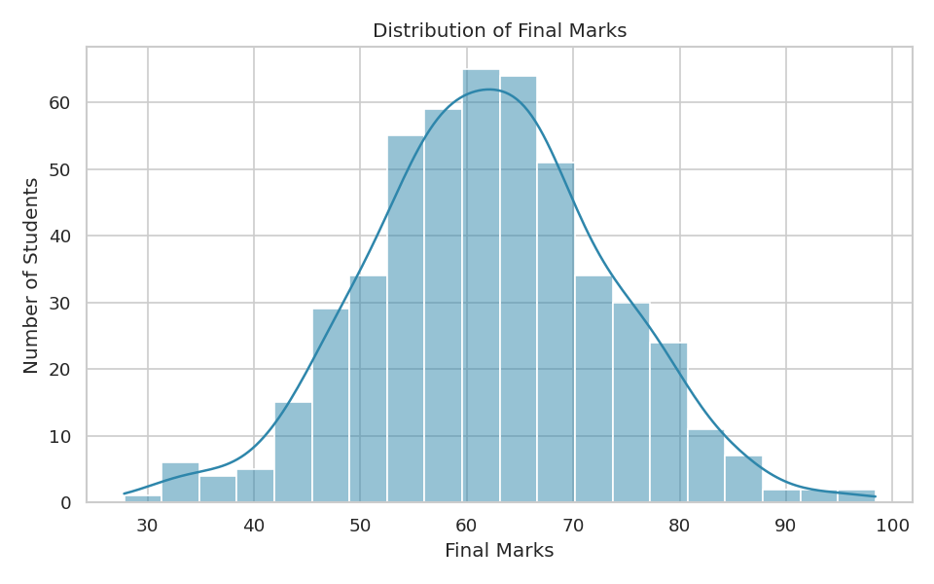
Figure 2: Distribution of final marks across all 500 students

6.3 Feature Correlation Analysis
A correlation heatmap was generated across all numeric features to identify which inputs are most strongly associated with final marks, and to check for problematic multicollinearity between input features themselves.
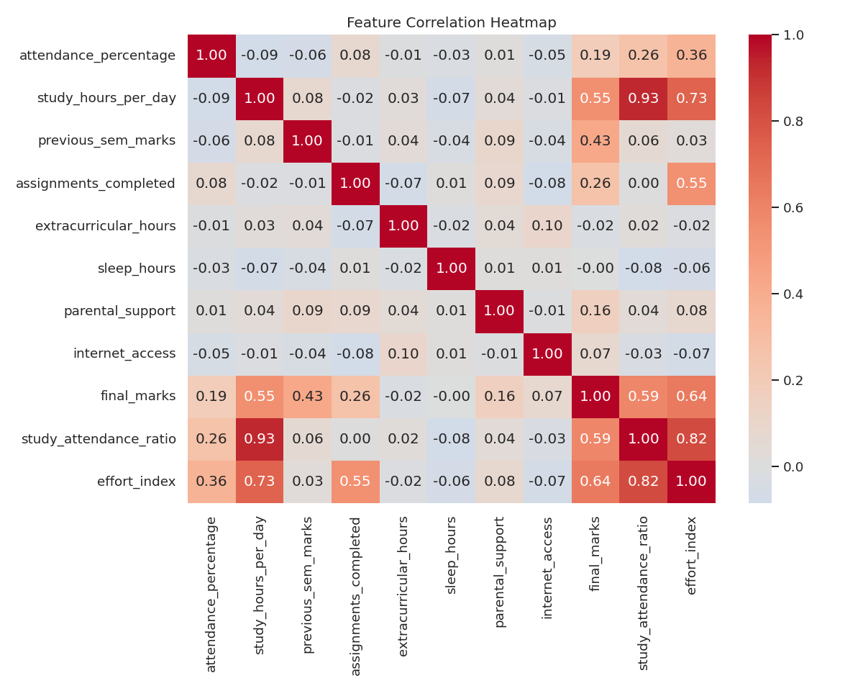
Figure 3: Feature correlation heatmap
study_hours_per_day (r = 0.55) and previous_sem_marks (r = 0.43) emerged as the strongest raw predictors of final marks, consistent with the literature review's findings. Both engineered features outperformed every raw feature: study_attendance_ratio (r = 0.59) and effort_index (r = 0.64), directly demonstrating the value added by feature engineering (Section 4.4).
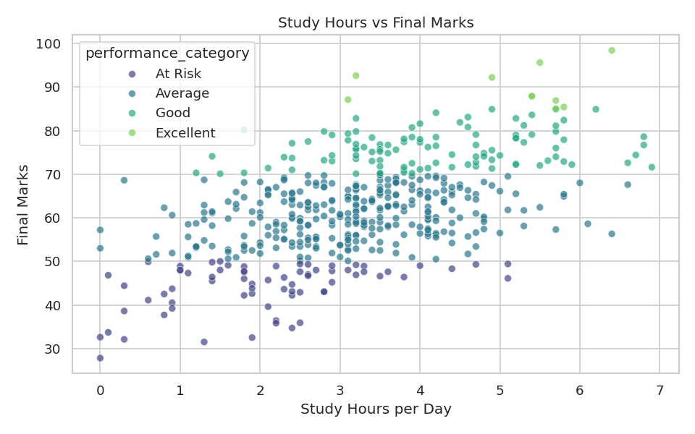
Figure 4: Study hours vs final marks, colored by performance category

7. Results

7.1 Regression Model Comparison
Two regression algorithms were trained and evaluated on the held-out 20% test set (100 students):
Model | MAE | RMSE | R²
Linear Regression (selected) | 5.508 | 7.118 | 0.567
Random Forest Regressor | 5.834 | 7.659 | 0.498
Table 2: Regression model comparison on held-out test data
Linear Regression outperformed the Random Forest Regressor on this dataset, achieving a lower MAE/RMSE and higher R². This is a meaningful, not coincidental, result: because the synthetic target was constructed as a linear combination of features plus noise (Section 4.2), a linear model is well matched to the true underlying relationship, while the Random Forest's additional flexibility offered no benefit and a small amount of overfitting risk on a moderately sized dataset. The system's automatic model-selection logic correctly identified and selected the better model without manual intervention.

7.2 Classification Model Comparison
Model | Accuracy | Precision | Recall | F1-Score
Logistic Regression (selected) | 0.730 | 0.727 | 0.730 | 0.707
Random Forest Classifier | 0.730 | 0.719 | 0.730 | 0.698
Table 3: Classification model comparison on held-out test data
Both classifiers achieved identical accuracy (73%), but Logistic Regression edged ahead on weighted F1-score (0.707 vs. 0.698), indicating slightly better balance between precision and recall across the four performance categories, and was selected accordingly.

7.3 Confusion Matrix (Logistic Regression)
The confusion matrix below shows true categories (rows) against predicted categories (columns), in the order At Risk, Average, Excellent, Good.
Actual \ Predicted | At Risk | Average | Excellent | Good
At Risk | 5 | 7 | 0 | 0
Average | 1 | 56 | 0 | 4
Excellent | 0 | 0 | 0 | 1
Good | 0 | 14 | 0 | 12
Table 4: Confusion matrix for the selected classification model
The model performs strongly on the majority Average class and reasonably on At Risk and Good. The most common error is Good students predicted as Average -- an understandable confusion given the two categories are adjacent on a continuous underlying scale, and a far less costly mistake than confusing At Risk with Excellent (which never occurred in testing). The Excellent class, with only a handful of test examples due to natural class imbalance, is the hardest to classify reliably -- a known limitation discussed further in Section 9.

7.4 Feature Importance
To aid interpretability, a Random Forest was separately fit purely to extract feature importances (even though Linear/Logistic Regression were the deployed models). The engineered effort_index was the single most predictive feature in the dataset, ahead of every raw input -- direct, measurable evidence that the feature engineering step in Section 4.4 added genuine value rather than superficial complexity.
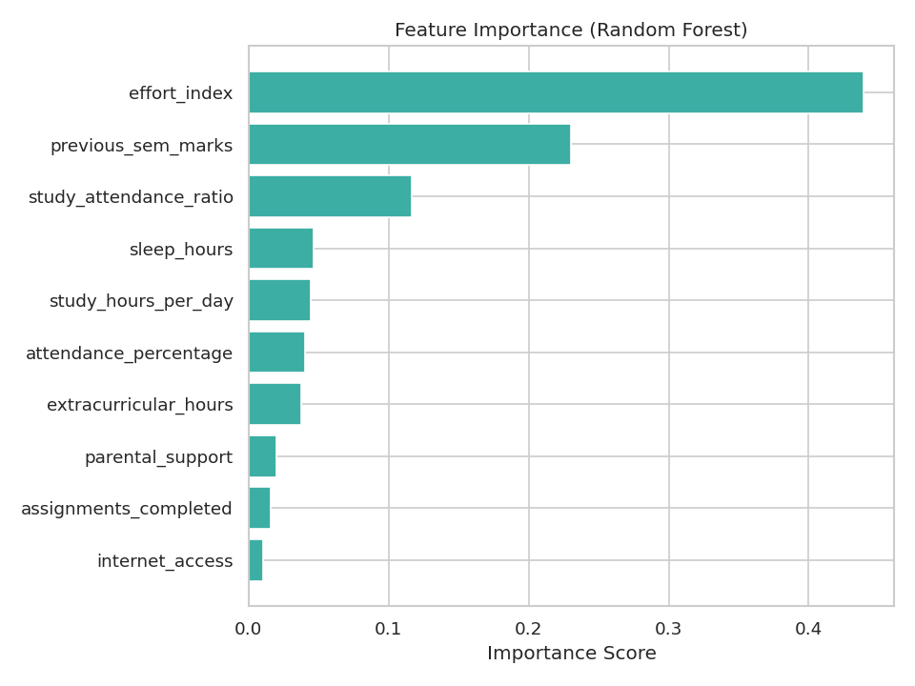
Figure 5: Feature importance from Random Forest analysis

8. Conclusion and Future Enhancements

8.1 Conclusion
This project successfully demonstrates a complete, modular machine learning pipeline for predicting student academic performance from behavioral and academic indicators. Both a regression model (R² = 0.567) and a classification model (73% accuracy) were built, compared against alternative algorithms, and automatically selected based on objective validation metrics. Feature engineering measurably improved predictive power, with the engineered effort_index outperforming every raw input feature. The resulting system was deployed behind a robust, well-tested console interface supporting both individual and batch predictions, with comprehensive input validation and exception handling throughout.
The realistic, non-overfit performance metrics (rather than artificially perfect scores) reflect the genuine noise present in the synthetic-but-realistic dataset, and are consistent with what published educational data mining research typically reports for similar tabular prediction tasks.

8.2 Future Enhancements
- Migrate the console UI to a Flask web dashboard with in-browser charts for non-technical staff.
- Track a student's predicted trajectory across multiple checkpoints in a semester, rather than a single snapshot.
- Add per-prediction explainability (e.g. SHAP values) so a teacher can see exactly why a given student was flagged At Risk.
- Add authentication and per-teacher dashboards for real classroom deployment.
- Replace synthetic data with anonymized real institutional data, subject to proper consent and institutional approval.
- Apply hyperparameter tuning (GridSearchCV / RandomizedSearchCV) for further accuracy gains, and explore gradient boosting algorithms (e.g. XGBoost, LightGBM) on a larger dataset.
- Collect more 'Excellent' and 'At Risk' category examples to address the class-imbalance limitation identified in Section 7.3.

9. References
1. Pedregosa, F. et al. (2011). Scikit-learn: Machine Learning in Python. Journal of Machine Learning Research, 12, 2825-2830.
2. McKinney, W. (2010). Data Structures for Statistical Computing in Python. Proceedings of the 9th Python in Science Conference.
3. Romero, C., & Ventura, S. (2010). Educational Data Mining: A Review of the State of the Art. IEEE Transactions on Systems, Man, and Cybernetics, Part C.
4. Baker, R.S., & Yacef, K. (2009). The State of Educational Data Mining in 2009: A Review and Future Visions. Journal of Educational Data Mining.
5. James, G., Witten, D., Hastie, T., & Tibshirani, R. (2013). An Introduction to Statistical Learning. Springer.
6. U.S. Department of Education. Family Educational Rights and Privacy Act (FERPA) -- referenced regarding the privacy rationale for using synthetic student data in this project.
7. CodeVedX AI/ML Internship Program -- Project Task Brief (internal document).

