1. Logging into the admin account using “admin” as Username and “pass” as Password.

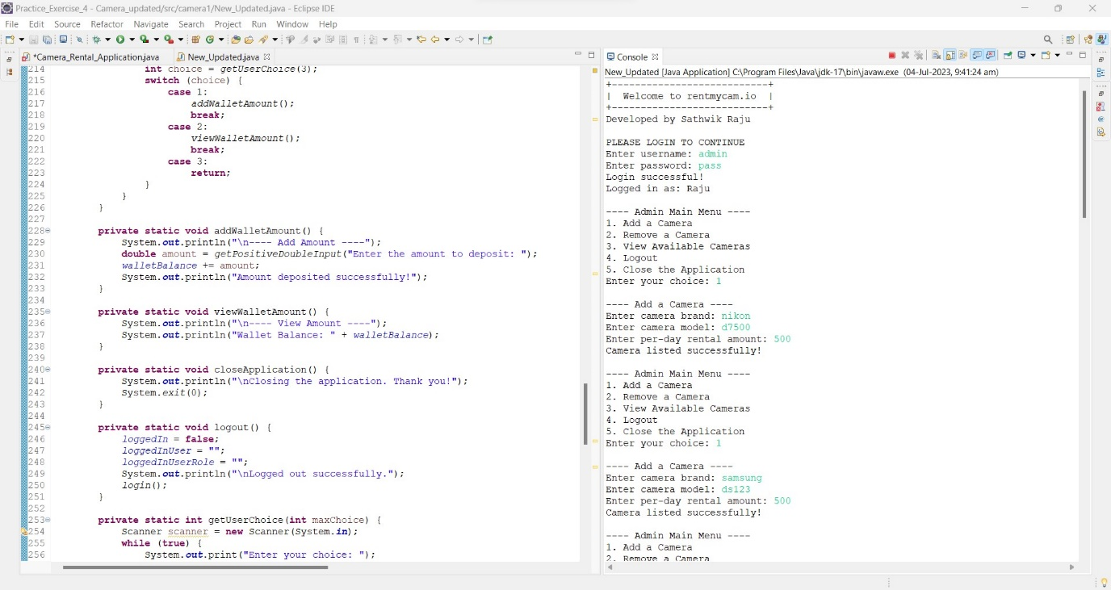

1. Adding the Cameras and view the Available Cameras in the list.

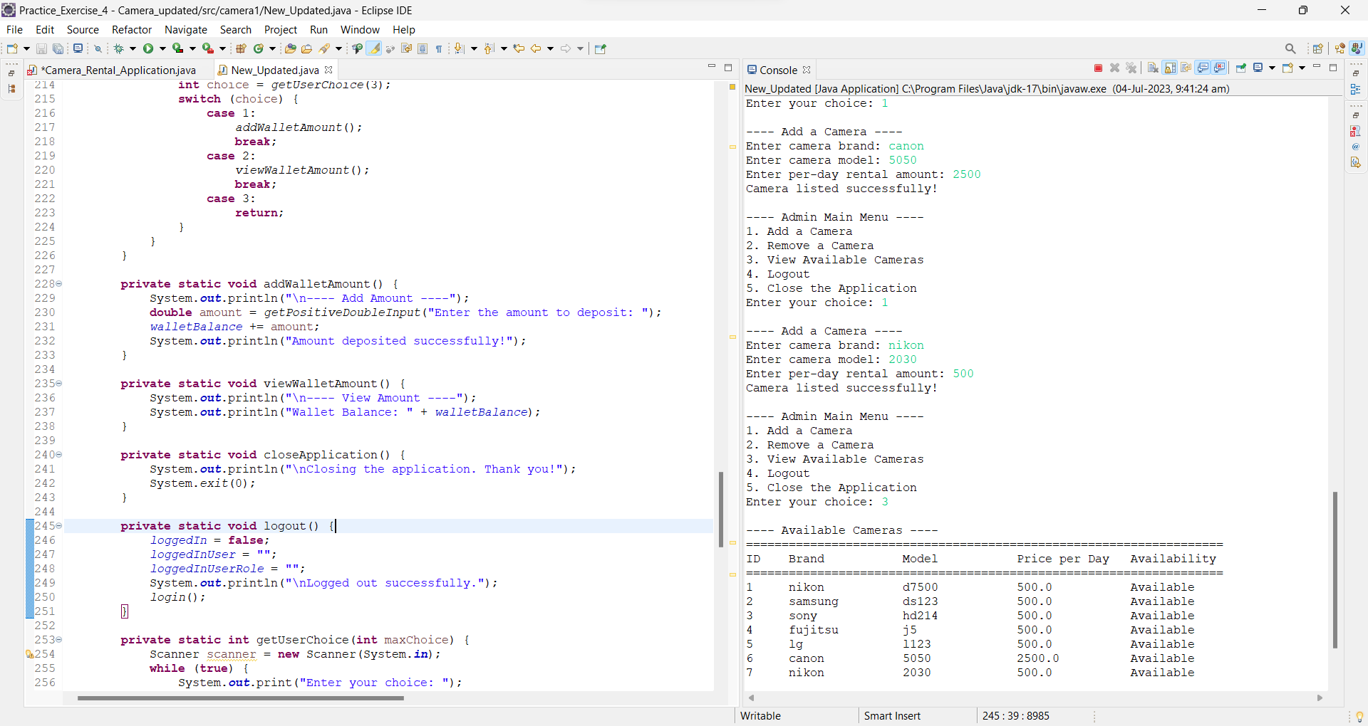

1. Removing a Camera from a list.

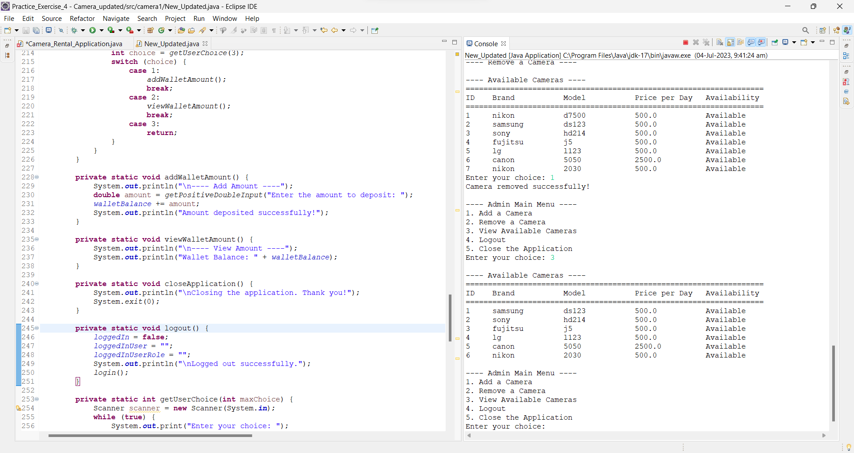

1. User login for functionality of renting a camera the user login through

Username – “user” , Password – “password”

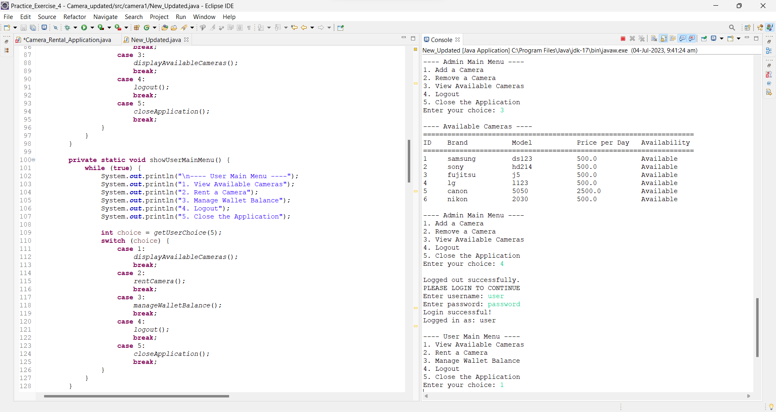

1. Rent a Camera

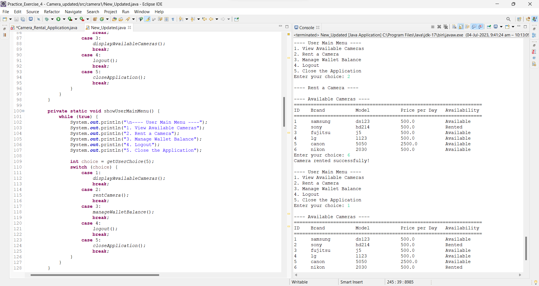

1. Failed renting due to insufficient funds

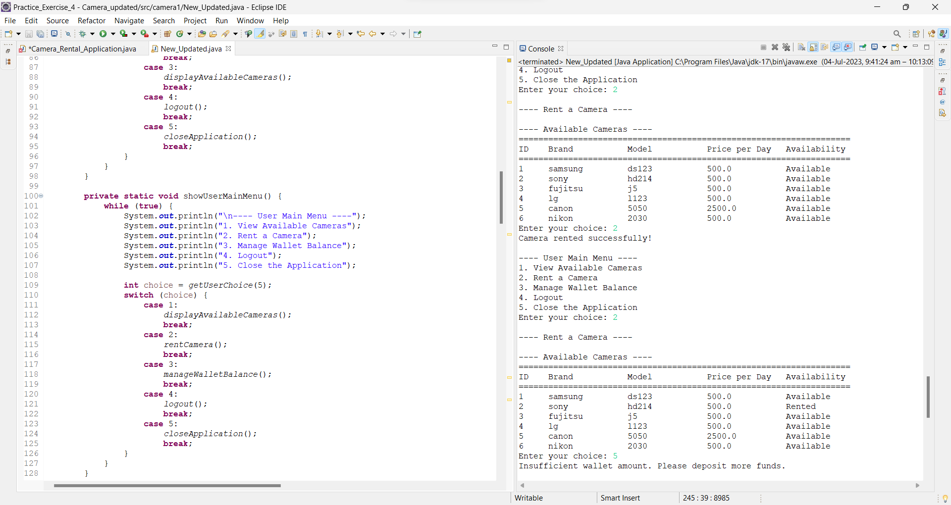

1. Adding amount to wallet through Manage wallet balance

