Code: Coefficient_extractor_polynomial.py
This code is expected to generate coefficients of the polynomial that the user gives as an input.
This is with respect to multivariate polynomial regression (which is a special case of linear regression) considering control variables as the features and NOx/Soot as the responses.
Python package used:
Sklearn (Sci-kit learn) which contains contains a lot of efficient tools for machine learning and statistical modeling including classification, regression, clustering and dimensionality reduction.
- Main usage:
PolynomialFeatures() : - used to generate polynomial and interaction features.
- Generate a new feature matrix consisting of all polynomial combinations of the features with degree less than or equal to the specified degree
Linearregression() : - Linear regression helps in predicting a dependent variable value (Y)
based on the independent variable (X). So, the regression finds out the
linear relationship between the variables.

INPUTS:
- An input file which helps in predicting the data and thus generating the coefficients of the desired polynomial.
- Order of the polynomial for which the coefficients are to be generated.
OUTPUTS:
- An Excel (.xlsx) sheet where the coefficients are generated corresponding to their variable features. (in a vertical manner)
- A text (.txt) file which gives us the equation of the response (putting the variables and their coefficients in place)

EXAMPLE:
- Sample data input:
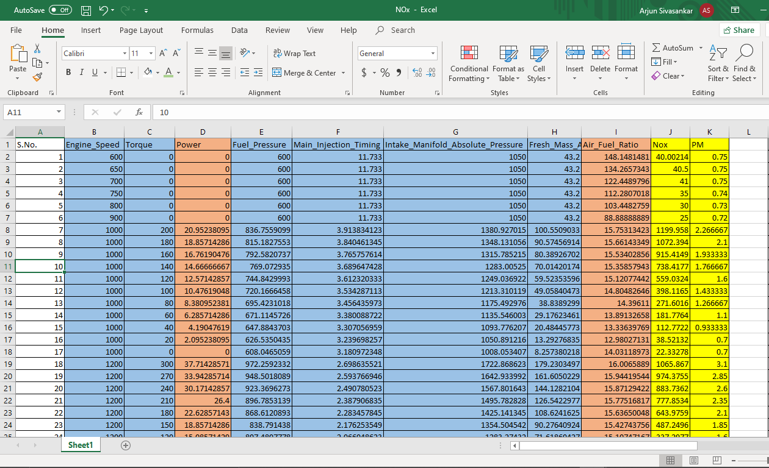
The input file is to be entered when the prompt asks for the data stating, ‘Enter data file:’.
A prompt will pop up asking for the type of response for which the coefficients need to be generated i.e. NOx or PM (Soot).
After desired response is selected, input prompt will pop up asking for the order of the polynomial for which coefficients needs to be generated.
The figure below shows the input execution of the code.
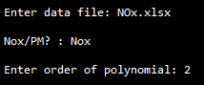
Here, NOx.xlsx excel sheet is entered when asked for an input file.
Once the data file is entered, NOx as a response is selected.
Order of the desired polynomial is entered to get the coefficients of the same.

RESULTS:
Excel (.xlsx) sheet is generated with the intercept and coefficients corresponding to their variables.
This sheet is an example of how the output will look like. NOx.xlsx data file was entered, NOx response chosen and ‘2’ entered as the order of the polynomial, which results in this sheet (NOx Coefficients of Degree2.xlsx).
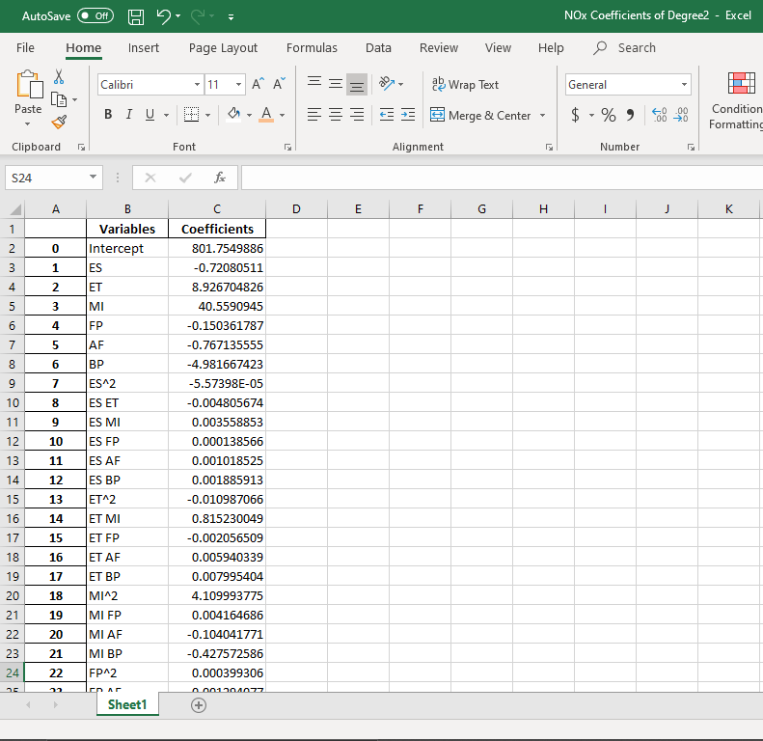
Similarly, this can be done for Soot response also. The only difference is to enter ‘PM’ when asked for a response.

A text (.txt) file is generated with the equation of the response by placing the intercept & coeffficients in correct order corresponding to their variables.
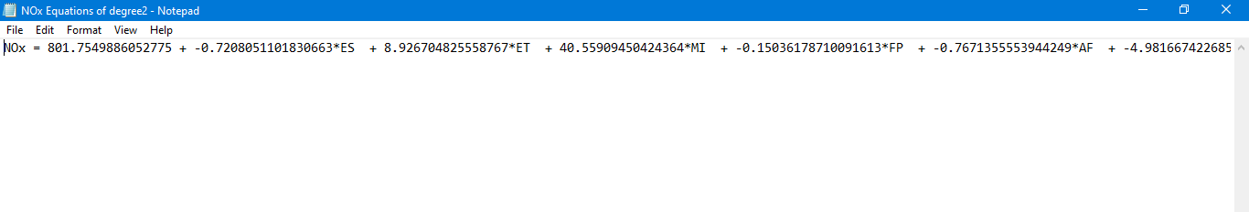
Similarly, this can be achieved for Soot also.

