Development Guide - Software Installation and Setup for SO and ORM Project
For Development Team
Contents
1. Install JDK 8: 3
2. Install Eclipse 7
3. Sonar lint / Sonarqube Configuration in eclipse 10
4. Install Node.js (To be done for CR application only) 10
5. Install Visual Studio: 13
6. SQL Developer On Windows 10 18
8. Setting Environment variables on local machine: 20
9. Install Git And TortoiseGit 20
10. OCE Access: 32
11. JIRA Access: 32
12. Related articles 32

Install JDK 8:
  - Download Java JDK 8You can download Java 8 from the Oracle’s Java Archive | Oracle
Scroll down and you will see various download options for various platforms.
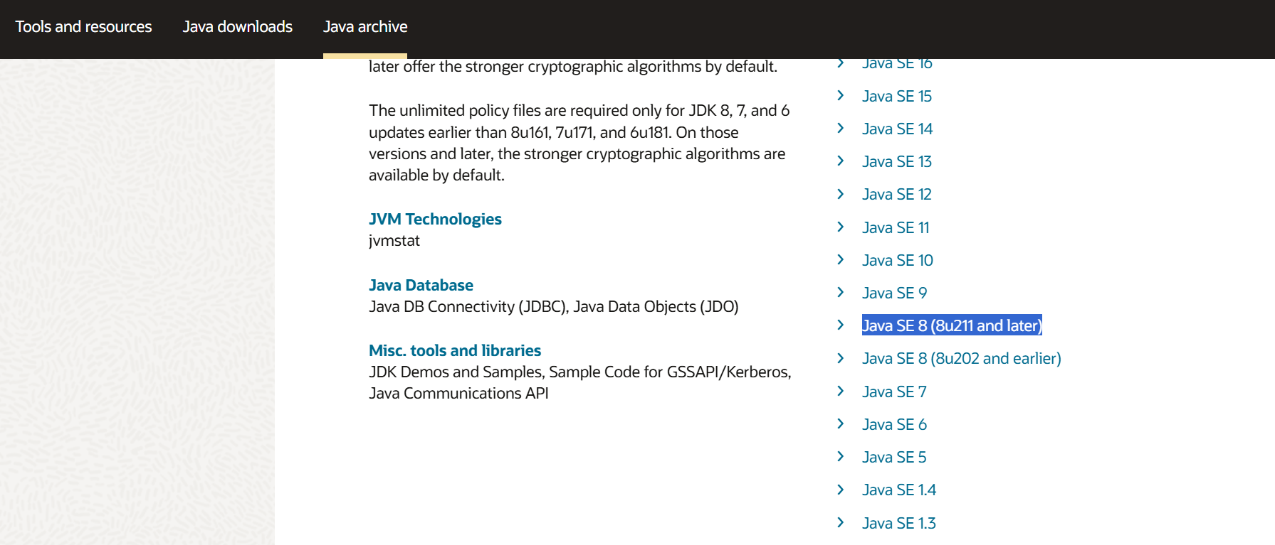
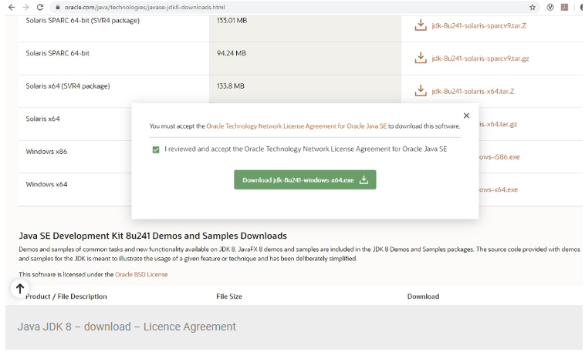

  - Run the Installer
To start the installation process, run the installer by double clicking it. You will see the installation wizard.
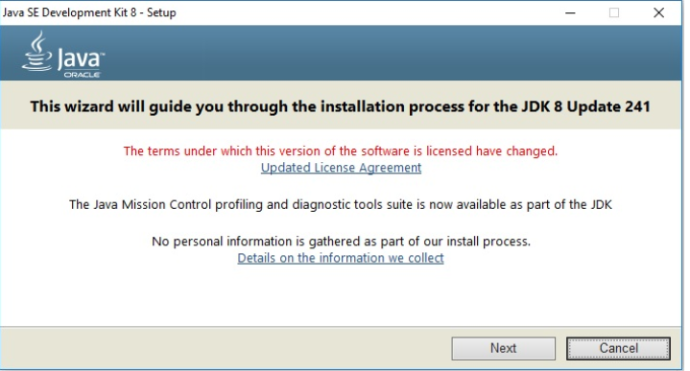
Click Next to continue
  - Custom Setup
In this screen you can change certain installation defaults. I accept this as it is. You can change the installation directory if you want by clicking on change. Click next to continue.
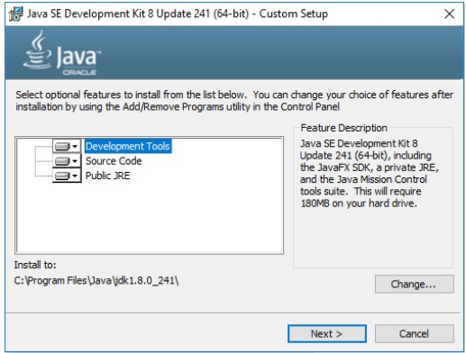

  - Installation begins
You will see the installation begins

  - You will be asked to specify the default installation folder for JRE. I accept the default and click next.
After this the installation will continue. Wait for sometime for the installation process to complete
  - Once the installation completes, you will see the Installation complete message.
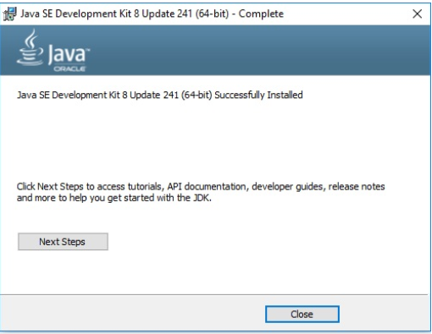
  - Click on close to complete the installation.

  - Check the version of Java installed
java -version to check the version of Java installed.
That’s it, now you have Java JDK installed on your system.

Install Eclipse
  - Download the Eclipse Installer
Download Eclipse Installer from http://www.eclipse.org/downloads
Eclipse is hosted on many mirrors around the world. Please select the one closest to you and start to download the Installer
  - Start the Eclipse Installer executable
For Windows users, after the Eclipse Installer executable has finished downloading it should be available in your download directory. Start the Eclipse Installer executable. You may get a security warning to run this file. If the Eclipse Foundation is the Publisher, you are good to select Run.
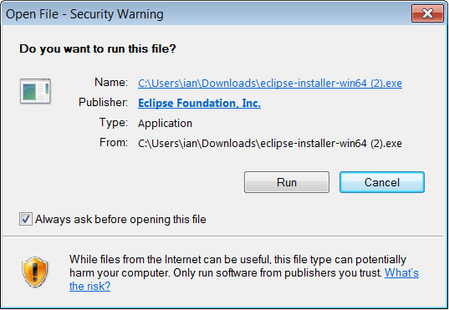
  - Select the package to install
The new Eclipse Installer shows the packages available to Eclipse users. You can search for the package you want to install or scroll through the list.
Select and click on the package you want to install.
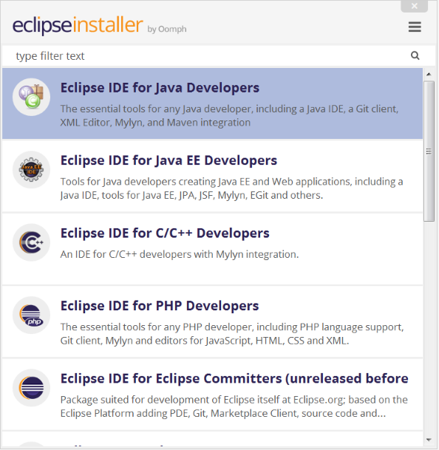
  - Select your installation folder
Specify the folder where you want Eclipse to be installed. The default folder will be in your User directory.
Select the ‘Install’ button to begin the installation.

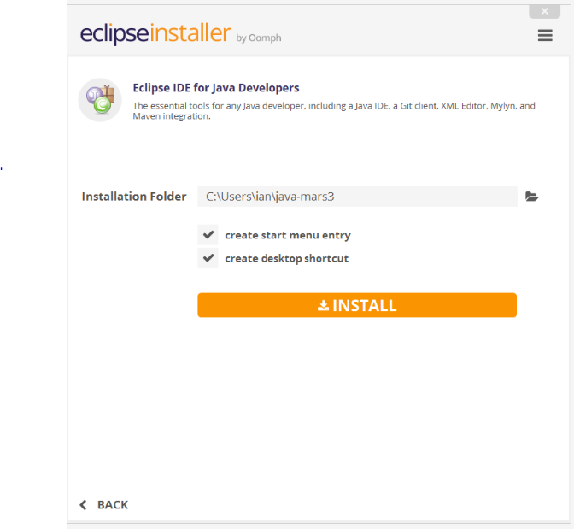
  - Launch Eclipse
Once the installation is complete you can now launch Eclipse. The Eclipse Installer has done it's work.

Sonar lint / Sonarqube Configuration in eclipse
  - Please follow the attached document for setting up Sonar lint plugin and SonarQube configuration in eclipse:

Install Node.js
  - You should install node.js to run your Angular app. It manages npm dependencies support some browsers when loading particular pages. It provides required libraries to run Angular project. Node.js serves your run-time environment as your localhost.
  - Just go to node.js official website Node.js — Download Node.js®
And Download and install latest version of node.js. download the msi installer and run the installer file.
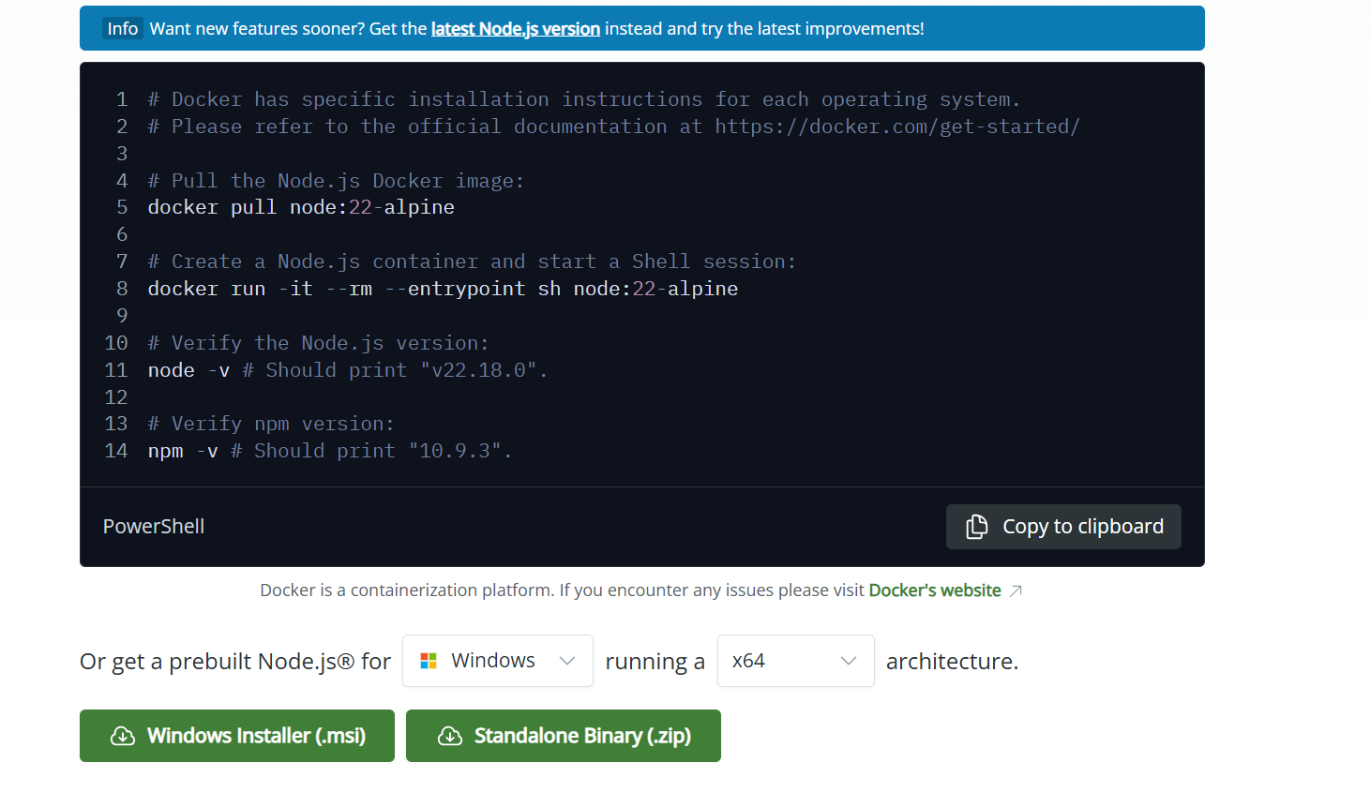
After the successful installation, you will see command prompt like this: or open cmd
And run command: node -v
You can see the node version
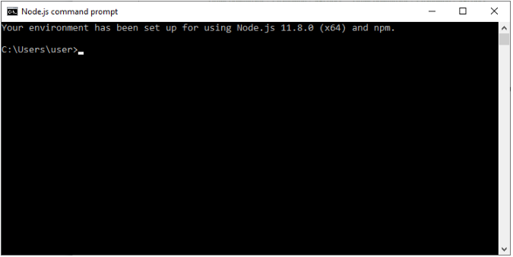
  - Use npm to install Angular CLI
npm install -g @angular/cli
while doing this disconnect with vpn if connected.
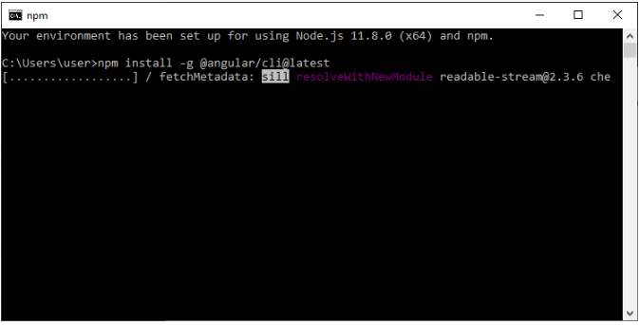
  - Just go to Angular CLI official website https://cli.angular.io/
You will see the whole cli command to create an Angular app. You need to run the first command to install Angular CLI. These steps are same for Windows
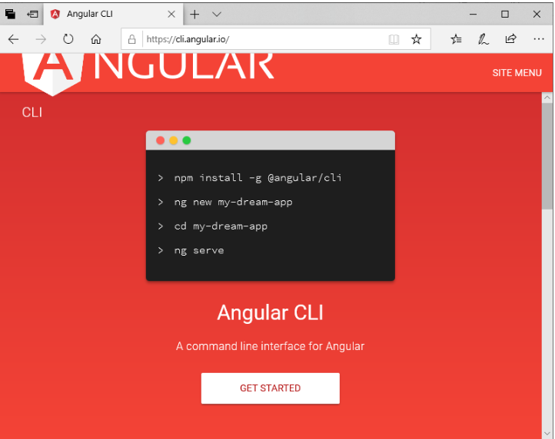
Angular Environment setup is complete now.

Install Visual Studio:
  - Visual Studio can be downloaded from the following link Download Visual Studio Code - Mac, Linux, Windows
  - Post reboot, open the Visual Studio IDE
  - Select a theme of your choice
  - Click Start Visual Studio.

SQL Developer On Windows 10
  - First, download the Oracle SQL Developer version 18.2 from the following link ( https://mydesktop.oraclecorp.com/myd/myd_software_licenses.show_complete_list ) and select the download option according to your Windows (64-bit or 32-bit) as shown above. JDK 9 included for the first option; you no need to install separately.
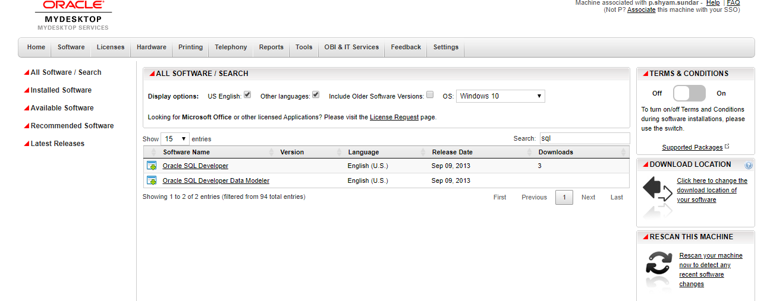
  - After completing the download, copy the ZIP file and paste to a folder on the drive where you want to keep the installation for Oracle SQL Developer. For example, create a folder OSD on C drive and paste the ZIP file.
  - Then extract the file in that folder, and you will see SQLDEVELOPER folder. Open this folder, and you will find sqldeveloper.exe, right click on it and choose the option Sent To > Desktop (create shortcut).
  - Now go to the Desktop and double-click the shortcut to start the Oracle SQL Developer. It may ask you to import the preferences from a previous installation; you can choose Yes or No.
Your installation for Oracle SQL Developer is now complete and ready to use.

Setting Environment variables on local machine:
Set below environment variables:
System Variable:
CATALINA_HOME: Path to your tomcat
CATALINA_OPTS: Catalina memory variable (Eg. -Xms512M -Xmx1024M)

User Variable:
JAVA_HOME: Path to your Java home
JRE_HOME: Path to your JRE home

TortoiseGit
  - Download the latest version of TortoiseSVN - Download – TortoiseGit – Windows Shell Interface to Git
It comes in 32-bit and 64-bit flavours, get the one that matches your system.
  - Double click the installer file.
  - Click the Run button.
  - The Custom Setup screen lets you deselect various elements of the install. Unless you are really low on disk space, it isn't worth worrying about this. When you're ready to continue, click Next
  - Click Install.
  - Tortoise is now installed. Click Finish.

Git Access:
  - How to Request Access (Oim.oraclecorp.com)
- Navigate to OIM
- Select "Request Access"
- Search for OCI Stack
- Select "Add to Cart" next to OCI Stack and click "Next
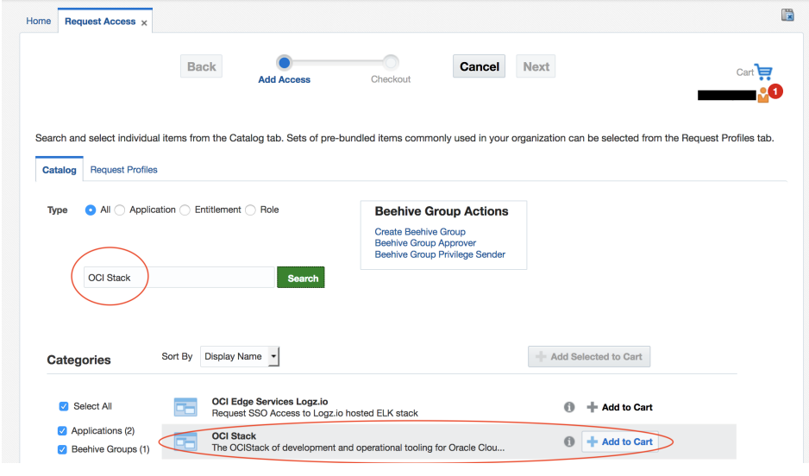
- Provide justification, select the appropriate Role for your access level and select "Update"
- Select "Submit" in the upper right hand corner
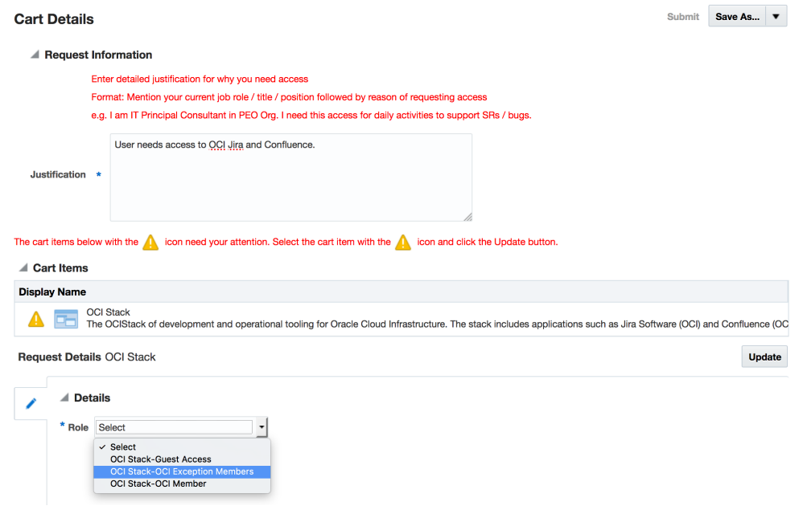
  - Generating a new SSH key
- Open cmd.
- Paste the text below, substituting in your SSO email address.
ssh-keygen -t ed25519 -C "your_email@example.com"
- This creates a new SSH key, using the provided email as a label.
- When you're prompted to "Enter a file in which to save the key," press Enter. This accepts the default file location.
- Enter a file in which to save the key (/c/Users/you/.ssh/id_algorithm):[Press enter]
- Press enter until all the inputs are completed.
  - Adding the generated SSH key into your bitbuket account.
- Login to bitbucket account.
- Click on your profile icon and go to Manage account option.
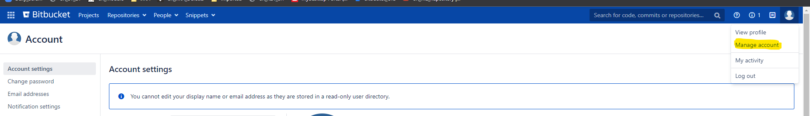

- Go to SSH keys option in left menu.
- Add the generated public SSH key which is available in the location “C:\Users\{{User}}\.ssh” and click on OK and exit.
  - Generating PPK using puttyGen.
- Download puttyGen
- Load the private ssh key get PPK by following the below attached screenshot.
- After load, click on save private key and name it ‘gitKey.ppk’.
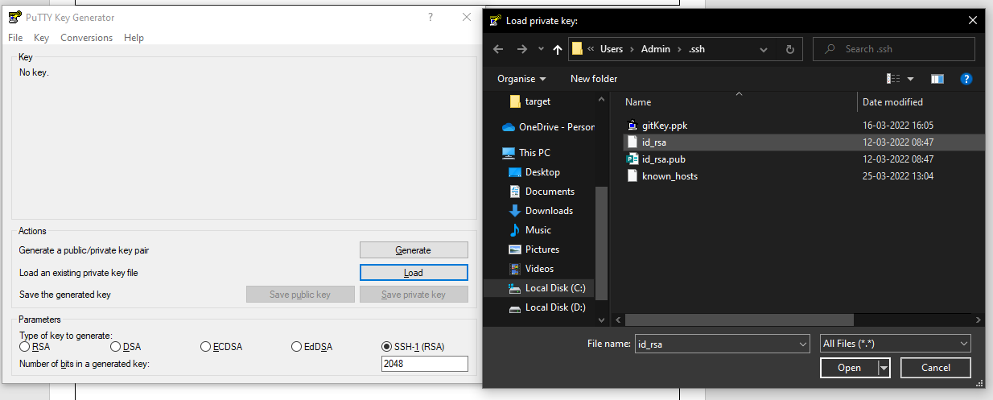
  - Access the git remote repository using tortoise Git.
- Download git and TortoiseGit from the below mentioned links and install: https://tortoisegit.org/download/
https://git-scm.com/downloads
- Create a folder named CR22 and right click to access the tortoiseGit options.
- Click on Git clone option. Fill the required URL, branch name and load the generated putty key from the .ssh folder the click on OK. (Please refer the below attached screenshot)
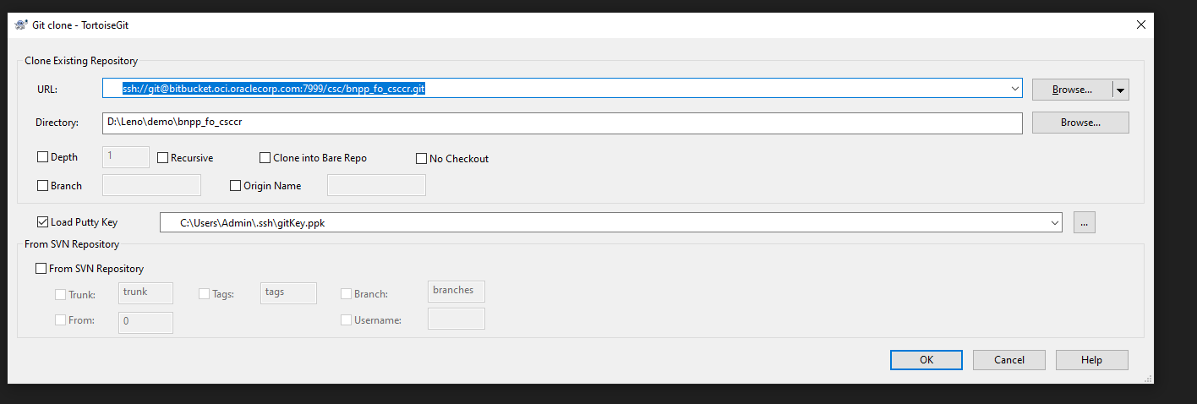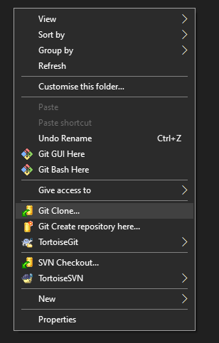

A guide for getting started with GIT
  - Git clone: Right click in the folder and select clone option and fill the required remote repo details.
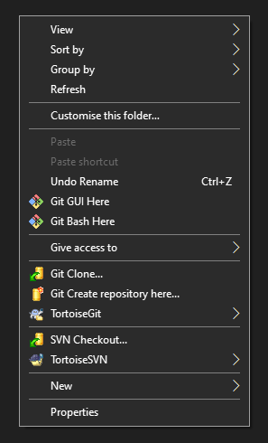

  - How to take pull with our changes intact in the local workspace.
Step 1: Go to your project workspace, right click and open ‘Git Bash Here’.
Step 2: Use ‘git status’ to see the modified files and the files that are not staged for commit.
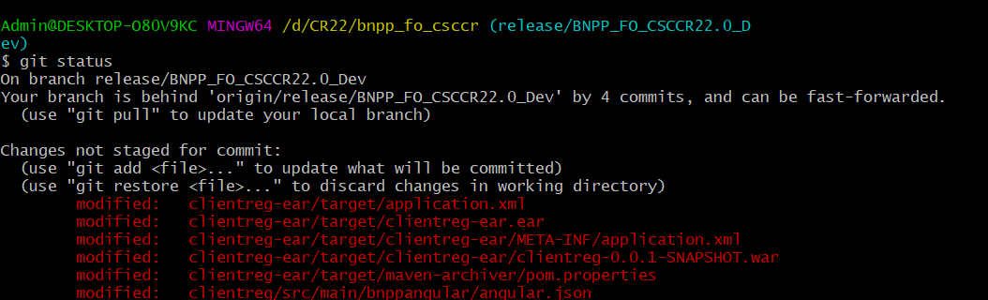

Step 3: Use ‘Git stash’ which is a built-in command that locally stores all the most recent changes in a workspace and resets the state of the workspace to the prior commit state.
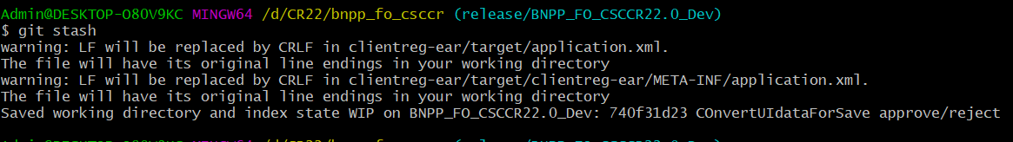

Step 4: Now using tortoise git take pull for the latest changes available in the remote repository.(i.e. Right click TortoiseGit Pull Ok)
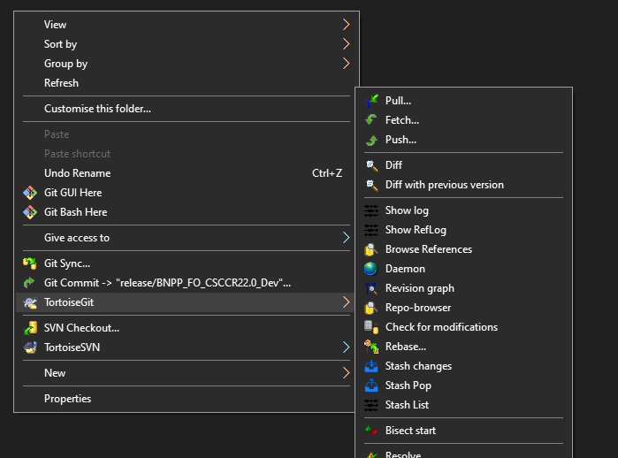

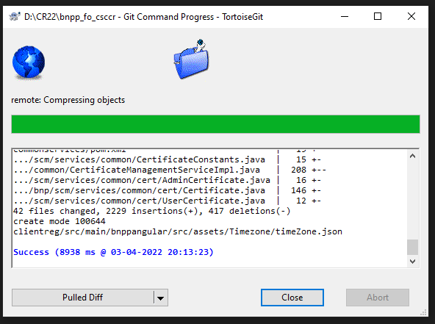

Step 5: Now using git bash run ‘git stash pop’. The ‘git stash pop’ Takes the files in a stash, places them back into the development workspace. After manual resolve the conflicts.

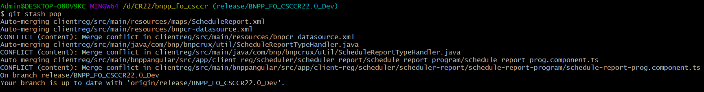

Step 6: After resolving the conflicts use ‘git status’ to see the files which are in staged and also the untracked files.
Note: The files shown in ‘green’ are in staged and the one in ‘red’ are either untracked or not staged for commit.
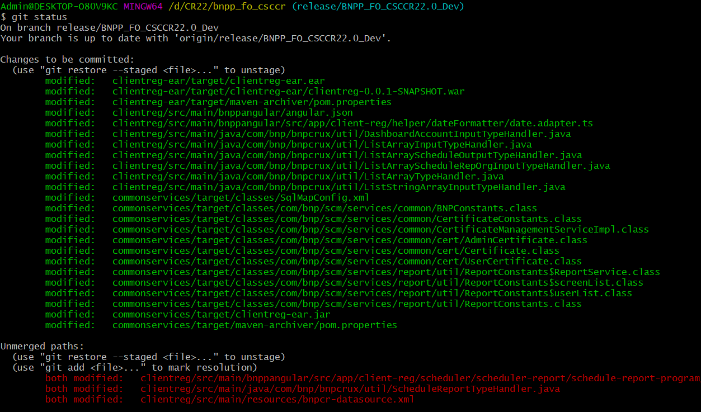

Step 7: Use ‘git restore --staged <filenames>’, The "git restore" command helps to unstage the unwanted files which are already present in the staging area (unwanted files which highlighted in green color).

Step 8: Use ‘git add <filenames>’ to add the files to staging area which will further used to commit and push.

Step 9: Check the status using ‘git status’ to see the staged files and the untracked files list.
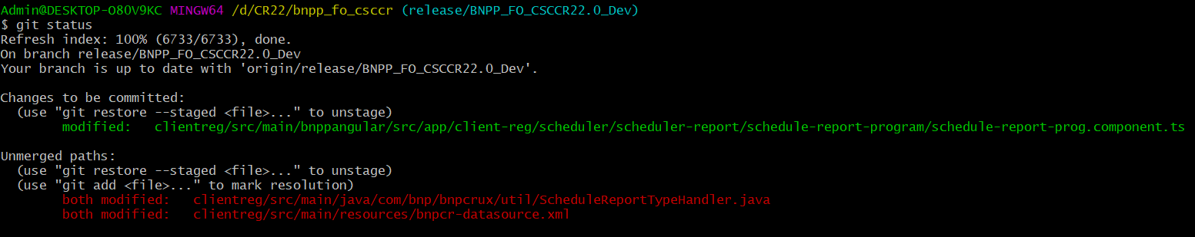

Step10: Use ‘git commit -m “meaningful commit message”’. The git commit command captures a snapshot of the project's currently staged changes. Committed snapshots can be thought of as “safe”.
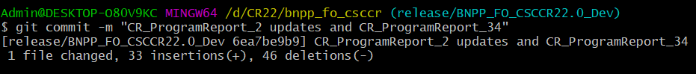

Step 11: Upon successful commit, now the code update is ready for push to the remote. This can be done using tortoise push/sync.
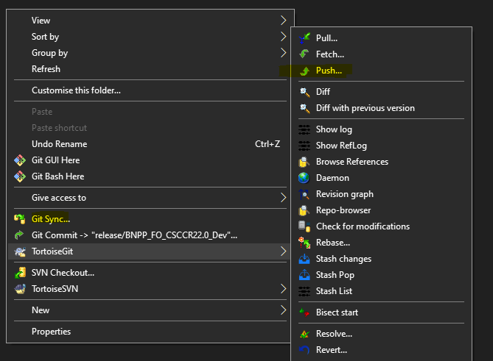

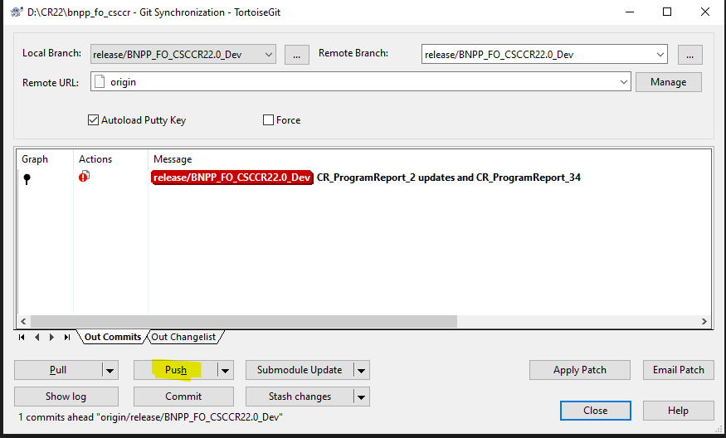

Vs Code Installation
  - Download vs code Download Visual Studio Code - Mac, Linux, Windows

KT session link for SO And ORM
  - SO Setup&KT –  SO_Setup&KT.mp4
  - ORM Setup&KT –  ORM_Setup&KT.mp4
  - Also checkout this path for access_token and .m2 repository - First Steps - OneDrive

