School Attendance Chatbot: Project Documentation
This report outlines the development of an AI-Driven Student Attendance System that leverages Natural Language Processing (NLP) to automate record retrieval.

1. Problem Statement
Manual attendance tracking and inquiry are time-consuming for both students and administrators. Students often need to verify their status or rectify errors, which requires manual lookup by staff.
Proposed Solution: A conversational AI assistant that provides instant, secure access to attendance records through a web-based interface, reducing administrative overhead.

2. System Architecture (Block Diagram)
The project is built on a Three-Tier Architecture:
- Presentation Layer (Frontend): HTML5, CSS3, and JavaScript. It provides the user interface and handles "Action Buttons" (Like, Copy, Reload).
- Application Layer (Middleware & AI): * Flask: Acts as the API Gateway.
  - Rasa NLU/Core: The "Brain" that understands intent and manages the flow.
- Data Layer (Backend): SQLite3 database storing student IDs, PINs, and attendance logs.

3. Logical Data Flow (Process Diagram)
This diagram illustrates the "Happy Path" of a conversation—from the initial greeting to the database result.
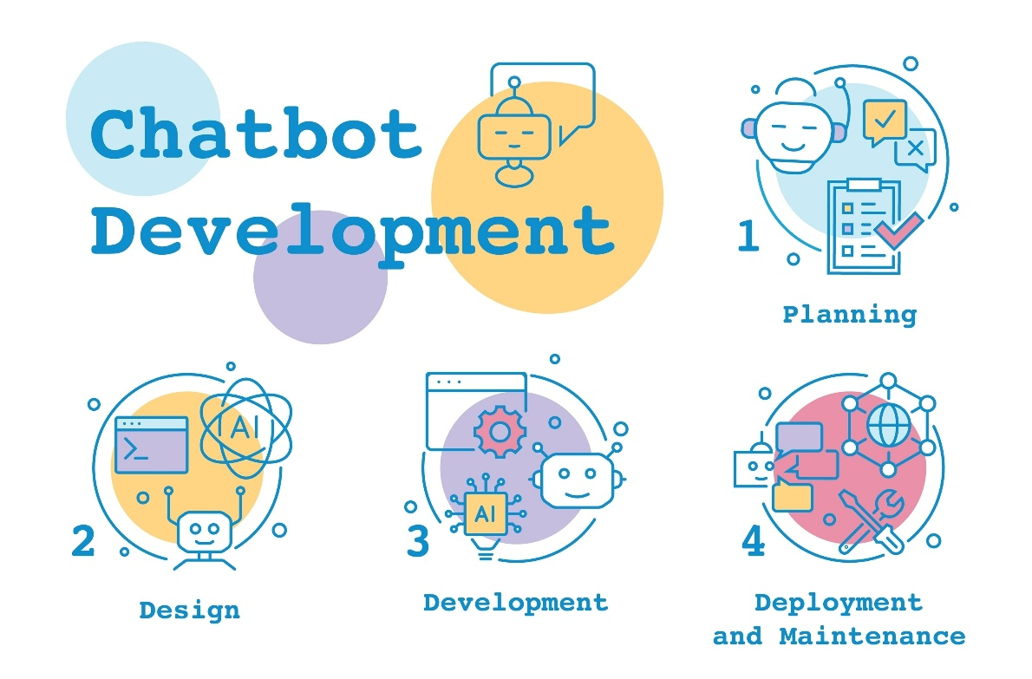
Shutterstock
- Intent Recognition: Rasa identifies the user wants to check attendance.
- Slot Filling: The bot checks if student_id and student_pin are present in the "Tracker."
- Prompting: If missing, the bot executes utter_ask_student_id.
- Validation: Once data is collected, it is sent to the Action Server.
- Execution: actions.py runs a SQL query: SELECT status FROM attendance WHERE id=? AND pin=?.

4. Component Technical Details
A. The Rasa Engine
- NLU (nlu.yml): Contains training examples for intents like greet, inform, and check_attendance.
- Stories (stories.yml): Defines the "Path" of the conversation.
- Domain (domain.yml): The registry of all Intents, Slots, Entities, and Responses.
B. The Custom Action (actions.py)
This is the Python bridge. It uses the rasa_sdk to:
- Extract slot values.
- Connect to sqlite3.
- Dispatch a message back to the user (e.g., "Sathya, you are Present").
C. The Web Middleware (app.py)
A Flask server that hosts the static files and provides a /chat endpoint. It handles CORS (Cross-Origin Resource Sharing) so the frontend can talk to the Rasa API safely.

5. Database Schema (ER Diagram)
The database follows a flat relational structure for high-speed lookups.
Field | Data Type | Constraint
student_id | TEXT | PRIMARY KEY
student_name | TEXT | NOT NULL
student_pin | INTEGER | NOT NULL
status | TEXT | Default: 'Absent'

6. Security & Interactive Features
- PIN Verification: Prevents students from checking each other's records without authorization.
- Copy Feature: Allows students to copy their status for official use.
- Session Reload: Clears the "Tracker" so multiple students can use the same terminal.

7. Conclusion & Future Scope
The current system successfully demonstrates the integration of AI with relational databases.
- Future Enhancement 1: Integration with a Document Summarizer to provide monthly attendance reports.
- Future Enhancement 2: Biometric integration via a Python-based face recognition module.

