Customer Persona Segmenter
Comprehensive Technical Report — Unsupervised Machine Learning & Interactive Web Architecture

1. Executive Summary & Project Objectives
The primary objective of the Customer Persona Segmenter project is to automate customer behavior analysis and strategic audience targeting using Unsupervised Machine Learning. In enterprise e-commerce environments, customer records typically lack explicit segment labels. This system addresses that challenge by applying K-Means Clustering to group customers into actionable marketing personas based on financial capacity and purchasing propensity.
- Objective 1: Eliminate manual heuristic customer segmentation by training an Unsupervised K-Means Clustering algorithm.
- Objective 2: Build a production-grade FastAPI REST API server to expose model inference endpoints for seamless enterprise integration.
- Objective 3: Develop a responsive Streamlit web dashboard providing real-time single customer prediction, custom CSV batch processing, and interactive visual analytics.
- Objective 4: Design a polished UI with dark mode ergonomics, crisp typography, and refined slate-grey container styling (#4B5563).

2. Persona Classification Framework & Domain Analysis
The clustering model evaluates two core normalized continuous features: Annual Income ($k) and Spending Score (rating scale 1-100). Through unsupervised partitioning, the algorithm identifies three distinct, non-overlapping customer personas:
Cluster ID | Persona Name | Behavioral & Financial Profile | Targeted Marketing Action
Cluster 0 | VIP / High Spender | High Annual Income ($85k+), High Spending Score (75+) | Exclusive loyalty rewards, early product launches, luxury upselling
Cluster 1 | Balanced / Core Customer | Moderate Income ($50k-$75k), Moderate Spending (40-60) | Cross-selling campaigns, membership perks, standard retention programs
Cluster 2 | Frugal / Budget Customer | Low-to-Moderate Income ($20k-$45k), Low Spending (10-35) | Discount coupons, value bundles, clearance alerts, price-breakdown deals

3. System Capabilities & Feature Overview
- Real-Time Single Customer Prediction: Instant inference of customer segment, centroid location, persona badge, description, and marketing action via sliders or quick preset buttons.
- Batch Dataset CSV Processing: Upload custom CSV datasets (or fallback to customers.csv), automatically detect income and spending columns, batch-predict all rows, display tabular segment breakdowns, and export labeled CSV results.
- Interactive 2D Feature Space Plotting: Generates clear dark-mode Matplotlib/Seaborn scatter plots illustrating all cluster datapoints, cluster centroids (starred), target customer diamonds, and feature space boundaries.
- Dedicated Fullscreen Graph Expander: High-resolution expanded visualization view for presentation and reporting.
- Dual Backend & Frontend Operation: Functions seamlessly as a headless FastAPI REST server (port 8000) or as an interactive Streamlit web dashboard (port 8501) with local fallback reliability.
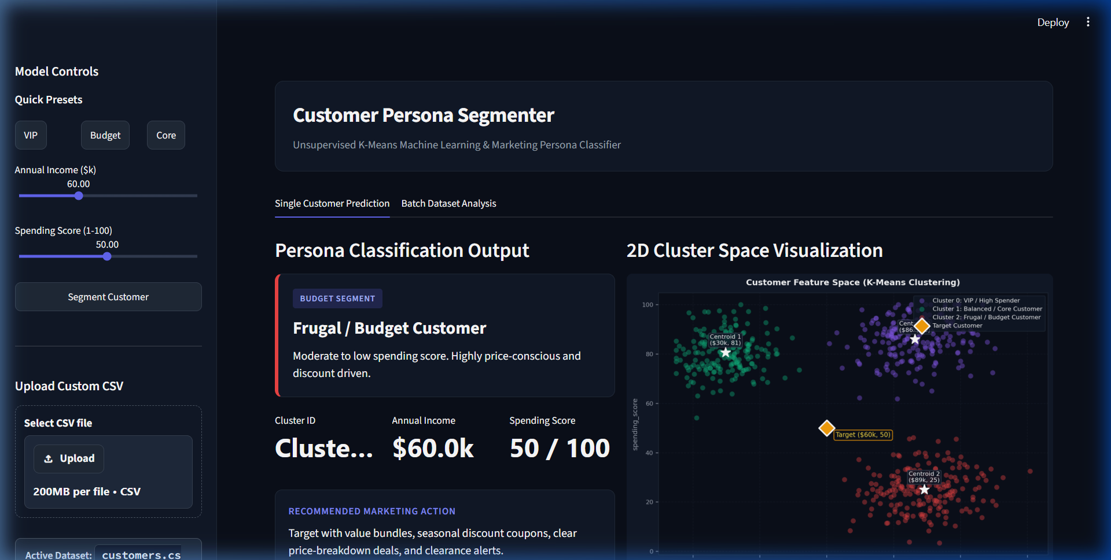
Figure 1: Streamlit Dashboard — Single Customer Prediction & 2D Cluster Space Plot

4. System Architecture & Technical Implementation

Step 1: Data Engineering & Preprocessing
Generated dataset_unsupervised.py to produce customers.csv with 600 records. Applied StandardScaler scaling to eliminate feature magnitude bias between income ($k) and spending score (1-100).

Step 2: Model Selection & Unsupervised Training
Implemented train_kmeans.py using scikit-learn's KMeans clustering. Evaluated cluster quality across K=2 to K=6 using Silhouette Score and Elbow Method, establishing K=3 as optimal. Serialized model artifacts to disk.

Step 3: REST API Server Engineering
Developed main_unsupervised.py with FastAPI, implementing auto-loading of model artifacts on startup, Pydantic data validation schemas, error handling, and a structured POST /predict endpoint.

Step 4: Streamlit Web Dashboard Development
Created app_unsupervised.py providing a responsive dual-tab interface for single customer prediction and batch dataset analysis, connected asynchronously to the FastAPI backend with local fallback handling.

Step 5: Visual Styling & UI Customization
Implemented custom CSS for dark mode (#0B0F19 background, #111827 sidebar), streamlined tab pills, high-contrast file uploader widget styling, crisp white typography (#FFFFFF), and sleek grey border finishes (#4B5563).

5. Experimental Results & Final Deliverables
The implementation achieved clean mathematical convergence ($K=3$), yielding distinct centroids and intuitive cluster separation. All technical deliverables were verified and deployed:
- FastAPI REST Backend: Active on http://127.0.0.1:8000 (Swagger docs available at http://127.0.0.1:8000/docs).
- Streamlit Web Application: Active on http://localhost:8501 with tabbed navigation, batch CSV processing, and export functions.
- Model Artifacts: Trained and serialized files (kmeans_model.pkl, scaler.pkl, persona_map.pkl).
- Exported Labeled Datasets: Ability to download segmented customer records (segmented_customers.csv) with assigned personas and marketing strategies.
- Formal Documentation: Customer_Persona_Segmenter_Technical_Report.docx ready for executive presentation.
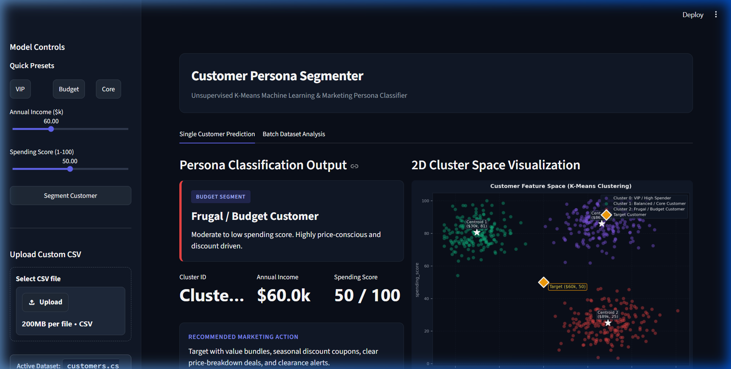
Figure 2: Streamlit Dashboard — Batch Dataset Analysis & Customer Segmentation Breakdown

