Case Study Report



**Tech Saksham**

Data Analytics with Power BI

**“INVENTORY OF SALES ANALYSIS OF DEPARTMENTAL STORE”**

**“College Name”**

|  |  |
| --- | --- |
| **NM ID** | **NAME** |
| **9AA74C544FD7027B97045912652B86A1** | **SATHYA V** |

**TRAINER NAME:**

**UMA MAHESHWARI**

**MASTER TRAINER:**

**UMA MAHESHWARI**

**ABSTRACT**

This study presents a comprehensive analysis of inventory management and sales performance aimed at optimizing efficiency and profitability for businesses. Through data-driven approaches, the research examines the interplay between inventory levels, sales trends, and customer demand to identify key insights and actionable recommendations. The analysis encompasses various methodologies, including inventory turnover ratio, ABC analysis, and sales forecasting techniques, to assess inventory efficiency, product categorization, and demand patterns. Additionally, the study explores the impact of factors such as seasonality, market trends, and promotional activities on sales performance.

**INDEX**

|  |  |  |
| --- | --- | --- |
| **Sr. No.** | **Table of Contents** | **Page No.** |
| 1 | Chapter 1: Introduction | 4 |
| 2 | Chapter 2: Services and Tools Required | 6 |
| 3 | Chapter 3: Project Architecture | 7 |
| 4 | Chapter 4: Modeling and Result | 9 |
| 5 | Conclusion | 18 |
| 6 | Future Scope | 19 |
| 7 | References | 20 |
| 8 | Links | 21 |

**CHAPTER 1**

**INTRODUCTION**

* 1. **Problem Statement**

The aim of this project is to develop a comprehensive Inventory and Sales Analysis System for a retail or e-commerce business. The system will address the following key challenges:

1. **Inventory Management: ** Efficiently manage and track inventory levels, including stock-in and stock-out activities, to ensure optimal stock levels and minimize stockouts or overstock situations.

2. **Sales Tracking: ** Capture and analyze sales data in real-time to monitor product performance, identify trends, and forecast demand accurately. This includes tracking sales by product, category, time period, and customer demographics.

3. **Data Integration: ** Integrate data from various sources such as point-of-sale (POS) systems, online platforms, and suppliers to provide a unified view of inventory and sales information.

* 1. **Proposed Solution**

**1. Inventory Management Module: **

- Develop a centralized database to store inventory data including product details, quantities, suppliers, and pricing.

- Implement functionalities for managing stock-in and stock-out activities, including barcode scanning and batch tracking.

- Set up automated alerts for low inventory levels and reorder points to prevent stockouts.

- Integrate with supplier systems for seamless procurement and inventory r

*2. Sales Tracking Module: **

- Capture sales data in real-time from POS systems, online platforms, and other sales channels.

- Analyze sales by product, category , time period, and customer demographics to identify top-performing products and trends.

- Implement predictive analytics to forecast future demand based on historical sales data and market trends.

- Provide customizable dashboards and reports for sales analysis and performance monitoring.

**3. Data Integration Mechanism: **

- Develop APIs and data connectors to integrate data from various sources into the system.

- Ensure data accuracy and consistency through regular synchronization and data validation processes.

- Support for real-time data streaming for instantaneous updates and insights.

* 1. **Feature**
* **Real-Time Analysis**: The dashboard will provide real-time analysis of customer data.
* **Trend Analysis**: The dashboard will identify and display trends in customer behavior.
* **Predictive Analysis**: It will use historical data to predict future customer behavior.
  1. **Advantages**
* **Data-Driven Decisions**: sales can make informed decisions based on real-time data analysis.
* **Improved Customer Engagement**: Understanding customer behavior and trends can help sales engage with their customers more effectively.
  1. **Scope**

By defining the scope of the Inventory and Sales Analysis System project upfront, stakeholders can ensure clarity of purpose, alignment of expectations, and successful execution of the project within the defined constraints and objectives

**CHAPTER 2**

**SERVICES AND TOOLS REQUIRED**

**2.1 Services Use**

* **Data Collection and Storage Services**: Banks need to collect and store customer data in real-time. This could be achieved through services like Azure Data Factory, Azure Event Hubs, or AWS Kinesis for real-time data collection, and Azure SQL Database or AWS RDS for data storage.
* **Data Processing Services**: Services like Azure Stream Analytics or AWS Kinesis Data Analytics can be used to process the real-time data.
* **Machine Learning Services**: Azure Machine Learning or AWS Sage Maker can be used to build predictive models based on historical data.

**2.2 Tools and Software used**

**Tools**:

* **Power BI**: The main tool for this project is Power BI, which will be used to create interactive dashboards for real-time data visualization.
* **Power Query**: This is a data connection technology that enables you to discover, connect, combine, and refine data across a wide variety of sources.

**Software Requirements**:

* **Power BI Desktop**: This is a Windows application that you can use to create reports and publish them to Power BI.
* **Power BI Service**: This is an online SaaS (Software as a Service) service that you use to publish reports, create new dashboards, and share insights.
* **Power BI Mobile**: This is a mobile application that you can use to access your reports and dashboards on the go.

**CHAPTER 3**

**PROJECT ARCHITECTURE**

**3.1 Architecture**

**USER FRONTEND BACKEND**

|  |  |  |
| --- | --- | --- |
|  | **HTML 5** | **NODEJS 14.0**  **Database** |

Here’s a high-level architecture for the project:

1. **Data Collection**: Real-time customer data is collected from various sources like sales and analysis. This could be achieved using services like Azure Event Hubs or AWS Kinesis.
2. **Data Storage**: The collected data is stored in a database for processing. Azure SQL Database or AWS RDS can be used for this purpose.
3. **Data Processing**: The stored data is processed in real-time using services like Azure Stream Analytics or AWS Kinesis Data Analytics.
4. **Machine Learning**: Predictive models are built based on processed data using Azure Machine Learning or AWS Sage Maker. These models can help in predicting customer behavior, detecting fraud, etc.
5. **Data Visualization**: The processed data and the results from the predictive models are visualized in real-time using Power BI. Power BI allows you to create interactive dashboards that can provide valuable insights into the data.
6. **Data Access**: The dashboards created in Power BI can be accessed through Power BI Desktop, Power BI Service (online), and Power BI Mobile.

This architecture provides a comprehensive solution for real-time analysis of bank customers. However, it’s important to note that the specific architecture may vary depending on the bank’s existing infrastructure, specific requirements, and budget. It’s also important to ensure that all tools and services comply with relevant data privacy and security regulations.

**CHAPTER 4**

**MODELING AND RESULT**

**Manage relationship**

The “disp” file will be used as the main connector as it contains most key identifier (account id, client id and display id) which can be use to relates the 8 data files together. The “district” file is use to link the client profile geographically with “district id”

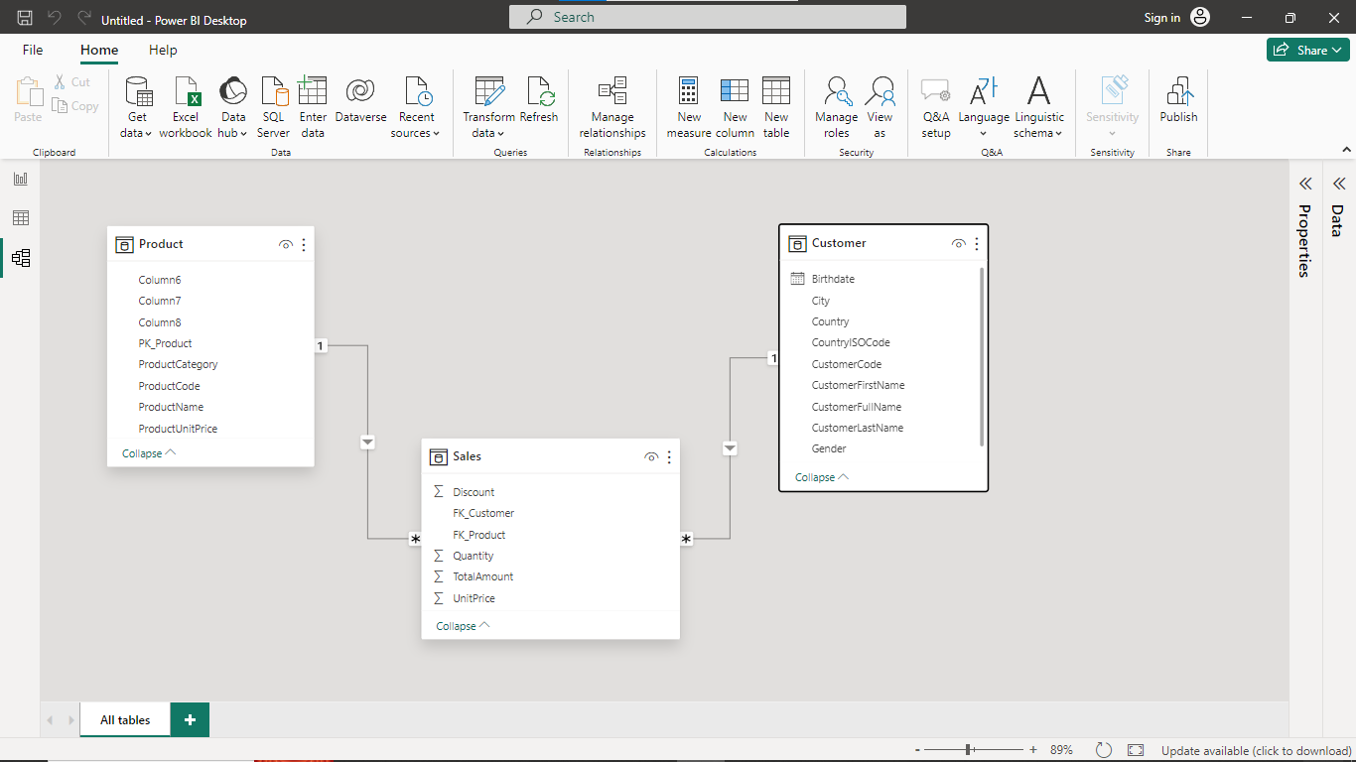

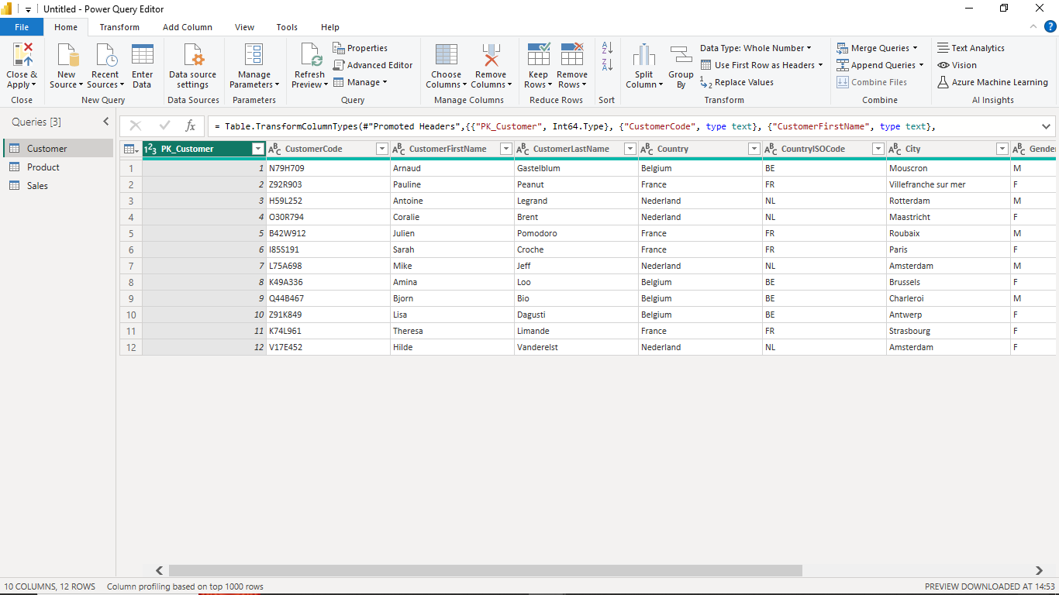

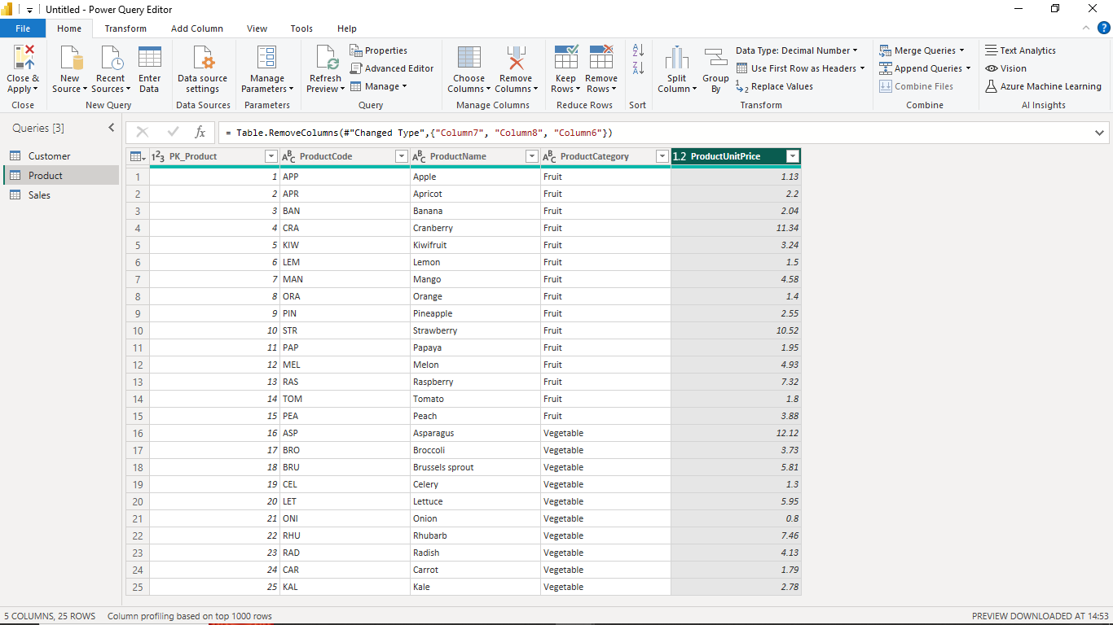

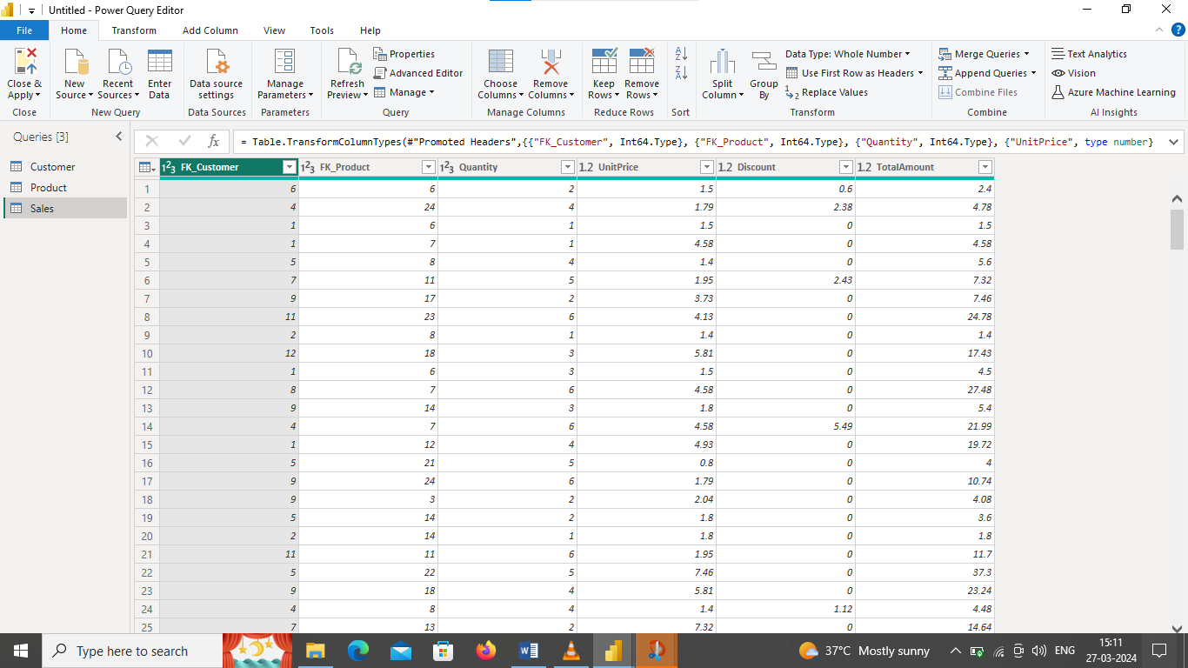

**DASHBOARD**

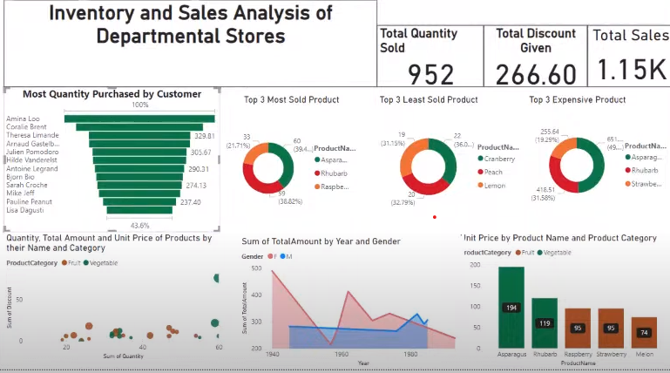

**CONCLUSION**

In conclusion, the Inventory and Sales Analysis System project aims to address the challenges faced by businesses in managing their inventory effectively and analyzing sales data comprehensively. By developing a robust system with advanced features and functionalities, businesses can streamline their operations, make data-driven decisions, and ultimately improve their profitability and customer satisfaction.

Throughout the project, the focus will be on delivering a solution that meets the functional and non-functional requirements outlined in the scope. This includes implementing inventory management features such as stock tracking and supplier management, sales tracking and analysis capabilities for identifying trends and forecasting demand, seamless data integration with external systems, and automation of routine tasks to enhance efficiency.

Moreover, the system will prioritize user experience with an intuitive interface, role-based access control, and compatibility across devices. Security, scalability, and reliability will also be key considerations to ensure data integrity, system performance, and compliance with regulatory standards.

By adopting agile project management methodologies and effectively managing project constraints, stakeholders can expect a successful implementation of the Inventory and Sales Analysis System within the defined timeline and budget. Ongoing maintenance, support, and collaboration with stakeholders will be essential to drive continuous improvement and ensure the system remains aligned with evolving business needs and market dynamics.

In summary, the Inventory and Sales Analysis System project holds the potential to transform how businesses manage their inventory and sales operations, enabling them to gain actionable insights, optimize their processes, and stay competitive in today's dynamic marketplace.

**FUTURE SCOPE**

The future scope of this project is vast. With the advent of advanced analytics and machine learnin, Power BI can be leveraged to predict future trends based on historical data. Integrating these predictive analytics into the project could enable the sales to anticipate customer needs and proactively offer solutions. Furthermore, Power BI capability to integrate with various data sources opens up the possibility of incorporating more diverse datasets for a more holistic view of customers. As data privacy and security become increasingly important, future iterations of this project should focus on implementing robust data sales strategies. This would ensure the secure handling of sensitive customer data while complying with data protection regulations. Additionally, the project could explore the integration of real-time data streams to provide even more timely and relevant insights.

**REFERENCES**

<https://en.m.wikipedia.org/wiki/Sales_management>

**LINK**