Lough Ree Bank DAC | Financial Crime Operations
Business cash review 2025-26: two customers referred to Financial Crime Investigations
To | Financial Crime Risk Committee, meeting of 21 January 2027
From | Malachy Crohan, Head of Financial Crime Operations
Date | 6 November 2026
Under | BCR-3, Business Cash Review Standard, issue 3, sections 4.1 to 4.3

We reviewed the 48 customers on the cash-intensive segment's list for the year to 30 September 2026. Two customers lodged more than EUR 40,000 that their own trading did not take, and we refer them to Financial Crime Investigations. Their accounts are restricted from the committee's decision until Investigations closes each case (BCR-3 4.3). A referral is not a finding of wrongdoing (4.4).
Customer | Trading name | Trade | Home branch | Unexplained cash
BC-10896 | Crystal Auto Spa | Car wash / valeting | Athlone | EUR 100,000
BC-10731 | Polished Nail Studio | Nail and beauty salon | Tuam | EUR 50,000
Source: account export and merchant services daily trade, review year 2025-26. Unexplained cash to the nearest EUR 5,000 (BCR-3 4.1, 4.3).

How the figures were reached
For each customer we set every cash lodgement in the year against the card trade its terminals took on the trading days since its previous lodgement, the days whose takings it carried. A customer's cash moves with its card trade at a ratio of its own, so we fitted that ratio, with a fixed part per lodgement, to the customer's own lodgements. The cash its trading took is that ratio times the card trade of the days its lodgements in the year carried; the rest of what it lodged is unexplained. For the customers on our till service BCR-3 4.2 applies and the till's own cash sales are the measure.
The 12 till customers show why the comparison has to be with each business's own trade. Their lodgements match the till's cash, net of paid-outs, over the same days to the cent, with no fixed part, yet their cash per euro of card trade runs from 16 per cent below to 13 per cent above their trade's median. A trade average would have mis-stated every one of them.

Crystal Auto Spa, Athlone, BC-10896 (97-41-10 64725605)
Each of its 103 lodgements in the year carried about EUR 970 more than the card trade of its days explains, in busy weeks and quiet ones alike. The cash that does move with its trade runs at 10 cent a euro of card trade, light for the trade. Over the year the fixed part comes to EUR 100,000 to the nearest five thousand.

Polished Nail Studio, Tuam, BC-10731 (97-41-60 78856209)
Each of its 103 lodgements in the year carried about EUR 485 more than the card trade of its days explains, in busy weeks and quiet ones alike. The cash that does move with its trade runs at 7 cent a euro of card trade, light for the trade. Over the year the fixed part comes to EUR 50,000 to the nearest five thousand.

Not referred
The Abbey Tea Rooms, Longford (BC-10444) and Old Town Barber Shop, Roscommon (BC-10643) lodge the most cash per euro of card trade against their trades, 2.6 and 1.9 times their trade's median. Their cash rises and falls with their own card trade lodgement by lodgement, with no fixed part, so their own trading took it, and neither is referred.

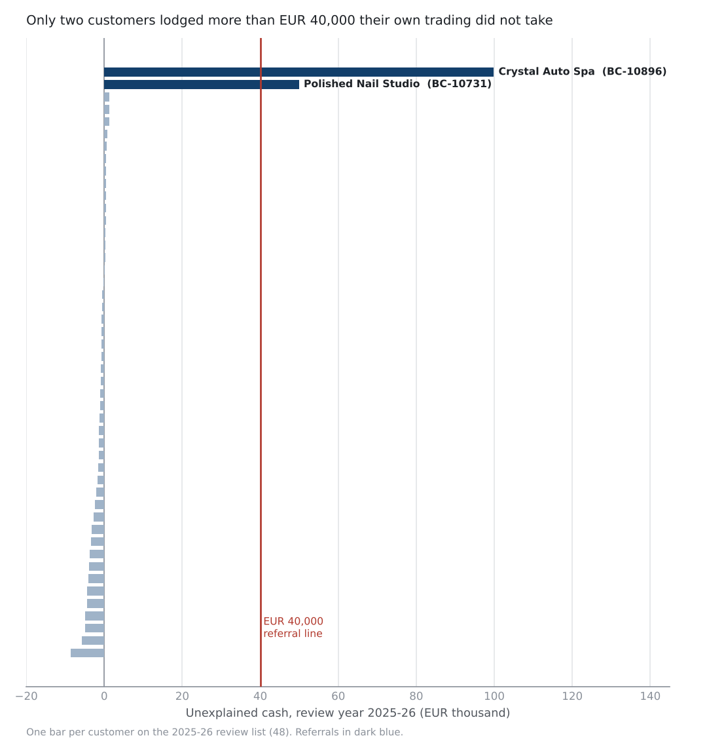
Figure 1. Unexplained cash by customer, review year 2025-26.

The monthly An Post and till service figures that support this paper are in cash_review_2026.xlsx.
Note. Post office lodgements are dated by the counter day carried in the An Post reference, not the day they were credited (BCR-3 3.2). The account export repeats April to June 2026 in full; each posting is counted once.

