Ministerial briefing MB27/0412 | To: Minister for Energy | From: Megan Robertson, Director, Energy Security | 18 March 2027 | For decision by 31 March 2027
Seven Tallowbark zone substations should be designated for spring 2027
Recommendation. Designate Gerrimbal, Kinnabar, Mundaree, Ondarra, Quorrabin, Tarravine and Wirrandel for spring 2027 and direct Tallowbark Networks to have emergency backstop arrangements in place for them by 1 September 2027. On the reference Sunday their lowest demand between 10.00 am and 3.00 pm is forecast below threshold: Gerrimbal (-13.1 MW against -12.5 MW), Kinnabar (-15.1 MW against -14.2 MW), Mundaree (-8.4 MW against -7.3 MW), Ondarra (-6.7 MW against -5.7 MW), Quorrabin (-10.6 MW against -9.9 MW), Tarravine (-8.5 MW against -7.6 MW), Wirrandel (-9.8 MW against -9.0 MW). The other nine clear their thresholds.
That you designate the seven zone substations above under section 2 of the minimum-load framework for spring 2027. | Agreed / Not agreed
The solar soak. From 1 September 2027 the network sends its controlled-load switch-on signals between 10.00 am and noon instead of overnight. Only heaters whose meter switches on that signal move: 23,257 of the 31,832 controlled-load heaters. The other 8,575 are on older meters whose contactor runs from an internal time switch, so they keep heating overnight. They are concentrated behind Gerrimbal, Kinnabar and Quorrabin, which is why those three stay below threshold even with the soak; counting every heater as moving would clear them.
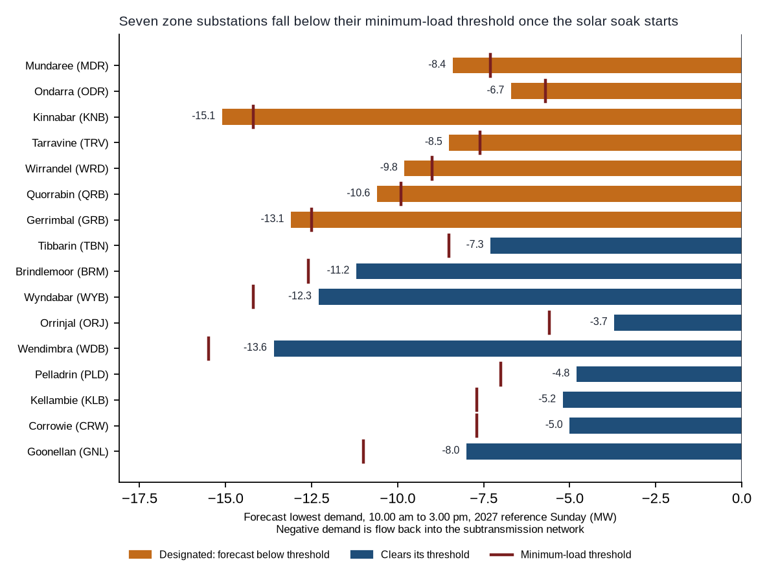
Figure 1. Forecast lowest demand on the reference Sunday against each zone substation's minimum-load threshold.
Backstop reach. Behind the seven designated substations 121.60 MW of rooftop solar was in service on 25 October 2026, of which 15.69 MW is on inverters installed since 1 July 2025 that accept remote curtailment. The workbook gives each substation's curtailment need and every substation's figures.
The reference Sunday is 25 October 2026, the lowest network half-hour of spring 2026 between 10.00 am and 3.00 pm (framework 2.2), carried forward with the solar forecast to connect by 1 October 2027 and the new signal times; nothing else is changed (framework 3.3). Negative demand is power flowing back into the subtransmission network.
Basis: minimum-load framework v2 (sections 2 to 5); Tallowbark notice NN-2027-02; Tallowbark solar connections outlook, 29 January 2027; SCADA, metering, load-control and connection records to December 2026. Contact: Megan Robertson, Director, Energy Security.

