Marrable Foodstores: Property Committee
Open Wrentoft, Mill Lane in 2027: it adds GBP 0.8 million a year
From: Joshua Ingram, Property and Network Planning To: Pauline Sullivan, chair Date: 9 October 2026

Recommendation
Approve S3, Wrentoft, Mill Lane, as the one new store for 2027. Once trading it adds GBP 0.8 million a year to the chain's contribution, against GBP 0.5 million at S1, Bellingtoft, Fenton Road, the next best site.

Why Wrentoft
Our spend-share model shares the grocery spend of each place among the stores that can win it. Fed only with the households the census counts, it ranks Wrentoft second of six at GBP 0.1 million, because the town has few residents. But Wrentoft Lakes Holiday Park, 1,750 pitches on the rating list, is nearer this site than any other on the shortlist, and its guests live outside the region, so no census output area holds them. Our own card data show what such guests spend: at Raddleford and Withybeck, the stores nearest the region's other large parks, cardholders from outside the LQ postcode area spend far more from March to October than in the winter months. Taking that excess at every store, grossed up for cash, and dividing by the pitches whose spend reaches our stores gives GBP 2,440 of in-store grocery spend a pitch for a season.
With every park carried as a place where spend starts, a store at Mill Lane sells GBP 7.1 million a year and takes little from our own stores, because none of them is near. That is the whole difference between the sites: the other five are priced almost unchanged.

The six sites
Site | Location | Addition (GBP m) | Residents only (GBP m)
S3 | Wrentoft, Mill Lane | 0.8 | 0.1
S1 | Bellingtoft, Fenton Road | 0.5 | 0.5
S2 | Darrowfield, Eastgate | 0.1 | 0.1
S6 | Sallowmere, Westway | 0.0 | 0.0
S5 | Quellby, Sutton Road | -0.1 | -0.1
S4 | Brackenmere, Northfield | -0.1 | -0.1
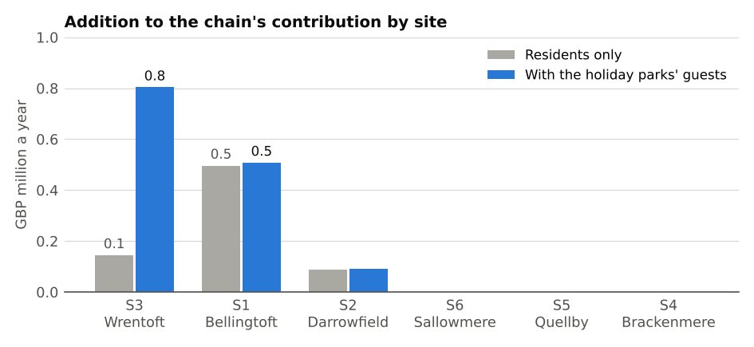
Source: site schedule (October 2026), spend-share model (June 2025), card feed FY2025/26.

Supporting measures
The appraisal workbook carries the distribution centre's cases a week and the paid hours a week at each of our stores over the 25 weeks from 6 October 2025, and the bus departures within 400 m of each site on Friday 15 January 2027.

Risks
The spend per pitch rests on one year of card data at our own stores; a weaker season at Wrentoft Lakes, or a park closing, would cut the site's trade. Floor areas are the rating list's measure throughout.

