Find-and-treat van 2027: Fenwold Recovery's new entrants
For decision. From Stephanie Davis, Director of Services, to the trustees' meeting of 12 November 2026. This paper completes the outreach team's plan of 6 October with the figures for the four settings.
Recommendation: the van works with Fenwold Recovery's new entrants in 2027. It would start about 70 people on hepatitis C treatment there, 20 more than at the needle exchange pharmacies' new registrants, the next best at about 50.
The 2026 rota found the most active infections per test at the needle exchange pharmacies and in the hostels, and a year that repeated 2026 would put the van at the pharmacies. 2027 will not repeat 2026 in either place. From 1 April 2027 the integrated care board commissions pharmacist test and treat at every needle exchange pharmacy (its 2027/28 intentions, PH-12). Three pharmacies, Gorse Street, Halden and Morrow & Pike, have done it since 2025, and there the van found 3 people with an active infection in 120 tests, against 0.168 per test at the other 21. From April every pharmacy will look like those three.
The hostels' figure in 2026 came from a first round. The van tested 737 of the 905 people on the hostels' 30 September lists and found 89 of them with an active infection, whom it does not test again, so in 2027 it would meet the other 648 with a negative test behind them; the infections still to find sit with the 168 residents it has not tested and the 264 people who arrive in a year. Fenwold Recovery's new entrants are a steady flow of people the van has not met, so the 2026 rates hold there.
What the van would find and start in 2027, by setting:
Setting | Active infections found | Started on treatment
Fenwold Recovery new entrants | 110 | 70
Needle exchange new registrants | 70 | 50
City hostels | 50 | 40
Approved premises | 40 | 20
People, rounded to the nearest 10. Sources: the van's tablet export and the network's treatment register for 2026; the settings' returns, the hostels' resident lists and the pharmacies' registrations for the twelve months to September 2026; Fenwold Pathology for new infections among hostel residents.
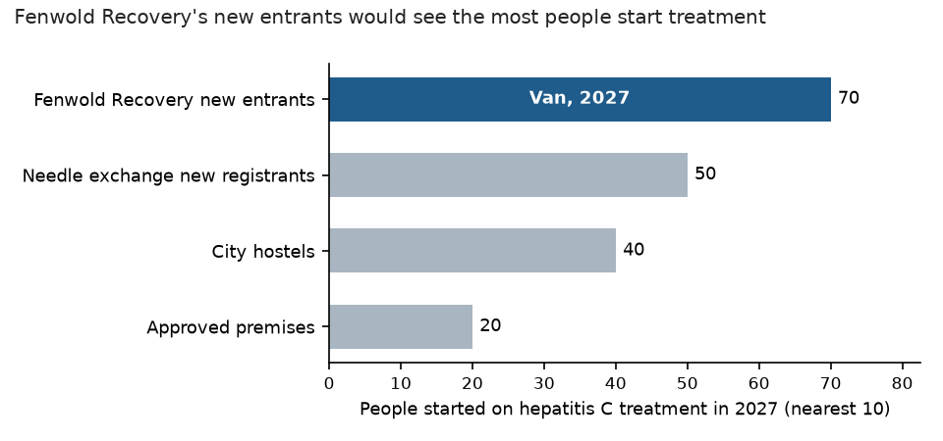
People started on treatment in 2027, by setting; the van's setting in blue.
How we sized it
Each setting's pool follows the plan: residents on 30 September 2026 and the arrivals of the twelve months to September, month for month. Each setting keeps the van's own 2026 share of people offered who took a test and of people found who started within twelve weeks, the latter over people found by 8 July 2026, the last day with twelve weeks of follow-up. At the pharmacies, January to March 2027 is at each pharmacy's own 2026 rate and April to December at the three test-and-treat pharmacies' rate. In the hostels, untested residents and arrivals are at the 2026 rate and the 648 residents who tested negative at the homeless health clinic's rate of new infection, 2 in 1,559 person-years.
Clinic outcomes for October 2024 to September 2025 are in the clinic cures workbook.

