Resource Planning Committee, 19 November 2026
Item 4: award of the 2027 capacity contract
Recommendation. Award the 2027 contract to Red Willow Hydro Authority for the 300 MW firm import over the Red Willow tie. Under RA-3 it removes 7,100 MWh of the 2027 fleet's 9,500 MWh of expected unserved energy, a net value of USD 106 million after its USD 35.8 million capacity payment.
The 2027 fleet's shortfalls all fall in Northgate curtailments. In 2016 to 2025 every hour with unserved energy came while Northgate had curtailed interruptible transportation and the ten peakers at Elk Prairie, Torrance and Wexford were out together on lack of fuel. Ketchum Ridge would take gas on the same interruptible service, so in those hours it would have been out with them: it removes no unserved energy, and its USD 23.2 million payment buys nothing under the standard. Rated at its 4.5 per cent EFORd in every hour it would look like the best offer, which is the reading the committee should not rely on.
Offer | MW | Payment (USD M) | EUE removed (MWh) | Net value (USD M)
Ketchum Ridge | 300 | 23.2 | 0 | -23
Red Willow import | 300 | 35.8 | 7,100 | 106
Sandhill Draw | 450 | 28.6 | 2,000 | 12
Coulee Flats | 500 | 25.8 | 400 | -17

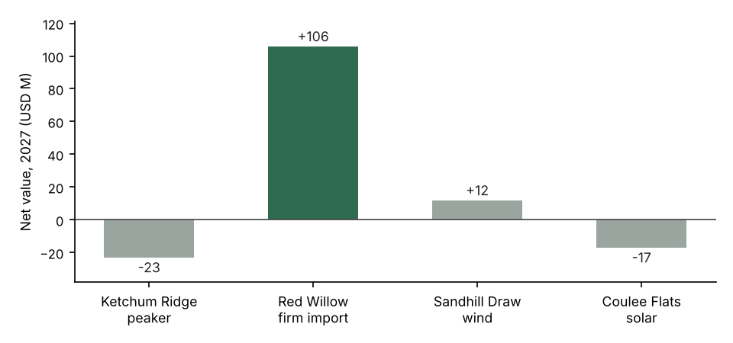
Figure 1. Net value of each offer in 2027: the EUE it removes at USD 20,000 per MWh less its capacity payment.
Sandhill Draw is the only other offer with a positive value, USD 12 million: its output in the curtailment hours is low, as the contracted farms' is. Coulee Flats produces nothing in the winter evening hours that carry the shortfall and comes out at USD -17 million.
Member allocation basis (MS-12)
The contract's cost is allocated on the members' 2025 12-CP averages. The 2025 figures below correct the meter data export for the current transformer replacements the MDM picked up late and for the meters that stayed on standard time after the spring change.
Member | 2025 net energy (MWh) | 2025 12-CP average (MW)
Bluestem Valley Electric | 1,881,448 | 317.2
Copper Ridge REA | 996,183 | 167.2
Lone Elm Cooperative | 1,452,327 | 245.6
Marais Electric | 1,309,755 | 224.8
Old Mill Power Association | 856,281 | 148.2
Sweetgrass Rural Electric | 1,770,626 | 293.3
Tamarack Electric Cooperative | 1,433,628 | 240.0
Wapsi Prairie Electric | 1,320,285 | 227.5

Prepared by Joseph Graham, Resource Planning. Workbook: capacity_award_2027.xlsx.

