Ngaio Road subdivision: connection to the PS03 Riverbank Road wastewater catchment
To | Council, meeting of 10 December 2026
From | Three Waters, Network Operations
Date | 13 November 2026
File | RM26-0187; AUTH-2024-0418; 3W-2029-04

Recommendation
That the Council defer the connection of the Ngaio Road subdivision (RM26-0187) to the public wastewater network until the PS03 storage upgrade (project 3W-2029-04) is commissioned, and decline the applicant's request to connect stage 1 from March 2027.

Why
Condition 8 of the network discharge permit AUTH-2024-0418 lets the Council accept a connection of 50 or more dwellings only while the overflow frequency at the receiving station, assessed under condition 7, stays within two wet weather overflows a year. Run through every hour of the 2004 to 2023 record, each day as it occurred, PS03 overflows 58 times in the twenty years as connected now (about 3 a year) and 64 times with Ngaio Road at full development (about 3 a year). With the upgrade's 1,100 m3 of storage the station overflows 15 times in the twenty years (about 1 a year), inside the limit.
The station's own record since 2024 (two overflows, both in 2026) understates this. Most of what reaches PS03 in a wet winter is groundwater entering the terrace sewers, and it rises by about 4.2 L/s for every kilometre of sewer below the water table. In 2024 to 2026 the water table stood low: on the median day only 0.2 km of sewer lay below it, against 2.1 km over 2004 to 2023. The June 2025 high river put about 21 km under water, as the wettest weeks of 2008 and 2017 did, which is how the effect can be measured on the meter.
A model with one response per millimetre of rain and the meter's own dry weather flow reproduces the two 2026 overflows and gives about 1 a year with the subdivision, but it misses the June 2025 high-river weeks by 43 L/s on average when they are held out of its fit, where the model above is within 0.2 L/s.
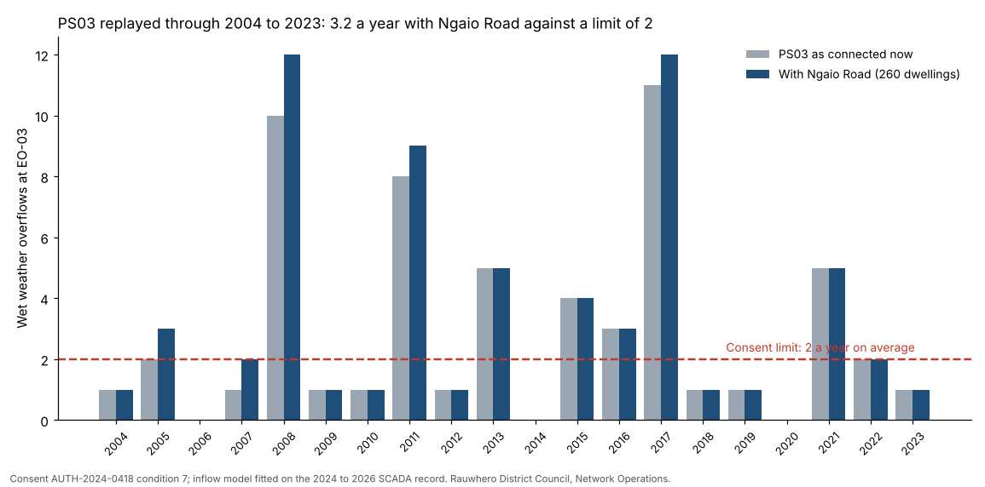
Overflows are counted as condition 3 of the permit counts them: discharges less than 24 hours apart are one overflow. The station's figures are 112.0 L/s with both pumps and 350 m3 of storage below the weir (data sheet revision 4).

Supporting figures
Residential water use in the PS03 catchment ran between 313 and 477 litres per dwelling per day in 2024 to 2026 (by quarter, in the assessment workbook), against the Code of Practice's design flow of 540 litres a dwelling.
Across the network's other stations, PS02 and PS05 recorded more than two wet weather overflows in both 2024 and 2025; the network had 3 emergency overflows in 2024 and 3 in 2025 (power failures). Station by station figures are in the workbook.

Next steps
Advise the applicant of the deferral and the upgrade programme; bring the upgrade's concept design to the Infrastructure Committee; reassess the connection under condition 8 when the tank is commissioned.

