Ironwood Hydro Distribution | P&C Asset Planning
MEMO
To: Angel Baird, Director, Asset Management
From: Rachael Villanueva, Manager, P&C Asset Planning
Date: 7 October 2026
Re: Last-time buy of VPR-340 power supply modules (Veldtek EOL-2026-07)

Order 13 lots (325 modules) of VPR340-PSU-02 for CAD 638,625 before Veldtek's 15 December deadline.
With the 14 modules we can use today, 13 lots give a 99.1 per cent chance of covering every power supply failure until the renewal programme reaches each relay, against the 95 per cent AM-PC-014 asks for; 12 lots would give 83.2 per cent. We expect 297.9 failures between October 2026 and the end of support, most of them in 2027 to 2031 while the fleet is still large.
How the figure is built. Rates are set for the AM-PC-014 module age bands from the PSU failures in the EAM history since January 2021, over the module-years each band has been in service since then; the 25-and-over band fails about a quarter of its modules a year. Each relay's present module is then aged month by month until the programme reaches its bay. A module that fails comes out and its replacement from this buy starts again in the 0-9 band, where failures are rare, so the old module's rate only applies for as long as it is likely to still be there.
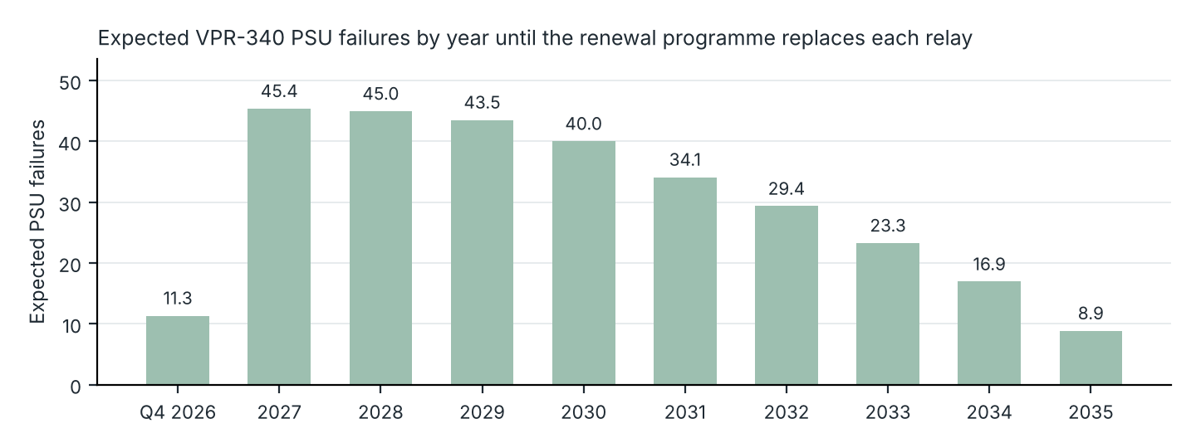
Expected failures by year (one decimal) from the workbook's Outlook sheet; Q4 2026 is October to December.
Lots ordered | Modules available with the buy | Cover (%) | Cost (CAD)
12 | 314 | 83.2 | 589,500
13 | 339 | 99.1 | 638,625
14 | 364 | 100.0 | 687,750

Available modules are the 12 serviceable at Central Stores and the two depots plus the 2 at Veldtek under open RMA, which the notice says will come back repaired; the 7 in quarantine are left out until they pass bench test. The workbook vpr340_psu_final_buy.xlsx carries every order from 8 to 22 lots, the outlook by year and region, and the band rates.
Signed for order: ______________________ Angel Baird, Director, Asset Management

