MEMORANDUM
To: | School Board (Deborah Johnson, Chair)
From: | Joyce Salinas, Director of Risk Management and Benefits
Copy: | Sandra Lopez, Superintendent; Anthony Olsen, Chief Financial Officer
Date: | 12 March 2027
Subject: | Certifying the Northcourt care management baseline for 1 April 2027 to 31 March 2028

I recommend that the Board approve a programme baseline of $4,060 per member per month for the 140 members Northcourt enrolls on 1 April: $1,438 for medical claims and $2,622 for pharmacy. Northcourt's 40 per cent share of savings will be measured against the tier baselines that make it up, under Schedule C of the agreement the Board approved on 9 February.
These members are on the list because 2026 was an expensive year for them, and for most it was the year of an operation, a heart attack, pneumonia, a cancer course or a premature birth that will not repeat. Northcourt ran the same model on our 2024 claims for its 2025 proposal, and because we cancelled that RFP before an award none of those 140 members was ever enrolled. Their claims from April 2025 to March 2026 show what a member the model flags costs in the following year without the programme, so each tier's baseline is that group's allowed claims per member month, counted for the months they were covered and brought forward 24 months at the 6.5 per cent medical and 9.0 per cent pharmacy trend in the February renewal. The four tiers are weighted by the members Northcourt enrolled in each.
Carrying the enrolled members' own 2026 claims forward at trend would have produced $8,830, 2.2 times the figure above, and we would have paid Northcourt a share of savings that were always going to happen.
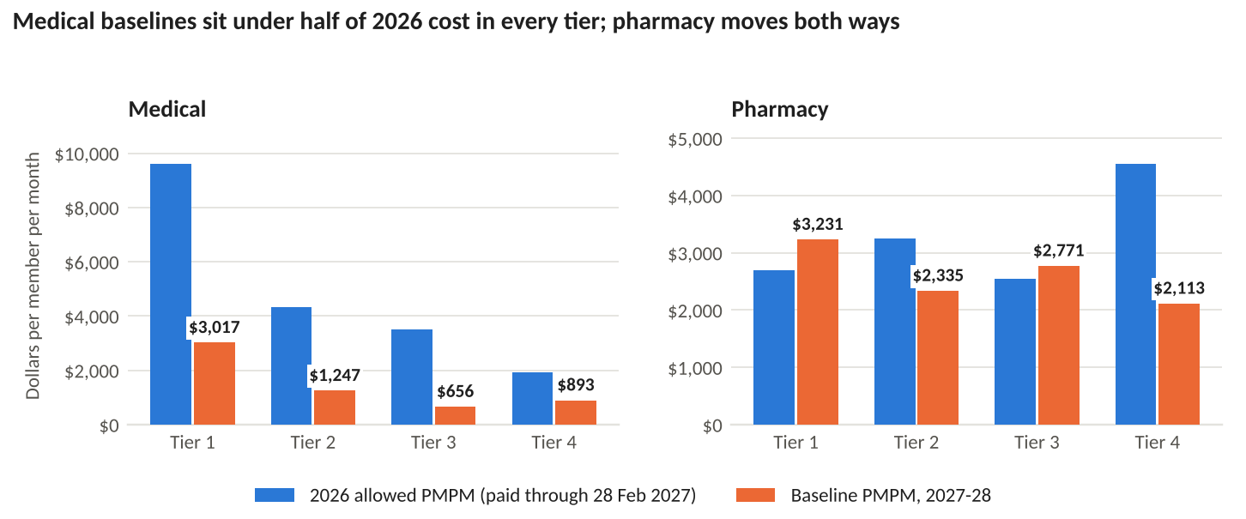
Per member per month. 2026: allowed claims incurred in 2026 and paid through 28 February 2027, not completed, as Schedule C.2 asks. Baseline: 2025 proposal members by tier, April 2025 to March 2026, at trend. Source: Ellery and Quarrystone claims; Northcourt lists of 21 February 2025 and 5 March 2027.
Allowed claims here include member cost sharing and are taken before pharmacy rebates and stop-loss reimbursements, as Schedule C.1 defines them. Tier figures and the working are in cohort_baseline_2027.xlsx. Once the Board approves, I will send the certification to Northcourt, who have 30 days to dispute it under Schedule C.6.

