Cypress Ridge should get the 2027 FORTIFIED Roof grant round
To the Board, from Sherry Lang, Catastrophe Risk Manager. November 20, 2026. Re: BRD-2026-118.
Recommendation: award the 2027 round to Cypress Ridge. Re-roofing its 1,500 portfolio homes to the FORTIFIED Roof standard removes about USD 3 million of expected annual hurricane loss, against about USD 2 million in Marlin Shoals, the runner-up, for the same USD 18.0 million.
Marlin Shoals carries the largest annual expected loss (USD 10.08 million) but 81 percent of it comes from events gusting 130 mph or more at the portfolio. Our claims since 2012 show the FORTIFIED Roof cuts paid loss per dollar insured by about 59 percent in storms gusting under 130 mph and by about 6 percent above, where wall, opening and connection failures drive the loss. Cypress Ridge's annual loss sits almost entirely below 130 mph.
The cut by gust class meets MG-04 on all five storms since 2012 with USD 10 million or more paid on FORTIFIED homes. A single cut for all storms does not, and ranks the counties by their annual loss instead.
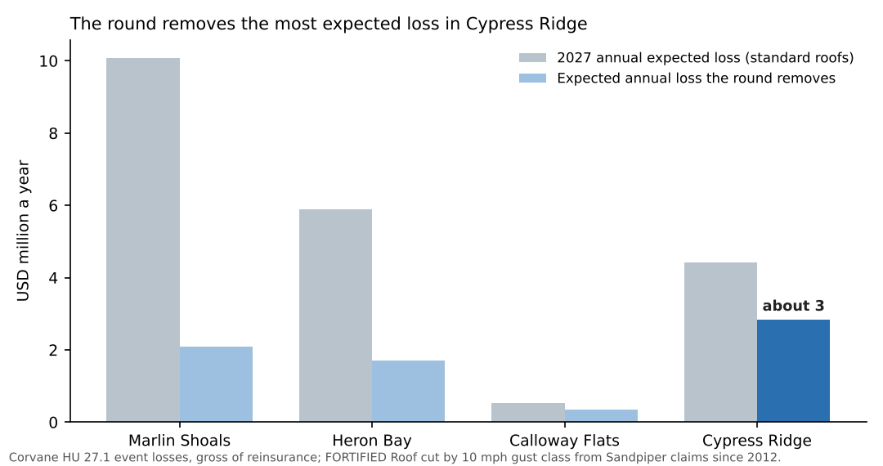
Detail by county, the MG-04 test table, the FORTIFIED counts at September 30, the pre-2012 storms and the portfolio roof ages are in retrofit_round_2027.xlsx.
Losses are Corvane HU 27.1's for each county's 1,500 listed homes, gross of reinsurance and after the 2 percent named-storm deductible, as the brief compares them; the 2025 storm is outside the MG-04 test.

