Quenmoor and Kirkbeck Integrated Care Board
Board meeting held in public, 12 November 2026
Agenda item | 11
Report title | 2027-28 additional lumbar spinal operations: five providers clear the outcome floor
Executive lead | Maureen Thompson, Director of Planned Care
Report author | Iain Kaur, Senior Analyst, Planned Care
Purpose | Decision

1. Recommendation
In September the board approved the contracting policy for the 1,250 additional lumbar decompression and discectomy operations it will commission in 2027-28. The policy places the volume on the outcomes patients reported a year after the same operations in 2023-24 and 2024-25, case-mix adjusted, with a floor of 14.5 points.
The board is asked to approve placing 910 operations with the five providers in Table 1 that clear the floor, each up to the volume it offered, and to hold the remaining 340 for in-year commissioning.
Table 1. 2027-28 placement by provider (outcome: case-mix adjusted mean change in the Oswestry Disability Index a year after the operation, in points)
Provider | Outcome | Offered | Placed
Hethercombe Park Hospital | 17 | 180 | 180
Cragsmoor General Hospital | 16 | 150 | 150
Shelderwick Hospital | 15 | 260 | 260
Ravensholt Royal Infirmary | 15 | 210 | 210
Corriemoor Penderwick House Hospital¹ | 15 | 110 | 110
Thistledene Hospital | 14 | 170 | 0
Ormsbrook Spine Clinic | 14 | 240 | 0
Oxlade Treatment Centre | 13 | 200 | 0
Tannerbrook Surgical Centre | 13 | 130 | 0
Gorsedene Hospital | 13 | 120 | 0
Total placed |  |  | 910
Source: Mossgill Outcomes questionnaire extracts and the board's hospital episode extract to 30 September 2026; providers' capacity returns, version 1.2. Outcomes are shown in whole points; the floor is applied to the unrounded outcome.
¹ Reported for 2023-24 and 2024-25 under provider code 41355 (Penderwick House Hospital); renamed and re-coded 41477 when Corriemoor Healthcare completed its purchase on 1 April 2025.
2. How the outcomes were measured
Each outcome is the policy measure over all 8,150 eligible operations, not only the 5,208 whose patients returned the 12-month questionnaire. Patients readmitted as an emergency within 90 days of discharge returned it far less often (33% against 68% of other patients), and those who did return it reported a change 17.5 points below the case-mix expectation. A missing 12-month score was therefore estimated from the patients at the same provider with the same readmission status, not from the pre-operative case-mix, on which those who returned the questionnaire and those who did not look alike.
Read from the returned questionnaires alone, Ormsbrook Spine Clinic and Thistledene Hospital would clear the floor and all 1,250 operations would go to seven providers; a larger share of their patients was readmitted as an emergency than at any other provider, and on the full measure both sit below 14.5 points.
3. Waiting list on 31 March 2026
Waits are counted under section 5 of the policy: from the day the musculoskeletal triage service received the referral where the patient came through it, with the clock kept running across the board's mutual-aid moves, and each patient counted once at the provider responsible on 31 March.
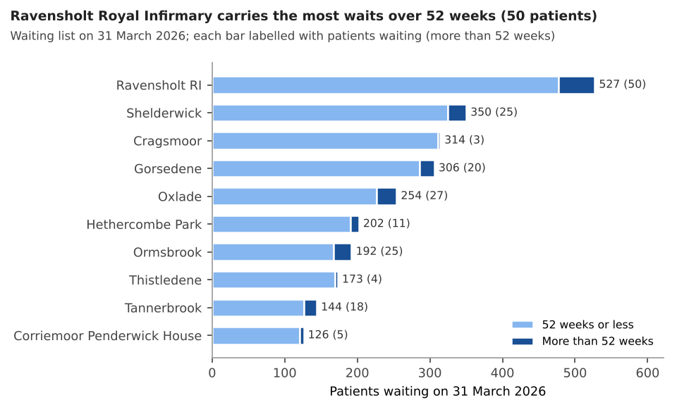
Figure 1. Patients waiting by provider, split at 52 weeks.
Table 2. Waits on 31 March 2026
Provider | Waiting more than 52 weeks | Waited 18 weeks or less (%)
Corriemoor Penderwick House Hospital | 5 | 56
Cragsmoor General Hospital | 3 | 46
Gorsedene Hospital | 20 | 31
Hethercombe Park Hospital | 11 | 56
Ormsbrook Spine Clinic | 25 | 54
Oxlade Treatment Centre | 27 | 50
Ravensholt Royal Infirmary | 50 | 33
Shelderwick Hospital | 25 | 49
Tannerbrook Surgical Centre | 18 | 55
Thistledene Hospital | 4 | 54
Source: providers' month-end waiting list submissions and removals; community MSK triage service referral log.
4. Pre-operative questionnaire participation, 2025-26
Participation is the share of each provider's 2025-26 index operations whose patient completed a scored pre-operative questionnaire in the 90 days up to and including the day of the operation (policy section 6), dated from the hospital record.
Provider | Participation (%)
Corriemoor Penderwick House Hospital | 81
Cragsmoor General Hospital | 85
Gorsedene Hospital | 84
Hethercombe Park Hospital | 80
Ormsbrook Spine Clinic | 81
Oxlade Treatment Centre | 84
Ravensholt Royal Infirmary | 84
Shelderwick Hospital | 81
Tannerbrook Surgical Centre | 81
Thistledene Hospital | 80
Source: hospital episode extract; Mossgill Outcomes questionnaire extracts and NHS number link.
5. Next steps
Contract variations will go to the five providers once the board approves. The 340 operations held back will be offered through in-year commissioning on the same measure. Providers below the floor will be offered a meeting with the clinical lead to go through their results.

