MEMORANDUM
To | Technical Committee, Brannoch Lake Commission
From | Kathy Dominguez, Water Quality Program Manager, Brannoch Lake Commission
Date | 12 January 2027
Subject | Water year 2026 tributary loads and the 2027 Tributary Restoration Fund

Fund the 2027 projects in the Kestle River, the Hessick River and Varrow Brook.
Under section 3.1 of the agreement the Fund takes the three tributaries whose water year 2026 load exceeded its allocation by the most kilograms. On the approved record those are the Kestle River (2,540 kg above its allocation), the Hessick River (1,250 kg) and Varrow Brook (1,120 kg). Ambrey River (350 kg) and Orrinwood Brook (210 kg) were also above, by less; the other five tributaries were under their allocations.
Table 1. Water year 2026 loads against Schedule 1 allocations (kilograms of total phosphorus).
Tributary | Load | Range, full record | Allocation | Above allocation | 2027 project
Kestle River | 16,820 | 16,440 to 16,920 | 14,280 | 2,540 | Yes
Hessick River | 6,910 | 6,800 to 6,930 | 5,660 | 1,250 | Yes
Varrow Brook | 4,360 | 4,350 to 4,460 | 3,240 | 1,120 | Yes
Ambrey River | 3,730 | 3,720 to 3,750 | 3,380 | 350 | No
Orrinwood Brook | 2,600 | 2,600 to 2,620 | 2,390 | 210 | No
Pellow Brook | 740 | 730 to 740 | 800 | -60 | No
Fallowmere Brook | 1,070 | 1,070 to 1,080 | 1,200 | -130 | No
Dunmarsh Brook | 1,660 | 1,660 to 1,690 | 1,830 | -170 | No
Corriden River | 3,570 | 3,560 to 3,580 | 3,930 | -360 | No
Tamsell River | 3,010 | 3,000 to 3,020 | 3,490 | -480 | No
Loads to the nearest 10 kg; the ranking is made on unrounded loads (agreement 2.2). The load is the seasonal rating curve with the smearing correction; the range covers the same curve without the seasonal cycle, with a quadratic term in discharge, and with the normal-theory correction, each fitted to the full record, rounded outward to 10 kg.
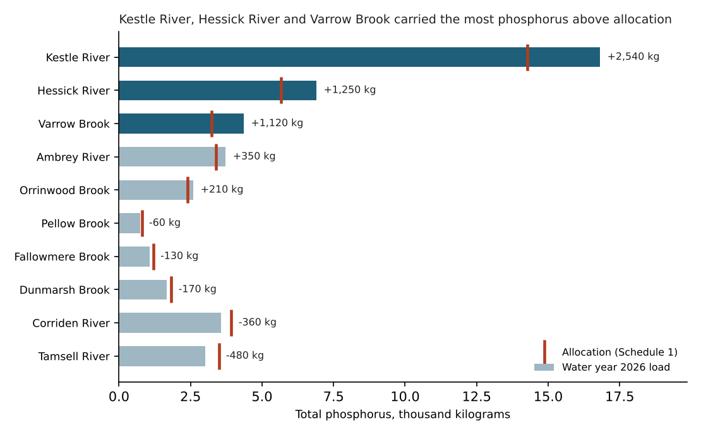
Figure 1. Each tributary's water year 2026 load (bars) against its allocation (red marks).

How the loads were built
A load is the year's daily discharge times the day's concentration, summed. Discharge comes from the approved 15-minute record, averaged over local days (Dunmarsh Brook's carried from its gage by the ratio of drainage areas). Concentration was sampled on about 26 days of the year at each station: the Commission's rounds on the first and third Tuesdays and the college's storm samples. In every tributary concentration rises with discharge (slopes of 0.31 to 0.86 on the log scale), and few samples fall on the high flows that carry the load: on the Kestle River the tenth of days with the highest discharge carried 63 per cent of the year's phosphorus and held 4 per cent of its samples. Carrying the samples across the days between them prices those days at the readings of the days around them. Each day's concentration is therefore taken from a rating curve fitted to every accepted routine sample from water years 2024 to 2026: log concentration on log discharge with a seasonal cycle, retransformed to the mean with the smearing factor.
Interpolating the samples between visit days instead puts the Kestle and Hessick rivers below their allocations and funds Ambrey River, Orrinwood Brook and Varrow Brook; the selection above holds on every rating curve we fitted (with or without the seasonal cycle, a quadratic term, the normal-theory correction, or a shorter calibration record).

Data notes
- Results from both organisations are used: the Commission's (BLC stations) and the college's storm samples (ACWL stations), joined through the station register. Field replicates, field blanks and rejected results are left out; results reported in micrograms per litre since July 2025 are converted.
- The approved discharge delivered on 14 December 2026 replaces the provisional values for July to September; two gages' ratings were shifted from 1 August 2026.
- The upstream wastewater phosphorus and cover crop acres the agreement's section 4.1 asks for are in tributary_loads_wy2026.csv.

