To: Melissa Hayden, ITS Program Manager
From: Lynn Dalton, ITS Engineer
Date: 21 May 2027
Subject: Spatial test re-tune list for winter 2027/28

Re-tune the air temperature spatial test at eight stations before winter 2027/28: SD-118 Halvorsen Meadow, SD-122 Bitterbrush Flat, SD-131 Teller Junction, SD-147 Larkspur Grade, SD-204 Cutler Meadow, SD-211 Ransom Creek, SD-226 Antimony Grade, SD-318 Ptarmigan Grade.
Under section 3 of the data quality standard a station goes on the list when the spatial test withheld a right air temperature in more than 2 per cent of the winter's hours. These stations were at 4, 14, 11, 14, 5, 8, 3, 3 per cent; every other station rounds to 0 per cent, so none is close to the line.
Most of what the test withheld at these stations was the basins' cold air on still nights. Halvorsen Meadow, Teller Junction and Bitterbrush Flat read together, as do Cutler Meadow and Ransom Creek, and their cold readings were the air: each withheld reading agrees with the other floor stations of its basin that hour. Larkspur Grade, Antimony Grade and Ptarmigan Grade sit above those pools; the test's estimate for them leans on the cold floor stations close by, and their withheld readings agree with the passes and benches around them carried to their elevation. A check against the regional lapse line, or against the HRRR forecast, calls the floor readings wrong, because neither has the pools in it.
What the test withheld at Monument Pass and Thunder Saddle (rime on the probe), Sapphire Hill (a connector fault), Big Prairie (sun on the radiation shield) and Fenwick (a wet filter in the spring) was wrong, and was rightly withheld; those stations are not on the list.
Station | Elevation (m) | Hours withheld | False-rejection hours | Share (%)
SD-118 Halvorsen Meadow | 1,118 | 205 | 205 | 4
SD-122 Bitterbrush Flat | 1,106 | 714 | 714 | 14
SD-131 Teller Junction | 1,142 | 564 | 564 | 11
SD-147 Larkspur Grade | 1,560 | 725 | 725 | 14
SD-204 Cutler Meadow | 1,418 | 250 | 250 | 5
SD-211 Ransom Creek | 1,441 | 406 | 406 | 8
SD-226 Antimony Grade | 1,878 | 163 | 163 | 3
SD-318 Ptarmigan Grade | 2,082 | 144 | 144 | 3
Share: winter hours with a false rejection by the spatial test, as a percentage of the 5,088 hours from 1 October 2026 00:00 to 1 May 2027 00:00 Mountain time.
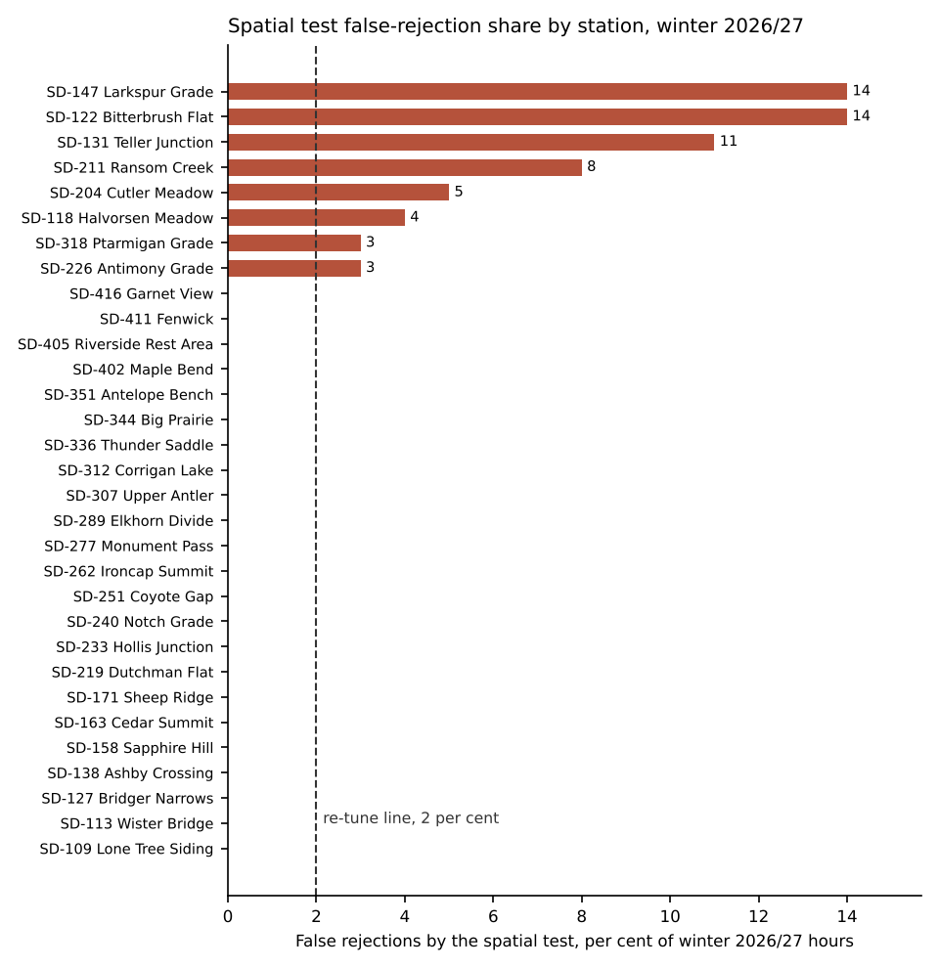
The workbook has every station's review line, and each maintenance section's Schedule B unavailable hours (4,572 station-hours across the network) and its travel-lane freezing and ice hours for the section reports.
Sources: ESS atmospheric export and Quillan QC withheld log, winter 2026/27; RWIS site register; central server message log, modem register and planned outage notices; pavement sensor export.

