Jobseekers will start 25 per cent of their own contacts in Ask Prairie Works in March and April
To: Loretta Rodgers, Head of Contact Services
From: Sabrina Ward, Digital Channels
Date: 5 January 2027
Subject: the March and April usage tier, due with the vendor on 8 January
Jobseekers on the register on 3 January 2027 will start 25 per cent of the contacts they make themselves between 1 March and 25 April 2027 in Ask Prairie Works.
That is up from 14 per cent in the last eight weeks of 2026, and well short of the 40 per cent a learning model with one rate for every contact gives once release 4.0 has answered every claimant-line call for eight weeks.

Why the assistant-first weeks convert fewer jobseekers than they appear to
In 2026 each jobseeker's channel choice followed what the two channels had done for them: a resolved conversation made the next one more likely, an unresolved one less. The calls the overflow transferred to the voice service are the only contacts in the record where a jobseeker who picked the phone met the assistant instead, 11,154 of them. In a learning model fitted to every jobseeker's 2026 contacts, those moved the jobseeker's later choices about a fifth as far as a conversation they had opened themselves (the workbook's Model comparison sheet has the fitted rates).
The assistant-first weeks are eight weeks of exactly that kind of contact. A model that learns from them at the chosen rate still looks right on 2026: fitted to January to October it predicts 14 per cent of November and December's own contacts in the assistant, and 14 per cent is what happened, because transfers are a small part of the record. Carried through the assistant-first weeks it gives 40 per cent. The separate rate predicts those 68,677 November and December choices better by 382 log-likelihood units, fits the whole record better by 1,419, and beats treating transfers as teaching nothing by 93.
Model of 2026 | Behind the split model, log-likelihood units | 1 March to 25 April
Separate rate for transfers (used) | 0 | 25%
One rate for every contact | 1,419 | 40%
Transfers teach nothing | 93 | 20%
Source: contact_legs_2026.csv and assistant_sessions_2026.jsonl, 5 January 2026 to 3 January 2027.
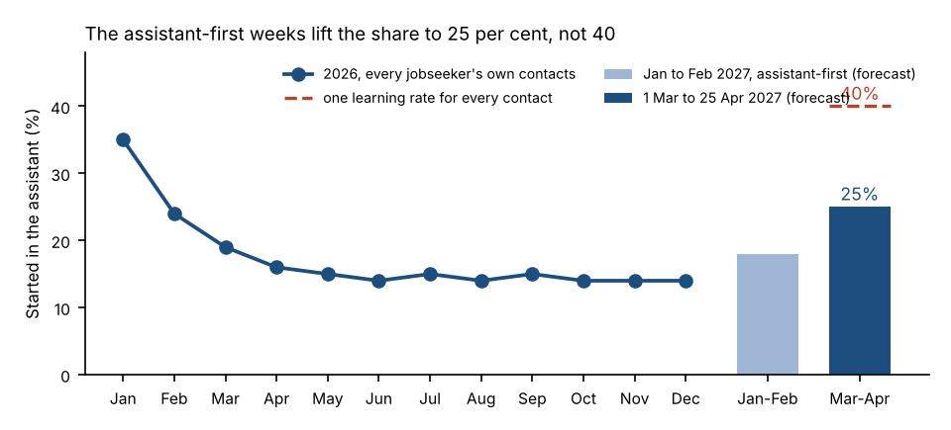
Share of jobseekers' own contacts started in Ask Prairie Works: 2026 by month, and the forecast for 2027.

What the forecast rests on
Release 4.0 resolving the conversations it takes as it resolved 2,041 of the acceptance test's 2,400; calls an adviser takes resolving as in 2026; check-ins every 14 days from each claim's opening; other questions at the 2026 rate; the overflow transfer back on from 1 March. Jobseekers whose claims close before March drop out without changing the share.

For the order
The March and April chat tiers carry employers and our own staff and test use as well as jobseekers. The workbook has their 2026 conversations month by month, counted the way the forecast counts jobseekers' contacts.
Attached: assistant_share_forecast_mar_apr_2027.xlsx (the forecast, the model comparison, the 2026 record and the monthly counts).
Shares are of contacts, not of jobseekers. A call the overflow transferred to the voice service counts as a call, as rollout plan 5.1 has it.

