QUALITY NOTE: 2027 ANNUAL LABOUR MARKET FLOWS
To: the management meeting, through Atinuke Adebisi, Director From: Comfort Olawale, survey methodologist Date: 10 February 2028
The 2027 annual flows tables cannot go out without the classification-error warning: 13 of the 24 district rates carry it.
The warning goes on the job-finding rates of Industrial Corridor, Cocoa Belt East, Cocoa Belt West, Northern Savanna, Central Hills and Creeks, and on the job-loss rates of Lagoon Coast, Cocoa Belt East, Cocoa Belt West, Northern Savanna, Central Hills, River Basin and University Towns. In each of them 45.1 to 69.0 per cent of the moves the rate counts are not real moves, a third or more. The other 11 rates go out without it, at 11.9 to 23.2 per cent. The chart shows every rate against the line.
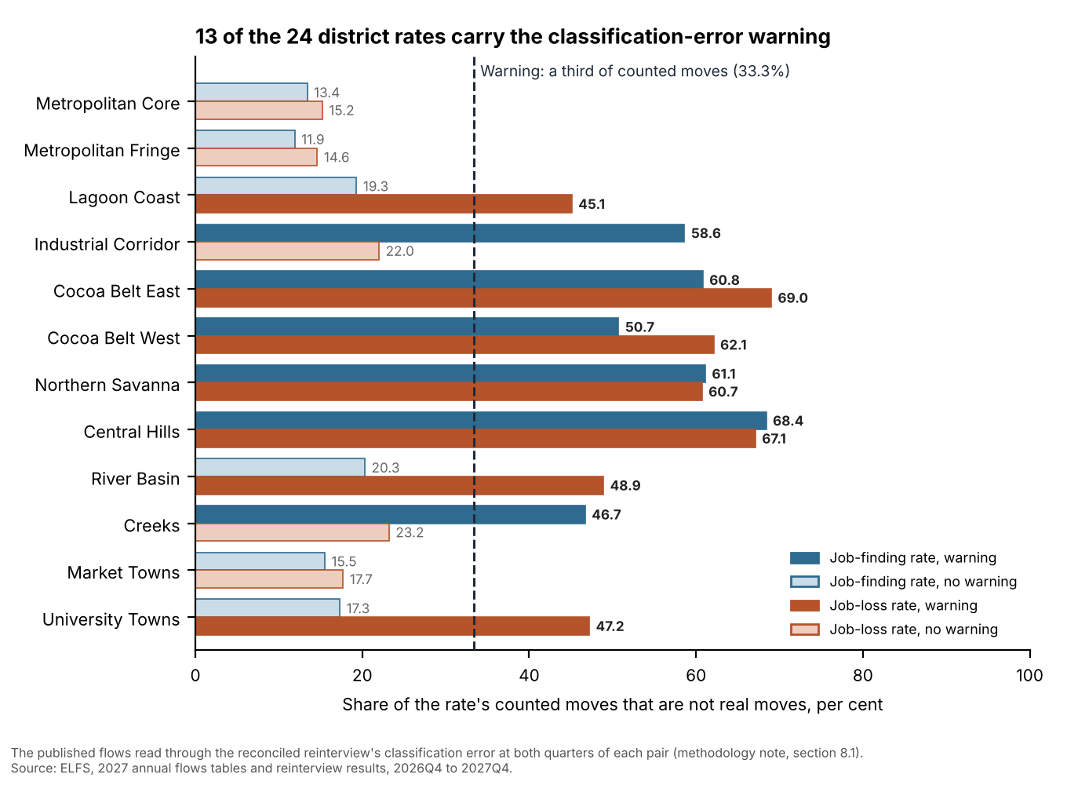
District | Rate | Published (%) | Error taken out (%) | Counted moves not real (%)
Lagoon Coast | Job-loss | 1.5 | 1.0 | 45.1
Industrial Corridor | Job-finding | 11.9 | 5.9 | 58.6
Cocoa Belt East | Job-finding | 17.5 | 9.3 | 60.8
Cocoa Belt East | Job-loss | 1.0 | 0.4 | 69.0
Cocoa Belt West | Job-finding | 20.7 | 14.1 | 50.7
Cocoa Belt West | Job-loss | 1.1 | 0.5 | 62.1
Northern Savanna | Job-finding | 17.7 | 9.4 | 61.1
Northern Savanna | Job-loss | 1.1 | 0.5 | 60.7
Central Hills | Job-finding | 15.1 | 6.3 | 68.4
Central Hills | Job-loss | 1.1 | 0.4 | 67.1
River Basin | Job-loss | 1.5 | 0.9 | 48.9
Creeks | Job-finding | 13.8 | 8.7 | 46.7
University Towns | Job-loss | 1.5 | 0.9 | 47.2
The 13 rates that carry the warning. Published: Table F2. Error taken out: the same rate on the true flows.
How the check was made. A person the tables count as moving between two statuses may have held the same status in both quarters and been recorded wrongly in one of them. The supervisors' reinterview measures how often that happens: of the 15,221 persons reinterviewed within the window over the five quarters whose interviews enter the tables, an employed person was recorded unemployed 0.44 per cent of the time, an unemployed person employed 5.87 per cent and outside the labour force 10.17 per cent, and a person outside the labour force unemployed 1.40 per cent. With that error taken out at both quarters of each pair, each district's published flows give its true flows, and a rate's share of counted moves that are not real moves is one less the true moves recorded correctly in both quarters, over the moves the table counts.
Why these rates. Most adults stay employed, or outside the labour force, from one quarter to the next, so rare misreadings of those large groups add up to a large part of the few real moves into or out of unemployment. The job-loss rates warned are those of the districts where few employed people lose work (true job-loss rates of 0.4 to 1.0 per cent a quarter, against 3.9 to 5.0 per cent in the other five), and the job-finding rates warned those where few of the unemployed find work (5.9 to 14.1 per cent, against 38.4 to 44.7 per cent). Multiplying the chances that each of a counted mover's two recorded statuses is right would put every rate at 18.1 per cent and warn none: a counted move is far likelier than a single record to be a misreading, because most people's status did not change.
Match rate and reinterview timing. Over the year's four quarter pairs, 90.3 to 92.0 per cent of the persons interviewed in a dwelling due another visit were interviewed again at its next visit, by district. The supervisors completed the 2027 reinterviews a mean of 6.1 to 7.3 days after each person's own interview. The workbook (elfs_2027_flows_quality.xlsx) has every figure.
Note. The six enumeration areas that moved from the Industrial Corridor to the Metropolitan Fringe on 1 April 2027 are counted in the Fringe in every quarter, their 2026Q4 and 2027Q1 interviews included, as the tables count them.
Sources: ELFS 2027 annual flows tables as tabulated (28 January 2028); reinterview results and fieldwork log, 2026Q4 to 2027Q4; quarterly person files, 2026Q4 to 2027Q4; district gazetteer; methodology note, 2027 edition; reinterview protocol, version 3.

