To: Leadership team, meeting of 7 December 2026
From: Glenn Taylor, CRM Analyst, for Marian Smith
Date: 24 November 2026
Subject: The restart series in the 2027 jobseeker email plan
Drop the restart series from the 2027 plan: its thirteen sends would cost about 300,000 sponsored clicks a year.
The pilot did bring paused jobseekers back. Over its six 28-day windows the mailed arm made 0.178 sponsored clicks per jobseeker against 0.034 for the held-out tenth, a gain of about 100,000 clicks among the paused pool. But every send went out from the same domain as the daily alerts, to addresses that had gone unread for months, and in the fortnight after each one the alerts of jobseekers with Google, Microsoft and Yahoo addresses drew markedly fewer sponsored clicks, even after the clicks those jobseekers made on the site and app instead. Read against the six mailbox groups that never moved, that loss comes to about 250,000 clicks over the pilot.
Netting the two, the pilot cost Quaywork about 150,000 sponsored clicks. Sized as the plan asks, at the average pilot send thirteen times, the 2027 series would cost about 300,000 clicks a year. The plan keeps a programme only if it adds sponsored clicks, so the restart series should not stay. Paused jobseekers keep the site and app routes to restart.
Sizing (sponsored clicks) | Figure
Gain among the paused pool, six sends | 100,000
Loss among jobseekers with alerts on | -250,000
Net effect of the pilot | -150,000
2027, thirteen sends | -300,000
Source: sponsored_clicks_by_mailbox_daily.csv; the pilot's figures to the nearest 50,000, 2027 to the nearest 100,000.
Of the restarts the alert system logged from each send's link, 46,756 in all, 13,256 were gateways at university and business addresses opening every link of the email in one pass; they are left out of the restart counts below.
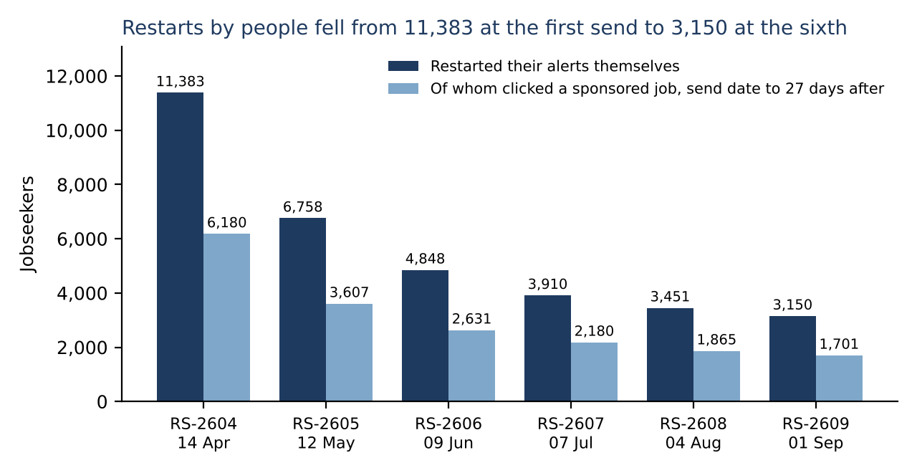
Each pilot send's restarts by people and, of them, those who clicked a sponsored job on the send's date or in the 27 days after it, before or after restarting (app clicks made logged out included where the device is theirs).

