To | Credit Committee
From | Direct Assignment desk
Date | 15 January 2027
Ref | DA/PVM/2026-12
Subject | Pool PVM/2026-12 from Prachi Valley Microfinance: six-month delinquency forecast and guardrail screen

About 300 of the pool's loans will be 90 or more days past due on 30 June 2027
We expect about 300 of the pool's 12,880 loans to be 90 or more days past due on 30 June 2027 (278.1 before rounding, 2.2 per cent of the loans).¹ Every loan in the pool is current at the cut-off, but some are current only because another member of the group paid the instalment at the centre meeting. At its last meeting on or before the cut-off, 3,372 of the pool's loans sat in groups paying for one member and 426 in groups paying for two or more. In the assignor's record a group carrying one member mostly keeps going, and 3.11 per cent of its loans reach 90 days within six months; a group carrying two at once often stops, and then every member's loan falls behind, the members who were paying included: 31.15 per cent. The forecast applies the record's rate for each count, read at the month ends from July 2023 to June 2026, to the pool's loans at that count.
Members the group paid for at its last meeting | Pool loans | Six-month rate in the record (%) | Expected 90+ on 30 June 2027
None | 9,082 | 0.34 | 30.8
One | 3,372 | 3.11 | 105.0
Two | 412 | 31.15 | 128.3
Three or more | 14 | 100.00 | 14.0
Total | 12,880 |  | 278.1
Source: assignor's collections, CollectPro (July 2023 to March 2025) and Kshetra (April 2025 to December 2026); pool tape at 31 December 2026. The rate for three or more rests on 4 loan-months.
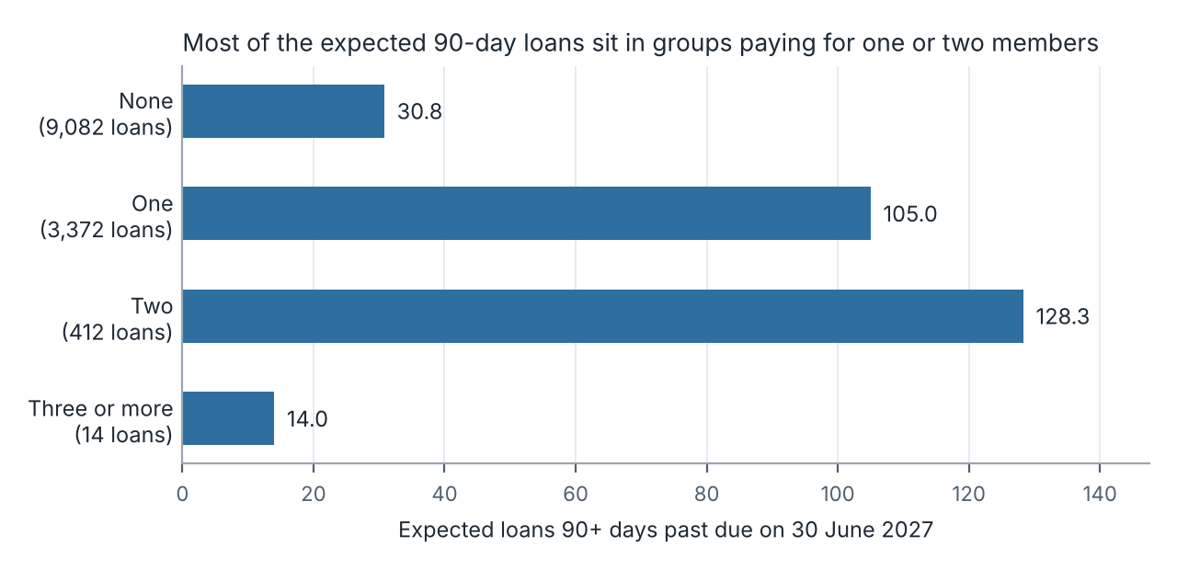
Guardrails. On the bureau report at the cut-off, 2,528 of the pool's borrowers were in breach of CPN-MF-07, with INR 821.3 lakh of pool principal outstanding on their loans; the workbook gives the branch split. Nirmala Small Finance Bank's pre-migration account numbers still show active on the bureau beside the new ones, and the bureau's own lender count treats Salandi's two member codes and Gandhamardan's BC portfolio as separate lenders, so the bureau's summary overstates breaches.
For the decision. Price and size the pool on about 300 loans 90 or more days past due on 30 June 2027, most of them in the Kendrapara and Jagatsinghpur districts, not on the assignor's portfolio report, which counts a co-member's payment as collected.
¹ Days past due as the assignor's JLG operating policy defines them (version 6.1, section 6): from the due date of the oldest instalment not paid in full.

