Kettle Ridge University
Facilities and Operations, Campus Utilities
1200 Fraser Street, Kettle Ridge, PA 16899
October 16, 2026
Samuel Reyes, P.E.
Sanitary Engineer
Pennsylvania Department of Environmental Protection
Safe Drinking Water Program, Northcentral District Office
Re: 2026 Sanitary Survey response, Kettle Ridge University Campus Water System, PWSID 4149327
Dear Mr. Reyes:
Thank you for your letter of September 15. Our responses to the three requests follow; the source capacity evaluation workbook (campus_water_capacity_2027.xlsx) is attached.

1. Source capacity
The system's maximum day demand in the evaluation period was 4,469,527 gallons, used on August 20, 2026 (3,103.8 gpm). That day the wells produced 3,716,646 gallons, with Well 1 out of service for rehabilitation, and the four tanks gave up 752,881 gallons during the first-year move-in and the heat. Firm capacity, from the wells' most recent pump tests less Well 1, the largest, is 2,920 gpm, 183.8 gpm short of the maximum day demand.
The University will add 184 gpm of firm well capacity before June 1, 2027. Capital Planning has scheduled the replacement of the Well 2 pump and motor with a larger unit: design in November 2026, installation in April 2027 and a pump test by May 15, 2027, which we will send to the district office when it is complete. Well 1 remains the largest well.

2. Water audit
Water lost is the water used in the system less the water delivered to the campus's buildings as their meters recorded it. For the year the system lost 125,629,212 gallons of the 1,021,278,949 gallons used, a water loss percentage of 12.3%.
Month | Water used (gal) | Delivered to buildings (gal) | Water lost (gal)
October 2025 | 97,215,588 | 87,965,860 | 9,249,728
November 2025 | 81,484,921 | 72,792,221 | 8,692,700
December 2025 | 78,769,290 | 69,784,219 | 8,985,071
January 2026 | 82,712,637 | 73,365,911 | 9,346,726
February 2026 | 88,067,409 | 79,799,959 | 8,267,450
March 2026 | 86,771,408 | 77,740,022 | 9,031,386
April 2026 | 93,990,800 | 84,501,884 | 9,488,916
May 2026 | 72,344,431 | 62,248,646 | 10,095,785
June 2026 | 70,421,340 | 58,301,951 | 12,119,389
July 2026 | 78,289,138 | 63,252,421 | 15,036,717
August 2026 | 91,201,041 | 76,754,032 | 14,447,009
September 2026 | 100,010,946 | 89,142,611 | 10,868,335
Year | 1,021,278,949 | 895,649,737 | 125,629,212
Water used: the wells' meters less the change in the four tanks' storage between the month's first midnights. Delivered: the buildings' service meters, AMR month-end reads and the vault meters' logged reads.
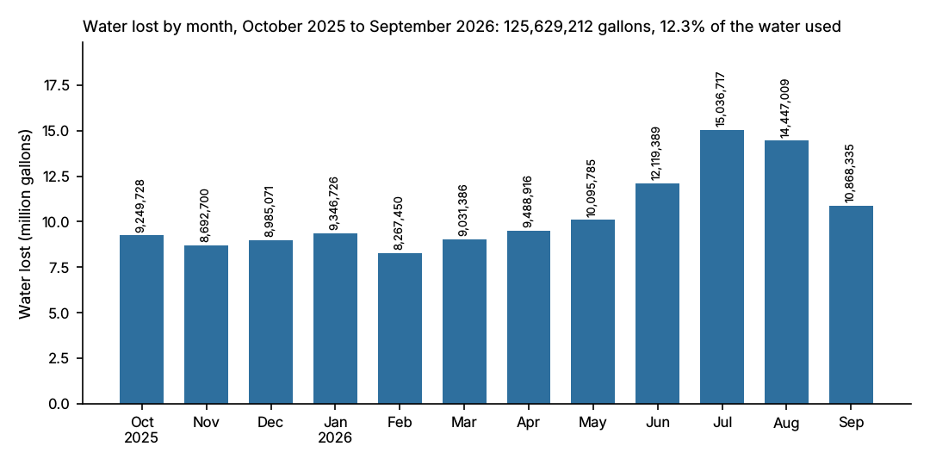
Grounds irrigation is unmetered and counts in the water lost; so does the water used to flush hydrants in April and lost at the two main breaks in January and February.

3. Water use by building group
Water delivered over the evaluation period, as the buildings' meters recorded it:
Building group | Water used (gal)
Residence halls | 280,319,280
Academic and research buildings | 366,798,732
Athletics facilities | 36,193,200
Central energy plant | 87,422,200
The academic and research buildings include the Science Annex until its meter was removed on December 19, 2025, before the building was demolished; the residence halls include Larch Hall, which took over the annex's building number, from its meter's installation on July 14, 2026.
Please call me with any questions.
Sincerely,
Shelly McCarthy
Director of Campus Utilities
cc: Darrell Clark, Capital Planning; Wayne Hicks, Chief Water Operator

