To | Board of the Quarrystone Regional Assessment Consortium
From | Assessment Office
Date | 19 April 2027
Item | Paper 6
Subject | Summer 2027 item-writing commission for the Corvane pools

Commission 199 new items below the Approaching cut for the July pools
Corvane opens a grade's pool only when it holds at least 150 items whose difficulty is below the grade's Approaching cut.¹ With the 2024 and 2025 workshop items calibrated, no grade reaches it. The summer workshop should write 199 items for the low band: grade 3 27, grade 4 39, grade 5 31, grade 6 33, grade 7 49, grade 8 20.
Why the bank's values cannot be loaded as they stand. Tessaline ran the workshop items at the writing panel's ratings, and every student's reported score was computed with those ratings. Reading an item against those scores returns the rating it started from, so we estimated each workshop item's difficulty from the 2025-26 responses together with the students' abilities, holding the launch items at their 2021 values. Estimated the same way, the launch items come back at their own values; read against the reported scores, the low launch items come back several points too easy. The panel placed several multi-step word problems well below the cut that the students' answers put above it, which is most of the gap between the panel's count and ours.
Grade | Launch items below the cut | Workshop items below the cut | Items below the cut | To commission
3 | 63 | 60 | 123 | 27
4 | 62 | 49 | 111 | 39
5 | 57 | 62 | 119 | 31
6 | 56 | 61 | 117 | 33
7 | 55 | 46 | 101 | 49
8 | 70 | 60 | 130 | 20
Total |  |  | 701 | 199
Source: Tessaline close-out export of 31 March 2027 (bank, events and item responses, 2025-26); consortium authoring catalog of 15 March 2027; cut scores from the 2021 scale note.
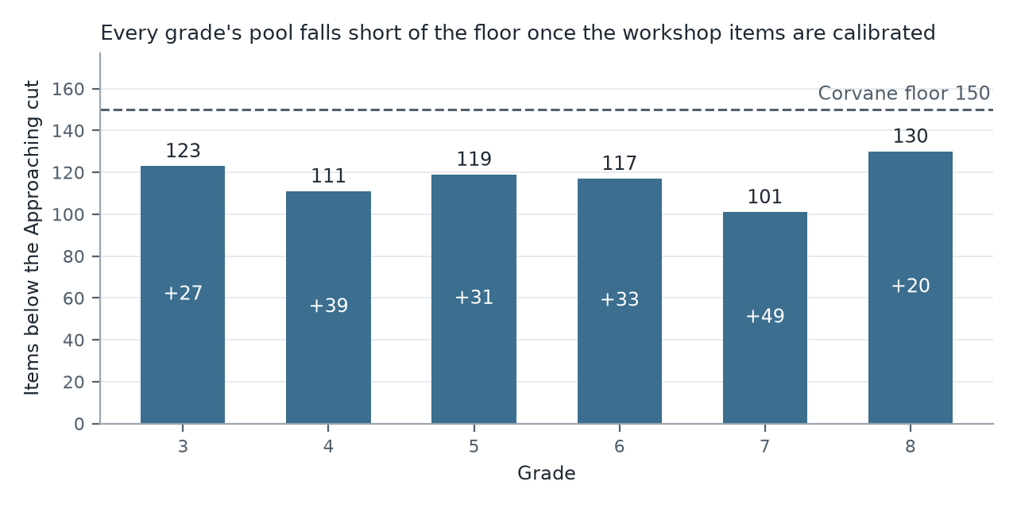
The import file. The import carries every operational item once, under its current key, with its difficulty, its 2026 framework domain and its enemy set; the pool summary gives the domain counts and the enemy sets by grade. Revised items that Tessaline re-keyed are loaded under the new key only.
¹ Corvane Item Pool Import Specification 3.2, section 5. A grade's pool opens once its commission is confirmed.

