Response to outlier notice HAISC/ON/2027/031
Kooralong Health, general surgery, procedures from 1 April to 30 September 2027. Prepared for the Executive Director of Medical Services, January 2028.

Consultants referred to professional practice review
GS-16 and GS-21 go to professional practice review; no other consultant does.
From 12 May 2027 operations whose instrument tray had last been sterilised by steriliser 3 carried 4.3 times the infection rate of the department's other operations. Steriliser 3 is the CSSD's one chamber for instrument containers over 10 kg, so it sterilises the heavy colorectal trays, among them every tray GS-05 and GS-12 use. Set those operations aside and each consultant's infections stand against the Centre's expectation for the rest of their procedures.

Each consultant against the upper control limit
Consultant | All procedures: infections | Limit | Procedures without a steriliser 3 tray | Infections | Limit
GS-03 | 6 | 17 | 285 | 6 | 17
GS-05 | 43 | 22 | 113 | 4 | 11
GS-08 | 10 | 17 | 263 | 10 | 17
GS-11 | 6 | 17 | 265 | 6 | 17
GS-12 | 45 | 23 | 110 | 5 | 12
GS-14 | 12 | 18 | 261 | 12 | 18
GS-16 (referred) | 35 | 22 | 270 | 35 | 22
GS-19 | 9 | 16 | 267 | 9 | 16
GS-21 (referred) | 62 | 21 | 177 | 26 | 16
GS-23 | 7 | 16 | 267 | 7 | 16

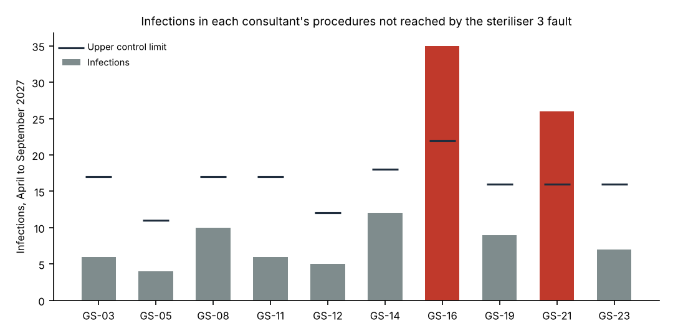

Finding outside the consultants' practice
Steriliser 3 has been withdrawn from service pending revalidation of its drying stage, and the trays it sterilised since its 12 May 2027 repair have been recalled for reprocessing.

